JM Biology
  - Biological data used in the joint jack mackerel assessment
Jack Mackerel Working Group
2026-05-11
Table of contents

 | SPRFMOSouth Pacific Regional Fisheries Management OrganisationJack Mackerel Working Group
1. SCW16/Paper-05
11 May 2026

1. Intro
2. This working paper evaluates the biological inputs used in the joint jack mackerel assessment data and control files for model 1.14. The immediate purpose is to provide a focused biological-data review for JM_SCW_prep, while keeping the assessment inputs and configuration files traceable to the neighboring jjm repository.
3. This contribution extends from the 2022 Jack Mackerel Benchmark Workshop (SCW14) and its final report, which provide the previous benchmark basis for the joint jack mackerel assessment (SPRFMO Scientific Committee, 2022a, 2022b).
4. Model 1.14 is the SC13 model update described in jjm/assessment/README.md as model 1.13 with updates to historical weight-at-age for the Far North fleet. The SC13 final report and Jack Mackerel Technical Annex provide the formal assessment context for this model series (SPRFMO Scientific Committee, 2025a, 2025b). The same data file is used with both assessment hypotheses: h1_1.14 for the single-stock model and h2_1.14 for the two-stock model.

2. Model data
5. The source files used by this report are listed in Table 1.
Table 1: Source files used by this biological-data working paper.
Role | Path
Common data file | ../jjm/assessment/input/1.14.dat
Single-stock control file | ../jjm/assessment/config/h1_1.14.ctl
Two-stock control file | ../jjm/assessment/config/h2_1.14.ctl

6. The common data file defines the temporal, age, fleet, composition, index, and weight-at-age information used by the model. The control files define how those data are mapped to stock hypotheses, including natural mortality, maturity, growth, population weight-at-age, catchability, and selectivity assumptions.
Table 2: High-level contents of the model 1.14 data file.
item | value
Model years | 1970-2025
Ages | 1-12
Fleets | N_Chile, SC_Chile_PS, FarNorth, Offshore_Trawl
Indices | Chile_AcousCS, Chile_AcousN, Chile_CPUE, DEPM, Peru_Acoustic, Peru_CPUE, Offshore_CPUE

7. The biological review should distinguish between information contained directly in 1.14.dat and assumptions introduced through the h1_1.14.ctl and h2_1.14.ctl control files. This distinction matters because some biological quantities are common to both stock hypotheses, while others differ by stock hypothesis. Table 2 summarizes the principal dimensions and named data components in the common model 1.14 data file.

3. Analyses
8. The analyses below are placeholders for reproducible checks against the model 1.14 files. They are intentionally organized around the three biological data questions requested for this working paper.

3.1 Natural mortality
9. Natural mortality is configured in the control files under #N_Mort. The single-stock model uses one natural mortality value, while the two-stock model may assign stock-specific values. These configured values are shown in Table 3.
Table 3: Natural mortality values configured for the model 1.14 stock hypotheses.
 | model | stock | natural_mortality
1 | h1_1.14 | Stock | 0.28
11 | h2_1.14 | Stock1 | 0.28
2 | h2_1.14 | Stock2 | 0.33

10. Items to evaluate:
- Whether the assumed values are consistent with the biological basis used in previous benchmark and annual assessment documents.
- Whether stock-specific assumptions in h2_1.14 are supported by distinct biological evidence.
- How sensitive derived spawning biomass and reference points are to plausible alternatives.

3.2 Maturity
11. Maturity-at-age is configured in the control files under #Pmatatage. The review should check whether the schedule is common or stock-specific, whether age-1 partial maturity remains defensible, and whether the schedule aligns with the biological source material used by the assessment.
12. In the JJM, maturity enters spawning biomass through a maturity-weighted population weight-at-age vector. For stock $s$, year $y$, and age $a$, spawning biomass is computed as
13.
SSBs,y=a​Ns,y,aSs,y,a(mspawn−1)/12ws,apopps,amat,
14. where $N_{s,y,a}$ is numbers-at-age at the start of year, $S_{s,y,a}=exp(−Z_{s,y,a})$ is annual survival, $m_{spawn}$ is the spawning month from #Pspwn in the data file, $w_{s,a}^{pop}$ is the population weight-at-age from #Pwtatage, and $p_{s,a}^{mat}$ is maturity-at-age from #Pmatatage. For model 1.14, #Pspwn is 10.5, so the spawning calculation occurs after $(10.5−1)/12=0.792$ of annual mortality has occurred.
15. The weight-at-age used in this equation is the stock-specific population weight-at-age in the control file. It is fixed through time within each stock. The time-varying fishery and index weight-at-age arrays in 1.14.dat (Fwtatage and Iwtatage) are used for predicted catch and index biomass, not for spawning biomass.
16. For the two-stock h2_1.14 model, the corresponding unfished spawning biomass per recruit, multiplied by 1000, is 1597.8 for Stock 1 and 1367.3 for Stock 2. These values use the stock-specific natural mortality, maturity-at-age, and population weight-at-age schedules in h2_1.14.ctl, with spawning at month 10.5 and the age-12 plus group. The age-specific contribution to those two values is shown in Figure 1.
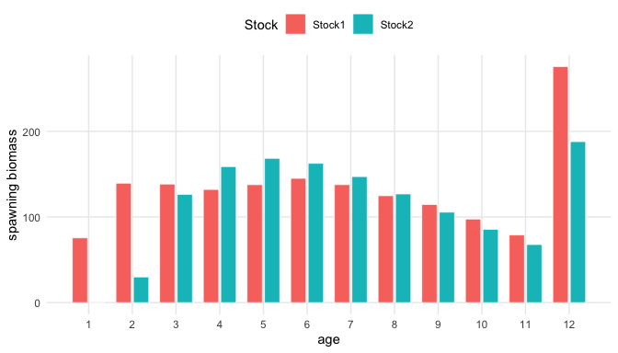
Figure 1: Age-specific spawning biomass per recruit for the two stocks in h2_1.14, multiplied by 1000.
Table 4: Maturity-at-age vectors read from the h2_1.14 control file.
model | stock | age | value
h2_1.14 | Stock1 | 1 | 0.52
h2_1.14 | Stock1 | 2 | 1.00
h2_1.14 | Stock1 | 3 | 1.00
h2_1.14 | Stock1 | 4 | 1.00
h2_1.14 | Stock1 | 5 | 1.00
h2_1.14 | Stock1 | 6 | 1.00
h2_1.14 | Stock1 | 7 | 1.00
h2_1.14 | Stock1 | 8 | 1.00
h2_1.14 | Stock1 | 9 | 1.00
h2_1.14 | Stock1 | 10 | 1.00
h2_1.14 | Stock1 | 11 | 1.00
h2_1.14 | Stock1 | 12 | 1.00
h2_1.14 | Stock2 | 1 | 0.00
h2_1.14 | Stock2 | 2 | 0.37
h2_1.14 | Stock2 | 3 | 0.98
h2_1.14 | Stock2 | 4 | 1.00
h2_1.14 | Stock2 | 5 | 1.00
h2_1.14 | Stock2 | 6 | 1.00
h2_1.14 | Stock2 | 7 | 1.00
h2_1.14 | Stock2 | 8 | 1.00
h2_1.14 | Stock2 | 9 | 1.00
h2_1.14 | Stock2 | 10 | 1.00
h2_1.14 | Stock2 | 11 | 1.00
h2_1.14 | Stock2 | 12 | 1.00

17. The maturity-at-age schedules used in the spawning biomass calculation are listed by stock for the two-stock model in Table 4. The single-stock model uses the same maturity schedule as Stock 1 in h2_1.14.
Table 5: Population weight-at-age used with maturity-at-age in the h2_1.14 spawning biomass equation.
model | stock | age | population_weight_at_age
h2_1.14 | Stock1 | 1 | 0.1815
h2_1.14 | Stock1 | 2 | 0.2303
h2_1.14 | Stock1 | 3 | 0.3025
h2_1.14 | Stock1 | 4 | 0.3820
h2_1.14 | Stock1 | 5 | 0.5268
h2_1.14 | Stock1 | 6 | 0.7345
h2_1.14 | Stock1 | 7 | 0.9226
h2_1.14 | Stock1 | 8 | 1.1060
h2_1.14 | Stock1 | 9 | 1.3435
h2_1.14 | Stock1 | 10 | 1.5135
h2_1.14 | Stock1 | 11 | 1.6205
h2_1.14 | Stock1 | 12 | 1.8285
h2_1.14 | Stock2 | 1 | 0.0380
h2_1.14 | Stock2 | 2 | 0.1460
h2_1.14 | Stock2 | 3 | 0.3240
h2_1.14 | Stock2 | 4 | 0.5550
h2_1.14 | Stock2 | 5 | 0.8190
h2_1.14 | Stock2 | 6 | 1.1000
h2_1.14 | Stock2 | 7 | 1.3840
h2_1.14 | Stock2 | 8 | 1.6600
h2_1.14 | Stock2 | 9 | 1.9220
h2_1.14 | Stock2 | 10 | 2.1650
h2_1.14 | Stock2 | 11 | 2.3870
h2_1.14 | Stock2 | 12 | 2.5880

18. The population weight-at-age vectors paired with maturity in the spawning biomass equation are shown for the two-stock model in Table 5. Again, the single-stock model uses the same vector as Stock 1 in h2_1.14.

3.3 Weight-at-age
19. Weight-at-age is the central biological data issue for this working paper because model 1.14 is specifically identified as updating historical weight-at-age for the Far North fleet. The model includes population weight-at-age in the control files and fishery or survey weight-at-age schedules in the data file. The fixed population weight-at-age vectors used for spawning biomass are repeated for h2_1.14 in Table 6 to separate them from time-varying fishery and index weights-at-age.
Table 6: Population weight-at-age vectors read from the h2_1.14 control file.
model | stock | age | value
h2_1.14 | Stock1 | 1 | 0.1815
h2_1.14 | Stock1 | 2 | 0.2303
h2_1.14 | Stock1 | 3 | 0.3025
h2_1.14 | Stock1 | 4 | 0.3820
h2_1.14 | Stock1 | 5 | 0.5268
h2_1.14 | Stock1 | 6 | 0.7345
h2_1.14 | Stock1 | 7 | 0.9226
h2_1.14 | Stock1 | 8 | 1.1060
h2_1.14 | Stock1 | 9 | 1.3435
h2_1.14 | Stock1 | 10 | 1.5135
h2_1.14 | Stock1 | 11 | 1.6205
h2_1.14 | Stock1 | 12 | 1.8285
h2_1.14 | Stock2 | 1 | 0.0380
h2_1.14 | Stock2 | 2 | 0.1460
h2_1.14 | Stock2 | 3 | 0.3240
h2_1.14 | Stock2 | 4 | 0.5550
h2_1.14 | Stock2 | 5 | 0.8190
h2_1.14 | Stock2 | 6 | 1.1000
h2_1.14 | Stock2 | 7 | 1.3840
h2_1.14 | Stock2 | 8 | 1.6600
h2_1.14 | Stock2 | 9 | 1.9220
h2_1.14 | Stock2 | 10 | 2.1650
h2_1.14 | Stock2 | 11 | 2.3870
h2_1.14 | Stock2 | 12 | 2.5880

20. For the single-stock model h1_1.14, correlations among fishery and acoustic-survey weight-at-age sources are generally modest across ages (Table 7), with the age pattern shown in Figure 2. CPUE indices and DEPM are excluded because the CPUE weights-at-age duplicate their associated fishery series and DEPM is omitted here to simplify the source comparison. The annual distributions of weight-at-age from this same reduced source set are shown for ages 1-9 in Figure 3; the plotted points mark the overall mean normalized weight-at-age for each source and age. For age 3, the median cross-source correlation is 0.04, with 8 negative source pairs out of 21 total pairs. The age-3 heatmap in Figure 4 shows that several high correlations are expected because some data sources share related biological sampling and imputation histories. For age 3, FarNorth remains strongly correlated with Peru_Acoustic. The same age-3 source subset is shown as a pairs plot in Figure 5, with pairwise correlations in the upper triangle and smoothed scatterplots in the lower triangle. Age 8 has the highest mean pairwise correlation among the age-specific weight-at-age series in Table 7; the corresponding correlation heatmap for the same reduced source set is shown in Figure 6. The same age-8 source subset is also shown as a pairs plot in Figure 7, which makes the linearity and outlying years behind the pairwise correlations easier to inspect.
Table 7: Pairwise correlations among h1_1.14 fishery and acoustic-survey weight-at-age time series, summarized by age. CPUE indices and DEPM are excluded.
age | mean_correlation | median_correlation | minimum_correlation | maximum_correlation | negative_pairs | pairs_ge_0.7 | pairs
1 | 0.19 | 0.16 | -0.15 | 0.94 | 2 | 1 | 21
2 | 0.07 | 0.02 | -0.23 | 0.90 | 10 | 1 | 21
3 | 0.08 | 0.04 | -0.66 | 0.83 | 8 | 1 | 21
4 | 0.09 | 0.12 | -0.54 | 0.85 | 6 | 1 | 21
5 | 0.10 | 0.10 | -0.59 | 0.87 | 5 | 1 | 21
6 | 0.11 | 0.06 | -0.50 | 0.88 | 8 | 1 | 21
7 | 0.10 | 0.10 | -0.35 | 0.88 | 10 | 1 | 21
8 | 0.12 | 0.05 | -0.32 | 0.89 | 9 | 1 | 21
9 | 0.10 | 0.06 | -0.30 | 0.66 | 9 | 0 | 21
10 | 0.10 | 0.04 | -0.21 | 0.66 | 6 | 0 | 21
11 | 0.12 | 0.06 | -0.22 | 0.71 | 5 | 1 | 21
12 | 0.10 | 0.00 | -0.33 | 0.66 | 6 | 0 | 21
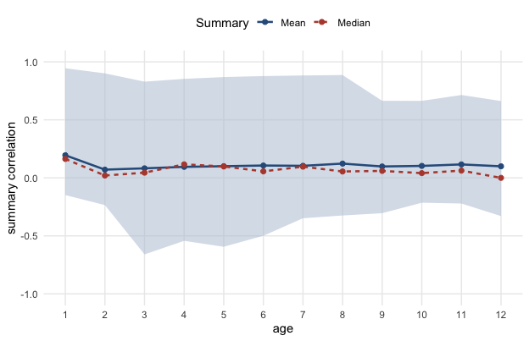
Figure 2: Mean, median, minimum, and maximum pairwise correlations by age for h1_1.14 fishery and acoustic-survey weight-at-age time series. CPUE indices and DEPM are excluded.
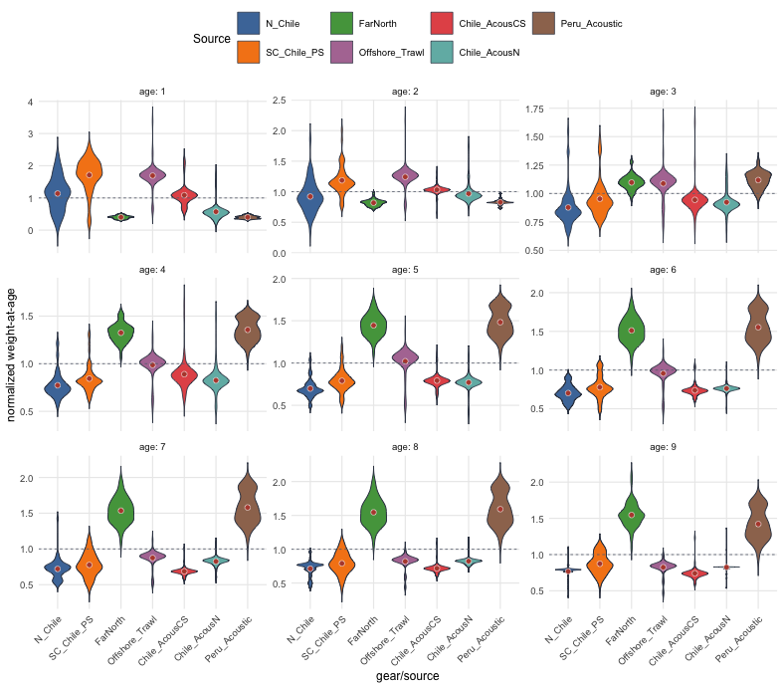
Figure 3: Annual h1_1.14 weight-at-age distributions for ages 1-9 from the reduced fishery and acoustic-survey source set, normalized by the age-specific mean across all retained sources and years. Violins are filled by source and points show the source-specific means.
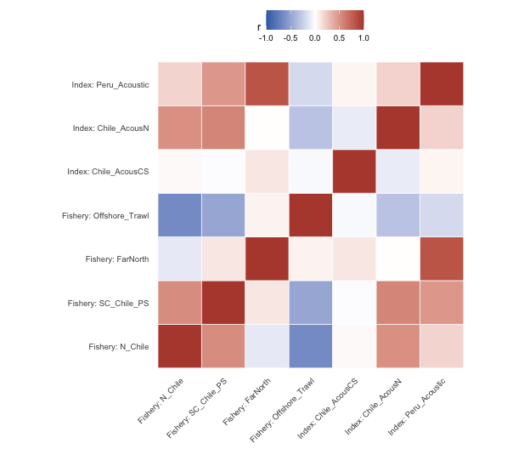
Figure 4: Pairwise correlations among h1_1.14 age-3 weight-at-age time series from fishery and acoustic-survey sources. CPUE indices and DEPM are excluded.
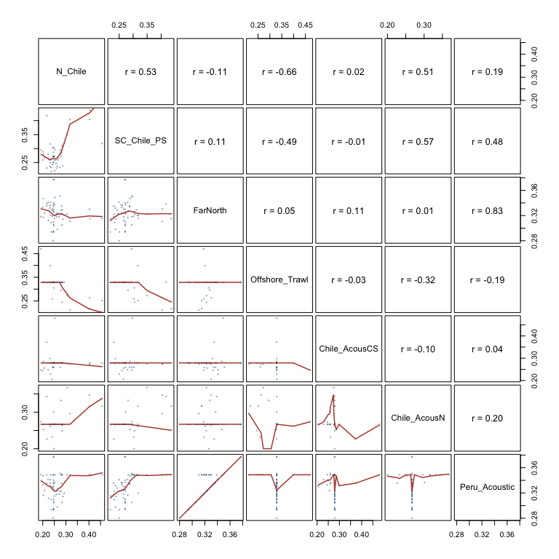
Figure 5: Pairs plot for h1_1.14 age-3 weight-at-age time series from the reduced fishery and acoustic-survey source set. Upper panels show pairwise correlations; lower panels show points and a smoother.
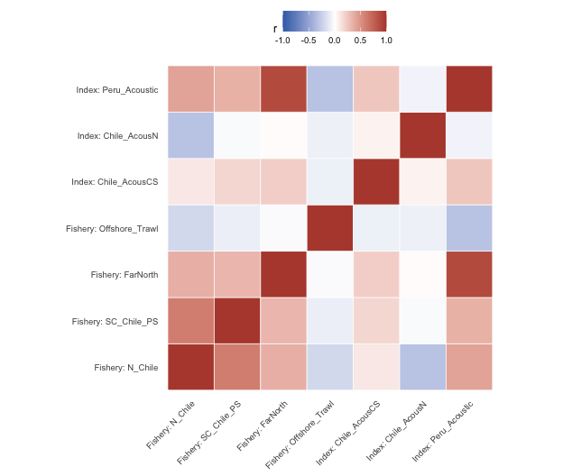
Figure 6: Pairwise correlations among h1_1.14 age-8 weight-at-age time series from fishery and acoustic-survey sources. CPUE indices and DEPM are excluded.
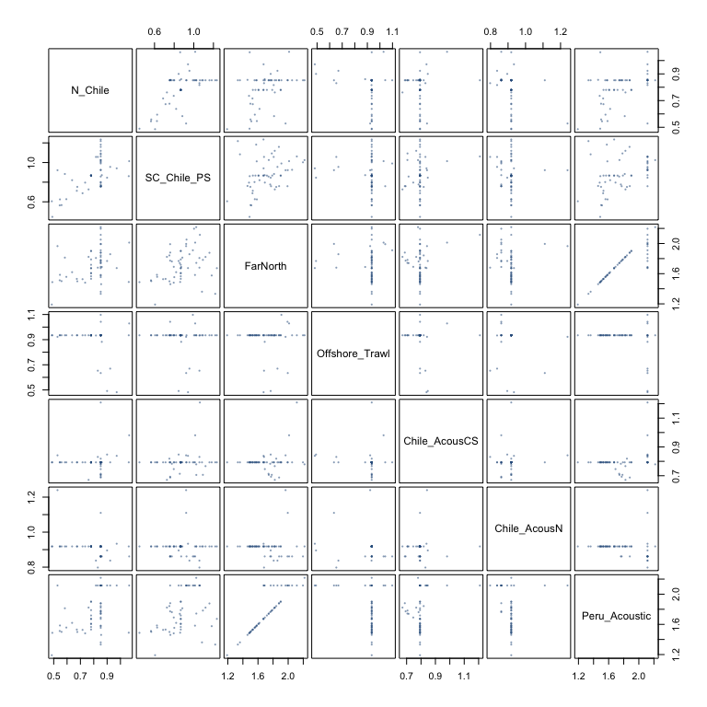
Figure 7: Pairs plot for h1_1.14 age-8 weight-at-age time series from the reduced fishery and acoustic-survey source set.
21. Items to evaluate:
- Which 1.14.dat sections contain Far North fishery and associated index weight-at-age schedules.
- How the historical Far North updates differ from model 1.13.
- Whether population, fishery, and survey weight-at-age schedules are internally consistent.
- Whether the updated historical weights change the biological interpretation of catch biomass, spawning biomass, or stock-specific productivity.

4. Results and discussion
22. This section should synthesize the biological checks rather than repeat the full assessment model description. The expected output is a concise judgement on whether the biological inputs in model 1.14 are internally consistent, adequately documented, and suitable as the basis for the JM_SCW_prep working paper package.
23. The age-structured contribution to estimated spawning biomass from the fitted h2_1.14 model is shown in Figure 8. Age groups 7 and older are pooled to keep the time series interpretable while retaining the dominant older-age contribution. Stock 1 has a broader distribution across ages, with substantial contributions from ages 2-5 and a smaller relative contribution from the pooled older ages in recent years. Stock 2 is shifted older because age-1 fish are immature and age-2 maturity is partial; its spawning biomass is therefore concentrated more strongly in ages 3-6 and the 7+ group, with the 7+ group contributing a larger share than in Stock 1.
24. The same fitted spawning biomass time series is shown by stock in Figure 9. The purpose of this second figure is to show the relative scale of spawning biomass between the two stocks.
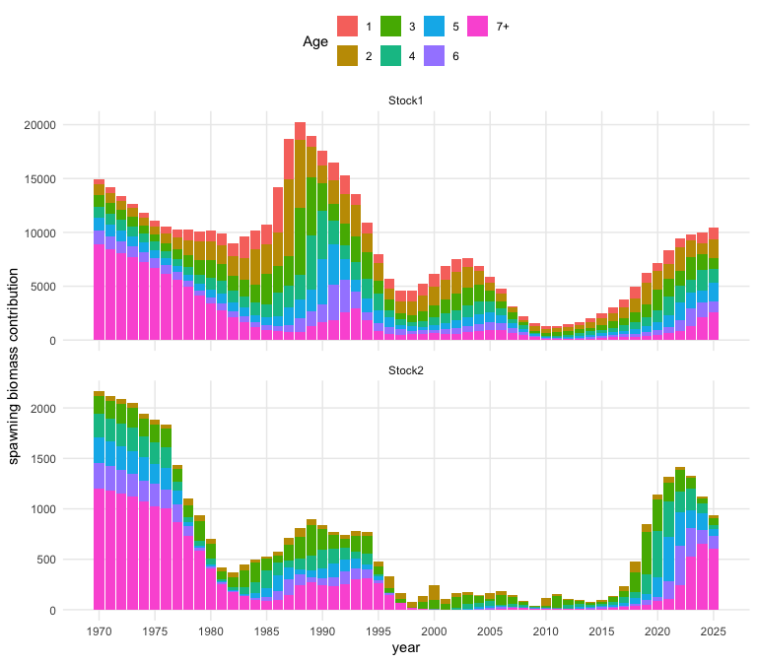
Figure 8: Age-structured contribution to estimated spawning biomass from the fitted h2_1.14 model. Ages 7 and older are pooled.
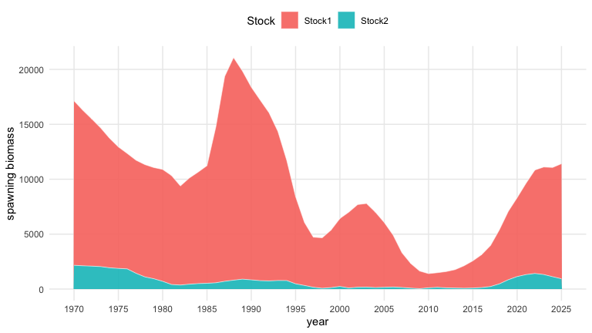
Figure 9: Stacked spawning biomass by stock from the fitted h2_1.14 model. This figure is intended to show the relative scale between stocks.
25. Initial points to carry forward:
- The authoritative files remain in jjm/assessment; this repository reads them directly for reproducibility.
- The single-stock and two-stock hypotheses share the same common data file but differ in biological and stock-structure assumptions through their control files.
- The Far North historical weight-at-age update should be evaluated explicitly against model 1.13, because that is the defining change from 1.13 to 1.14.

5. References
SPRFMO Scientific Committee. (2022a). Jack mackerel benchmark workshop (SCW14). South Pacific Regional Fisheries Management Organisation (SPRFMO). https://www.sprfmo.int/meetings/scientific-committee/sc-workshops/scw14-jack-mackerel
SPRFMO Scientific Committee. (2022b). SPRFMO scientific committee jack mackerel benchmark workshop (2022) report. South Pacific Regional Fisheries Management Organisation (SPRFMO). https://www.sprfmo.int/assets/Meetings/SC_WS/SCW14-Jack-Mackerel-2022/SPRFMO-SC-JM-Benchmark-Workshop-2022-Report-SCW14.pdf
SPRFMO Scientific Committee. (2025a). 13th scientific committee meeting report (p. 180). South Pacific Regional Fisheries Management Organisation (SPRFMO). https://sprfmo.int/assets/Meetings/02-SC/13th-SC-2025/SC13-REPORT-ADOPTED-13SEPT2025c.pdf
SPRFMO Scientific Committee. (2025b). Annex 11: Jack mackerel technical annex. South Pacific Regional Fisheries Management Organisation (SPRFMO). https://sprfmo.int/assets/Meetings/02-SC/13th-SC-2025/SC13-Report-Annex-11_final.pdf

