2. A)
Business Rules Implementation
Business rules define the conditions and constraints under which the system operates. In the Automated Digital Forensics Evidence Collection and Analysis System, business rules are implemented across different modules described as follows:

1. User Authentication & Authorization Module
- Only registered users can access the system
- Role-based access control is enforced:
- Admin → Manage users and datasets
- Investigator → Upload and view evidence
- Analyst → Perform forensic analysis
- Unauthorized users are denied access to protected resources.
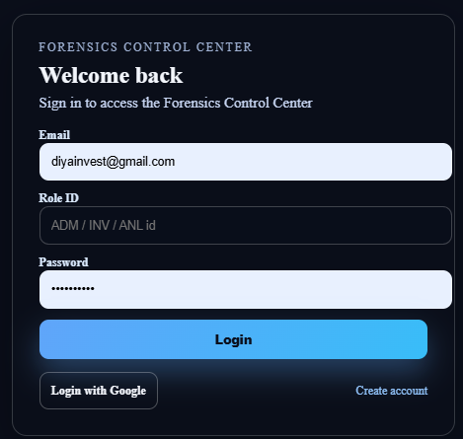

2. Evidence Management Module
- Only authenticated users can upload evidence.
- Supported file formats (images, biometrics, etc.) are enforced.
- Each uploaded evidence is assigned:
- Unique ID
- Timestamp
- Owner information
- Duplicate or corrupted files are rejected.
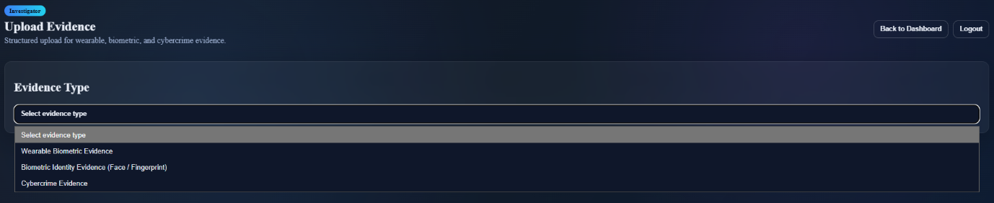
3. Evidence Integrity & Chain of Custody Module
- Every evidence file is hashed (e.g., SHA-based hashing).
- Any modification in evidence results in hash mismatch.
- All actions (upload, access, analysis) are logged.
- Only authorized roles can access sensitive evidence.
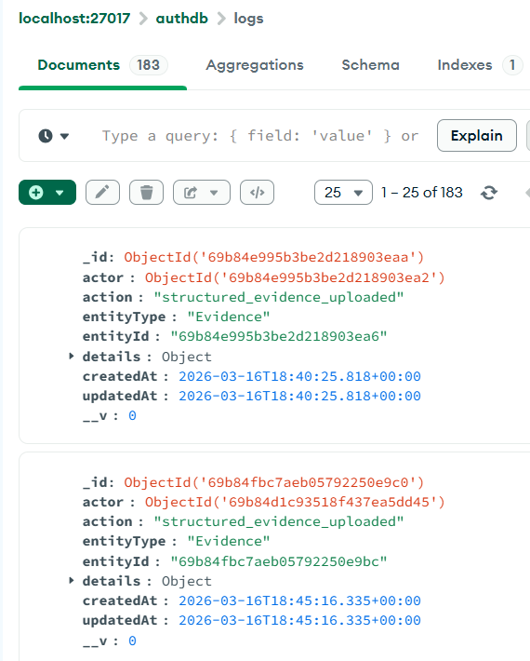
4. Forensic Analysis Module
- Analysis is performed only on pre-processed evidence.
- ML models are selected based on evidence type.
- Confidence scores must meet a threshold to be considered valid.
- Invalid or unsupported inputs are rejected before analysis.
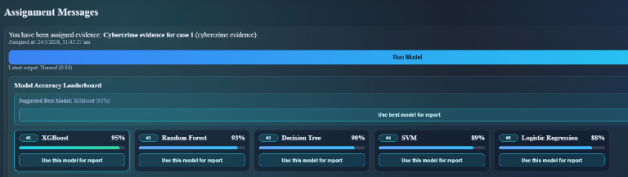

5. Report Generation Module
- Reports are generated only after successful analysis.
- Reports include:
- Evidence details
- Analysis results
- Confidence scores
- Reports are read-only after generation (to maintain integrity).
These rules ensure security, correctness, and forensic reliability.


B)
Validation Logic
Validation logic plays a critical role in ensuring that only accurate, consistent, and properly formatted data enters the system before further processing. In the Automated Digital Forensics Evidence Collection and Analysis System, validation is implemented at multiple levels to prevent errors, maintain data integrity, and enhance system security.

1. Input Validation (Frontend Level)
- File Type Validation: Only supported formats such as images, biometric data, or predefined forensic file types are accepted. Unsupported formats are rejected at the UI level.
- Mandatory Field Validation: Essential fields such as evidence description, evidence type, and user credentials must be filled before submission.
- Input Format Validation: Standard formats are enforced for inputs such as:
- Email (proper structure with domain)
- Password (minimum length, special characters)
- Text fields (restricted characters if needed)
- Client-side Error Handling: Users are notified instantly about invalid inputs, improving usability and reducing unnecessary server requests.
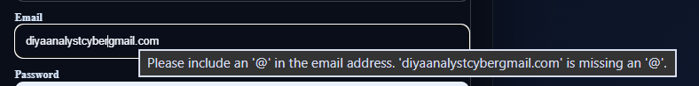

2. Backend Validation
- Re-validation of Inputs: All inputs received from the frontend are validated again to prevent malicious or incorrect data entry.
- File Size and Content Validation: Uploaded files are checked for:
- Maximum size limits
- File integrity
- Correct MIME types
- Duplicate Evidence Detection: The system checks whether the same evidence has already been uploaded using:
- Hash comparison
- Metadata matching
- Authentication Validation: User credentials are securely verified, and only authorized users are allowed access to system functionalities.
- Error Handling and Logging: Invalid requests are logged for auditing/debugging purposes.

3. Database-Level Validation
Constraints such as:
- Unique Constraints: Ensures uniqueness of:
- User IDs
- Evidence IDs
- Non-null Constraints: Critical fields such as user credentials, evidence metadata, and timestamps cannot be left empty.
- Referential Integrity: Relationships between tables (e.g., users, evidence, reports) are maintained using foreign keys to prevent orphan records.
- Data Type Enforcement: Ensures that stored data matches the expected type (e.g., integers, strings, timestamps).
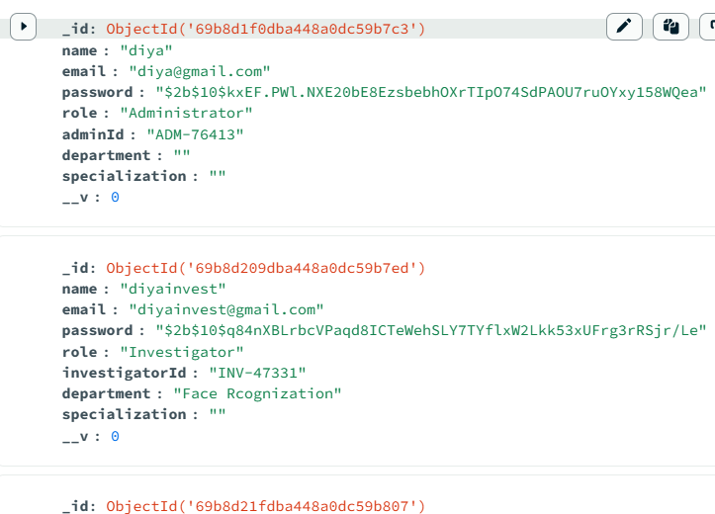

4. ML Input Validation
- Format Compatibility Check: Input data must match the format required by the model (e.g., image dimensions, feature vectors).
- Corruption Detection: Incomplete or corrupted files are rejected to avoid incorrect predictions.
- Data Normalization and Preprocessing: Input data is transformed into a standardized format, including:
- Scaling
- Normalization
- Feature extraction
- Threshold Validation: Predictions below a certain confidence level may be flagged or rejected.
These multi-level validations ensures data accuracy, consistency, and security. 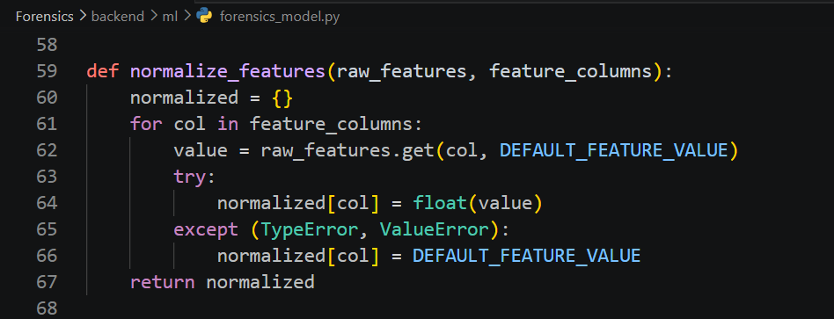

C)
Data Transformation
Data transformation refers to the process of converting raw data from one format or structure into another so that it can be effectively used across different layers of the system. In the Automated Digital Forensics Evidence Collection and Analysis System, data transformation ensures seamless communication between the data layer, business logic layer, machine learning components, and presentation layer.

1. Database to Backend Transformation
- Conversion to Structured Objects: Database records are transformed into structured objects (e.g., JSON format) that can be easily processed by backend services.
- Field Extraction and Mapping: Only relevant fields are extracted, such as:
- Evidence ID
- Metadata (timestamp, owner, type)
- Analysis results
- Data Cleaning: Null values, inconsistent entries, or redundant fields are handled before further processing.
- Abstraction Layer: ORM (Object Relational Mapping) or query handlers abstract raw database queries into usable application data.
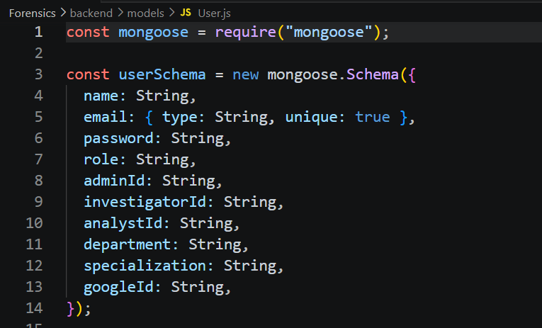

2. Backend to ML Layer Transformation
Data is preprocessed before analysis:
- Preprocessing Operations
- Image resizing to standard dimensions
- Noise removal and enhancement
- Data normalization (scaling pixel values or features)
- Feature Extraction
- Important attributes are extracted from raw evidence
- Example: facial features, texture patterns, biometric signals
- Format Conversion: Data is converted into arrays, tensors, or feature vectors as required by ML frameworks
- Standardization: Ensures uniform input format across all datasets for consistent model performance

Data is formatted according to ML model requirements.

3. Backend to Frontend Transformation
Processed results are converted into UI-friendly formats:
- API Response Formatting
- Data is structured into JSON responses
- Includes:
  - Analysis results
  - Confidence scores
  - Evidence details
- Filtering and Structuring
- Only necessary information is sent to the frontend
- Sensitive or irrelevant data is excluded
- Data Aggregation: Multiple backend results may be combined into a single response for efficient rendering

4. Visualization Transformation
Analytical results are transformed into:
- Graphical Representation: Data is converted into charts and graphs (bar charts, pie charts, etc.)
- Confidence Score Representation: ML outputs are presented as percentages or probability scores
- Comparative Visualization: Enables comparison between real vs fake images or different evidence samples
- User-Friendly Formatting: Data is simplified for better readability and understanding
This improves readability and interpretation.

5. Report Formatting
- Structured Report Generation: Reports are organized into sections such as:
- Summary
- Evidence Description
- Analysis Findings
- Human-Readable Format: Technical outputs are converted into understandable language
- Standardization: Reports follow a consistent format suitable for documentation and legal purposes
This ensures smooth communication between layers and improves usability and clarity.

Hence, the system effectively implements business rules, validation logic, and data transformation mechanisms to ensure data integrity, system security, accurate analysis, and user-friendly presentation of forensic results.

