TA-Q3

Jakki Seshapanpu (11915005),

Manoj Sharma (11915050),

Utkarsh Agrawal (11915020)

###########################################################

Github link: <https://github.com/shmanoj5/TA-assignment>

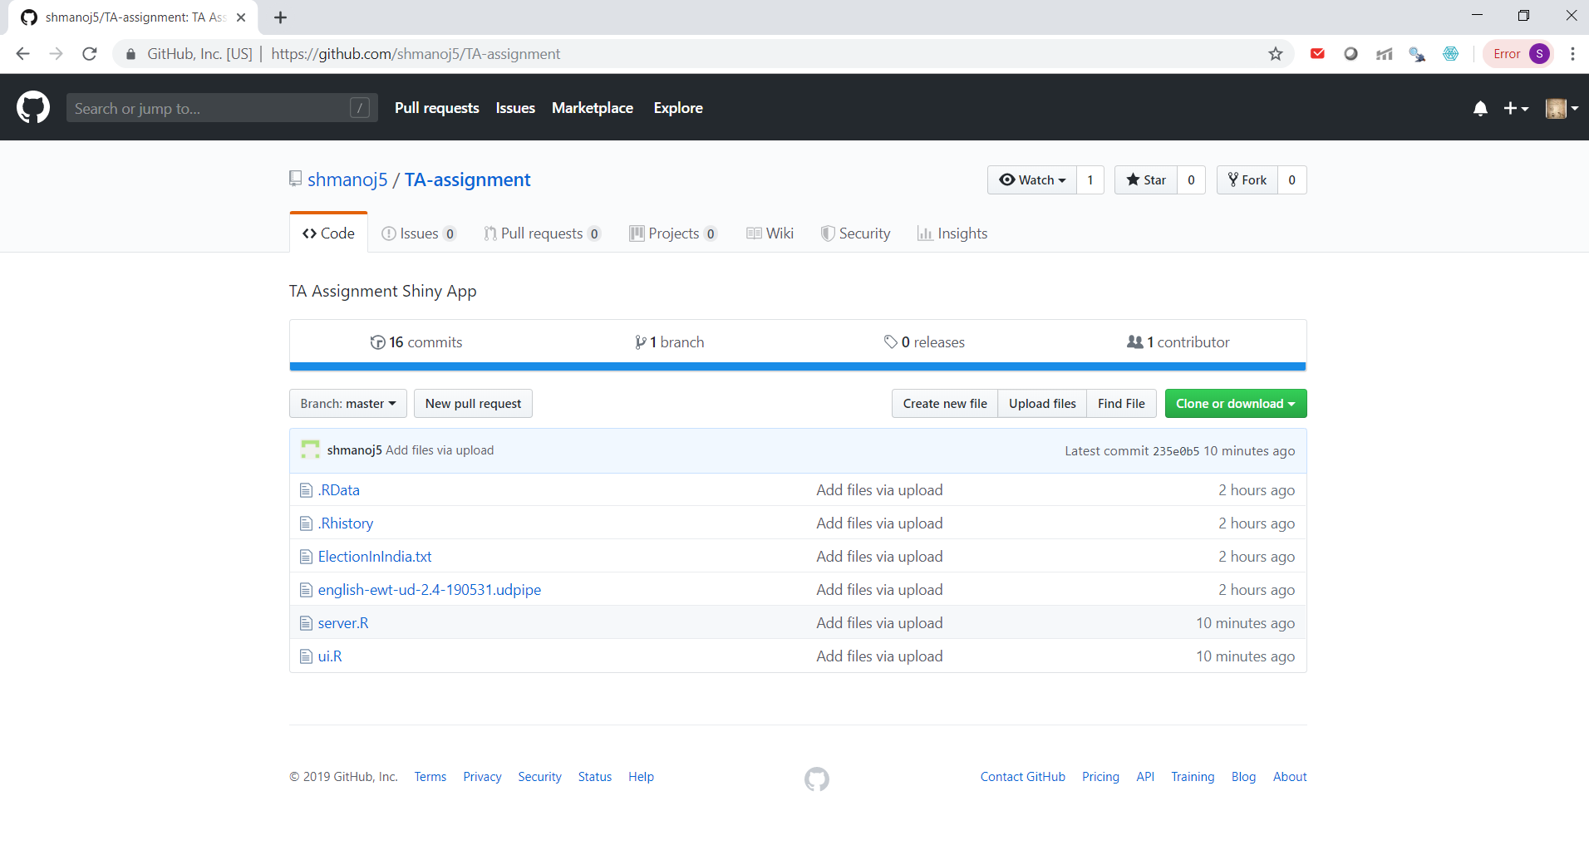

User Interface

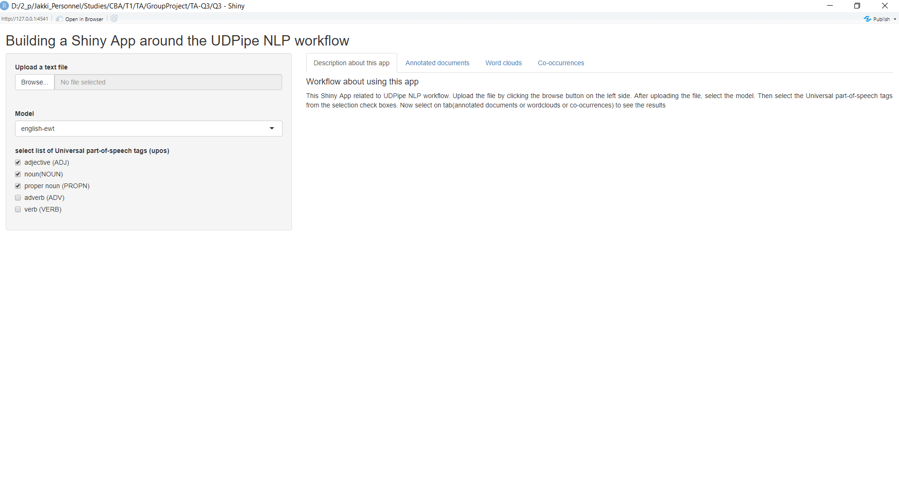

Annotated document Table with Download button

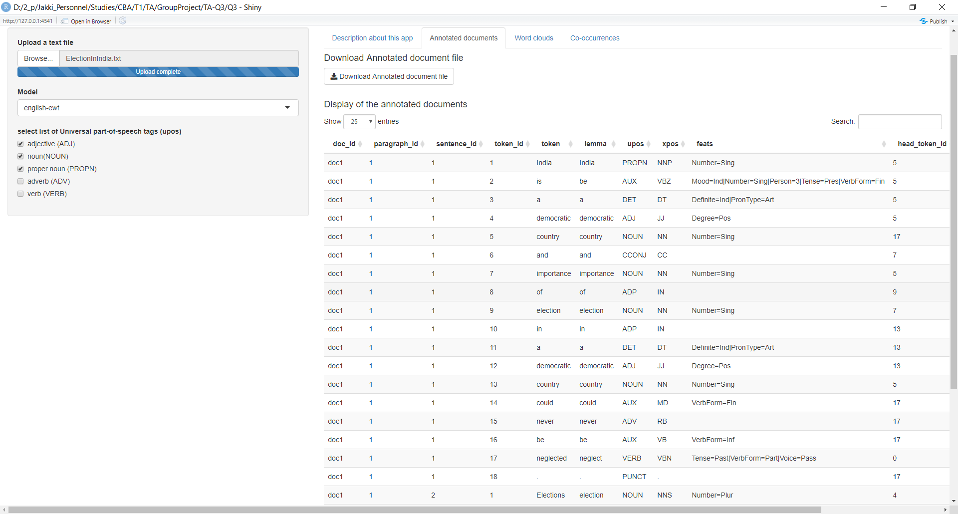

Nouns word cloud

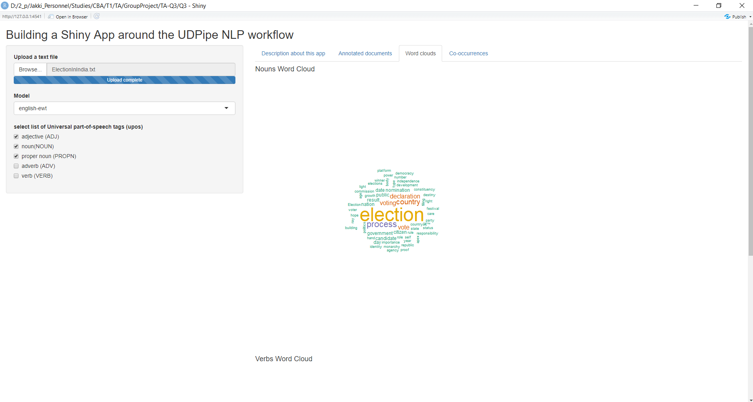

Verbs word cloud

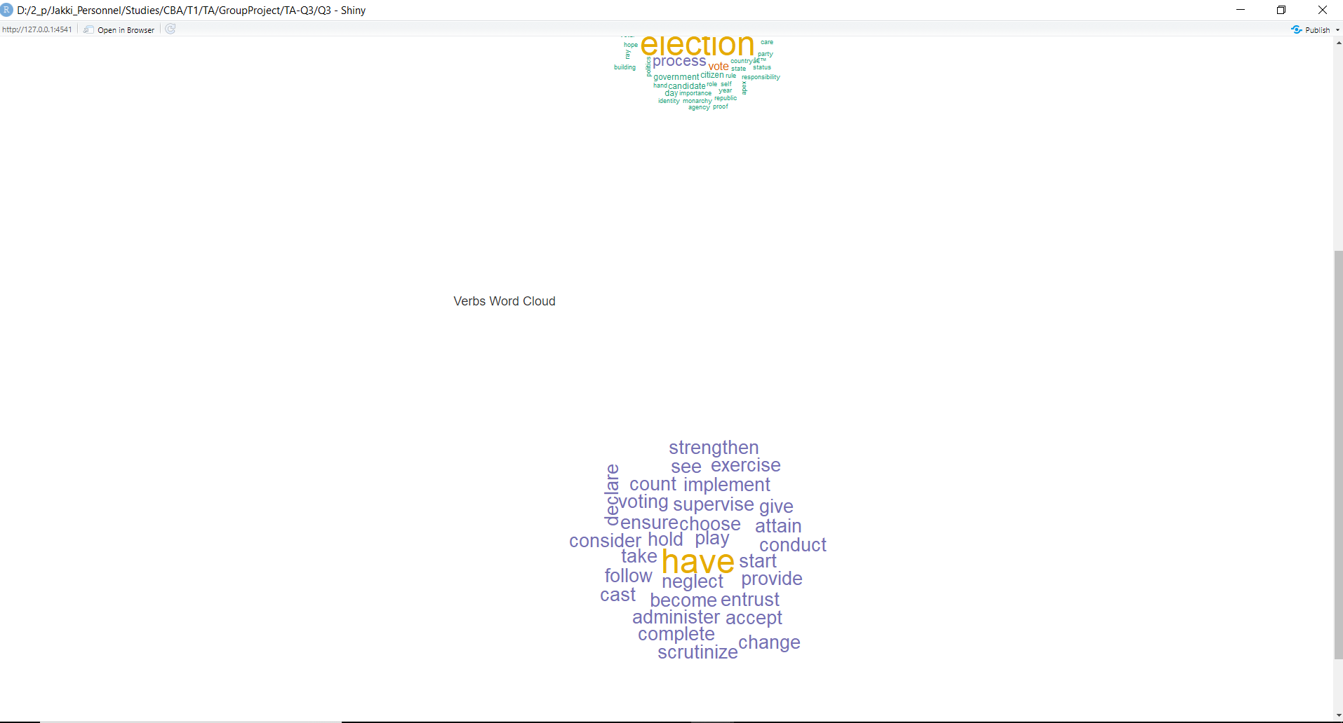

Co-occurrence graph

