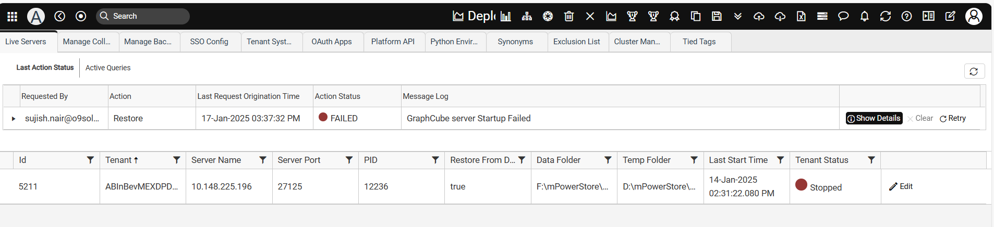

Pro Environment:

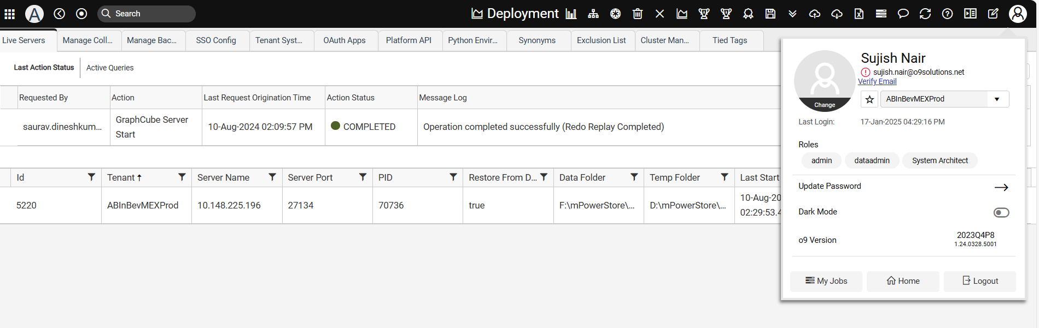

Live Servers

