o9 SOP

for

HPE DP

Document History

Date | Version | Author
3/5/2024 | 01 | Imran Ali, Lingam Reshma Choudhary

Contents

Issue Types 5
★ Infra Issues 5
★ DevOps Requests 6
★ Add new user 7
★ User Deletion 8
★ Process of downloading and attaching the attachments from SNOW: 8

Overview

HPE DP is all about deal and demand planning. It is a business-focused organization which works in servers, storage, networking, software and consulting. O9 does the demand and deal planning for various components like servers, storage, networking and e.t.c, for all the regions across the globe.
For more details:
- HPE DP | Solution Design Documentation
- HPE o9 Planning Overview
- HPE Integration process overview
- HPE Customer Success drive

Distribution List
- o9 Customer Success - hpe-customer-success-team@o9solutions.com
- o9 Project team - (dennis.teo@o9solutions.com, mike.ni@o9solutions.com, )
- o9 Solutions Architect - Mike Ni (mike.ni@o9solutions.com )

Issue Types

Infra Issues
- We may get tickets from HPE saying the audit trail functionality is not working or giving incorrect results like it is showing the data for the last 30 days only from UI. In these cases check from yourselves if the issue mentioned by users is the same by following the screenshot mentioned in the ticket for specific intersection.
If not able to resolve then raise a DevOps ticket, explaining the issue.
- Examples of such tickets: 161109, 223602, 195785
- Adding the screenshots below:
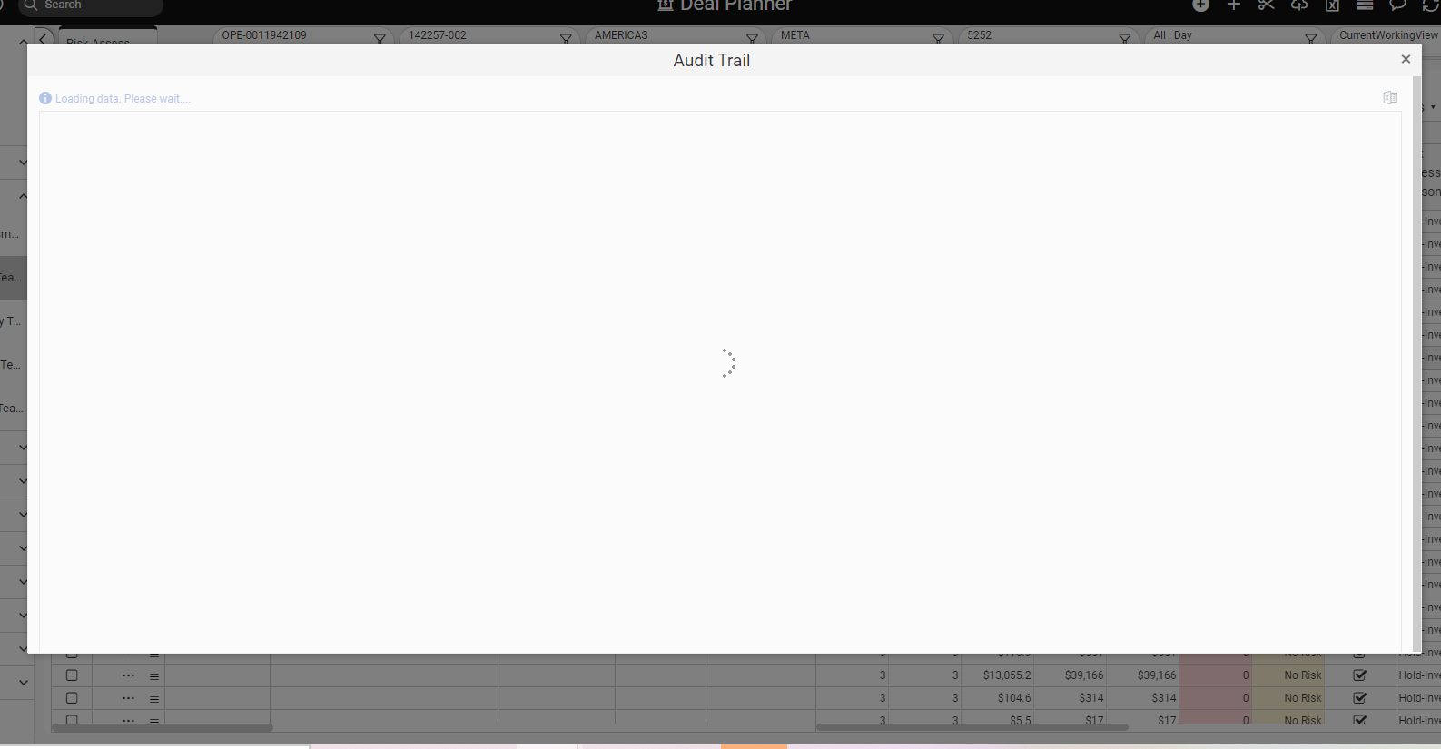
The Audit trail server may keep loading like this and wouldn’t show data.

  - Click here to submit a DevOps request
  - Select ‘request type’ as ‘DevOps ticket form’
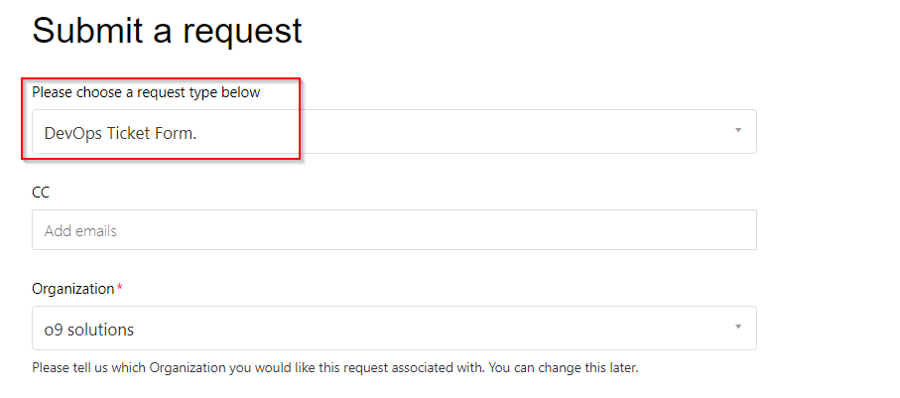

DevOps Requests
- From time to time, DevOps will request downtime to perform a WebAPI restart or to perform some other maintenance activities. In such cases, let HPE know about the downtime and request their approval.Once HPE approves the request, let DevOps know about the downtime.
- Point of contact for Downtime: Email list for approval
- Preferred downtime for all regions:

- If DevOps say it is a Dev. issue then create an ADO ticket for the same.
- Link for creating an ADO ticket.

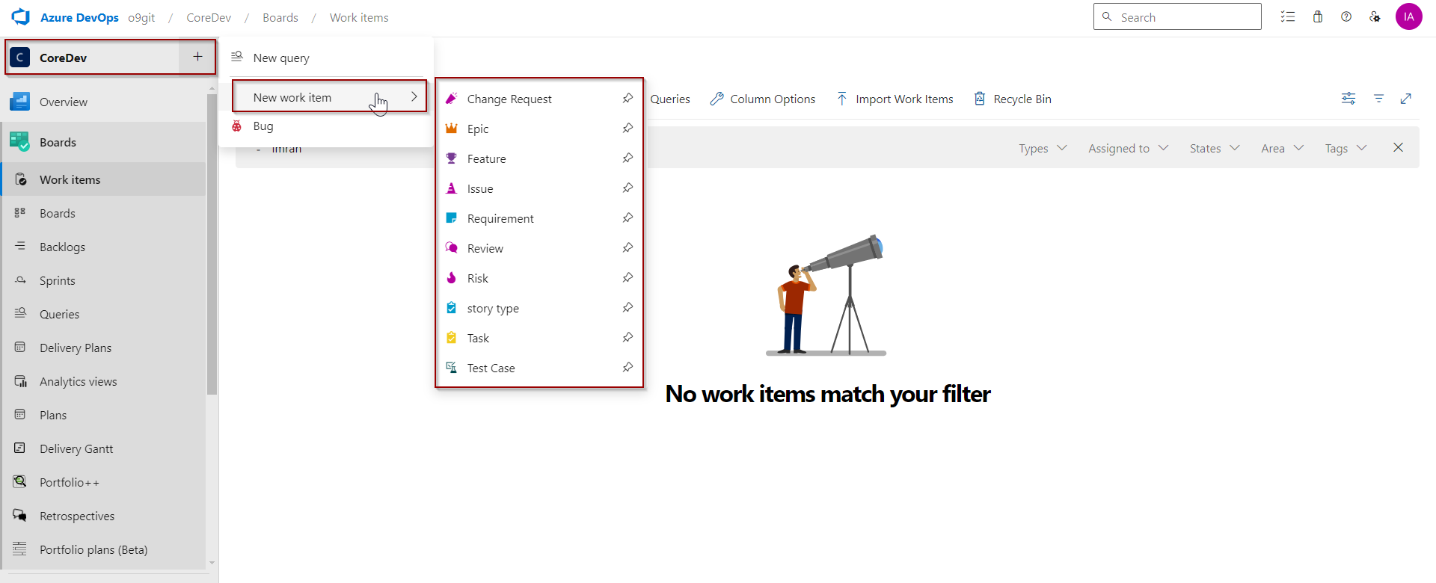

Add new user
- Gather basic information such as username and email address.
- Request for an existing user’s email who’s access can be mimicked for the new users.
- If step 2 details are not available, ask the roles to be added for the user.
- Navigate to the User Management workspace in the tenant.
- Click the ‘Add new record’ button
  - Fill in the details for the new User as shown above:
  - For User Name, provide the First and Last Name of the User.
  - Set the password as Welcome@123.
  - Add the email address of the User.
  - Add the appropriate User roles.
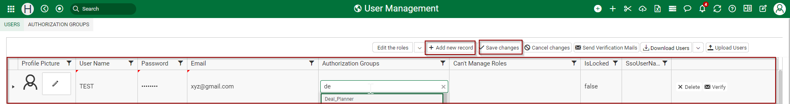
  - Verify the details and click on the Save Changes button.
- The user should be able to login to the tenant though SSO.
NOTE - Recommendation here is to ask the client to provide the reference of some other user , then that reference could be used to provide the authorization for the new user.

User Deletion
To delete the users, go to User management workspace and then select the name of the user you want to delete after that click on Delete icon. This way gets removed from the system.

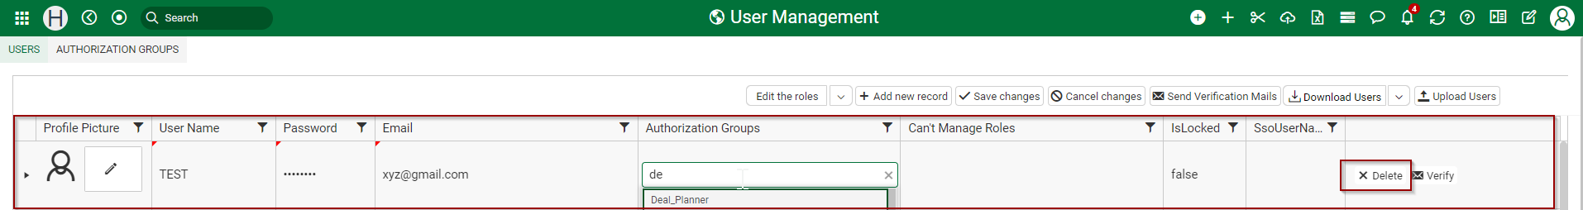

Process of downloading and attaching the attachments from SNOW:

- HPE users use the SNOW portal for creating their tickets and handling them.
- Since we are integrating SNOW and Zendesk, the attachments we receive from the users will be in the form of a link.
- Adding below the screenshot on how the attachment looks:
- 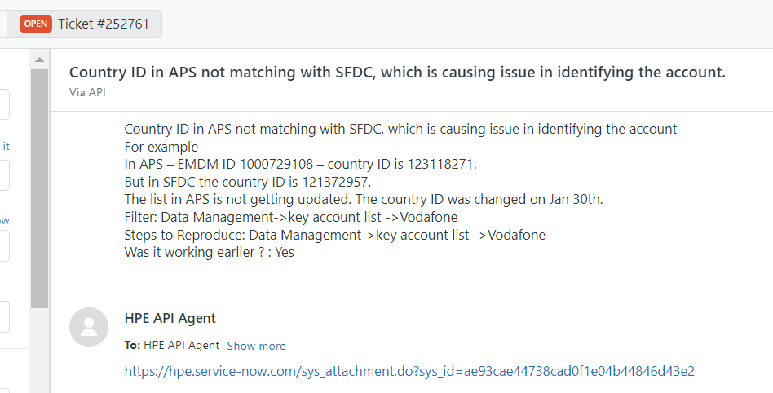
- We need to download the attachments and add them as an internal note. Adding a screenshot of the internal note with attachments below:
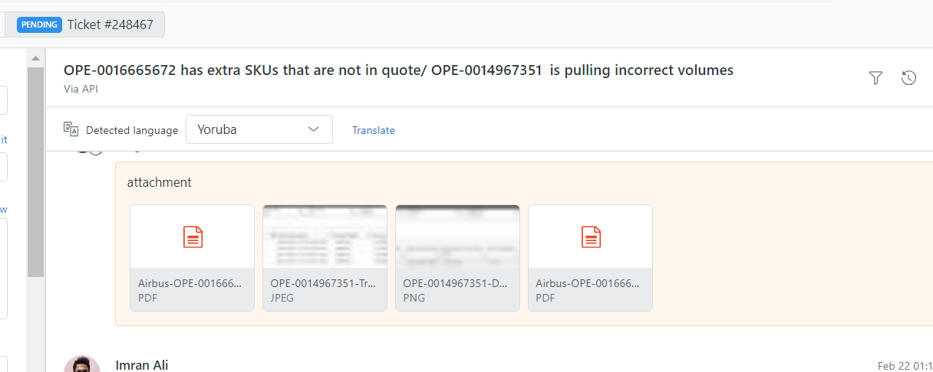
PFB the steps that need to be followed to download the attachment.
- Click on the link below:
https://hpe.service-now.com/login.do
- Login to the ServiceNow instance using the credentials given below:
Username: zendesk_account
Password: Zendesk*hpe%2023
- Now get back to the Zendesk Ticket and click on the link provided to download the attachments, it will download the attachment to your local.
- Go to Zendesk and add the downloaded attachments in the ticket as an internal note.

