
Team Odyssey

📰About
Our idea is to create a School Events & Notification Center that makes organizing and joining school activities simple, fair, and automated. Through event creation, registration, and a smart waitlist system, students and organizers can efficiently manage participation while an event-driven notification system keeps users informed in real time.

📥Installation
1. Open a terminal on your local machine and clone the repository by the link below.
2. Run the application and you are ready to go!
https://github.com/SPSolinkov23/OdysseyTeamAIBEST

📥How to run
1. Requirements - .NET 9 SDK, MySQL(XAMPP), Node.js, Seq
2. Start the MySQL database with XAMPP
3. Run cd backend/src/SchoolEvents.Api → dotnet run API to start the project on http://localhost:5080
4. Worker cd backend/src/SchoolEvents.Worker → dotnet run Worker

🖥️Technologies
Code editors and collaborative services used:
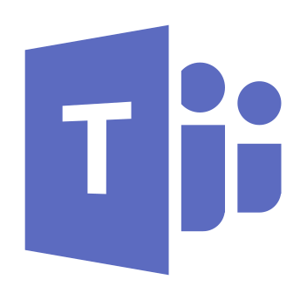
Programming languages:
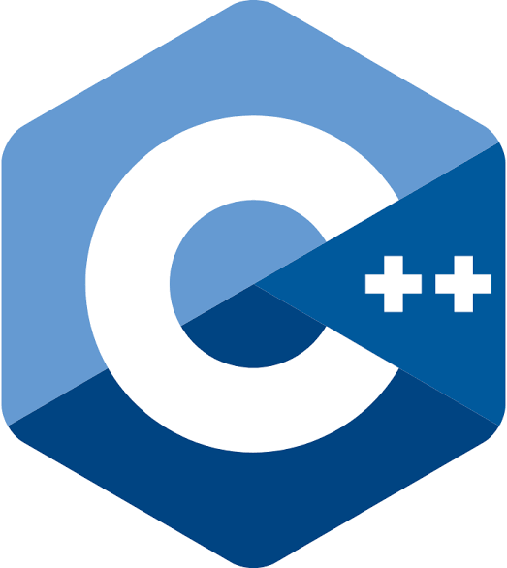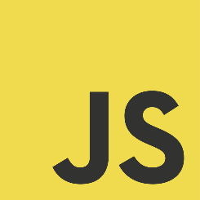
Other languages used:
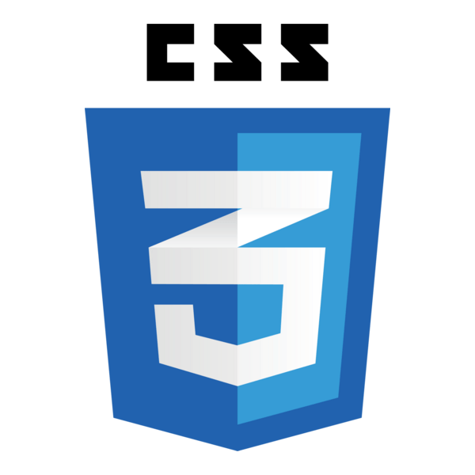
Used programs for creating documentation and presentation:
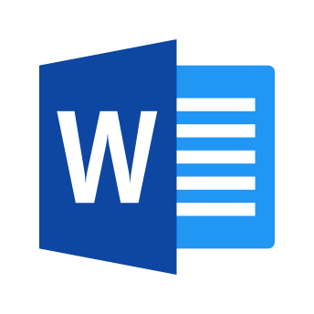

🧒Our team
- Bogdan Kehayov [Mentor]
- Konstantin Sotirov [Front-end developer]
- Stilian Solinkov [Front-end developer]
- Aleksey Atanasov [Front-end developer]
- Konstantin Nikolov [Back-end developer]
- Radoslav Petrov [Back-end developer]
- Eray Mustafa [Back-end developer]
- Anatoli Garbuchev [Back-end developer]
- Hristo Mitev [Back-end developer]

Thank you for checking out our repo! If you had a good time you can leave us a ⭐!

