Week 9 Work
Ideal case
The first Week 9 Richardson test was completed using synthetic complex impedance data. A simple R-L impedance model was used as the known reference, and two artificial scan estimates were generated using different resolution parameters. The rough estimate had a median relative error of $6.0×{10}^{-3}$, while the refined estimate had a lower median error of $1.5×{10}^{-3}$. After applying Richardson extrapolation, the error reduced to approximately numerical precision. This confirms that the Richardson formula is implemented correctly for an ideal case where the scan error follows the assumed $h^{p}$convergence behaviour. The result is a validation step only; real PSCAD/Rezonance scan data may not improve this perfectly because noise, nonlinear effects, and non-monotonic scan errors can affect the extrapolation.
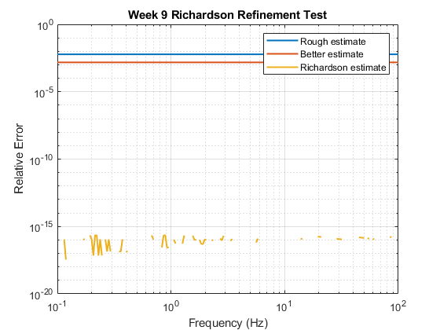
Figure 1 - Richardson Refinement Validation on Synthetic R-L Impedance
%%Median error rough estimate: 6.0000e-03
Median error better estimate: 1.5000e-03
Median error Richardson: 0.0000e+00
Max error rough estimate: 6.0000e-03
Max error better estimate: 1.5000e-03
Max error Richardson: 2.2204e-16
%%
With random noise
After validating Richardson refinement on an ideal synthetic case, small random complex noise was added to the rough and refined impedance estimates to represent more realistic scan uncertainty. The rough estimate had a median relative error of $6.01×{10}^{-3}$, while the refined estimate reduced this to $1.83×{10}^{-3}$. The Richardson estimate further reduced the median error to $1.53×{10}^{-3}$, showing improvement on average. However, the maximum Richardson error was slightly higher than the refined estimate, indicating that Richardson can amplify random noise at some frequency points. This confirms that Richardson refinement should not be applied blindly to noisy scan data and will require quality checks or rejection rules before being used on PSCAD/Rezonance results.
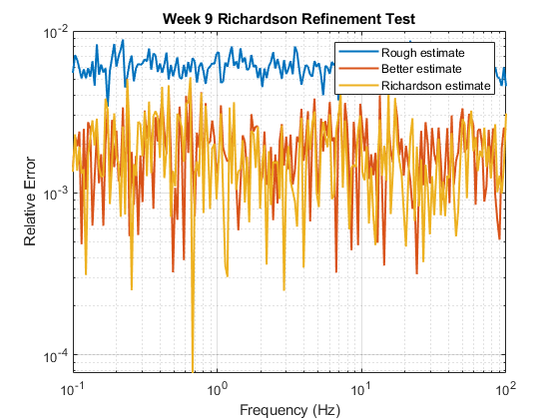
Figure 2 - Relative error comparison for rough, refined, and Richardson-extrapolated impedance estimates using a synthetic R-L impedance model with added random complex noise.
%% Median error rough estimate: 6.0122e-03
Median error better estimate: 1.8332e-03
Median error Richardson: 1.5334e-03
Max error rough estimate: 8.8688e-03
Max error better estimate: 5.0724e-03
Max error Richardson: 5.1788e-03
%%

Testing for 2x2 matrix
Richardson refinement test on a synthetic 2×2 dq impedance matrix with added random complex noise. The refined estimate reduced the median matrix error compared with the rough estimate. The Richardson estimate remained better than the rough estimate but was slightly worse than the refined estimate due to noise amplification. This shows that Richardson refinement should not be applied blindly to noisy matrix impedance data and requires quality checks before use on PSCAD/Rezonance scan results.
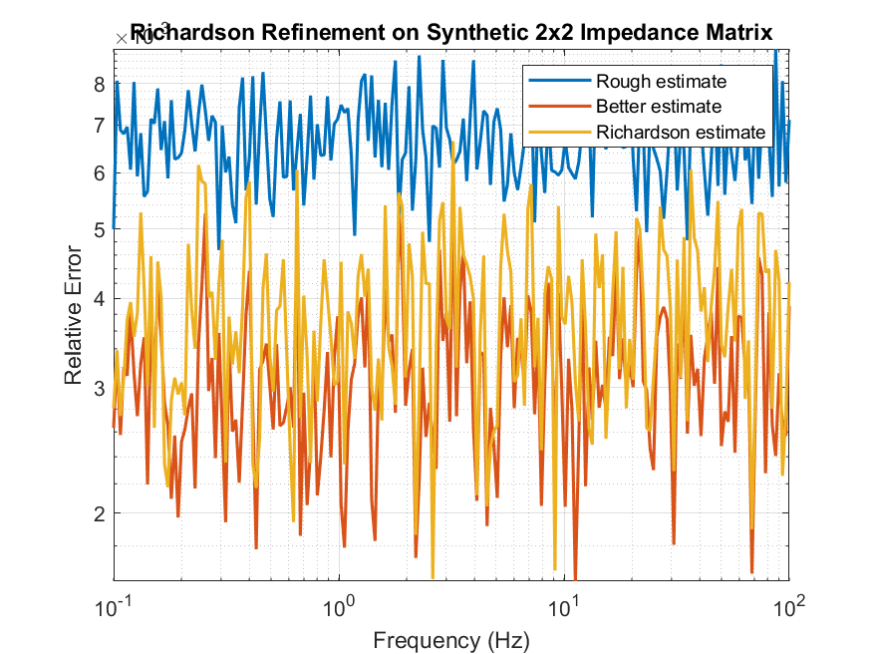
Figure 3 - Relative error comparison for rough, refined, and Richardson-estimated 2×2 dq impedance data with added noise.
%%
Median error rough estimate: 6.6565e-03
Median error better estimate: 3.0549e-03
Median error Richardson: 3.7637e-03
Max error rough estimate: 8.9453e-03
Max error better estimate: 5.6340e-03
Max error Richardson: 6.6400e-03
%%
A sensitivity check showed that, for this synthetic noisy case, Richardson refinement became better than the refined estimate when the refinement ratio $r=h_{1}/h_{2}$was above approximately 3.2. This suggests that the two scan settings may need to be sufficiently separated for Richardson extrapolation to overcome random noise. However, this threshold is specific to this test and should not be treated as a general rule.

Week 10 Work
Aim
The aim of Week 10 was to extend the Week 9 Richardson refinement test by checking how the result changes with different scan-window qualities. Three synthetic scan cases were created:
Short-window scan = fast scan, highest error
Medium-window scan = moderate scan, medium error
Long-window scan = slow scan, lowest error
This represents the practical idea that shorter Rezonance/PSCAD scans are faster but usually less accurate, while longer scans are slower but more reliable.

Method
The same synthetic 2×2 dq impedance matrix from Week 9 was used as the known reference:
Z_true = ideal/correct impedance matrix
Three artificial scan estimates were generated:
Z_short, Z_medium, Z_long
The short-window scan was assigned the largest artificial error and noise, while the long-window scan was assigned the smallest error and noise.
Richardson refinement was then applied using three scan pairs:
Richardson short + medium
Richardson medium + long
Richardson short + long
These were tested because Richardson refinement requires two estimates of the same impedance taken using different scan settings.

Results
Method | Median relative error | Maximum relative error
Short-window scan | 2.5878e-02 | 3.2891e-02
Medium-window scan | 7.3015e-03 | 1.1497e-02
Long-window scan | 2.4019e-03 | 3.8164e-03
Richardson short + medium | 6.0633e-03 | 1.1808e-02
Richardson medium + long | 2.8603e-03 | 4.9418e-03
Richardson short + long | 2.0867e-03 | 3.6416e-03

The normal scan results behaved as expected: the short-window scan had the largest error, the medium-window scan improved the error, and the long-window scan produced the best normal scan estimate.
Richardson improved the median error for:
Short + medium: 7.3015e-03 → 6.0633e-03
Short + long: 2.4019e-03 → 2.0867e-03
However, Richardson did not improve the medium + long case:
Medium + long: 2.4019e-03 → 2.8603e-03
This shows that Richardson can improve scan accuracy in some cases, but it can also become worse when the input scans are already high quality and noise is amplified.

Graph interpretation
Graph 1 — Relative error plot
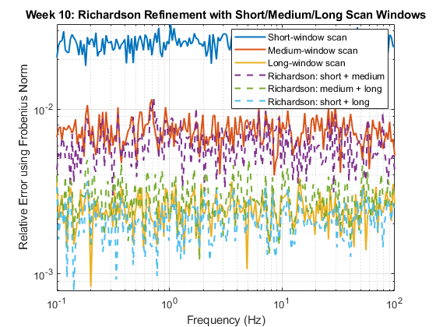

This graph compares the relative Frobenius-norm error over frequency. It shows that the long-window scan has the lowest normal scan error, while the short-window scan has the highest. Richardson short + medium and short + long reduce the median error, but Richardson medium + long is slightly worse than the long-window scan.
This is the main Week 10 result because it shows that Richardson performance depends on the scan pair used.

Graph 2 — Acceptance/rejection plot
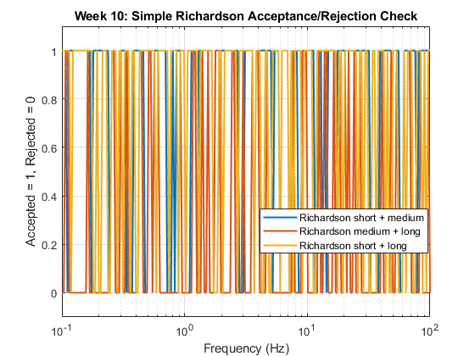
The second graph checks whether Richardson should be accepted or rejected at each frequency point. The rule used was:
Accept Richardson only if it improves the error compared with the better input scan.

The acceptance percentages were:
Richardson pair | Accepted frequency points
Short + medium | 79.0%
Medium + long | 25.0%
Short + long | 74.5%

The medium + long case was accepted only 25% of the time, confirming that Richardson should not be applied blindly. A quality-check rule is needed before using Richardson-refined impedance data in a Rezonance-style workflow.

Conclusion
Week 10 work shows that Richardson refinement can reduce systematic scan error and may help reduce scan effort. However, the improvement is not guaranteed. It depends on scan-window quality, refinement ratio, and noise level.
The key conclusion is:
Richardson refinement can improve impedance scan accuracy, but it must include an acceptance or rejection rule because it can amplify noise and make some frequency points worse.
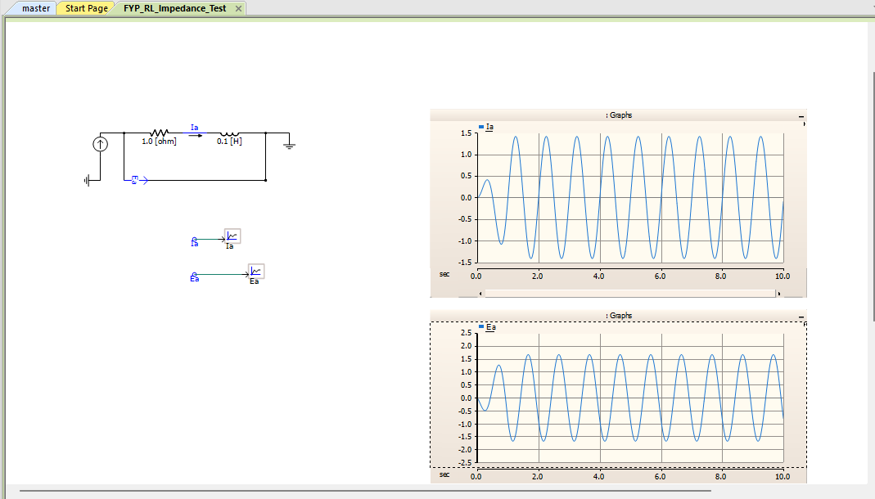
PSCAD RL test without noise

Analytical true impedance:
Z_true = 1.000000 + j0.628319 ohm
|Z_true| = 1.181010 ohm

Estimated impedance values:
Short-window estimate: 1.000000 + j0.628350 ohm
Medium-window estimate: 1.000000 + j0.628331 ohm
Long-window estimate: 1.000000 + j0.628326 ohm
Richardson short + medium: 1.000000 + j0.628328 ohm
Richardson medium + long: 1.000000 + j0.628323 ohm
Richardson short + long: 1.000000 + j0.628325 ohm

Relative Error:
Short-window scan: 2.6605e-05
Medium-window scan: 1.0645e-05
Long-window scan: 6.6546e-06
Richardson short + medium: 7.6046e-06
Richardson medium + long: 4.0968e-06
Richardson short + long: 5.3246e-06

Richardson Acceptance Check:
Short + medium accepted: 1
Medium + long accepted: 1
Short + long accepted: 1

Conclusion:
Richardson short + medium improved compared with the medium-window estimate.
Richardson medium + long improved compared with the long-window estimate.
Richardson short + long improved compared with the long-window estimate.
This PSCAD RL test checks whether the synthetic Richardson workflow also works on real PSCAD time-domain data.
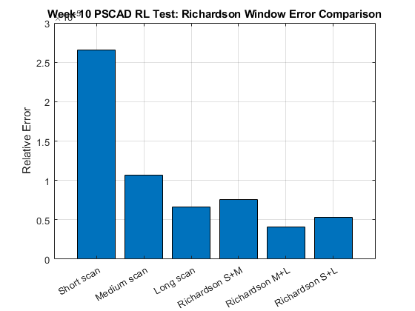
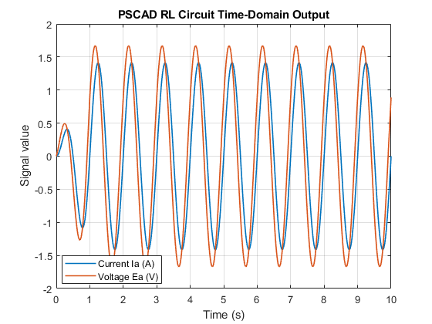

PSCAD RL test with 0.1% noise

Analytical true impedance:
Z_true = 1.000000 + j0.628319 ohm
|Z_true| = 1.181010 ohm

Estimated impedance values:
Short-window estimate: 1.000014 + j0.628342 ohm
Medium-window estimate: 1.000001 + j0.628328 ohm
Long-window estimate: 0.999997 + j0.628325 ohm
Richardson short + medium: 0.999999 + j0.628325 ohm
Richardson medium + long: 0.999994 + j0.628324 ohm
Richardson short + long: 0.999996 + j0.628324 ohm

Relative Error:
Short-window scan: 2.3175e-05
Medium-window scan: 7.8929e-06
Long-window scan: 6.2121e-06
Richardson short + medium: 5.5752e-06
Richardson medium + long: 6.5428e-06
Richardson short + long: 5.8830e-06

Richardson Acceptance Check:
Short + medium accepted: 1
Medium + long accepted: 0
Short + long accepted: 1

Conclusion:
Richardson short + medium improved compared with the medium-window estimate.
Richardson medium + long did NOT improve compared with the long-window estimate.
Richardson short + long improved compared with the long-window estimate.
This PSCAD RL test checks whether the synthetic Richardson workflow also works on real PSCAD time-domain data.

A simple PSCAD RL circuit was also created to test the impedance extraction workflow using real PSCAD time-domain data. The circuit used R = 1 Ω and L = 0.1 H with a 1 Hz sinusoidal current injection. Voltage and current waveforms were exported from PSCAD and processed in MATLAB to calculate impedance using Z = V/I.

After correcting the voltage polarity in MATLAB, the estimated impedance closely matched the analytical value Z = 1 + j0.6283 Ω. This confirmed that the PSCAD-to-MATLAB impedance extraction process was working correctly.

Small artificial noise was then added to the PSCAD voltage and current waveforms. The noisy PSCAD result followed the expected pattern, the short-window estimate had the highest error, while the medium- and long-window estimates had lower errors. Richardson refinement improved the short + medium and short + long combinations, but did not improve the medium + long case.

This supports the main Week 10 conclusion, which is that Richardson refinement can improve scan-window estimates, but it needs an acceptance/rejection quality check before being applied to PSCAD/Rezonance scan data.

Week 11 Work
Baseline parameters
fs = 1000;
Tsim = 20;
pulse_amp = 1;
pulse_width = 0.5;
pulse_start = 2;

Case 1 – pulse width – 0.2s
Pulse is shorter but still produced accurate impedance estimates for the clean synthetic case.
Case 2 – pulse width – 1s
Pulse is wider, and it also matched the analytical impedance well. This suggests that pulse width can be selected based on the frequency range of interest.
wider pulses are more useful for low-frequency content, while narrower pulses spread energy over a wider frequency band.
Case 3 – Tsim -5s
Frequency= 1/5 = 0.2 Hz
still works for the clean analytical case, but it gives poor low-frequency resolution. pulse methods still require sufficient observation time for low-frequency resolution.
Case 4 – Tsim – 50s
Frequency – 1/50 = 0.02 Hz
still works for the clean analytical case, and the longer window improves low-frequency resolution.
Case 5 – 0.1% noise
Even small noise affects the pulse-derived impedance, mostly where the frequency spectrum of the pulse is weak.
With 0.1% voltage noise, the pulse estimate remained close to the analytical impedance, but small fluctuations appeared in magnitude and phase. the pulse method is sensitive to noise, although the estimate is still usable at this noise level.
Case 6 – 1% noise
The pulse method still roughly follows the true impedance trend, but the quality is clearly worse. Some frequency points become unreliable. need quality filtering or rejection rules before using pulse-derived points for stability analysis.
Case 7 – 5% noise
The pulse-derived impedance is not reliable and relative error increased significantly.
Test | Result | Meaning
Clean baseline | Match with true analytical impedance. | method works
Pulse width 0.2 s | Match with true analytical impedance. | Narrow pulse works
Pulse width 1.0 s | Match with true analytical impedance. | Wider pulse also works
Tsim 5 s | Accurate but lower frequency resolution | Short window is not ideal for low-frequency points
Tsim 50 s | Accurate with better resolution | Longer window is better for low-frequency work
0.1% noise | Small error | Still usable
1% noise | Moderate error | Needs quality checks
5% noise | Large error | Not reliable without filtering/rejection

To avoid using unreliable frequency points, each frequency was checked using the magnitude of the current pulse FFT. If the input FFT was below a threshold, the point was rejected. If the excitation was strong and the relative error was below 5%, the point was accepted. Otherwise, the point was rejected due to high error.
This accept/reject rule was useful because the rectangular pulse does not excite all frequencies equally. For example, when the pulse width was 0.2 s, the pulse spectrum had a weak point near 5 Hz, so the 5 Hz impedance estimate had a very large error and was rejected. When the pulse width was changed, the weak-frequency location also changed. This shows that pulse width selection is important and that pulse-derived impedance points should not be accepted blindly.

Results for 0.2 pulse width
