Richardson Refinement
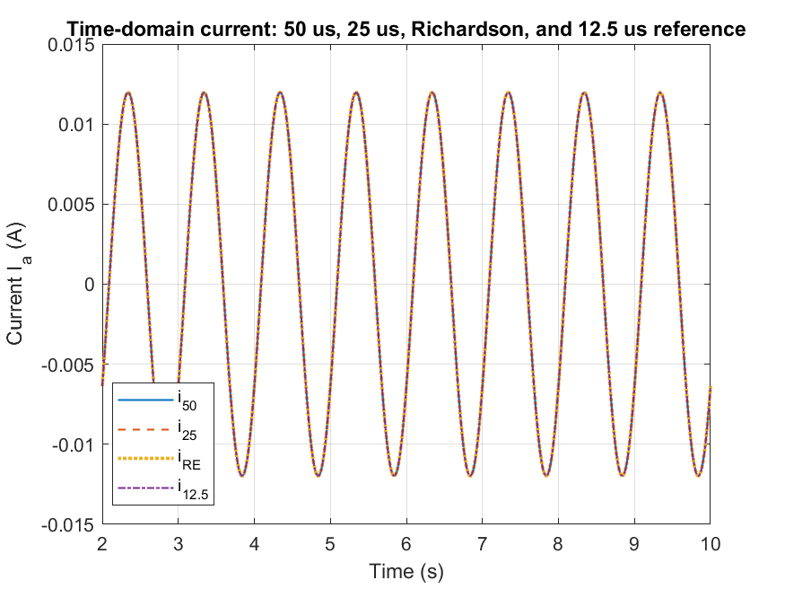
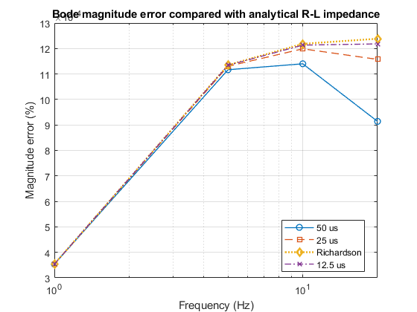
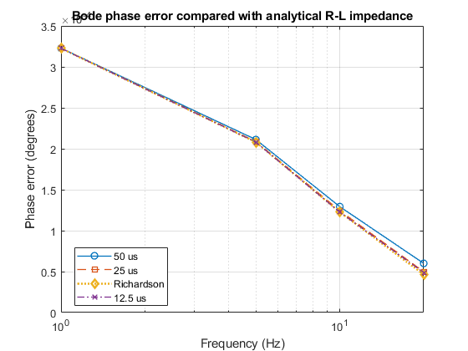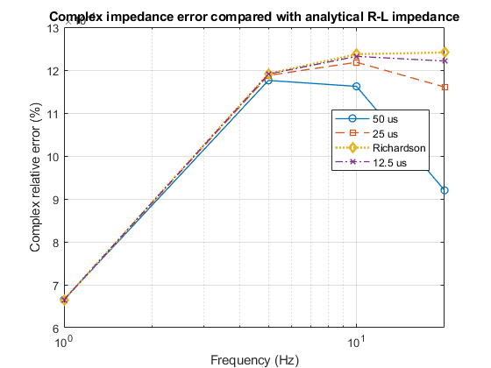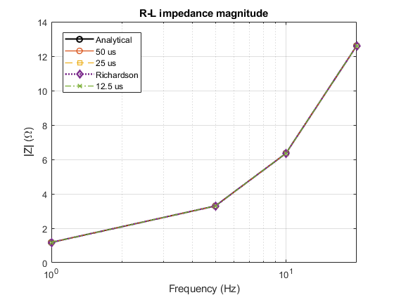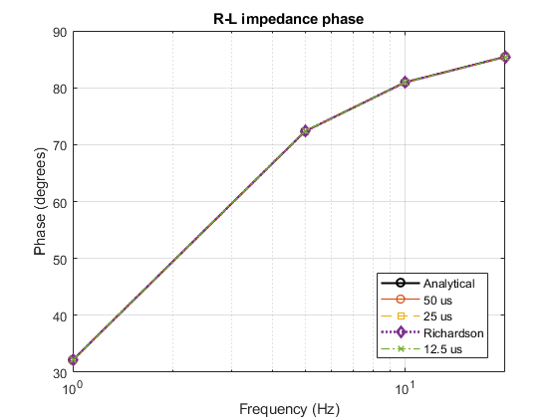

PSCAD Simulation settings
Item | Value
Benchmark | Series R–L circuit
Resistance | R = 1Ω
Inductance | L = 0.1H
Source type | Single-phase sinusoidal voltage source
Source frequencies | 1, 5, 10, 20 Hz
Solver steps | 50 µs, 25 µs, 12.5 µs
Logging/export step | 50 µs
Simulation duration | 10 s
Measured signals | E_{a}, I_{a}
Voltage sign correction | Used -E_{a} for passive R–L impedance convention
Analytical reference | Z(jw) = R+jwL
Richardson formula | y_{RE}=y₂₅+(y₂₅ – y₅₀)/3

Analytical Impedance reference
Frequency | Ztrue (Ω) | |Ztrue| (Ω) | Phase (deg)
1 Hz | 1+ j0.6283 | 1.1810 | 32.142
5 Hz | 1+ j3.1416 | 3.2969 | 72.343
10 Hz | 1+ j6.2832 | 6.3623 | 80.957
20 Hz | 1+ j12.5664 | 12.606 | 85.450

Error results
Frequency | Method | Magnitude error (%) | Phase error (deg) | Complex error (%)
1 Hz | 50 µs | 0.00035358 | 0.00032287 | 0.00066526
1 Hz | 25 µs | 0.00035379 | 0.00032270 | 0.00066512
1 Hz | Richardson | 0.00035386 | 0.00032265 | 0.00066508
1 Hz | 12.5 µs | 0.00035384 | 0.00032265 | 0.00066508
5 Hz | 50 µs | 0.00111670 | 0.00021120 | 0.00117600
5 Hz | 25 µs | 0.00113030 | 0.00020887 | 0.00118760
5 Hz | Richardson | 0.00113480 | 0.00020809 | 0.00119150
5 Hz | 12.5 µs | 0.00113410 | 0.00020808 | 0.00119080
10 Hz | 50 µs | 0.00114000 | 0.00012930 | 0.00116210
10 Hz | 25 µs | 0.00119880 | 0.00012438 | 0.00121830
10 Hz | Richardson | 0.00121840 | 0.00012275 | 0.00123700
10 Hz | 12.5 µs | 0.00121330 | 0.00012248 | 0.00123200
20 Hz | 50 µs | 0.00091394 | 0.00006006 | 0.00091993
20 Hz | 25 µs | 0.00115730 | 0.00004982 | 0.00116060
20 Hz | Richardson | 0.00123840 | 0.00004641 | 0.00124110
20 Hz | 12.5 µs | 0.00121810 | 0.00004881 | 0.00122110

Speed vs Accuracy
Method | Runs required | Measured solve time | Accuracy result | Role
50 µs solver step | 1 | 31 ms | Complex error around (10^{-3}%) | Coarse EMT result
25 µs solver step | 1 | 78 ms | Similar to 50 µs | Fine EMT result
Richardson 50+25 µs | 2 | (31+78 = 109 ms) | Similar to 12.5 µs reference | Workflow verified
12.5 µs solver step | 1 | 125 ms | Fine PSCAD numerical reference | Used only for validation
Analytical R–L formula | 0 | No simulation | Exact reference | Used for true error calculation

The R–L benchmark was tested at 1, 5, 10, and 20 Hz using 50 µs, 25 µs, and 12.5 µs solver steps. The 50 µs and 25 µs time-domain voltage/current waveforms were combined using the Richardson formula before impedance extraction. The estimated impedance magnitude and phase closely matched the analytical R–L impedance at all tested frequencies. The error plots show very small errors, approximately 10⁻³%, confirming that the PSCAD export, time alignment, Richardson correction, and impedance extraction workflow are working correctly.
Richardson did not show a large improvement in this R–L case because the circuit is simple and all solver steps were already highly accurate. Therefore, this result should be presented as a workflow verification benchmark. A more demanding RLC or GFMI case is needed to test whether Richardson gives a stronger accuracy benefit.
Pulse Identification and Accept/Reject Bin Test
Pulse Identification settings
Item | Value
Benchmark | Analytical R–L circuit
Resistance | R = 1Ω
Inductance | L = 0.1H
Simulation time | 20 s
Sampling/logging step | 50 µs
Pulse amplitude | 0.01 A
Pulse width | 0.2 s
Pulse start time | 2 s
Noise level | 0.1%
Tested pulse shapes | Rectangular, raised-cosine, Gaussian
Impedance formula | Z(f)=V(f)/I(f)
Analytical reference | Z(jw) = R+jwL

A pulse-identification test was carried out using the same analytical R–L benchmark. Instead of running a separate sinusoidal simulation at each frequency, a single current pulse was applied and the voltage/current signals were transformed into the frequency domain using FFT. The impedance was then estimated using Z(f) = V(f)/I(f). Since a pulse does not excite all frequency bins equally, an accept/reject rule was applied based on input spectral energy. A frequency bin was accepted only when the current FFT magnitude was greater than 1% (-40 dB threshold) of the maximum input FFT magnitude.
Pulse-shape comparison
Pulse shape | Accepted selected points | Rejected selected points | Accepted bins from 0–50 Hz | Rejected bins from 0–50 Hz | Mean complex error of accepted selected points (%) | Best selected frequency | Best complex error (%)
Rectangular | 4 | 3 | 896 | 104 | 10.959 | 0.5 Hz | 1.965
Raised-cosine | 5 | 2 | 267 | 733 | 0.0387 | 2 Hz | 0.00896
Gaussian | 6 | 1 | 294 | 706 | 0.55855 | 2 Hz | 0.1139

Best accuracy – Raised-Cosine
Worst accuracy – Rectangular
Results for Raised-Cosine pulse
Frequency | Ztrue | Zest | Magnitude error (%) | Phase error (deg) | Complex error (%) | Decision
0.2 Hz | 1+j0.1257 | 1.0002+j0.1258 | 0.01734 | 0.00376 | 0.01854 | Accepted
0.5 Hz | 1+j0.3142 | 1.0001+j0.3149 | 0.03318 | 0.03385 | 0.06776 | Accepted
1 Hz | 1+j0.6283 | 1.0006+j0.6283 | 0.03984 | 0.01784 | 0.05057 | Accepted
2 Hz | 1+j1.2566 | 1.0000+j1.2568 | 0.00648 | 0.00355 | 0.00896 | Accepted
5 Hz | 1+j3.1416 | 0.9986+j3.1409 | 0.03291 | 0.01977 | 0.04768 | Accepted
10 Hz | 1+j6.2832 | 5.2511-j0.0464 | 17.462 | 81.463 | 119.84 | Rejected
20 Hz | 1+j12.566 | 2.9973-j3.4287 | 63.874 | 134.29 | 127.87 | Rejected

The raised-cosine pulse gave accurate accepted impedance estimates from 0.2 Hz to 5 Hz. The complex error at accepted selected frequencies was below 0.07%, with the best result at 2 Hz. The 10 Hz and 20 Hz points were rejected because the input spectral strength was far below the 1% threshold, causing large impedance errors. This confirms that pulse identification should not use all FFT bins blindly.
The rectangular pulse accepted more FFT bins overall, but the selected-frequency accuracy was worse. Although 0.2, 0.5, 1, and 2 Hz were accepted, their errors were noticeably higher than the raised-cosine case. At 5, 10, and 20 Hz, the input spectral energy was very weak and the impedance estimates became extremely unreliable. This shows that a simple rectangular pulse can create weak-frequency-bin problems and should not be used without careful accept/reject screening.
The Gaussian pulse accepted six selected frequency points, but its accepted-point accuracy was not as strong as the raised-cosine pulse. The mean complex error of accepted selected points was 0.55855%, compared with 0.0387% for the raised-cosine pulse. The 20 Hz point was rejected due to weak input spectral energy and high error. This shows that Gaussian-like pulses are useful, but the raised-cosine pulse gave the best accuracy for this benchmark.
The pulse-shape comparison confirms that pulse identification is strongly dependent on input spectral energy. The rectangular pulse produced weak-bin problems and large rejected-bin errors. The Gaussian pulse accepted more selected frequency points, but the raised-cosine pulse gave the lowest mean complex error for accepted selected frequencies. Therefore, the raised-cosine pulse was selected as the main pulse result for the R–L benchmark. This result supports the use of accept/reject rules in pulse-based impedance identification, because bins with weak input FFT magnitude can produce large and misleading impedance errors.
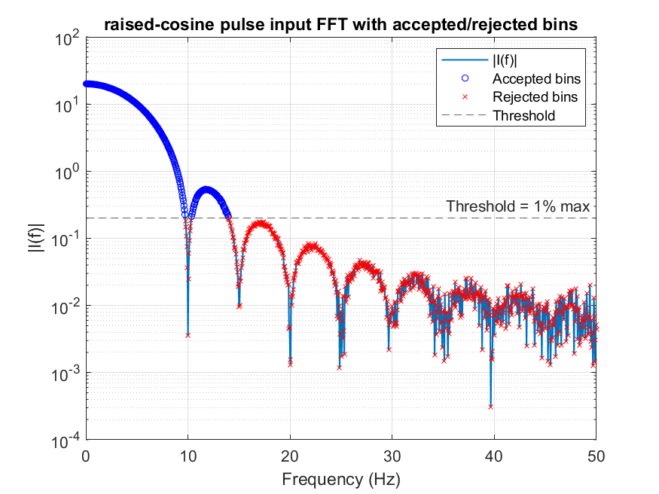
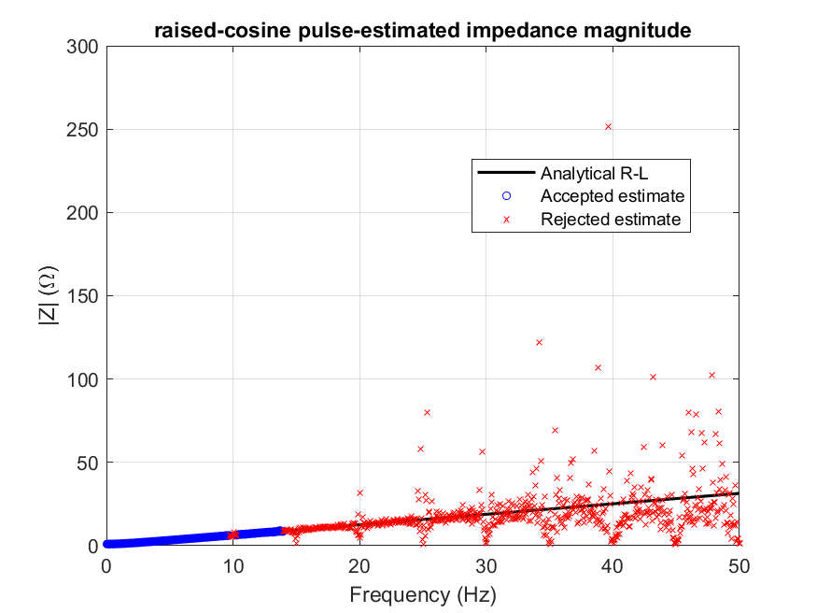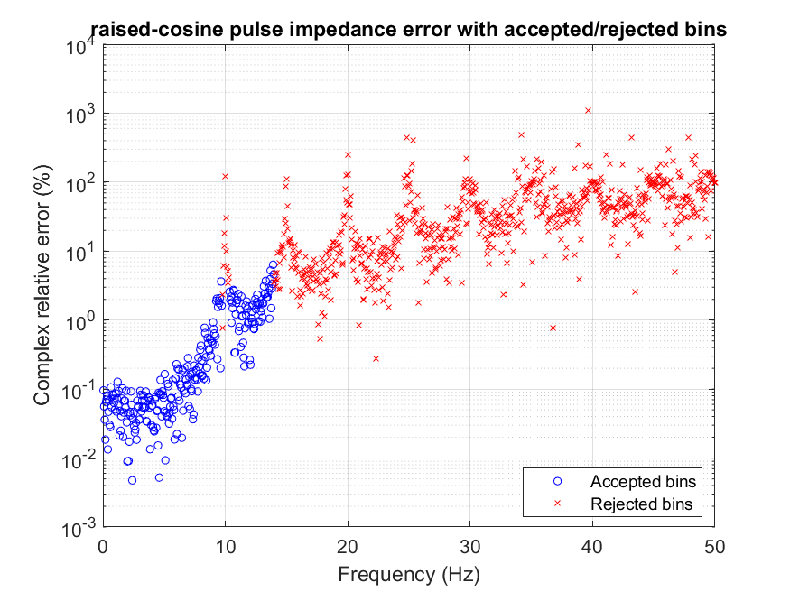
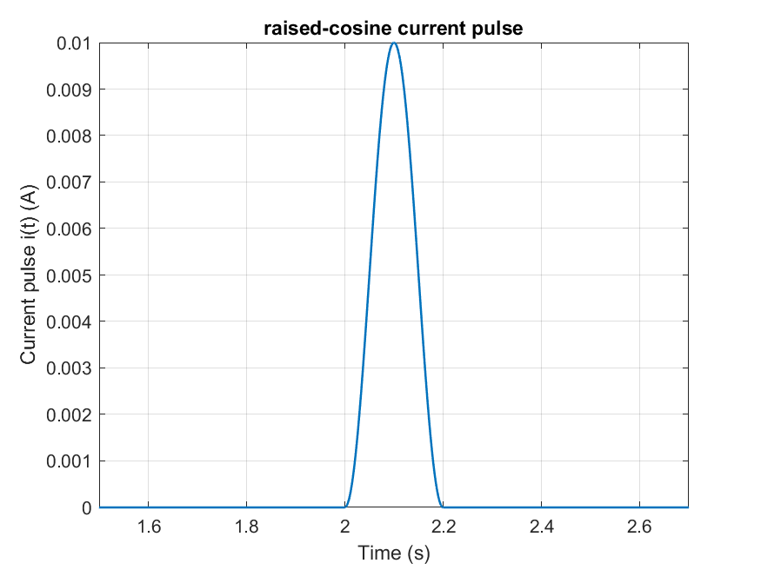

Speed Accuracy Comparison
Method | Runs required | Simulation / processing time | Reference used | Magnitude error | Phase error | Complex error | Decision
Coarse EMT, 50 µs | 1 | 31 ms solve time | Analytical R–L | 0.00035–0.00114% | 0.00006–0.00032° | 0.00067–0.00118% | Already accurate for simple R–L
Fine EMT, 25 µs | 1 | 78 ms solve time | Analytical R–L | 0.00035–0.00120% | 0.00005–0.00032° | 0.00067–0.00122% | Similar accuracy to 50 µs
Richardson 50+25 µs | 2 | 109 ms solve time | Analytical R–L and 12.5 µs waveform | 0.00035–0.00124% | 0.00005–0.00032° | 0.00067–0.00124% | Workflow verified
12.5 µs EMT reference | 1 | 125 ms solve time | Analytical R–L | 0.00035–0.00122% | 0.00005–0.00032° | 0.00067–0.00123% | Fine numerical waveform reference
Raised-cosine pulse | 1 | One 20 s pulse record | Analytical R–L | Accepted bins below 0.07% | Accepted bins below 0.06° | Accepted bins below 0.07% | Best pulse result, rejected weak FFT bins
Analytical R–L formula | 0 | No simulation | Exact formula | 0 | 0 | 0 | True reference
The current Richardson result is based on a simple scalar R–L benchmark, so it should be treated as workflow verification rather than final proof of large Richardson improvement. The simple R–L circuit already has very small numerical time-step error, which is why the 50 µs, 25 µs, Richardson, and 12.5 µs results are very close. The next step is to apply the same workflow to a more demanding RLC benchmark and then to an average IBR/GFMI model.
The current pulse accept/reject rule is based on input FFT spectral strength, which is suitable for the scalar R–L test. For future dq impedance identification, additional reliability checks will be required, including dq matrix conditioning, perturbation-amplitude linearity, repeatability, and comparison with selected single-tone reference scans. These checks will be added when moving from the scalar R–L benchmark to dq IBR/GFMI impedance identification.
Richardson refinement for R-L-C PSCAD circuit
RLC PSCAD Simulation Settings
Item | Value
Benchmark | Series RLC circuit
Resistance (R) | 1 Ω
Inductance (L) | 0.1 H
Capacitance (C) | 100 µF
Resonance frequency | 50.3 Hz
Solver steps | 50 µs, 25 µs, 12.5 µs
Logging step | 50 µs
Source frequencies tested | 10, 20, 40, 50, 60, 80, 100 Hz
Reference | Analytical RLC impedance and 12.5 µs PSCAD run
Impedance formula | Z(jw)=R + jwL+ 1/(jwC)

RLC Richardson Error Summary
Frequency | Region | 50 µs complex error (%) | 25 µs complex error (%) | Richardson complex error (%) | 12.5 µs complex error (%) | Comment
10 Hz | Below resonance | 0.002195 | 0.002205 | 0.002208 | 0.002206 | All close; Richardson not useful here
20 Hz | Below resonance | 0.000779 | 0.000666 | 0.000658 | 0.000654 | All very small; 12.5 µs slightly lowest
40 Hz | Below resonance | 0.005824 | 0.001470 | 0.000078 | 0.000383 | Richardson clearly improves
50 Hz | Near resonance | 0.120023 | 0.029938 | 0.000153 | 0.007417 | Strong Richardson improvement
60 Hz | Above resonance | 0.016941 | 0.004227 | 0.000088 | 0.001055 | Richardson clearly improves
80 Hz | Above resonance | 0.012254 | 0.003123 | 0.000941 | 0.001058 | Richardson slightly better than 12.5 µs
100 Hz | Above resonance | 0.013778 | 0.003687 | 0.000967 | 0.001388 | Richardson better than 12.5 µs

The RLC circuit has a resonance near 50.3 Hz, so the impedance changes sharply around this frequency. The error summary shows that Richardson gives the clearest improvement near resonance and in the post-resonance region. At 50 Hz, the complex error reduced from 0.120023% for the 50 µs run and 0.029938% for the 25 µs run to 0.000153% after Richardson correction. This confirms that solver-step Richardson is most useful when the dominant error follows the expected second-order time-step behaviour. At low frequencies such as 10 Hz and 20 Hz, all errors are already very small and close to each other, so Richardson does not provide a meaningful improvement.
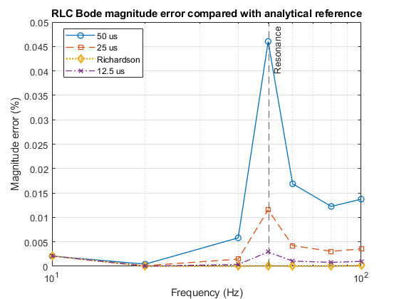
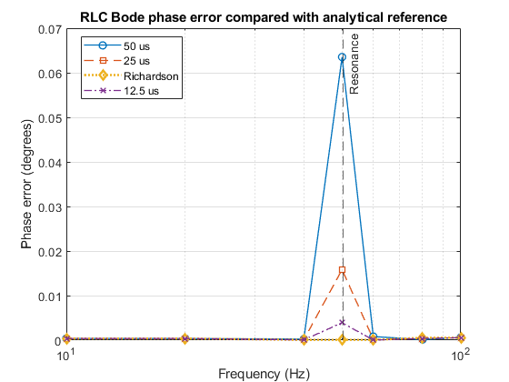
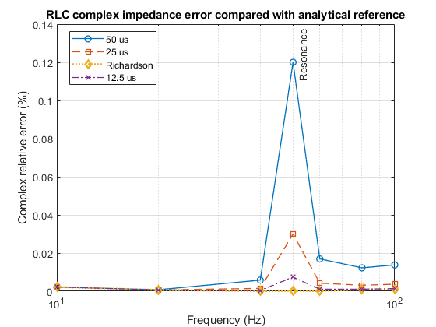
The complex impedance error plot shows that the RLC case gives a clearer Richardson benefit than the simple R–L case. The largest improvement occurs near 50 Hz, close to the resonance point, where the Richardson-corrected result has much lower error than both the 50 µs and 25 µs estimates.

