Validated Richardson Extrapolation for Accelerated Average-Model GFMI Impedance Identification
1. Objective
This study investigates whether Richardson extrapolation can reduce the simulation time required for low-frequency dq-admittance identification of an average-model grid-forming inverter (GFMI).
The main objective is to reconstruct the accuracy of a very small PSCAD solver timestep using simulations performed at substantially larger timesteps. The study evaluates:
- Direct simulations at 50, 25 and 12.5 µs.
- First-order Richardson extrapolation.
- Second-order Richardson extrapolation.
- Mixed \(h+h^2\) Richardson extrapolation.
- A direct 0.1 µs simulation used as a held-out high-fidelity reference.
- Three perturbation frequencies: 1, 5 and 10 Hz.
- Two operating points:
  - OP1: Pref = 1 pu
  - OP2: Pref = 0.6 pu
The 0.1 µs reference is not included in the extrapolation. It is used only to evaluate the accuracy of each direct and extrapolated result.
2. Model and Operating Points
The same validated average GFMI model was used for every simulation. Controller parameters, grid conditions, output channels and perturbation magnitudes were kept unchanged between solver timesteps.
Operating point | Pref | Qref | Vref
OP1 | 1.0 pu | 0 pu | 1 pu
OP2 | 0.6 pu | 0 pu | 1 pu
Testing the method at two active-power operating points determines whether the convergence behaviour is specific to one equilibrium or remains consistent when the operating condition changes.

3. Perturbation and Data-Processing Method
3.1 Applied perturbations
Two separate simulations were performed at every combination of operating point, frequency and solver timestep.
The d-axis perturbation was a 1% voltage-magnitude sinusoid:
$$V_{source}\left(t\right)=1+0.01\sin\left(2πf_{pert}t\right), t≥2\text{ s}$$
The q-axis perturbation was a \(0.5^\circ\) phase sinusoid:
$$ϕ_{source}\left(t\right)=0.5\sin\left(2πf_{pert}t\right)\text{ degrees}, t≥2\text{ s}$$
A PSCAD time-comparator block kept the perturbation signal at zero until 2 s. This allowed the model to initialise and approach steady operation before the sinusoidal excitation was applied. The tested perturbation frequencies were 1,5, and 10 Hz.
3.2 Solver timesteps
The Richardson inputs were:
$$h_{1}=50 μ\text{s}, h_{2}=25 μ\text{s}, h_{3}=12.5 μ\text{s}.$$
A direct simulation at
$$h_{ref}=0.1 μ\text{s}$$
was retained as an independent high-fidelity reference.
The exported signals used a common logging interval of 50 µs, corresponding to 20 kHz. Therefore, all eight files used for one frequency shared the same exported time grid despite having different internal PSCAD solver timesteps.
3.3 Analysis window
Each simulation was run for 10 s. Although the perturbation begins at 2 s, the analysis was restricted to 6s < t < 10s. This excludes the model startup and the transient produced when the excitation is enabled. The common dq transformation angle was estimated over $8\text{ s}≤t≤10\text{ s}.$
The perturbation remains active during this interval. However, the angle is obtained from the fundamental 50 Hz voltage component through synchronous demodulation. The low-frequency perturbation has zero mean over the selected integer-cycle windows and therefore does not introduce a significant bias into the fitted reference angle.
3.4 Admittance calculation
The d- and q-axis perturbation simulations provide two independent voltage-current responses. At each tested frequency, the voltage and current matrices are
$$V=\left[\begin{matrix}V_{d}^{\left(d\right)} & V_{d}^{\left(q\right)} \\ V_{q}^{\left(d\right)} & V_{q}^{\left(q\right)}\end{matrix}\right], I=\left[\begin{matrix}I_{d}^{\left(d\right)} & I_{d}^{\left(q\right)} \\ I_{q}^{\left(d\right)} & I_{q}^{\left(q\right)}\end{matrix}\right].$$
The identified dq-admittance matrix is
$$Y_{dq}=IV^{-1}=\left[\begin{matrix}Y_{dd} & Y_{dq} \\ Y_{qd} & Y_{qq}\end{matrix}\right].$$
The reported full-matrix error is the relative Frobenius-norm difference from the direct 0.1 µs reference:
$$ε_{Y}=\frac{{\left\|Y-Y_{ref}\right\|}_{F}}{{\left\|Y_{ref}\right\|}_{F}}×100\%.$$
4. Richardson Extrapolation Methods
Richardson extrapolation assumes the numerical result can be represented by
$$z\left(h\right)=z_{0}+c_{1}h+c_{2}h^{2}+⋯,$$
where z0 is the zero-timestep limit.
4.1 First-order Richardson extrapolation
Using 50 and 25 µs,
$$z_{RE1}=2z_{25}-z_{50}.$$
This formulation removes the leading error when convergence is approximately first order.
4.2 Second-order Richardson extrapolation
Using 50 and 25 µs,
$$z_{RE2}=\frac{4z_{25}-z_{50}}{3}.$$
This formulation assumes the leading error is proportional to \(h^2\).
4.3 Mixed (h+h^2) Richardson extrapolation
Using 50, 25 and 12.5 µs,
$$z_{mixed}=\frac{1}{3}z_{50}-2z_{25}+\frac{8}{3}z_{12.5}.$$
This formulation removes both the h and h^2 error terms.
Extrapolation was applied at waveform level before dq transformation, phasor estimation and admittance calculation. This preserves a consistent processing sequence for the direct and extrapolated cases.
5. Numerical Qualification
Several checks were completed before comparing admittance results.
5.1 Operating-point consistency
Across the completed tests, voltage and current RMS differences between the coarse simulations and the 0.1 µs reference were below approximately 0.001%.
This confirms that the simulations correspond to the same physical operating condition. The measured admittance differences therefore represent numerical timestep effects rather than a change in equilibrium.
5.2 dq-angle consistency
The dq-angle difference between the 25 µs and 0.1 µs simulations was less than 0.0001 degrees in the completed cases.
The phase-reference calculation was therefore consistent across solver timesteps.
5.3 Voltage-matrix conditioning
The calculated voltage-matrix condition numbers remained approximately between 1.25 and 1.46. These values are close to unity and indicate that the d- and q-axis perturbations provide sufficiently independent excitation.
Therefore, the matrix inversion used to obtain Ydq is well conditioned.
6. Operating Point 1 Results
6.1 OP1 at 1 Hz
At 1 Hz, the direct timestep error decreased from 0.315689% at 50 µs to 0.078295% at 12.5 µs.
Method | Full-matrix error
Direct 50 µs | 0.315689%
Direct 25 µs | 0.157496%
Direct 12.5 µs | 0.078295%
First-order Richardson | 0.001565%
Second-order Richardson | 0.104748%
Mixed Richardson | 0.001188%
The observed element-wise convergence orders were close to one. The mixed formulation produced the smallest full-matrix error, although first-order Richardson was also highly accurate.
The direct reference matrix was
$$Y_{ref}=\left[\begin{matrix}3.805088∠-{164.836}^{∘} & 6.533549∠-{118.939}^{∘} \\ 10.970784∠-{4.758}^{∘} & 7.762708∠-{61.324}^{∘}\end{matrix}\right].$$
The selected mixed-Richardson matrix was
$Y_{mixed}=\left[\begin{matrix}3.805188∠-{164.835}^{∘} & 6.533629∠-{118.940}^{∘} \\ 10.970854∠-{4.758}^{∘} & 7.762753∠-{61.324}^{∘}\end{matrix}\right]$.
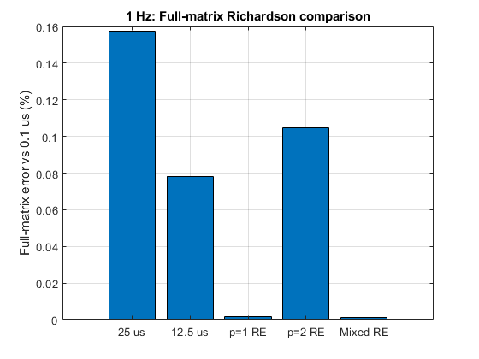 | 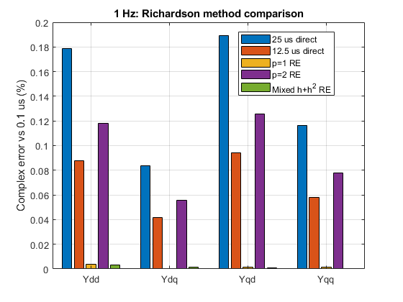
Figure 1. OP1 1 Hz comparison between the direct 0.1 µs reference, direct coarse-timestep results and Richardson estimates
6.2 OP1 at 5 Hz
At 5 Hz, the effect of solver timestep became more noticeable. The direct 50 µs result had an error of 1.570754%, while the mixed extrapolation reduced the error to 0.003077%.
Method | Full-matrix error
Direct 50 µs | 1.570754%
Direct 25 µs | 0.782190%
Direct 12.5 µs | 0.389145%
First-order Richardson | 0.020382%
Second-order Richardson | 0.519185%
Mixed Richardson | 0.003077%
The direct reference matrix was
$$Y_{ref}=\left[\begin{matrix}6.336338∠-{157.951}^{∘} & 12.241893∠-{174.245}^{∘} \\ 9.094264∠-{8.814}^{∘} & 9.455390∠-{153.790}^{∘}\end{matrix}\right].$$
The selected mixed-Richardson matrix was
$$Y_{mixed}=\left[\begin{matrix}6.336246∠-{157.954}^{∘} & 12.241928∠-{174.246}^{∘} \\ 9.094204∠-{8.814}^{∘} & 9.455276∠-{153.792}^{∘}\end{matrix}\right].$$

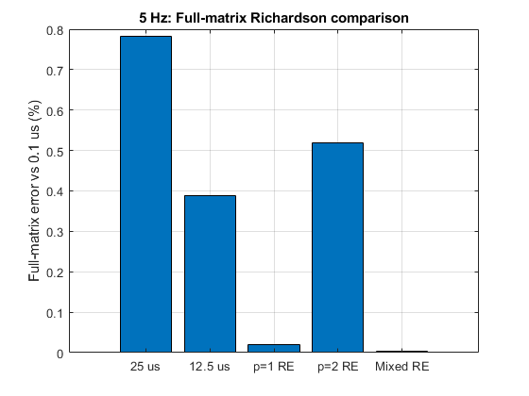 | 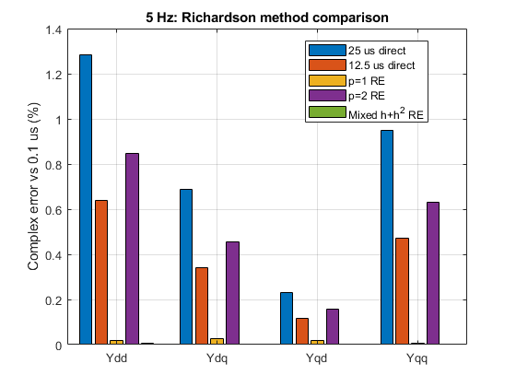

Figure 2. OP1 5 Hz comparison between the direct 0.1 µs reference, direct coarse-timestep results and Richardson estimates.
6.3 OP1 at 10 Hz
The largest direct errors occurred at 10 Hz. The direct 50 µs simulation differed from the reference by 2.619481%, while mixed Richardson reduced the error to 0.004289%.
Method | Full-matrix error
Direct 50 µs | 2.619481%
Direct 25 µs | 1.281278%
Direct 12.5 µs | 0.632064%
First-order Richardson | 0.072444%
Second-order Richardson | 0.836859%
Mixed Richardson | 0.004289%
The direct reference matrix was
$$Y_{ref}=\left[\begin{matrix}7.906670∠-{154.421}^{∘} & 13.136877∠{171.359}^{∘} \\ 10.227464∠-{9.341}^{∘} & 9.079388∠-{161.497}^{∘}\end{matrix}\right].$$
The selected mixed-Richardson matrix was
$$Y_{mixed}=\left[\begin{matrix}7.906333∠-{154.424}^{∘} & 13.136621∠{171.356}^{∘} \\ 10.227415∠-{9.343}^{∘} & 9.079086∠-{161.499}^{∘}\end{matrix}\right].$$
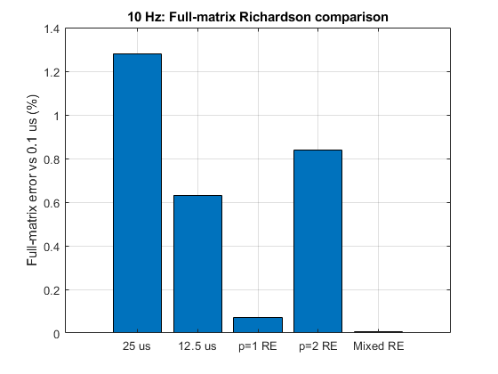 | 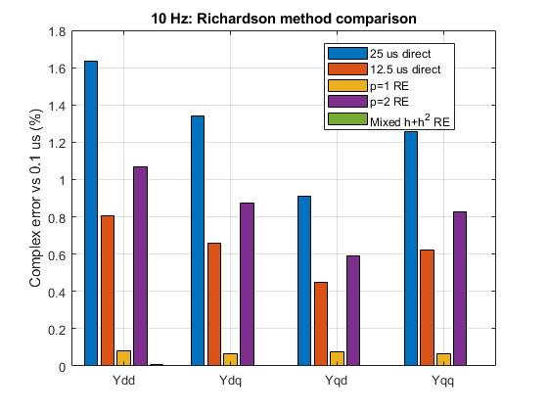

Figure 3. OP1 10 Hz comparison between the direct 0.1 µs reference, direct coarse-timestep results and Richardson estimates.
7. Operating Point 2 Results
7.1 OP2 at 1 Hz
At Pref = 0.6 pu and 1 Hz, the operating point remained highly consistent across all timesteps. The maximum reported RMS voltage deviation was approximately 0.000050%, and the maximum current deviation was approximately 0.000034%.
The direct results again showed approximately first-order convergence.
Method | Full-matrix error
Direct 50 µs | 0.305930%
Direct 25 µs | 0.152706%
Direct 12.5 µs | 0.076030%
First-order Richardson | 0.001185%
Second-order Richardson | 0.101612%
Mixed Richardson | 0.000811%
The observed element-wise orders were approximately:
$$R50_to_25=0.997\text{ to }1.011,$$
$$R25_to_12.5=1.001\text{ to }1.016.$$
The direct 0.1 µs reference matrix was
$$Y_{ref}=\left[\begin{matrix}2.966984∠-{134.803}^{∘} & 6.223070∠-{114.233}^{∘} \\ 12.366736∠-{6.791}^{∘} & 5.814695∠-{66.142}^{∘}\end{matrix}\right].$$
The selected mixed-Richardson matrix was
$$Y_{mixed}=\left[\begin{matrix}2.967047∠-{134.802}^{∘} & 6.223116∠-{114.233}^{∘} \\ 12.366815∠-{6.791}^{∘} & 5.814720∠-{66.142}^{∘}\end{matrix}\right].$$
The full-matrix mixed-Richardson error was only 0.000811%, which is smaller than the corresponding OP1 result of 0.001188%.
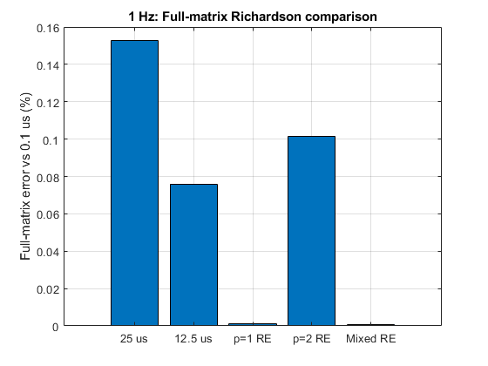 | 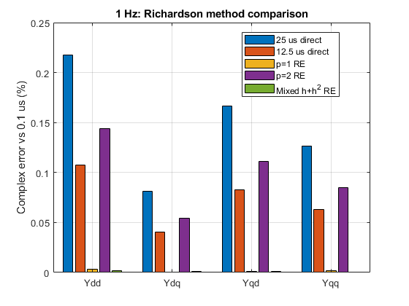

Figure 4. OP2 1 Hz direct and Richardson admittance errors.
7.2 OP2 at 5 Hz
Method | Full-matrix error
Direct 50 µs | 1.605242%
Direct 25 µs | 0.799446%
Direct 12.5 µs | 0.397755%
First-order Richardson | 0.020763%
Second-order Richardson | 0.530694%
Mixed Richardson | 0.003128%
Observed convergence order:
R50_to_25 = 0.975 to 1.009,
R25_to_12.5 = 0.992 to 1.009.
Direct 0.1 µs reference matrix:
$$Y_{ref}=\left[\begin{matrix}7.128164∠-{156.087}^{∘} & 12.461435∠-{173.237}^{∘} \\ 8.837780∠-{11.600}^{∘} & 8.963249∠-{154.032}^{∘}\end{matrix}\right]$$
Selected Richardson matrix:
$$Y_{mixed}=\left[\begin{matrix}7.128044∠-{156.090}^{∘} & 12.461465∠-{173.238}^{∘} \\ 8.837723∠-{11.600}^{∘} & 8.963143∠-{154.034}^{∘}\end{matrix}\right]$$
At 5 Hz, the direct timestep error increased relative to the 1 Hz case. The observed convergence order remained approximately first order, ranging from 0.975 to 1.009 across the four admittance elements. Mixed h+h^2 Richardson produced the lowest full-matrix error of 0.003128%. This result is consistent with the convergence behaviour observed at OP1 and the other OP2 frequencies.
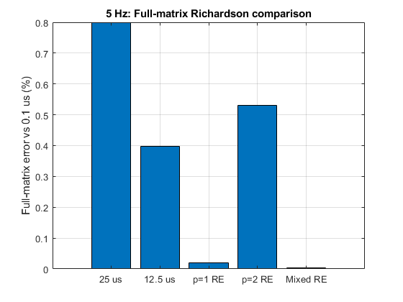 | 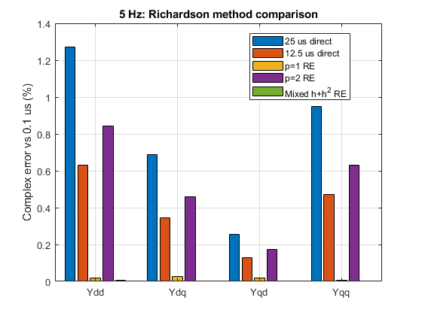

Figure 5. OP2 5 Hz direct and Richardson admittance errors.
7.3 OP2 at 10 Hz
At 10 Hz, the direct 50 µs result had a full-matrix error of 2.646332%. Reducing the direct timestep to 12.5 µs lowered the error to 0.638677%, but the mixed Richardson result reduced it further to 0.004357%.
Method | Full-matrix error
Direct 50 µs | 2.646332%
Direct 25 µs | 1.294598%
Direct 12.5 µs | 0.638677%
First-order Richardson | 0.072990%
Second-order Richardson | 0.845746%
Mixed Richardson | 0.004357%
The observed element-wise orders were:
$${R50_to_25}_{50→25}=1.018\text{ to }1.046,$$
$$R25_to_12.5=1.012\text{ to }1.027.$$
The direct 0.1 µs reference matrix was
$$Y_{ref}=\left[\begin{matrix}8.319705∠-{156.386}^{∘} & 13.228935∠{171.265}^{∘} \\ 10.085937∠-{9.406}^{∘} & 8.801532∠-{160.457}^{∘}\end{matrix}\right].$$
The selected mixed-Richardson matrix was
$$Y_{mixed}=\left[\begin{matrix}8.319328∠-{156.388}^{∘} & 13.228678∠{171.263}^{∘} \\ 10.085887∠-{9.407}^{∘} & 8.801254∠-{160.459}^{∘}\end{matrix}\right].$$
The mixed method improved upon the direct 12.5 µs result by a factor of approximately 146.6.
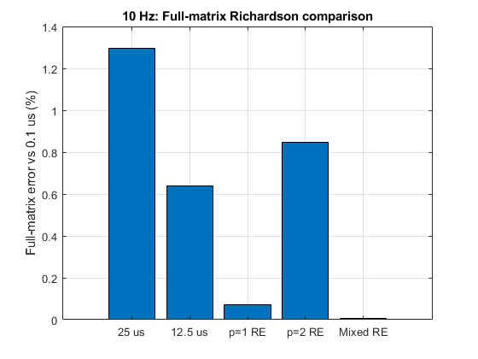 | 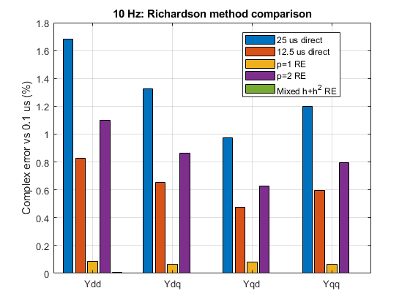

Figure 6. OP2 10 Hz direct and Richardson admittance errors.
8. Comparison Between Operating Points
The available results show highly consistent numerical behaviour at both operating points.
Frequency | Operating point | Direct 50 µs | Direct 25 µs | Direct 12.5 µs | RE1 | RE2 | Mixed
1 Hz | OP1 | 0.315689% | 0.157496% | 0.078295% | 0.001565% | 0.104748% | 0.001188%
1 Hz | OP2 | 0.305930% | 0.152706% | 0.076030% | 0.001185% | 0.101612% | 0.000811%
5 Hz | OP1 | 1.570754% | 0.782190% | 0.389145% | 0.020382% | 0.519185% | 0.003077%
5 Hz | OP2 | 1.605242% | 0.799446% | 0.397755% | 0.020763% | 0.530694% | 0.003128%
10 Hz | OP1 | 2.619481% | 1.281278% | 0.632064% | 0.072444% | 0.836859% | 0.004289%
10 Hz | OP2 | 2.646332% | 1.294598% | 0.638677% | 0.072990% | 0.845746% | 0.004357%
At 1,5 and 10 Hz, changing Pref from 1.0 to 0.6 pu changed the physical dq-admittance matrix, as expected, but did not materially alter the numerical convergence pattern.
This distinction is important:
- The admittance values depend on operating point.
- The timestep-error structure remains approximately first order.
- Mixed Richardson remains the most accurate formulation.
- First-order Richardson remains the faster two-simulation alternative.
Therefore, the acceleration method is not limited to only the OP1 equilibrium.
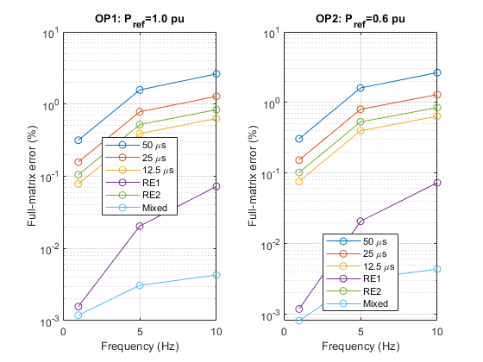
Figure 7. Full-matrix error versus frequency for OP1 and OP2.
9. Discussion – Timestep and Frequency Dependence
The direct PSCAD error increased with perturbation frequency.
For OP1, the direct 50 µs error increased from $0.3157\%\text{ at 1 Hz}$to $1.5708\%\text{ at 5 Hz}$ and $2.6195\%\text{ at 10 Hz}.$
A similar pattern was observed at OP2, where the direct 50 µs error was 0.3059% at 1 Hz and 2.6463% at 10 Hz.
This indicates that higher-frequency impedance points are more sensitive to timestep-dependent phase and amplitude errors. A fixed timing or phase displacement represents a larger fraction of the perturbation cycle as frequency increases.
Reducing the direct timestep improved accuracy approximately linearly. Halving the timestep from 50 to 25 µs approximately halved the error, and reducing it again to 12.5 µs approximately halved the error a second time.
This behaviour explains why first-order Richardson is substantially more effective than second-order Richardson. Although the underlying simulation may contain higher-order numerical components, the complete measurement chain exhibits a dominant O(h) error over the tested timestep range.
The second-order formulation assumes an O(h^2) leading term and therefore does not cancel the dominant observed error. Consequently, its accuracy was only slightly better than a direct 25 µs result.
The mixed formulation removes both O(h) and O(h^2) components and consistently produced the smallest full-matrix error.
10. Richardson Runtime and Error
Frequency | 50 µs | 25 µs | 12.5 µs | RE1/RE2 total | Mixed total | 0.1 µs reference
1 Hz | 10.83 s | 18.77 s | 32.86 s | 29.60 s | 62.46 s | 4510 s
5 Hz | 10.54 s | 18.50 s | 33.30 s | 29.04 s | 62.34 s | 4563 s
10 Hz | 10.41 s | 18.44 s | 33.56 s | 28.85 s | 62.41 s | 4588 s
A direct 0.1 µs simulation required approximately 40 minutes for each perturbation direction. Since both d- and q-axis simulations are required, one complete impedance point required approximately 4510–4588 s. First-order Richardson required approximately 29 s, providing a speed-up of 152–159 times. Mixed Richardson required approximately 62 s, providing a speed-up of 72–74 times.
11. Accuracy–Speed Pareto Analysis
11.1 1 Hz
At 1 Hz, both first-order and mixed Richardson provide very low error.
For OP1:
- First-order Richardson: 0.001565% error using approximately 29.60 s.
- Mixed Richardson: 0.001188% error using approximately 62.46 s.
- Direct 0.1 µs reference: approximately 4510 s.
First-order Richardson is attractive when throughput is the main requirement because it obtains nearly the same accuracy as the mixed method using only two timestep simulations.
The mixed method provides the lowest numerical error, but the practical improvement over first-order Richardson is small at 1 Hz.
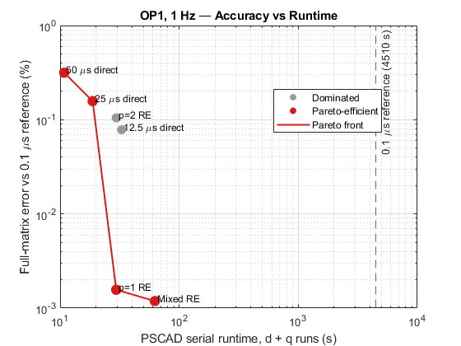
Figure 8. Accuracy-speed Pareto plot at 1 Hz.
11.2 5 Hz
At 5 Hz, mixed Richardson provides a clearer advantage.
For OP1:
- First-order Richardson: 0.020382% error.
- Mixed Richardson: 0.003077% error.
- Mixed Richardson is approximately 126 times more accurate than the direct 12.5 µs result based on the reported improvement factor.
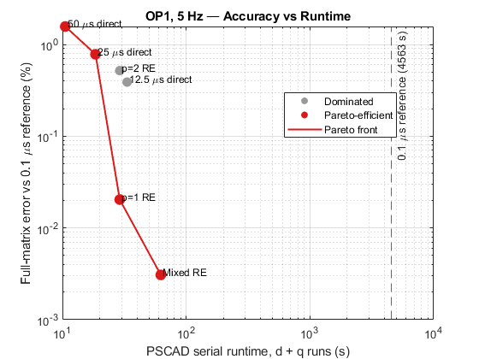
Figure 9. Accuracy-speed Pareto plot at 5 Hz.
11.3 10 Hz
At 10 Hz, the accuracy benefit of the third timestep is substantial.
For OP1:
- First-order Richardson: 0.072444% error.
- Mixed Richardson: 0.004289% error.
For OP2:
- First-order Richardson: 0.072990% error.
- Mixed Richardson: 0.004357% error.
At OP1, mixed Richardson is approximately 16.9 times more accurate than first-order Richardson and approximately 147 times more accurate than the direct 12.5 µs result. Mixed Richardson remains approximately 74 times faster than the direct 0.1 µs reference.
First-order Richardson provides a larger speed-up of approximately 159, but its error is noticeably higher at 10 Hz. Therefore, mixed Richardson provides the better accuracy-speed balance when high accuracy is required at the upper end of the tested frequency range.
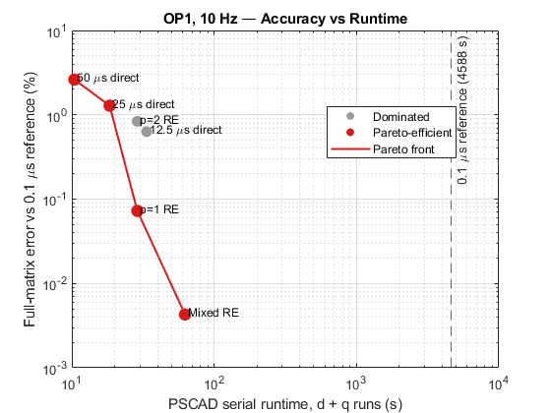
Figure 10. Accuracy-speed Pareto plot at 10 Hz.
12. Rezonance Comparison
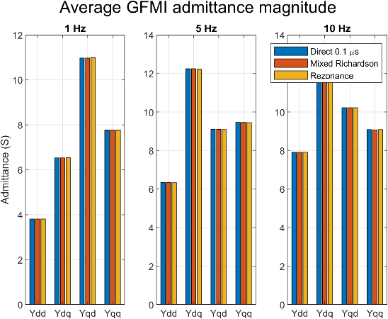 | 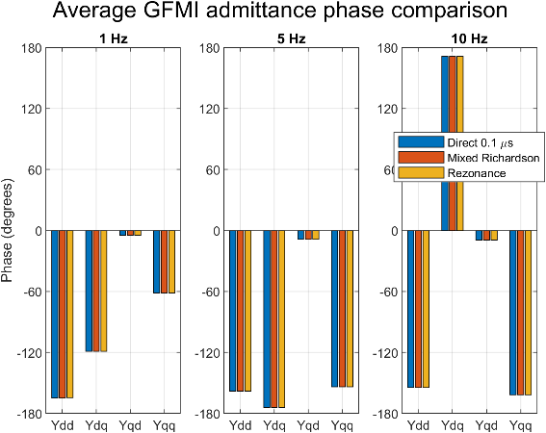

Figure 11. Comparison of the direct 0.1 µs reference, mixed Richardson and Rezonance admittance magnitudes and phases at OP1.
The final OP1 admittance matrices were compared with an independent scan obtained using Rezonance. The Rezonance results were converted from per unit to siemens using the system base admittance and corrected to use the same current-direction convention as the PSCAD results. The direct 0.1 µs PSCAD result was used as the common reference.

Frequency | Mixed Richardson error | Rezonance error
1 Hz | 0.001188% | 0.253099%
5 Hz | 0.003078% | 0.050901%
10 Hz | 0.004289% | 0.051206%
Mixed Richardson closely reproduced the direct fine-timestep result at all three frequencies, with full-matrix errors below 0.005%. The Rezonance results also showed close agreement, with errors of approximately 0.05% at 5 and 10 Hz and 0.25% at 1 Hz.
The Richardson errors are smaller because Richardson extrapolation uses PSCAD results from the same model and signal-processing procedure as the direct reference. Rezonance performs a separate impedance-identification scan, so some difference is expected. Nevertheless, the close agreement in both magnitude and phase independently supports the validity of the identified admittance matrices.
The larger Rezonance difference at 1 Hz indicates that the lowest-frequency point is more sensitive to differences between the two identification procedures. However, the error remains below 0.3%, so it does not indicate a significant disagreement.
Overall, the Rezonance comparison confirms that the accelerated Richardson results preserve the physical admittance response of the GFMI model while avoiding the very long runtime required by a direct 0.1 µs simulation.
13. Practical Recommendation
The results support two different recommendations depending on the required balance between accuracy and computational cost.
For rapid repeated impedance scans, first-order Richardson is the preferred practical option. It requires only the 50 and 25 µs simulations, completes one dq-admittance point in approximately 29 s, and provides a very large accuracy improvement over either direct coarse-timestep result.
For final high-accuracy results, mixed h+h^2 Richardson is preferred. It requires the additional 12.5 µs simulation but consistently produced the lowest full-matrix error at both operating points and every completed frequency.
The method should not be selected solely from the theoretical order of the PSCAD solver. A short convergence qualification should first confirm that:
- The operating point remains consistent between timesteps.
- The voltage matrix is well conditioned.
- The direct error decreases regularly as the timestep is reduced.
- The observed order is reasonably consistent across the relevant timestep range.
For the present GFMI model, the measured order is approximately one. Therefore, first-order and mixed Richardson formulations are appropriate, whereas second-order Richardson is not the preferred method.
14. Main Findings
The validated results demonstrate that:
- The average GFMI impedance measurement chain exhibits approximately first-order timestep convergence between 50, 25 and 12.5 µs.
- Direct coarse-timestep error increases with perturbation frequency.
- Second-order Richardson provides only limited improvement because the leading observed error is not second order.
- First-order Richardson gives a strong accuracy improvement using only two coarse simulations.
- Mixed h+h^2 Richardson consistently gives the smallest full-matrix error.
- At OP1, mixed-Richardson error remains between approximately 0.0012% and 0.0043% across 1–10 Hz.
- At the all three tested OP2 frequencies, mixed-Richardson error remains between approximately 0.0008% and 0.0044%.
- The same convergence pattern is observed at Pref= 1.0 pu and Pref = 0.6 pu.
- A complete direct 0.1 µs dq test requires approximately 80 minutes, while mixed Richardson requires approximately 62 s.
- Mixed Richardson therefore retains near-reference accuracy while providing an approximate 73-times reduction in simulation time.
15. Conclusion
This study demonstrates that waveform-level Richardson extrapolation can significantly accelerate low-frequency dq-admittance identification for the tested average-model GFMI.
The direct PSCAD results show a clear, approximately first-order dependence on solver timestep. This finding is consistent across the tested frequencies and both operating points. First-order Richardson effectively cancels the dominant numerical error and provides a computationally efficient two-simulation method.
Mixed h+h^2 Richardson provides the highest accuracy by using the 50, 25 and 12.5 µs waveforms to remove both first- and second-order timestep-error components. Across all completed cases, its full-matrix error relative to the direct 0.1 µs reference remains below 0.005%.
The principal practical result is that a reference-quality impedance estimate can be obtained in approximately 62 s rather than approximately 80 minutes. This corresponds to an estimated speed-up of around 73 while preserving close agreement with the held-out reference.

