Understanding Objects in JavaScript:

Function-Based Objects vs Class-Based Objects (with Rectangle & Box)
In JavaScript, there are multiple ways to create objects.
Two common approaches are:
- Using a function that returns an object
- Using a class and creating objects with new
Both approaches work, but they differ greatly in structure, scalability, and extensibility.
We will use Rectangle and Box examples to clearly show the difference.

1️⃣ Creating Objects Using a Function

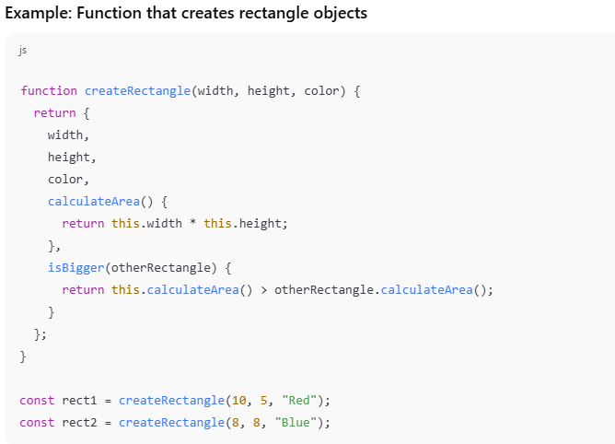

What is happening here?
- The function manually builds and returns an object
- Each rectangle is just a plain JavaScript object
- The methods (calculateArea, isBigger) are copied into every object

Key characteristics
- Simple and easy to understand
- Works well for small programs
- No formal “type” information
- No built-in way to extend behaviour cleanly

2️⃣ Creating Objects Using a Class (Rectangle)

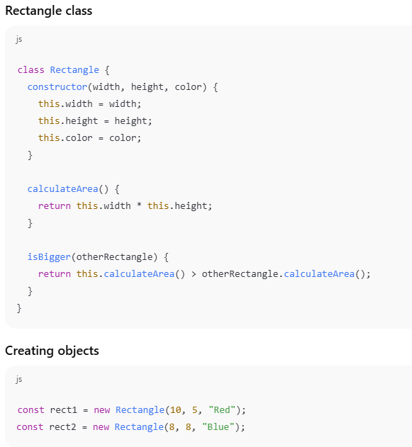

What is different?
- Rectangle is a blueprint
- Objects are created in a consistent and predictable way
- Methods are shared via the prototype (written once, reused many times)

3️⃣ Clear “Type” and Easier Debugging (Why Classes Matter)

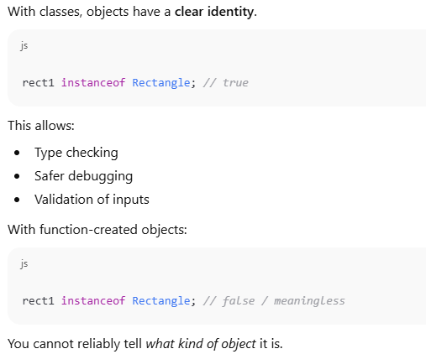

Why this matters
In larger programs:
- Bugs are harder to trace
- You may accidentally pass the wrong object
- Classes help prevent silent errors

4️⃣ Extending Behavior: Introducing Box
Now let’s add a new requirement:
“We want a Box, which is like a Rectangle but also has depth and volume.”

❌ With function-based objects (problematic)
Using functions:
- You must write a separate createBox
- You will duplicate rectangle logic
- No natural way to reuse rectangle behaviour

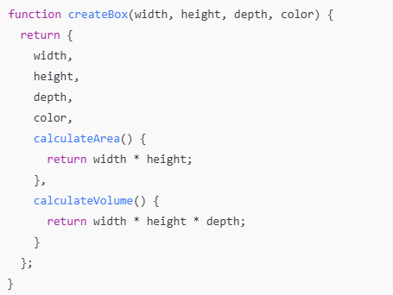
Problems:
- Code duplication
- No relationship between Rectangle and Box
- Harder to maintain and extend

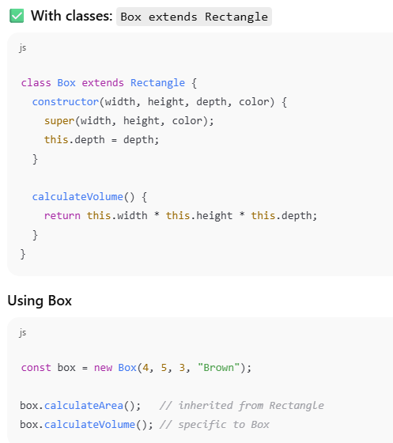

What this shows
- Code reuse: no duplicated area logic
- Clear relationship: “A Box IS a Rectangle”
- Easy extension: new behavior added cleanly

5️⃣ Inheritance + Type Checking

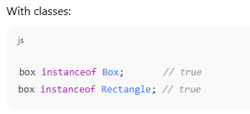
This enables:
- Polymorphism
- Safer APIs
- Cleaner logic when handling different shapes
This is not realistically achievable with simple factory functions.

6️⃣ Easier to Extend in the Future
Suppose later we want to add:
- calculatePerimeter()
- validation rules
- logging
- static counters
With classes:
- Add the method once
- All existing objects benefit automatically
With functions:
- Must update every factory
- Risk of inconsistent objects

🎓 Final Teaching Conclusion
Both approaches create objects,
but classes are better when modelling real-world concepts that grow over time.
Use functions:
- for small scripts
- for quick data grouping
Use classes:
- for real models (Rectangle, Box, Player, Account)
- when behaviour must be reused
- when inheritance or extension is needed

~ END ~

