1️⃣ From hard-coded loops to “combining values”
In programReduce01.js, the code uses two separate loops:
- One to add up all the numbers
- One to find the largest number
Each loop repeatedly updates a running value:
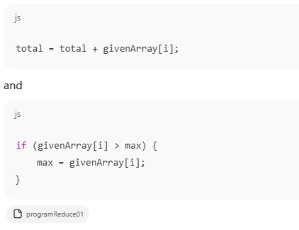
Here, the loop is doing two jobs at once:
- Walking through the array
- Deciding how to combine values
This works, but it is not flexible.

2️⃣ Making the “combine step” visible
In programReduce02.js, the key idea becomes clearer:
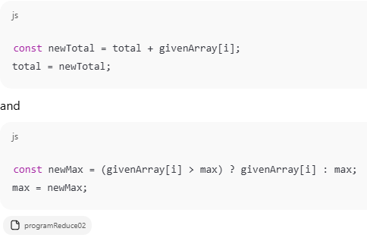
Now you can see that:
Each loop step takes the previous result and combines it with the next value to produce a new result.
This is the heart of what reduce does.

3️⃣ Turning the combining logic into functions
In programReduce03.js, the combination logic is extracted:
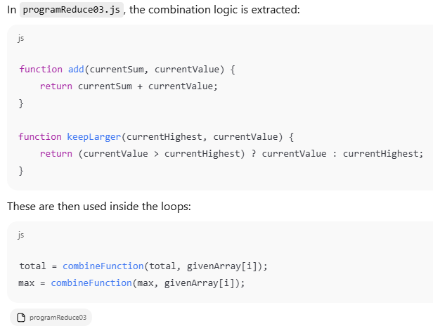
Now the loop no longer knows how to add or compare —
it simply calls a callback function and trusts the answer.

4️⃣ One generic reduce function
In programReduce04.js, this idea becomes a true reduce:
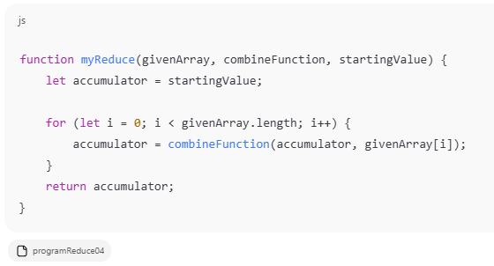
Now the algorithm is:
“Take a running value (accumulator) and keep combining it with each array element using a callback.”
The callback decides how the combination happens.

5️⃣ Callback functions on the fly
In programReduce05.js, the callback is written inline:
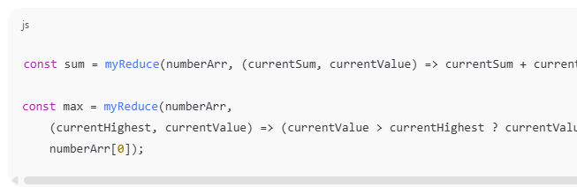Refer to actual code for the complete code
This shows that:
The reduce algorithm does not care what the rule is — it just calls the callback again and again.

6️⃣ JavaScript’s built-in Array.reduce()
Finally, programReduce06.js uses the real thing:
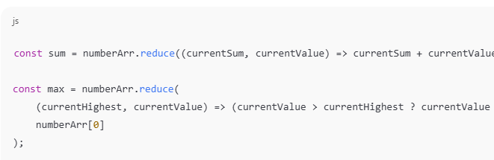Refer to actual code for the complete code
This is exactly the same as myReduce, except JavaScript provides it for you.

🎯 Final Concept Students Should Understand
Array.reduce() separates two responsibilities:
Part | Responsibility
reduce | Loops through the array and keeps track of the accumulator
Callback | Decides how to combine the accumulator with each value
So when you write:
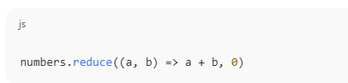
you are not telling JavaScript how to loop —
you are only telling it how to combine two values.
That is the core idea of reduce.
~ END ~

