Understanding JavaScript Objects and Classes
In JavaScript, objects allow us to model real-world things in code.
A game character, a customer, a bank account, or a student can all be represented as objects.
A class is a blueprint for creating objects.
It defines:
- What data an object has (properties)
- What actions it can perform (methods)
In this program, we model a simple battle game using two main classes:
- Attack
- Player
1. The Attack Class — A Simple Object Blueprint
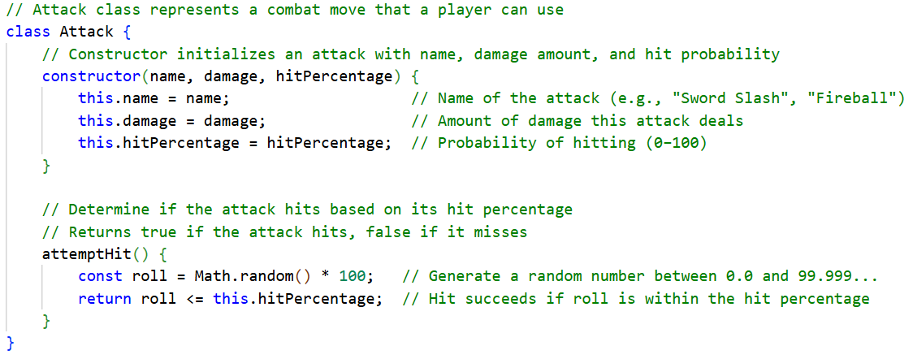
This class describes what an attack is.
Every Attack object has:
- name → e.g. "Fireball"
- damage → how much HP it removes
- hitPercentage → chance to hit (0–100)
The method attemptHit() uses randomness to simulate chance.
This shows an important idea:
Objects contain both data and behavior
The data is the attack’s stats.
The behaviour is the ability to determine whether it hits.

2. The Player Class — Objects Made of Other Objects
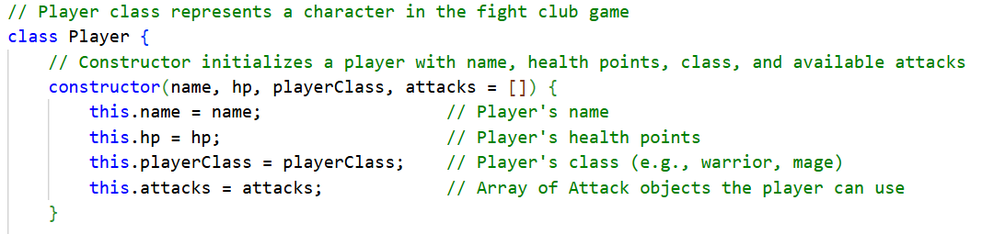
A Player object has:
- name
- hp (health points)
- playerClass (Warrior, Wizard, etc.)
- attacks → an array of Attack objects
This shows composition:
A Player is built from other objects (Attack objects).
So instead of storing raw numbers or strings, a Player contains real Attack objects.
3. Player Behaviour
Still in Player.js
This method checks the internal state of the object.

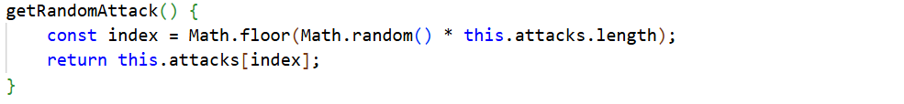
The player can randomly choose one of its own attacks.

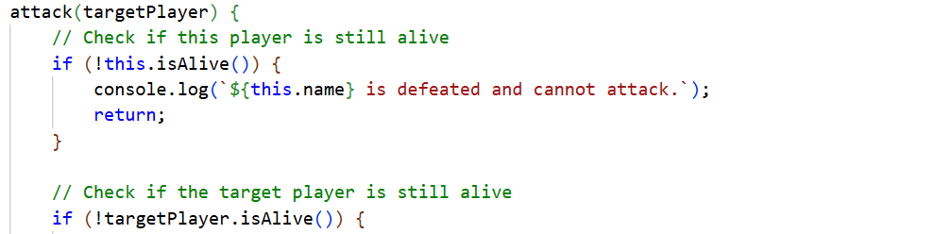
Here, one object (Player) is interacting with another object (another Player) using an Attack object.
This is a powerful idea in OOP:
Objects send messages to each other by calling methods.

4. Objects in Action
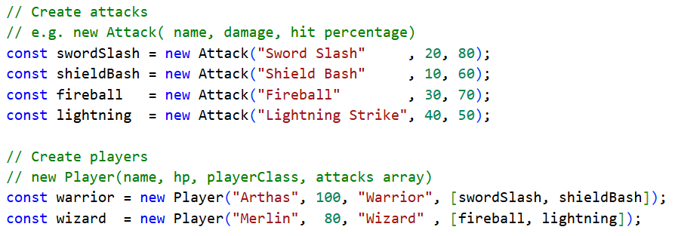
Here we create real objects from the Attack class.
We create two Player objects.
Each Player gets its own set of Attack objects.
This means:
- Arthas and Merlin are separate objects
- They have their own HP
- They have different attacks
- They act independently

5. The Battle Loop — Objects Changing State
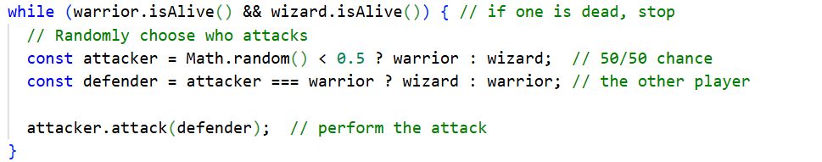
Each loop:
- A random player is chosen
- That object calls attack() on the other
- The defender’s HP is reduced
Objects remember their state.
HP decreases over time until one object is defeated.

6. Final Result — Objects Decide the Outcome
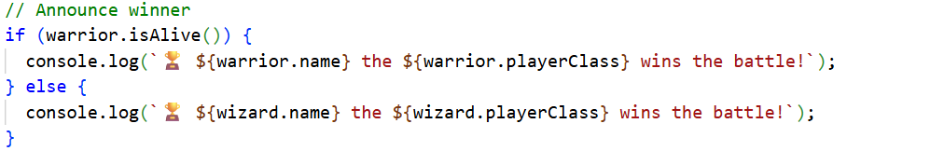
The winner is not tracked manually.
It is determined by asking each object about its own state.
This is a key idea:
Objects manage their own data — we ask them questions instead of calculating everything ourselves.

~ END ~

