1️⃣ From “hard-coded logic” to “decision making”
In the first two programs, the filtering logic is hard-wired inside the loop.
For example, the program literally checks:
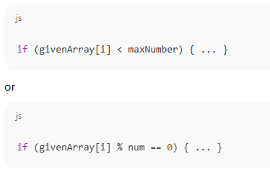
The loop does two jobs at once:
- Go through every element
- Decide whether the element should be kept
This works, but it is not flexible.
If you want a new rule (e.g. “greater than 70”), you must write a new function.
In Program 2, this logic is made clearer by pulling the condition into a variable:
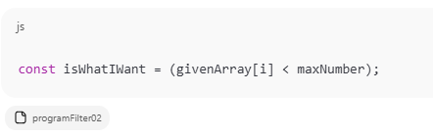
This is the first hint that filtering is really about evaluating a true/false decision.

2️⃣ Turning the decision into a function
In Program 3, the rule is separated from the loop:
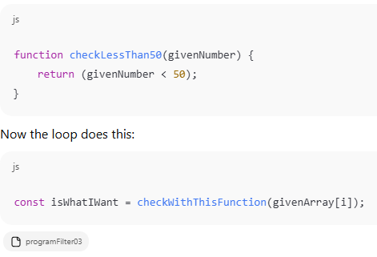
This means:
“For every number in the array, ask another function whether this number should be kept.”
This other function is what we call a callback function.
The loop does not know the rule — it only knows:
“Call this function and expect a true or false back.”

3️⃣ Generalising into myFilter
In Program 4, both “less than 50” and “divisible by 3” are handled by the same function:
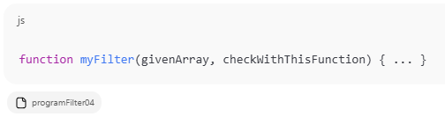
The algorithm is now clear:
For every element:
- Send the element into the callback
- Get back true or false
- If true, push it into the result array
So conceptually:
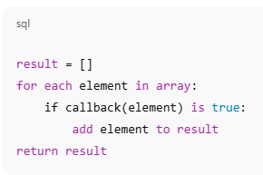
This is exactly what filter means.

4️⃣ Callback functions can be created on the fly
In Program 5, instead of writing named functions like checkLessThan50, the callback is written directly:
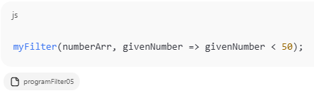
This works because JavaScript allows functions to be passed like values.
The filter algorithm does not care where the function came from — only that it returns true or false.

5️⃣ The built-in Array.filter() is the same idea
Finally, Program 6 shows:
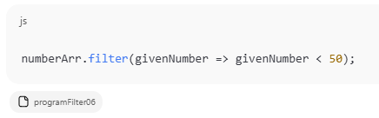
This means:
“JavaScript now provides the myFilter function for you — built into every array.”
Internally, Array.filter() is doing almost exactly what your myFilter function did:
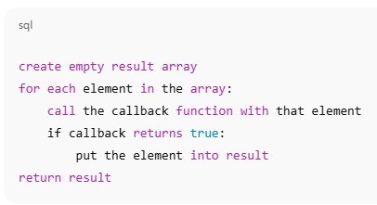

🎯 Final Concept Students Should Understand
Array.filter() does not know what you are looking for.
It only knows how to:
- Walk through the array
- Call your callback function on every element
- Keep the elements for which your callback returns true
So when you write:
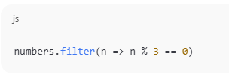
You are not telling JavaScript how to loop —
you are only telling it how to decide.
That separation of:
“how to loop” vs “how to decide”
is what makes higher-order functions like filter() so powerful.

~ END ~

