The Derivative

The concept of Derivative is at the core of Calculus and modern mathematics. The definition of the derivative can be approached in two different ways. One is geometrical (as a slope of a curve) and the other one is physical (as a rate of change). Historically there was (and maybe still is) a fight between mathematicians which of the two illustrates the concept of the derivative best and which one is more useful. We will not dwell on this and will introduce both concepts. Our emphasis will be on the use of the derivative as a tool.

The Physical Concept of the Derivative
This approach was used by Newton in the development of his Classical Mechanics. The main idea is the concept of velocity and speed. Indeed, assume you are traveling from point A to point B, what is the average velocity during the trip? It is given by
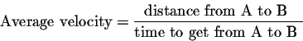

If we now assume that A and B are very close to each other, we get close to what is called the instantaneous velocity. Of course, if A and B are close to each other, then the time it takes to travel from A to B will also be small. Indeed, assume that at time t=a, we are at A. If the time elapsed to get to B is , then we will be at B at time 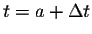. If is the distance from A to B, then the average velocity is
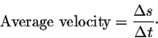

The instantaneous velocity (at A) will be found when get smaller and smaller. Here we naturally run into the concept of limit. Indeed, we have
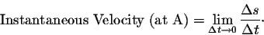

If f(t) describes the position at time t, then 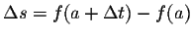. In this case, we have
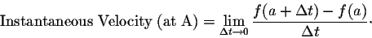

Example. Consider a parabolic motion given by the function f(t) = t². The instantaneous velocity at t=a is given by
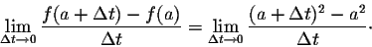

Since
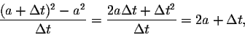

we conclude that the instantaneous velocity at t=a is 2 a.
This concept of velocity may be extended to find the rate of change of any variable with respect to any other variable. For example, the volume of a gas depends on the temperature of the gas. So in this case, the variables are V (for volume) as a function of T (the temperature). In general, if we have y = f(x), then the average rate of change of y with respect to x from x = a to 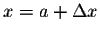, where 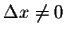, is
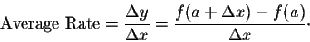

As before, the instantaneous rate of change of y with respect to x at x = a, is

Notation. Now we get to the hardest part. Since we can not keep on writing "Instantaneous Velocity" while doing computations, we need to come up with a suitable notation for it. If we write dx for small, then we can use the notation
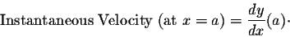

This is the notation introduced by Leibniz. (Wilhelm Gottfried Leibniz (1646-1716) and Isaac Newton (1642-1727) are considered the inventors of Calculus.)

The Geometrical Concept of the Derivative
Consider a function y = f(x) and its graph. Recall that the graph of a function is a set of points (that is (x,f(x)) for x's from the domain of the function f). We may draw the graph in a plane with a horizontal axis (usually called the x-axis) and a vertical axis (usually called the y-axis).
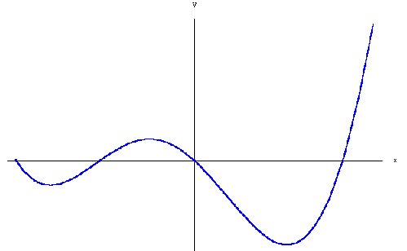
Fix a point on the graph, say (x₀, f(x₀)). If the graph as a geometric figure is "nice" (i.e. smooth) around this point, it is natural to ask whether one can find the equation of the straight line "touching" the graph at that point. Such a straight line is called the tangent line at the point in question. The concept of tangent may be viewed in a more general framework.
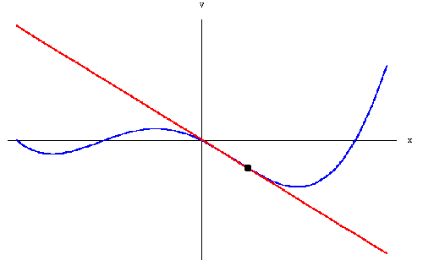
(Note that the tangent line may not exist. We will discuss this case later on.) One way to find the tangent line is to consider points (x,f(x)) on the graph, where x is very close to x₀. Then draw the straight-line joining both points (see the picture below):
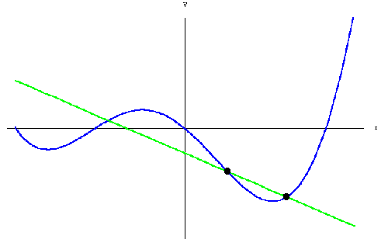
As you can see, when x get closer and closer to x₀, the lines get closer and closer to the tangent line. Since all these lines pass through the point (x₀,f(x₀)), their equations will be determined by finding their slope: The slope of the line passing through the points (x₀,f(x₀)) and (x,f(x)) (where 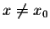) is given by
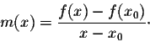

The tangent itself will have a slope m, which is very close to m(x) when x itself is very close to x₀. This is the concept of limit once again!
In other words, we have
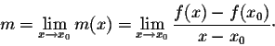

So the equation of the tangent line is
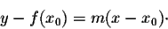

Notation. Writing "m" for the slope of the tangent line does not carry enough information; we want to keep track of the function f(x) and the point x₀ in our notation. The common notation used is
m = f'(x₀).

In this case, the equation of the tangent line becomes
y - f(x₀) = f'(x₀) (x-x₀)

where
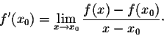

One last remark: Sometimes it is more convenient to compute limits when the variable approaches 0. One way to do that is to make a translation along the x-axis. Indeed, if we set h=x-x₀, we get
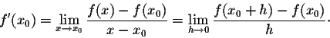

Using the Definition to Compute the Derivative

We have seen in the previous page how the derivative is defined: For a function f(x), its derivative at x=a is defined by
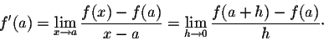

Let us give some examples.

Example 1. Let us start with the function f(x) = x². We have
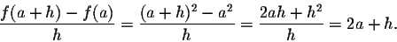

So
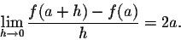

which means f '(a) = 2a.
What about the derivative of f(x) = x^{n}. Similar calculations, using the binomial expansion for (x+y)^{n} (Pascal's Triangle), yield
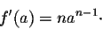

Example 2. Consider the function f(x)=1/x for 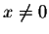. We have
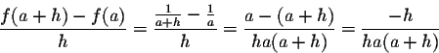

Consequently,
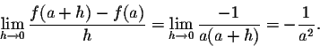

Have you noticed? The algebraic trick in both of the examples above has been to factor out "h" in the numerator, so that we can cancel it with the "h" in the denominator! This is what you try to do whenever you are asked to compute a derivative using the limit definition.

You may believe that every function has a derivative. Unfortunately that is not the case.
Example 3. Let us discuss the derivative of f(x) = |x| at 0. We have
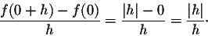

But
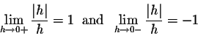

which implies that f '(0) does not exist.
Remark. This example is interesting. Even though the derivative at the point does not exist, the right and the left limit of the ratio do exist. In fact, if we use the slope-interpretation of the derivative we see that this means that the graph has two lines close to it at the point under consideration. They could be seen as "half-tangents". See Picture.
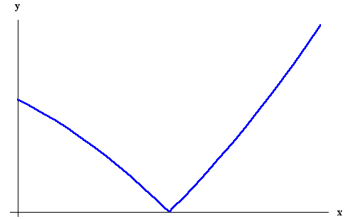

So let's push it a little bit more and ask whether a function always has a tangent or half-tangents at any point. That is not the case either.
Example 4. Let us consider the function 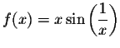for , with f(0) = 0. We have
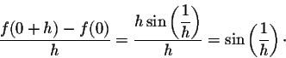

Recall that the function 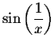has no limit when x goes to 0. So the function has no derivative and no half-derivatives as well at x=0.

What else can go wrong?
Example 5. Consider the function 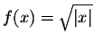. Then we have
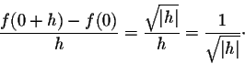

Since
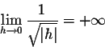

then f '(0) does not exist. But observe that the graph as a geometric figure has a tangent -- albeit vertical:
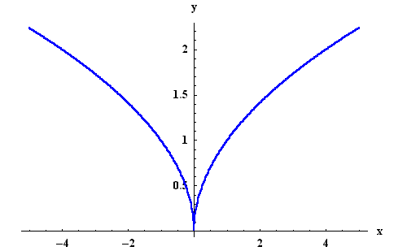
In fact, the way the concept of the tangent line was introduced is based on the notion of slope. You already know that vertical lines do not have slopes. So we say that the derivative does not exist whenever the tangent line is vertical. Nevertheless keep in mind that when the limit giving the derivative is 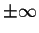then the function has a vertical tangent line at the point.
It can be quite laborious (or impossible) to compute the derivative by hand as we have done so far. In the next pages we will show how techniques of differentiation help bypass the limit calculations and make our life much easier.

Techniques of Differentiation

Maybe the easiest and most useful formulas are the ones that say that the derivative is linear:
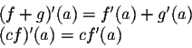

Combined with the formula (x^{n})' = n x^{n-1}, we see that every polynomial function has a derivative at any point.
Example. For P(x) = 1-2x + 3x⁴ -5 x⁶, we have
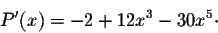

The next two formulas are the most powerful ones. They deal with the derivative of a product and a quotient. They are commonly called the product rule and the quotient rule. We have

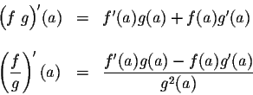

In particular, we have
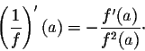

So, we have
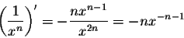

which means that the formula (x^{r})' = r x^{r-1} is also valid for negative exponents.
Before we discuss the derivative of trigonometric functions, let us stop here and reflect a little bit more on polynomial functions. Indeed, we saw that the derivative of a polynomial function is also a polynomial function. So we can take another derivative and generate a new function. This function is called the second derivative. We can keep doing this as long as we want to. The functions obtained are called higher derivatives. The common notations used for them are
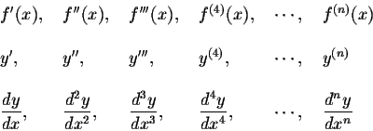

First and Second Order Differential Equations

First Order Differential equations
A first order differential equation is of the form:
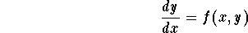

Linear Equations:
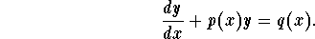
The general general solution is given by
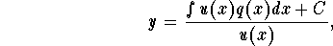
where
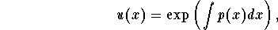
is called the integrating factor.

Separable Equations:
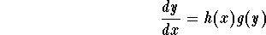
(1)
Solve the equation g(y) = 0 which gives the constant solutions.
(2)
The non-constant solutions are given by
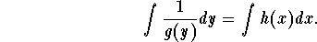

Bernoulli Equations:
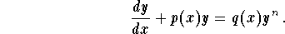
(1)
Consider the new function 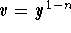.
(2)
The new equation satisfied by v is
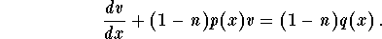
(3)
Solve the new linear equation to find v.
(4)
Back to the old function y through the substitution 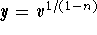.
(5)
If n > 1, add the solution y=0 to the ones you got in (4).

Homogenous Equations:
is homogeneous if the function f(x,y) is homogeneous, that is
By substitution, we consider the new function
The new differential equation satisfied by z is
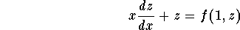
which is a separable equation. The solutions are the constant ones f(1,z) - z =0 and the non-constant ones given by
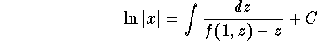
Do not forget to go back to the old function y = xz.

Exact Equations:
is exact if
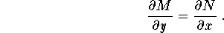
The condition of exactness insures the existence of a function F(x,y) such that
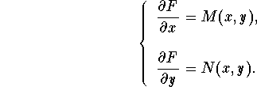
All the solutions are given by the implicit equation

Second Order Differential equations

Homogeneous Linear Equations with constant coefficients:
Write down the characteristic equation
(1)
If and are distinct real numbers (this happens if ), then the general solution is
(2)
If (which happens if ), then the general solution is
(3)
If and are complex numbers (which happens if ), then the general solution is
where
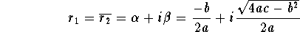
that is
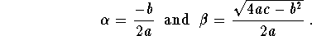

Non Homogeneous Linear Equations:
The general solution is given by
where is a particular solution and 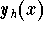is the general solution of the associated homogeneous equation
In order to find two major techniques were developed.

Method of undetermined coefficients or Guessing Method
This method works for the equation
where a, b, and c are constant and
where 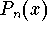is a polynomial function with degree n. In this case, we have
where
The constants and have to be determined. The power s is equal to 0 if is not a root of the characteristic equation. If is a simple root, then s=1 and s=2 if it is a double root.
Remark. If the nonhomogeneous term g(x) satisfies the following
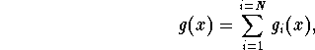
where 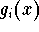are of the forms cited above, then we split the original equation into N equations
then find a particular solution . A particular solution to the original equation is given by
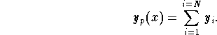

Method of Variation of Parameters
This method works as long as we know two linearly independent solutions of the homogeneous equation
Note that this method works regardless if the coefficients are constant or not. a particular solution as
where and are functions. From this, the method got its name.
The functions and are solutions to the system:
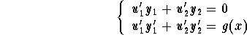
which implies
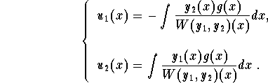
Therefore, we have

Euler-Cauchy Equations:
where b and c are constant numbers. By substitution, set
then the new equation satisfied by y(t) is
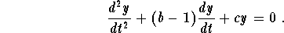
which is a second order differential equation with constant coefficients.
(1)
Write down the characteristic equation
(2)
If the roots and are distinct real numbers, then the general solution is given by
(2)
If the roots and are equal ( ), then the general solution is
(3)
If the roots and are complex numbers, then the general solution is
where 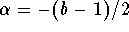and 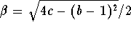.

Some Basic Derivatives

In the table below, u,v, and w are functions of the variable x. a, b, c, and n are constants (with some restrictions whenever they apply). 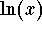designate the natural logarithmic function and e the natural base for . Recall that .
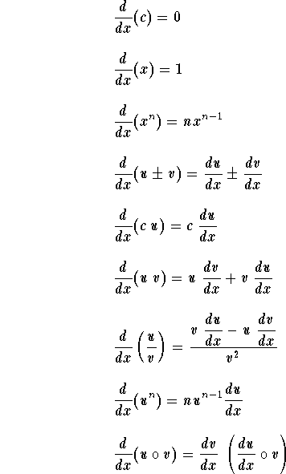
Chain Rule
The last formula
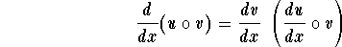
is known as the Chain Rule formula. It may be rewritten as
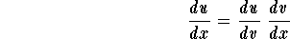
Another similar formula is given by
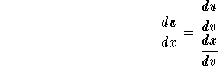

Derivative of the Inverse Function

The inverse of the function y(x) is the function x(y), we have
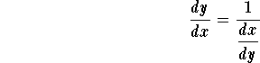

Derivative of Trigonometric Functions and their Inverses
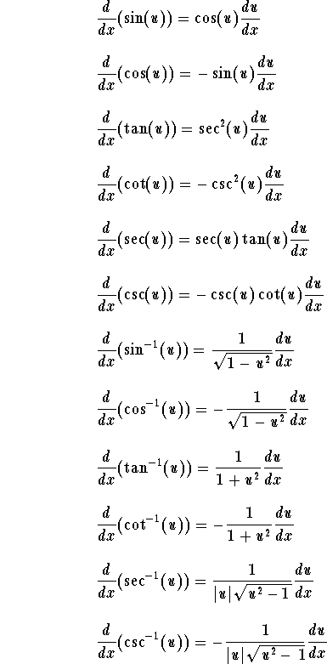
Recall the definitions of the trigonometric functions

Derivative of the Exponential and Logarithmic functions

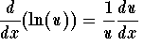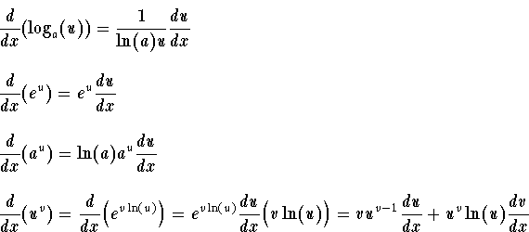
Recall the definition of the logarithm function with base a > 0 (with ):
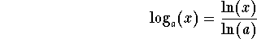

Derivative of the Hyperbolic functions and their Inverses

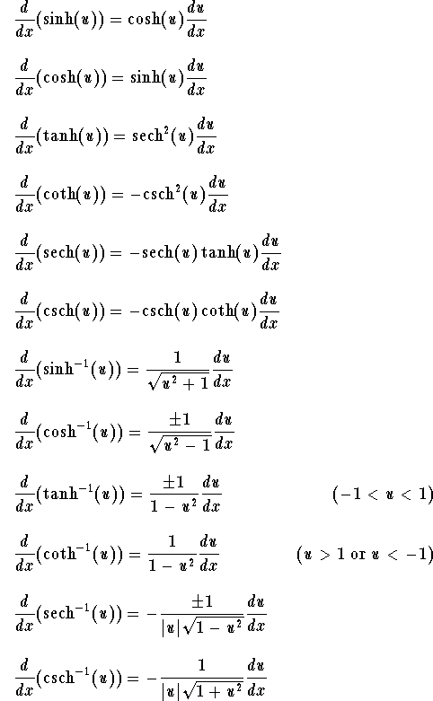
Recall the definitions of the trigonometric functions
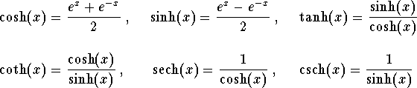

Higher Order Derivatives

Let y = f(x). We have:
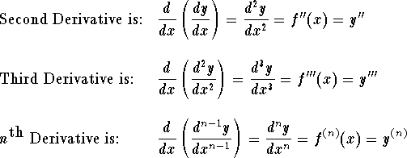
In some books, the following notation for higher derivatives is also used:
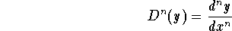

Higher Derivative Formula for the Product: Leibniz Formula

where 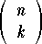are the binomial coefficients. For example, we have
