Integral

The Area Problem and the Definite Integral

Integration is vital to many scientific areas. Many powerful mathematical tools are based on integration. Differential equations for instance are the direct consequence of the development of integration.
So what is integration? Integration stems from two different problems. The more immediate problem is to find the inverse transform of the derivative. This concept is known as finding the antiderivative. The other problem deals with areas and how to find them. The bridge between these two different problems is the Fundamental Theorem of Calculus.
What is the "area problem"? We want to find the area of a given region in the plane. It is not hard to see that this problem can be reduced to finding the area of the region bounded above by the graph of a positive function f (x), bounded below by the x-axis, bounded to the left by the vertical line x = a, and to the right by the vertical line x = b.
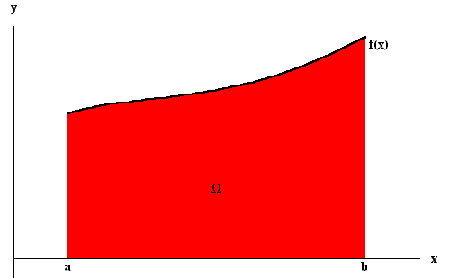
The answer to this problem came through a very nice idea. Indeed, let us split the region into small subregions which we can approximate by rectangles or other simple geometrical figures (whose areas we know how to compute). This is how it goes: split the interval [a, b] into subintervals, preferably with the same width x,
x₀ = a < x₁ < x₂ < ... < x_{n} = b
with x_{i + 1} - x_{i} = x = 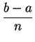, for i = 0, 1, ... , n - 1.
Let be the subregion bounded above by the graph of f (x), bounded below by the x-axis, bounded to the left by x = x_{i - 1}, and to the right by x = x_{i}, for i = 1, ... , n. Clearly we have
Area() = Area() + Area() + ... + Area() .
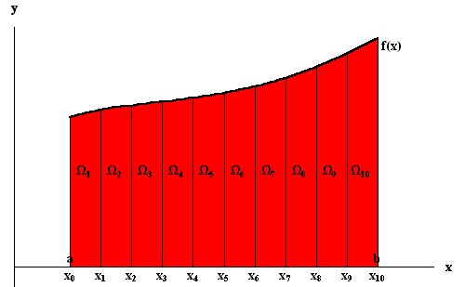
So we focus on the subregions , for i = 1, ... , n. Since we want to approximate the regions by rectangles, then we only have to worry about the upper boundary of each region (since on the other sides we already have straight lines). Again: We are looking for good approximations of the regions by rectangles.
The easiest way to choose a height for our rectangles is to choose the value of the function at the left (or right) end points of the small intervals [x_{i - 1}, x_{i}].
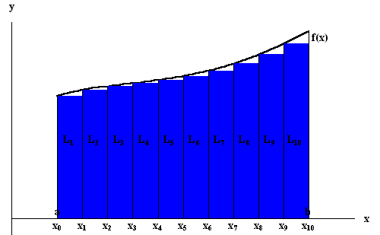

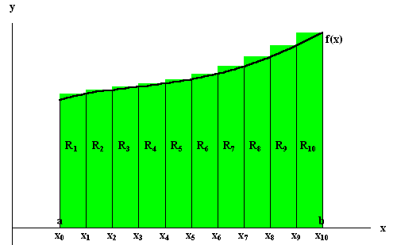
Let L_{i} be the rectangle defined by the left-end point and R_{i} be the rectangle defined by the right-end point. Then an approximation to Area() is given by
Area(L₁) + Area(L₂) + ... + Area(L_{n}) = xf (x₀) + xf (x₁) + ... + xf (x_{n - 1})
which we will call the left-sum denoted LEFT(n), and
Area(R₁) + Area(R₂) + ... + Area(R_{n}) = xf (x₁) + xf (x₂) + ... + xf (x_{n})
which we will call the right-sum denoted RIGHT(n)

Example. Consider the function
f (x) = x²
for x [0, 1]. Let us split the interval into 4 subintervals. We have
x₀ = 0 , x₁ = , x₂ = , x₃ = , x₄ = 1 .
We have x = and
LEFT(4) = 0² + + + =
and
RIGHT(4) = + + + 1² = .
Note that Area() equals , a result which we will prove in later pages.
Indeed if the function f (x) is not too badly behaved, we will show that when n gets larger, the numbers LEFT(n) and RIGHT(n) get closer to Area(), i.e.
Area() = 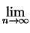LEFT(n) = RIGHT(n) .
This is the main idea described above. The number Area() is called the definite integral (or more simply the integral) of f (x) from a to b and is denoted by
f (x) dx .
Note that in the expression f (x) dx the variable x may be replaced by any other variable.
Example. Let 0. Then we have
dx = (b - a) .
This is true since the region is simply a rectangle.
Example. We have
x dx = (b² - a²) .
Indeed, the region is simply the union of two regions: one rectangle and one triangle.
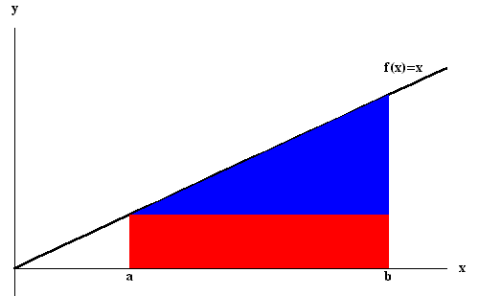
The rectangle (depicted in red) is bounded above by x = a and its area is a(b - a). The triangle (in blue) is determined by the points: (a, a), (a, b), and (b, b). Its area is (b - a)². So we have
xdx = a(b - a) + (b - a)² = (b² - a²) .
A precise definition for the definite integral involves partitions and lower as well as upper sums:
Definition. A partition P of the interval [a, b] is a sequence of numbers {x_{i};i = 0, 1, ... , n} such that
x₀ = a < x₁ < x₂ < ... < x_{n} = b
For a function f (x) defined on [a, b] and a partition P of [a, b], set
m_{i} = inf{f (x); x [x_{i - 1}, x_{i}]} and M_{i} = sup{f (x); x [x_{i - 1}, x_{i}]}
for i = 1, ... , n, provided that f (x) is bounded on [a, b]. The sum
L_{f}(P) = m₁(x₁ - x₀) + m₂(x₂ - x₁) + ... + m_{n}(x_{n} - x_{n - 1})
is called the lower sum for f (x) over the partition P, and
U_{f}(P) = M₁(x₁ - x₀) + M₂(x₂ - x₁) + ... + M_{n}(x_{n} - x_{n - 1})
is called the upper sum for f (x) over the partition P.
Theorem. We have
L_{f}(P) Area() U_{f}(P)
for any partition P of [a, b]. Moreover if f (x) is continuous on [a, b], except maybe at a finite number of points, and I is a number such that
L_{f}(P) I U_{f}(P)
for any partition P of [a, b], then I = Area().
This theorem is fundamental. Let us illustrate this with the following example.
Example. Use the above theorem to show
x²dx = (b³ - a³)
where b a 0. Let P = {x₀, x₁, ... , x_{n}} be a partition of [a, b]. Since f (x) = x² is increasing on [a, b], then m_{i} = x_{i - 1}² and M_{i} = x_{i}². So we have
U_{f}(P) = x²₁(x₁ - x₀) + x²₂(x₂ - x₁) + ... + x²_{n}(x_{n} - x_{n - 1})
and
L_{f}(P) = x²₀(x₁ - x₀) + x²₁(x₂ - x₁) + ... + x²_{n - 1}(x_{n} - x_{n - 1}) .
For each i, we have
x_{i - 1}² x_{i - 1}² + x_{i - 1}x_{i} + x_{i}² x_{i}²
since x_{i - 1} x_{i}. If we multiply by x_{i} - x_{i - 1}, we get
x_{i - 1}²(x_{i} - x_{i - 1}) x_{i - 1}² + x_{i - 1}x_{i} + x_{i}²(x_{i} - x_{i - 1}) x_{i}²(x_{i} - x_{i - 1}) .
But
x_{i - 1}² + x_{i - 1}x_{i} + x_{i}²(x_{i} - x_{i - 1}) = x_{i}³ - x_{i - 1}³
which implies
x_{i - 1}²(x_{i} - x_{i - 1}) (x_{i}³ - x_{i - 1}³) x_{i}²(x_{i} - x_{i - 1}) .
Hence
L_{f}(P) (b³ - a³) U_{f}(P)
since
(x₁³ - x₀³) + (x₂³ - x₁³) + ... + (x_{n}³ - x_{n - 1}³) = b³ - a³ .

Properties of the Definite Integral

The following properties are easy to check:
Theorem. If f (x) and g(x) are defined and continuous on [a, b], except maybe at a finite number of points, then we have the following linearity principle for the integral:
(i)
f (x) + g(x)dx = f (x) dx + g(x) dx;
(ii)
f (x) dx = f (x) dx, for any arbitrary number .
The next results are very useful in many problems.
Theorem. If f (x) is defined and continuous on [a, b], except maybe at a finite number of points, then we have
(i)
f (x) dx = 0;
(ii)
f (x) dx = f (x) dx + f (x) dx;
(iii)
f (x) dx = - f (x) dx;
for any arbitrary numbers a and b, and any c [a, b].
The property (ii) can be easily illustrated by the following picture:
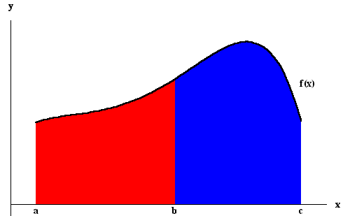
Remark. It is easy to see from the definition of lower and upper sums that if f (x) is positive then f (x) dx 0. This implies the following
If f (x) g(x) for x [a, b] f (x) dx g(x) dx .
Example. We have
(x² - 2x)dx = x² dx - 2x dx .
We have seen previously that
x² dx = and x dx = .
Hence
(x² - 2x)dx = - 2 = - .

More on the Area Problem.

We have seen that the area of the region under the graph of a positive function f (x) on [a, b] is given by the definite integral f (x) dx. The above properties may help extend this result. Indeed, consider the region bounded above by the graph of f (x) and below by the graph of g(x), and bounded on the sides by the vertical lines x = a and x = b, with a b. Of course, we assume that g(x) f (x) for x [a, b]. Then we have
Area() = f (x) - g(x)dx .
Note that here we do not assume both functions are positive since f (x) - g(x) is a positive function.
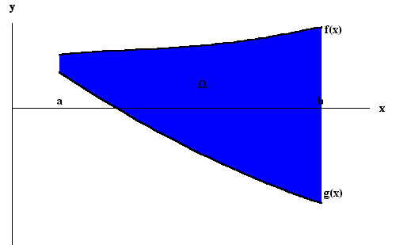
Remark. Sometimes you may be asked to find the area of the region bounded by the graph of two or more functions. The idea is to split the region into subregions of the type described above and then use the formula for the subregions.
Example. Let us find the area of the region bounded by the graphs of
f (x) = x² and g(x) = 8 .
First let us graph these functions.
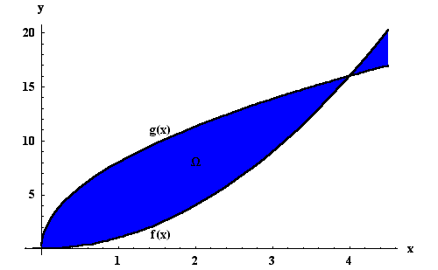
Notice that the region is bounded above by g(x) and below by f (x). To find the boundary points which will give the vertical side lines we need to solve
f (x) = g(x) or x² = 8 .
Easily we get x = 0 and x = 4. So the answer is
Area() = 8 - x²dx .
We have
8 - x²dx = x^{3/2} - x³ = .
Example. Find the area of the region bounded by the three lines
x + y = 2, x - y = - 1, and x + 2y = 2 .
First we graph the three lines to see the region.
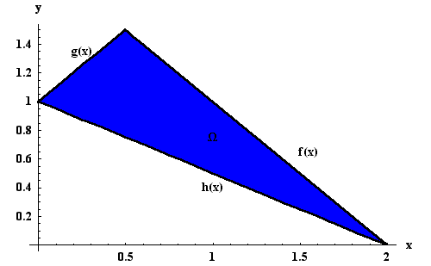
Before we proceed with any integration we need to find the points of intersection of the three lines represented by the functions
f (x) = 2 - x, g(x) = x + 1, and h(x) = - x + 1 .
The three points of intersection are (0,1), (2,0), and (1/2, 3/2).
The region may be subdivided into two regions bounded above by the graph of g(x) and below by h(x) with 0 x , and bounded above by the graph of f (x) and below by h(x) with x 2.

The Fundamental Theorem of Calculus

This theorem bridges the antiderivative concept with the area problem. Indeed, let f (x) be a function defined and continuous on [a, b]. Consider the function
F(x) = f (t)dt
defined on [a, b]. Then we have
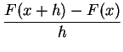= 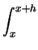f (t)dt .
Since dt = h, we get
- f (x) = f (t) - f (x)dt .
Since F(t) is continuous, we can easily prove that
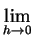- f (x) = 0 .
This means that the function F(x) is differentiable and F '(x) = f (x). In other words, the function F(x) is an antiderivative of f (x). From this and what we learned about antiderivatives, we obtain the following fundamental result:
The Fundamental Theorem of Calculus Let f (x) be continuous on [a, b]. If F(x) is any antiderivative of f (x), then
f (x)dx = F(b) - F(a) .
Remark. The number F(b) - F(a) is also denoted by [F(x)]^{b}_{a} (or F(x) ). So
f (x)dx = [F(x)]^{b}_{a}
Example. We have
cos(t)dt = [sin(t)]₀^{x} = sin(x) - sin(0) = sin(x) .
So
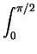cos(t)dt = sin = 1 .
Example. We have
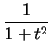dt = [arctan(t)]₀^{x} = arctan(x) .
In particular, we have
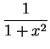dt = arctan(1) = .
Combining the Chain Rule with the Fundamental Theorem of Calculus, we can generate some nice results. Indeed, let f (x) be continuous on [a, b] and u(x) be differentiable on [a, b]. Define the function
F(x) = 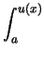f (t)dt .
Then the Chain Rule implies that F(x) is differentiable and
F '(x) = fu(x)u '(x) .
We can generalize this a little bit more to find the derivative of a function of the form
H(x) = 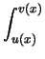f (t)dt
where u(x) and v(x) are both differentiable on [a, b]. We have
H '(x) = fv(x)v '(x) - fu(x)u '(x) .
Example. Find the derivative of
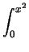cos(t²)dt .
Set
F(x) = cos(t²)dt .
From the Fundamental Theorem of Calculus, we know that F(x) is an antiderivative of cos(x²). We have
cos(t²)dt = F(x²) .
The Chain Rule then implies that
cos(t²)dt = F '(x²)2x = 2x cos(x²)² = 2x cos(x⁴) .
Note that F(x) does not have an explicit form. So it is quite amazing that even if F(x) is defined via some theoretical result, we are still able to find the derivative of the given function.
Example. Find the derivative of
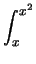e^{-t2}dt .
Set
F(x) = e^{-t2}dt .
From the Fundamental Theorem of Calculus, we know that F(x) is an antiderivative of e^{-x2}. We have
e^{-t2}dt = F(x²) - F(x) .
The Chain Rule implies
e^{-t2}dt = F '(x²)2x - F '(x) = 2xe^{-x4} - e^{x2} .

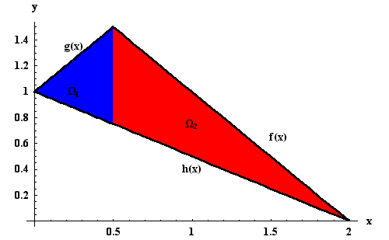
So
Area() = 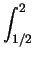g(x) - h(x)dx = x dx = ,
and
Area() = f (x) - h(x)dx = 1 - dx = ,
which implies
Area() = Area() + Area() = + = .

Mean Value Theorems for Integrals

Let f (x) be continuous on [a, b]. Set
F(x) = f (t)dt .
The Fundamental Theorem of Calculus implies F '(x) = f (x). The Mean Value Theorem implies the existence of c (a, b) such that
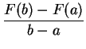= F '(c), or equivalently F(b) - F(a) = F '(c)b - a
which implies
f (t)dt = f (c)b - a .
This is known as the First Mean Value Theorem for Integrals. The point f (c) is called the average value of f (x) on [a, b].
As the name "First Mean Value Theorem" seems to imply, there is also a Second Mean Value Theorem for Integrals:
Second Mean Value Theorem for Integrals. Let f (x) and g(x) be continuous on [a, b]. Assume that g(x) is positive, i.e. g(x) 0 for any x [a, b]. Then there exists c (a, b) such that
f (t)g(t)dt = f (c)g(t)dt .
The number f (c) is called the g(x)-weighted average of f (x) on the interval [a, b].
As an application one may define the Center of Mass of one-dimensional non-homogeneous objects such as a metal rod. If the object is homogeneous and lying on the x-axis from x = a to x = b, then its center of mass is simply the midpoint
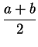 .
If, on the other hand, the object is not homogeneous with (x) being the density function, then the total mass M is
M = (x)dx .
The density-weighted average x_{c} is defined by
x(x)dx = x_{c}(x)dx = x_{c}M,
or equivalently
x_{c} = x(x)dx .
The point x_{c} is the center of mass of the object.
Example. A rod of length L is placed on the x-axis from x = 0 to x = L. Assume that the density (x) of the rod is proportional to the distance from the x = 0 endpoint of the rod. Let us find the total mass M and the center of mass x_{c} of the rod. We have (x) = kx, for some constant k > 0. We have
M = (x)dx = k x dx = k = 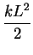
and
x_{c} = x(x)dx = kx²dx = k = L .
If the rod was homogeneous, then the center of mass would be at the midpoint of the rod. Now it is closer to the endpoint x = L. This is not surprising since there is more mass at this end.

Common Integrals
1.
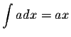
2.
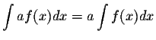
3.
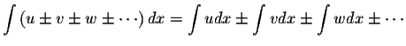
4.
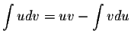
5.
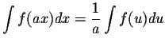
6.
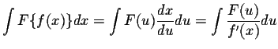
7.
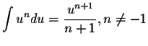
8.
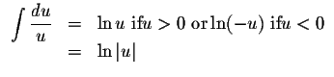
9.
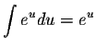
10.
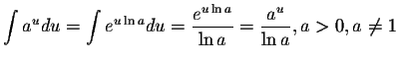
11.
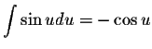
12.
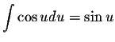
13.
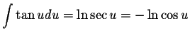
14.
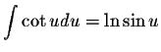
15.
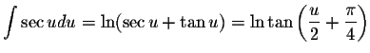
16.
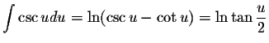
17.
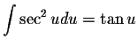
18.
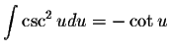
19.
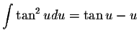
20.
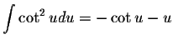
21.
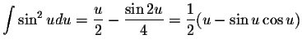
22.
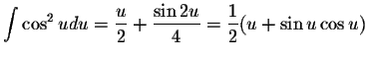
23.
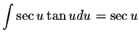
24.
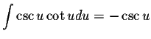
25.
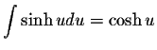
26.
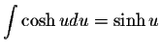
27.
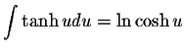
28.
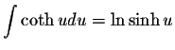
29.
sech 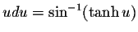or
30.
csch 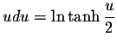or 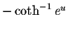
31.
sech
32.
csch ² u du =-coth u
33.
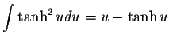
34.
coth ² u du = u -coth u
35.
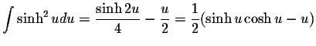
36.
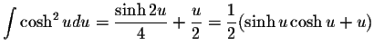
37.
sech 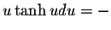sech u
38.
csch ucoth u du = -csch u
39.
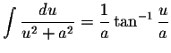
40.
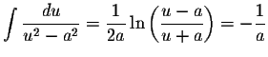coth 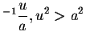
41.
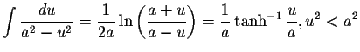
42.
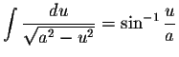
43.
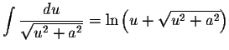or 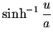
44.
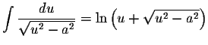
45.
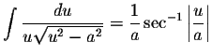
46.
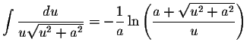
47.
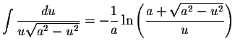
48.
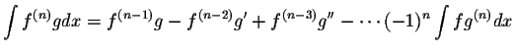

COMMON SUBSTITUTIONS
1.
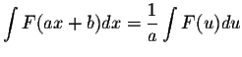
where 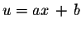
2.
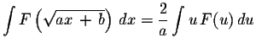
where 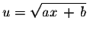
3.
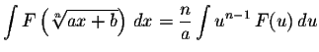
where 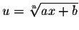
4.
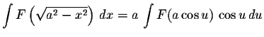
where
5.
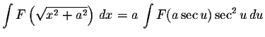
where
6.
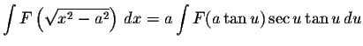
where
7.
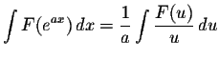
where
8.
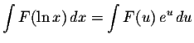
where
9.
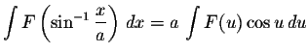
where 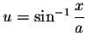

DEFINITE INTEGRALS THAT CONTAIN TRIGONOMETRIC FUNCTIONS
Note that all the constant are positive.
1.
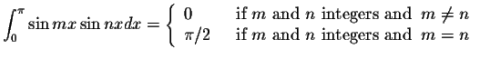
2.
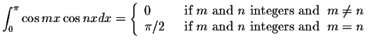
3.
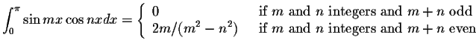
4.
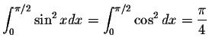
5.
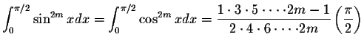,
m=1,2,...
6.
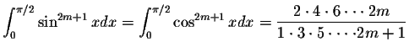,
m=1,2,...
7.
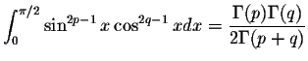
8.
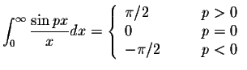
9.
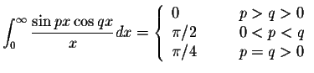
10.
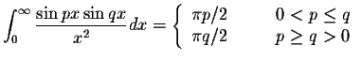
11.
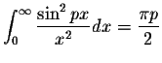
12.
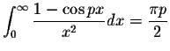
13.
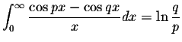
14.
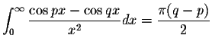
15.
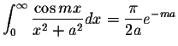
16.
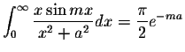
17.
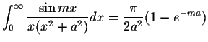
18.
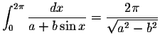
19.
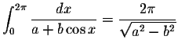
20.
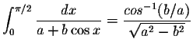
21.
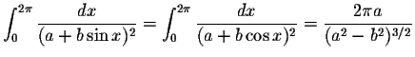
22.
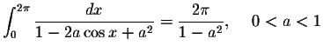
23.
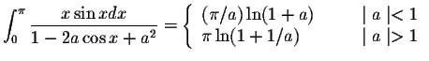
24.
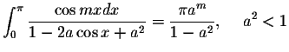,
m=0,1,2,...
25.
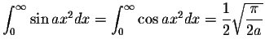
26.
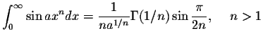
27.
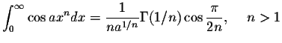
28.
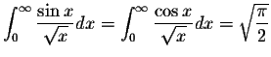
29.
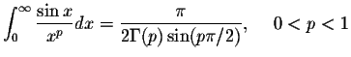
30.
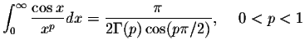
31.
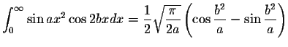
32.
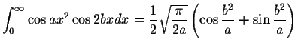
33.
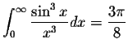
34.
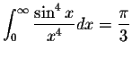
35.
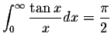
36.
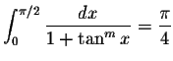
37.
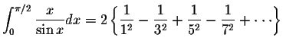
38.
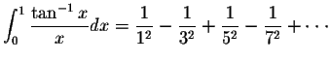
39.
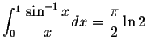
40.
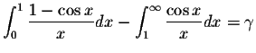
where the constant is the Euler's constant.
41.
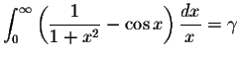
where the constant is the Euler's constant.
42.
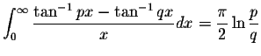

Euler's constant
