

**iMMe**

**Individual Report**

**Li Xingxuan**

**1002189**

**What do I do**

1. Explore Django:
   1. At the beginning of the project, we decided to explore different server frameworks and chose the best framework.
   2. Django framework is a very convenient server framework. However, it requires us to have our own server host, or find a third part server host.
   3. Compared with google app engine, if we use Django framework, it will take much more time to deal with the server issue. Google app engine has already set up all the stuff.
   4. At last, we choose google app engine as our server host.
2. Explore OCR
   1. Since we are doing the KYC project, during the authentication part, it requires users to upload their identical information from passport, IC, or other documentations. OCR would be a fancy feature which can make it easier for users to enter the needed information.
   2. During the exploration, I did find several ways to implement OCR. However, due to the limited budget, we cannot afford the cost of OCR, we eventually give up the feature.
3. User to user use case front-end
   1. These features are eventually used in the final app.
   2. User to user mode provides a platform for two strangers to identify with each other.
   3. The sender takes a selfie and the receiver’s NRIC and send to the server. The server will verify the selfie and if succeed, server will send back an OTP. The sender passes the OTP to the receiver via NFC. After receiver has the OTP, he will send this OTP and his selfie to the server. After server successfully verify the selfie and OTP, it will send back true.
   4. I implement the front-end feature which includes app UI and other necessary functions, including Http handler, Camera instance and so on.
4. User to device use case front-end
   1. In this feature, I also implement all the front-end features except NFC.
   2. I designed the UI and other necessary functions.
   3. To test this mode, I also develop an app to simulate devices.
   4. This feature also need to allow verified user to add device to firebase. And I also implement this function.

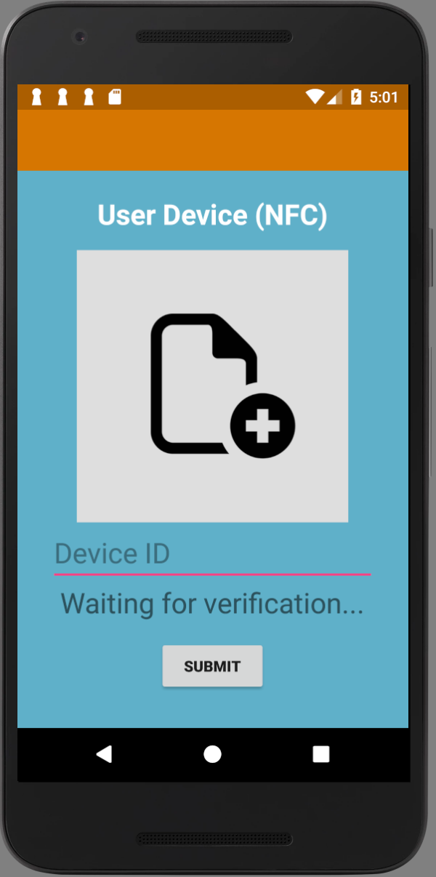 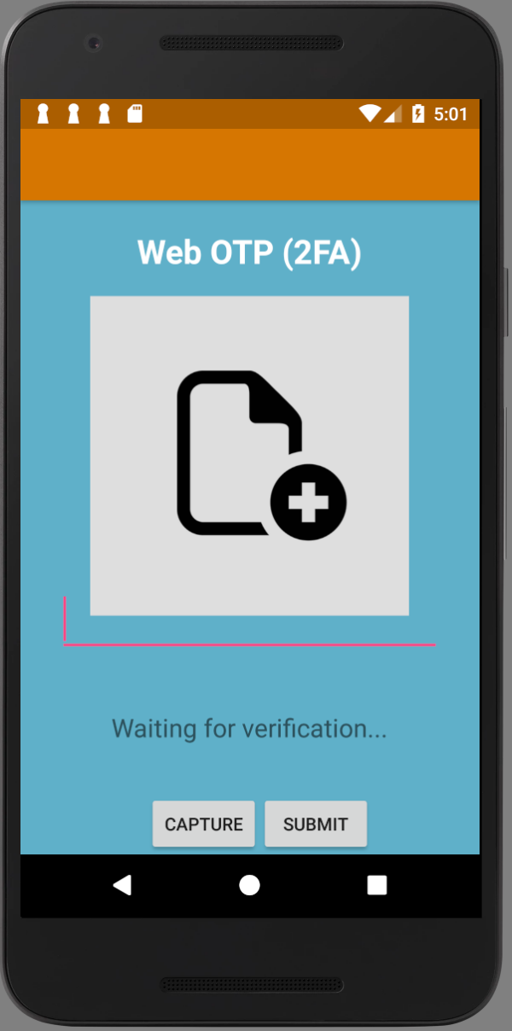

1. User to web use case front-end
   1. In this feature, user is required to submit a selfie and web ID to server.
   2. It basically has the same functions which are required to be implemented as the last use case. It also includes UI design and other functions, including Http handler and Camera instance.
2. Upload photos front-end
   1. The app need to allow verified user to upload their selfies to the server so that the server can do the facial recognition.
   2. I implement these functions.

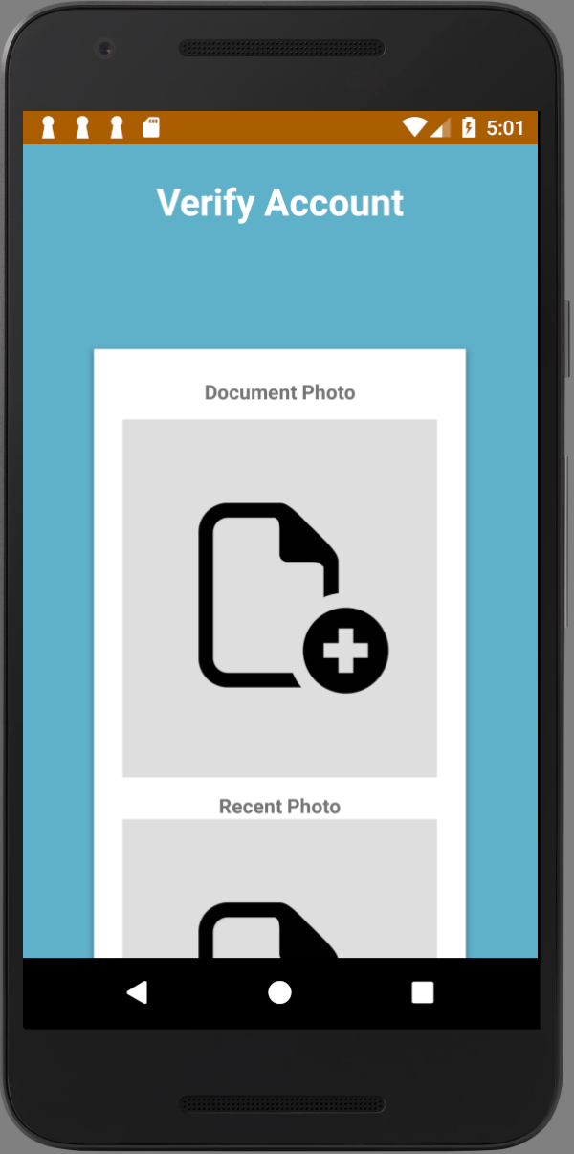 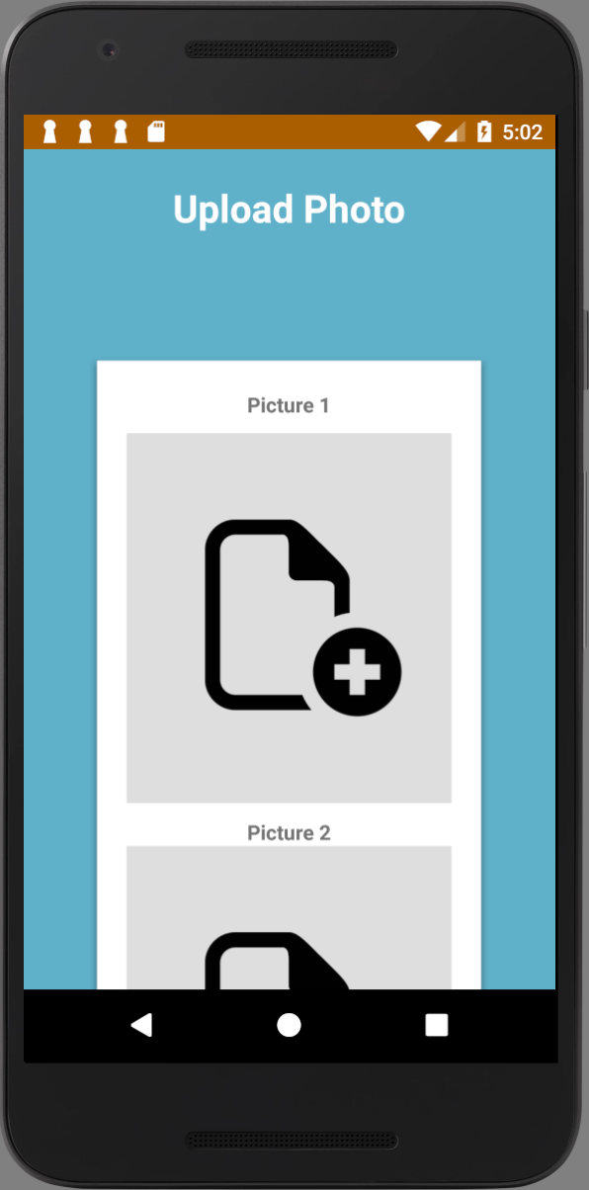

1. Account verification front-end
   1. Verification part is the basic part of the whole process. Without verification, the user is not allowed use any mode of the app.
   2. In this part, I implemented UI and OCR.
2. Design the logic and draw sequence diagrams
   1. Tian Lerk and I designed the whole logic of the system of our app, including all the three modes and the verification logic.
   2. I draw the sequence diagrams for the final report.

**What do I learn from all the problems I encountered**

1. The most troublesome problem I encountered during the whole project is how to send Json packet to server and receive and parse response Json packet. The issue was about the image. Since Json only takes in image as a string. I need to convert the image to Bitmap and then to string by using Base64 encoding. Base64 encoding has several modes and the default mode was different from the server side. What I learnt from this is that it is always better to set the encoding and decoding mode both in front-end and back-end.
2. The second most troublesome problem was the NFC part. It was finally fixed by Jingjin. From the implementation of NFC, I figured out how phones process NFC request and response.
3. There are other minor problems that I encountered when I was doing the project.

**Peer evaluation**

**Hoong Tian Lerk:**

Tian Lerk is a good leader and a good teammate. He was doing all the back-end coding. Also, he helped design the logic of our system.

**Soong Cun Yuan:**

Cun Yuan is a good teammate. He was doing the account verification part. He put OCR in the verification and implement dlib in this part.

**Jiang Jinjing:**

Jinjing is a good teammate. She helped with the front-end coding. She also implemented NFC into our app.