**Exercise 1:**

1. 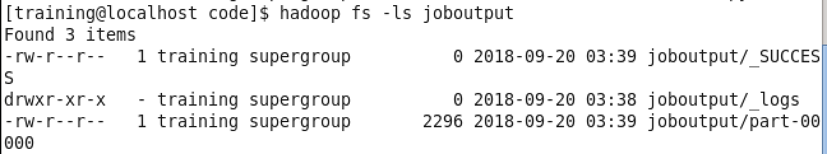
2. 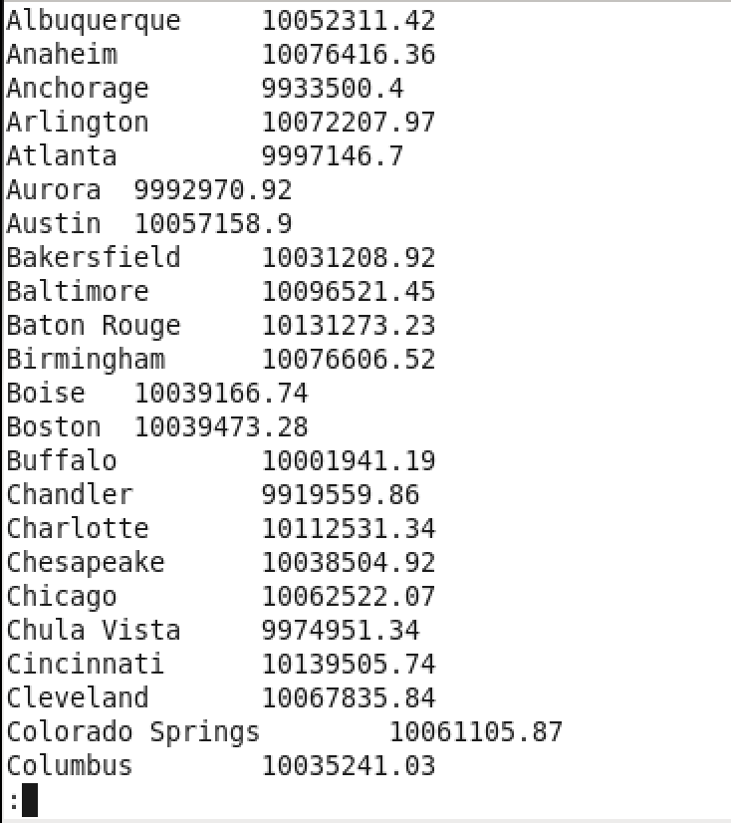
3. 
4. 

**Exercise 2:**

1. 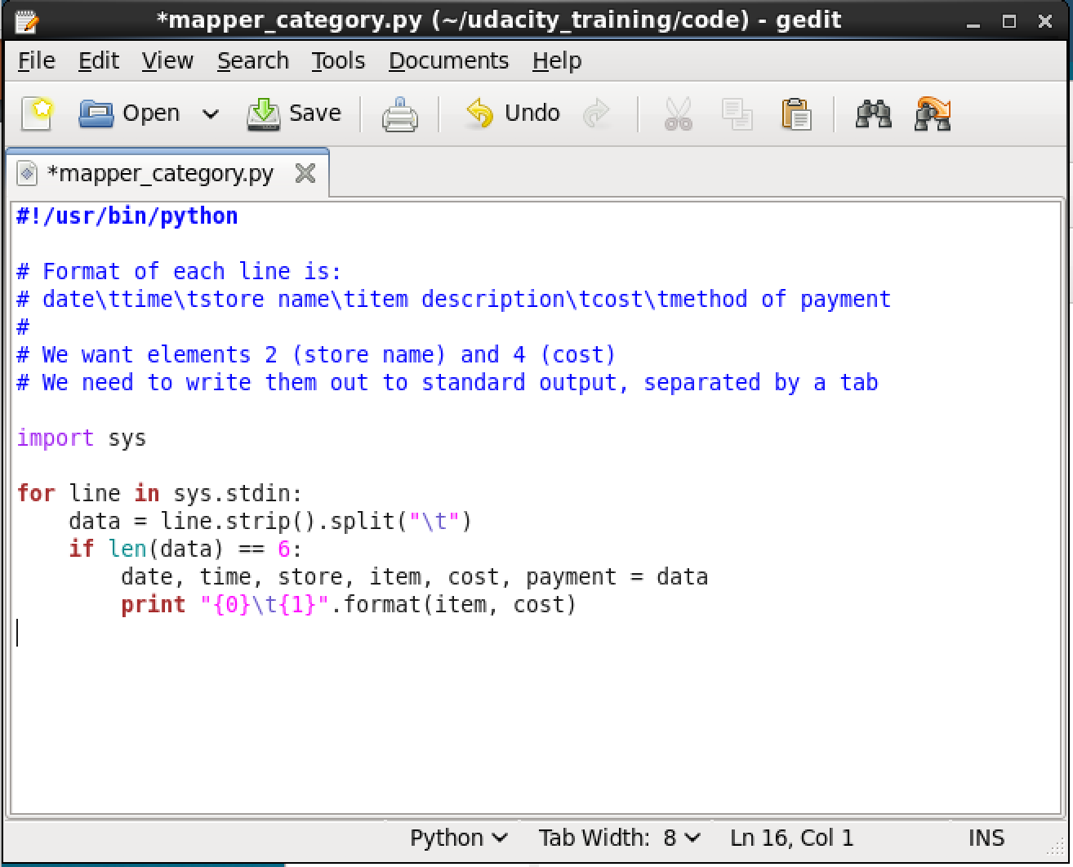
2. 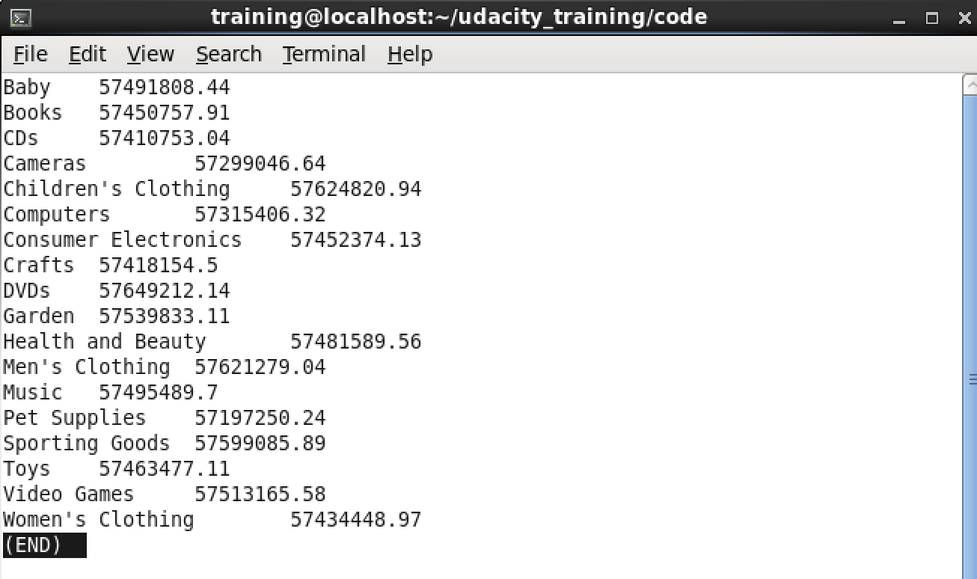

Exercise 3:

1. 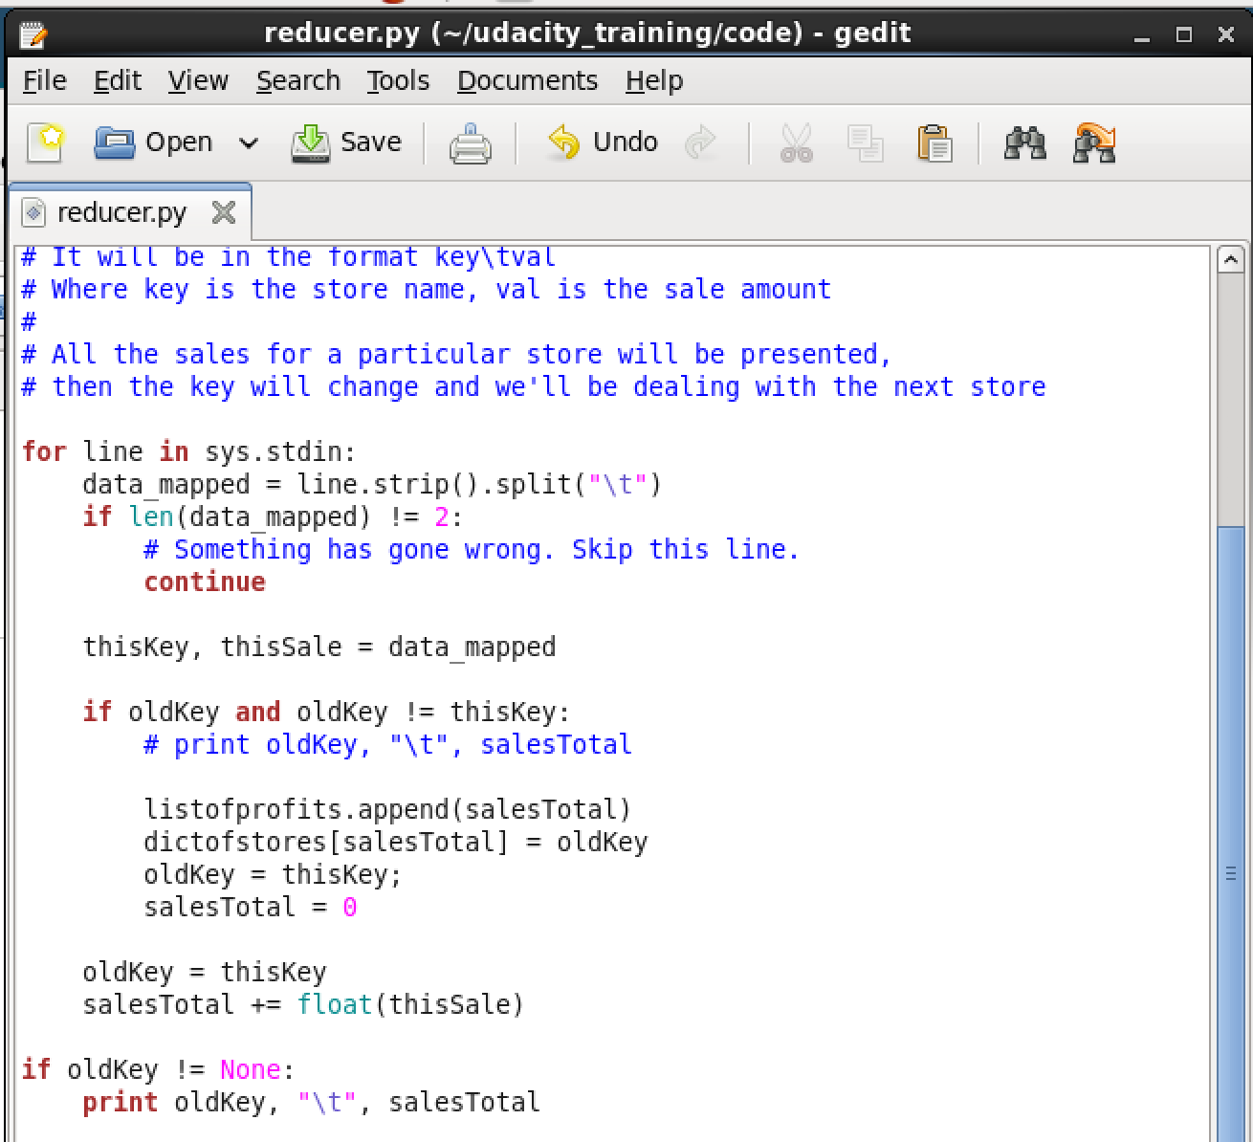
2. 

Exercise 4: