**Artificial Intelligence Fine Tune Report**

Li Xingxuan 1002189

1. Loss: cross entropy loss
2. Network A (Resnet18 without loading weights):
   1. 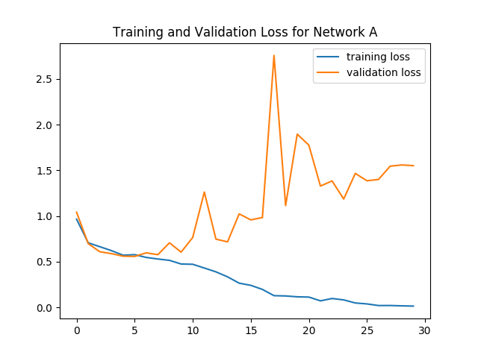
   2. 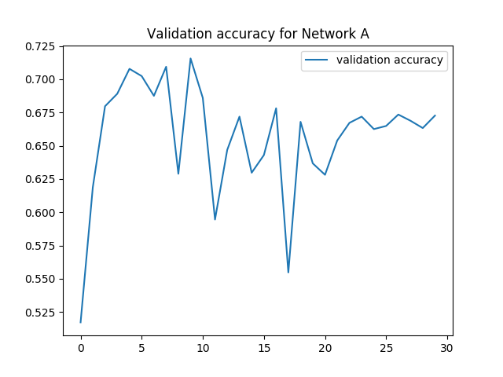
   3. Best epoch: 10
   4. Testing loss: 1.442
   5. Testing accuracy: 70%
3. Network B (Resnet18 with loading model weights before training):
   1. 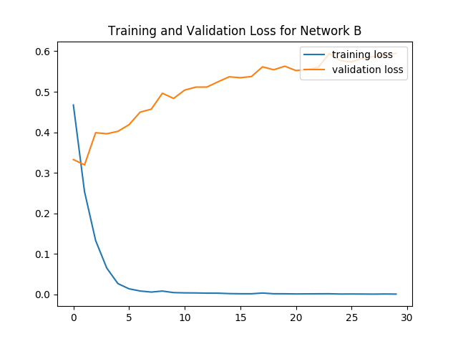
   2. 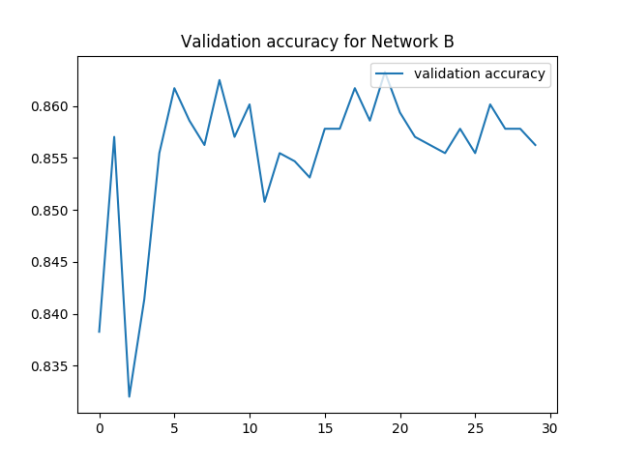
   3. Best epoch: 20
   4. Testing loss: 0.51203
   5. Testing accuracy: 86.6375%
4. Network C (Resnet18 with loading model and train last two layers):
   1. 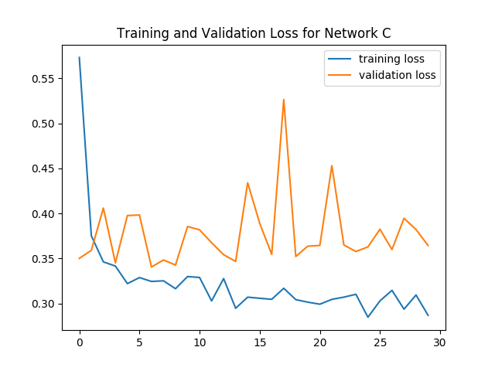
   2. 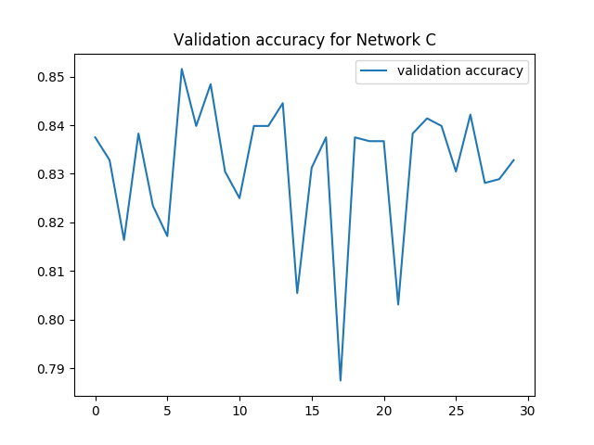
   3. Best epoch: 7
   4. Testing loss: 0.3054
   5. Testing accuracy: 86.4875%
5. Differences between the validation and the test accuracy of these models: The first network do not have stable validation loss nor training loss, thus testing accuracy is not as good as validation or training accuracy. The second network increases its accuracy stably. Also, the second network has a better testing accuracy than the third one.