**Artificial Intelligence**

**Li Xingxuan 1002189**

Image 1:

VGG16, LRP:

VGG16, LRP, Heat Map:

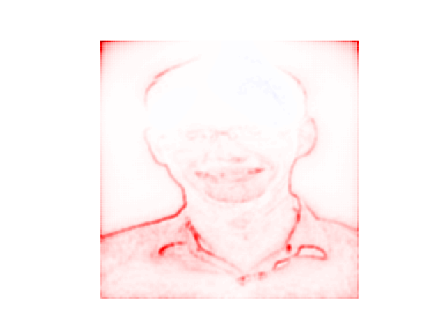

VGG16, Gradient:

VGG16, Gradient, Heat Map:

VGG16, Guided backprop:

VGG16, Guided backprop, Heat Map:

Dense121, LRP:

Dense121, LRP, Heat Map:

Dense121, Gradient:

Dense121, Gradient, Heat Map:

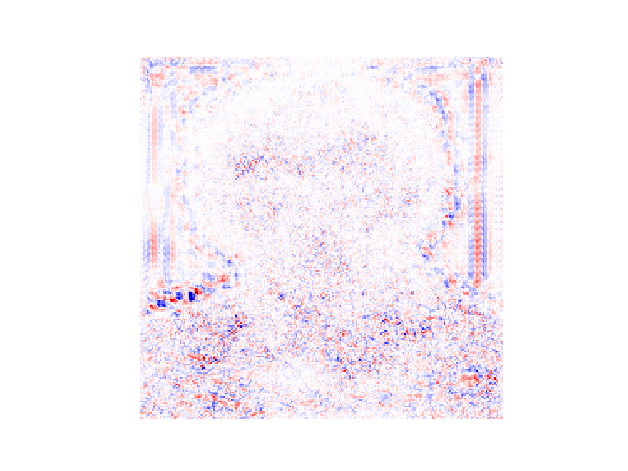

Dense121, Guided backprop:

Dense121, Guided backprop, Heat Map:

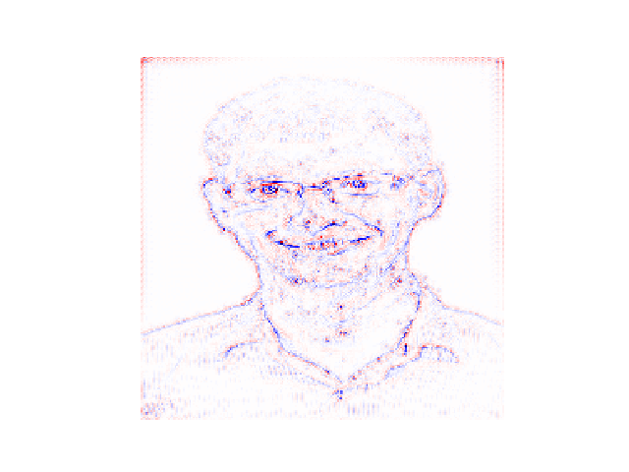

Image 2:

VGG16, LRP:

VGG16, LRP, Heat Map:

VGG16, Gradient:

VGG16, Gradient, Heat Map:

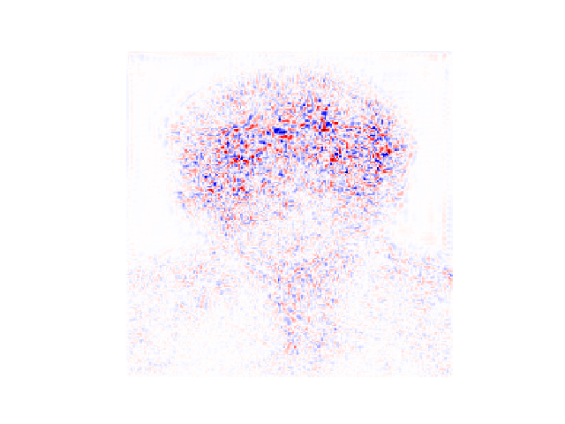

VGG16, Guided backprop:

VGG16, Guided backprop, Heat Map:

Dense121, LRP:

Dense121, LRP, Heat Map:

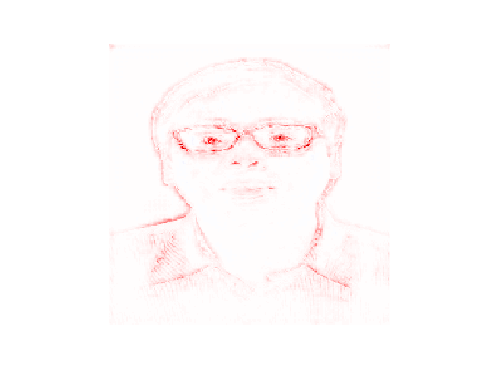

Dense121, Gradient:

Dense121, Gradient, Heat Map:

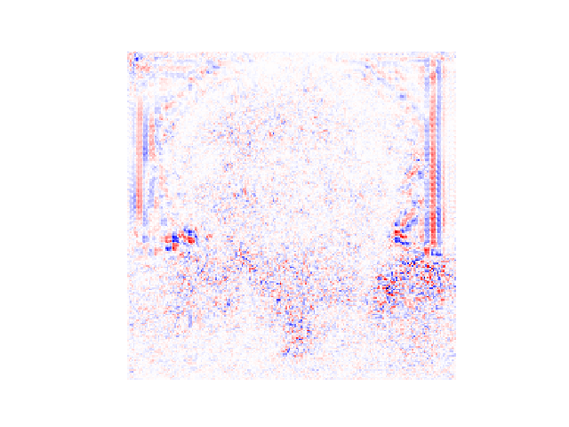

Dense121, Guided backprop:

Dense121, Guided backprop, Heat Map:

