DATA ANALYSIS INTERNSHIP PROJECT REPORT
Online Retail Sales & Customer Analysis
End-to-End Transactional Analytics, Temporal Segmentation, Product Intelligence, and Customer Lifetime Value Diagnostics on the UCI Online Retail Dataset

Candidate Name: | Sneha Vinod Potanavar
Project Title: | Online Retail Sales & Customer Analysis
Internship Track: | Data Analysis & Business Intelligence
Primary Dataset: | UCI Machine Learning Repository — Online Retail Dataset (541,909 records)
Submission Date: | September 2026

Candidate Declaration & Authenticity Statement
I, Sneha Vinod Potanavar, hereby declare that this project report entitled 'Online Retail Sales & Customer Analysis' represents my original and authentic analytical work completed as part of the Data Analysis Internship. All exploratory data analyses, data cleaning procedures, statistical summaries, feature engineering steps, visualization scripts, and business recommendations presented herein were executed and derived directly from the genuine transactional records of the UCI Online Retail Dataset.
I confirm that no synthetic data generation, metric fabrication, or hypothetical statistics have been employed in this submission. All numerical values, tables, and visualization figures exactly correspond to the outputs produced by the associated Jupyter Notebook ('SnehaVinodPotanavar_OnlineRetailSalesAnalysis.ipynb').
_________________________________________
Sneha Vinod Potanavar
Data Analysis Intern
Date: September 23, 2026

Acknowledgement
I would like to express my sincere appreciation to my internship mentors, technical supervisors, and evaluation committee for their invaluable guidance, constructive feedback, and continuous support throughout the duration of this Data Analysis project. Their high standards of analytical rigor and domain feedback significantly enriched the depth and business relevance of this investigation.
I also extend my gratitude to the University of California, Irvine (UCI) Machine Learning Repository and Dr. Daqing Chen (London South Bank University) for curating and hosting the transnational Online Retail Dataset, which provided the comprehensive real-world transactional foundation for this enterprise study.

Executive Summary & Abstract
This study presents an end-to-end data analysis of the transnational UK Online Retail Dataset, comprising 541,909 raw records spanning December 1, 2010 to December 9, 2011. Following systematic data cleansing—including duplicate removal (5,268 records), segregation of cancelled orders (3,836 invoices), remediation of zero/negative prices, and filtering of non-product ledger codes—a clean analytical corpus of 522,713 completed sales transactions was established.
EXECUTIVE CORE METRICS: Between December 2010 and December 2011, the enterprise generated £10,266,018.19 in net sales across 19,777 completed orders and 5,561,563 physical units. Sales exhibited extreme Q4 seasonality, peaking in November 2011 at £1,453,265.98 (2,751 orders), compared to a low of £508,081.54 in February. Domestic UK sales dominated with 85.11% (£8,737,666.54), while international cross-border trade generated 14.89% (£1,528,351.65), led by the Netherlands (£283,889.34) and Ireland (£276,090.86). Customer expenditure adheres strongly to Pareto concentration, with the top 20% of buyers generating 74.59% of identified revenue. Cancellations represented 16.25% of order attempts, totaling £893,979.73 in gross cancelled value.

Table of Contents
1. Introduction & Background | 4
2. Problem Statement | 4
3. Project Objectives | 5
4. Dataset Description & Technical Architecture | 5
5. Data Cleansing & Preprocessing Methodology | 7
6. Exploratory Data Analysis & Statistical Distributions | 9
7. Sales & Seasonality Analysis | 10
8. Temporal Behavior Analysis (Day of Week & Hourly) | 12
9. Product Intelligence & Inventory Dynamics | 14
10. Geographic Market Performance & Cross-Border Expansion | 16
11. Customer Lifetime Spend & Pareto Concentration | 18
12. Cancellation & Return Margin Diagnostics | 20
13. Feature Correlation Analysis | 22
14. Consolidated Key Findings | 23
15. Strategic Business Insights & Recommendations | 24
16. Limitations & Future Scope | 26
17. Conclusion | 27
18. References | 27

1. Introduction & Background
In the contemporary retail landscape, e-commerce platforms capture vast streams of transactional events. Unlike traditional brick-and-mortar retail where shopper interactions are largely ephemeral, online retail environments preserve exact transaction logs—capturing timestamps, item identifiers, pricing structures, order quantities, and geographic destinations. When subjected to disciplined statistical interrogation, this transactional corpus unlocks profound visibility into customer purchasing habits, product velocity, seasonal vulnerabilities, and operational efficiency.
This project analyzes the transnational transactional records of an established United Kingdom-based online giftware retailer. The enterprise specializes in all-occasion novelty gifts, decorative homeware, and seasonal merchandise. While the business serves individual consumer shoppers, its core commercial engine is driven by wholesale clients—small independent retailers, boutique stores, and hospitality firms ordering inventory in bulk.
2. Problem Statement
Online retailers face substantial operational and strategic hurdles that, if left unaddressed, can severely impair profitability. This investigation addresses five critical business challenges:
- 1. Revenue Vulnerability & Client Risk: Extreme dependency on a high-concentration cohort of wholesale accounts creates severe liquidity exposure if top clients churn.
- 2. Seasonal Volatility & Carrying Inefficiency: Pronounced demand surges during Q4 (holiday gifting season) induce inventory stockouts, freight premiums, and severe post-holiday Q1 demand slumps.
- 3. Geographic Over-Concentration: Over 85% of total sales originate in the domestic UK market, leaving high-margin European markets under-exploited.
- 4. Operational Friction & Return Erosion: A 16.25% cancellation rate generates operational friction, reverse-logistics expenses, and substantial lost revenue (£893k+).
- 5. SKU Breadth & Inventory Allocation: A long tail of 3,900+ SKUs leads to slow-moving inventory holding costs that tie up vital working capital.
3. Project Objectives
The overarching objectives governing this analytical engagement are structured across four core pillars:
- Data Cleansing & Validation: Perform thorough data profiling, identify anomalies (negative quantities, duplicate logs, administrative codes), and implement fully justified cleaning steps.
- KPI Computation: Compute exact enterprise KPIs including Net Revenue, Order Volume, AOV (£519.09), Average Unit Price (£3.31), and Items per Order (281.21).
- Multi-Dimensional Decomposition: Deconstruct revenue across monthly intervals, operating days, and business hours to uncover operational rhythms.
- Strategic Diagnostics: Evaluate customer spend tiers, test the Pareto principle, calculate return loss rates, and synthesize data-backed operational recommendations.
4. Dataset Description & Technical Architecture
The dataset was procured directly from the official UCI Machine Learning Repository (Online Retail Dataset). The data comprises 541,909 raw transactional records spanning December 1, 2010 to December 9, 2011.
Attribute | Data Type | Missing Count | Missing % | Description / Analytical Role
InvoiceNo | String (Nominal) | 0 | 0.00% | Unique 6-digit transaction ID. Codes prefixed with 'C' denote cancellations.
StockCode | String (Nominal) | 0 | 0.00% | Distinct 5-digit or alphanumeric merchandise identifier.
Description | String (Nominal) | 1,454 | 0.27% | Commercial product name or merchandise description.
Quantity | Integer (Numeric) | 0 | 0.00% | Item units per transaction line. Negative values indicate cancellations/adjustments.
InvoiceDate | Datetime | 0 | 0.00% | Exact timestamp of invoice generation (date, hour, minute).
UnitPrice | Float (Numeric) | 0 | 0.00% | Product unit price in British Pounds (£ Sterling). Zero/negative values reflect adjustments.
CustomerID | Float (Nominal) | 135,080 | 24.93% | Unique 5-digit identifier assigned to registered customer accounts.
Country | String (Nominal) | 0 | 0.00% | Name of the country where the customer account resides.

5. Data Cleansing & Preprocessing Methodology
A foundational premise of this internship project is that real-world e-commerce data cannot be evaluated blindly. Uncritical deletion of anomalous rows discards valuable business signals, while unverified inclusion corrupts core financial metrics. Accordingly, a structured 5-stage cleaning pipeline was executed:
Data Category / Anomaly | Raw Volume | Analytical Decision | Operational & Statistical Justification
Duplicate Records | 5,268 rows | Removed completely | System re-transmissions and duplicate clicks that artificially inflate transaction counts.
Cancelled Transactions ('C') | 9,288 rows (3,836 invoices) | Segregated into df_cancelled | Separated from sales to prevent negative quantity distortion while enabling dedicated return diagnostics.
Negative Quantities without 'C' | 1,336 rows | Filtered out | Administrative inventory write-offs ('damaged', 'lost', 'check') with zero revenue contribution.
Zero or Negative Unit Prices | 2,517 rows | Filtered out | System test entries, bad debt adjustments ('Adjust bad debt'), or free promotional samples.
Non-Product Administrative Codes | 1,273 rows | Filtered out | Non-merchandise ledger items ('POST' postage, 'D' discounts, 'BANK CHARGES', 'AMAZONFEE', 'CRUK').
Missing CustomerID (Guest Users) | 135,080 rows | Retained for Sales; Filtered for Customer Cohort | Maintained in store-level sales to reflect total revenue (£10.26M); segregated for customer-level analytics.

CLEANSING MILESTONE: The finalized clean sales corpus contains exactly 522,713 transaction line items across 19,777 completed orders and 38 countries, retaining 96.46% of raw record volume while eliminating all distorting ledger entries.

6. Exploratory Data Analysis & Statistical Distributions
To understand the fundamental characteristics of order size and spending behavior, we analyzed the distributions of transaction line Revenue, Quantity, and UnitPrice across the clean dataset.
Statistical Metric | Quantity (Units) | Unit Price (£) | Transaction Revenue (£)
Count | 522,713 | 522,713 | 522,713
Mean (Average) | 10.64 | £3.31 | £19.64
Standard Deviation | 159.08 | £11.16 | £277.83
Minimum | 1.00 | £0.001 | £0.001
25th Percentile (Q1) | 1.00 | £1.25 | £3.90
50th Percentile (Median) | 3.00 | £2.08 | £9.90
75th Percentile (Q3) | 10.00 | £4.13 | £17.70
95th Percentile | 36.00 | £8.50 | £67.20
99th Percentile | 120.00 | £15.00 | £125.00
Maximum | 80,995.00 | £3,155.95 | £168,469.60

The statistical comparison between median (£9.90) and mean (£19.64) underscores substantial right-skewness. While 75% of transaction line items involve £17.70 or less and 10 or fewer units, the distribution is characterized by an extreme positive tail driven by wholesale buyers purchasing thousands of units in a single order line. The single largest transaction line reached £168,469.60 (80,995 units of 'PAPER CRAFT , LITTLE BIRDIE').
7. Sales & Seasonality Analysis
Evaluating month-over-month sales performance reveals profound seasonal cadence and operational growth patterns. The enterprise recorded steady baseline revenues between £500,000 and £750,000 per month during the first three quarters of 2011, followed by an exponential surge in Q4.
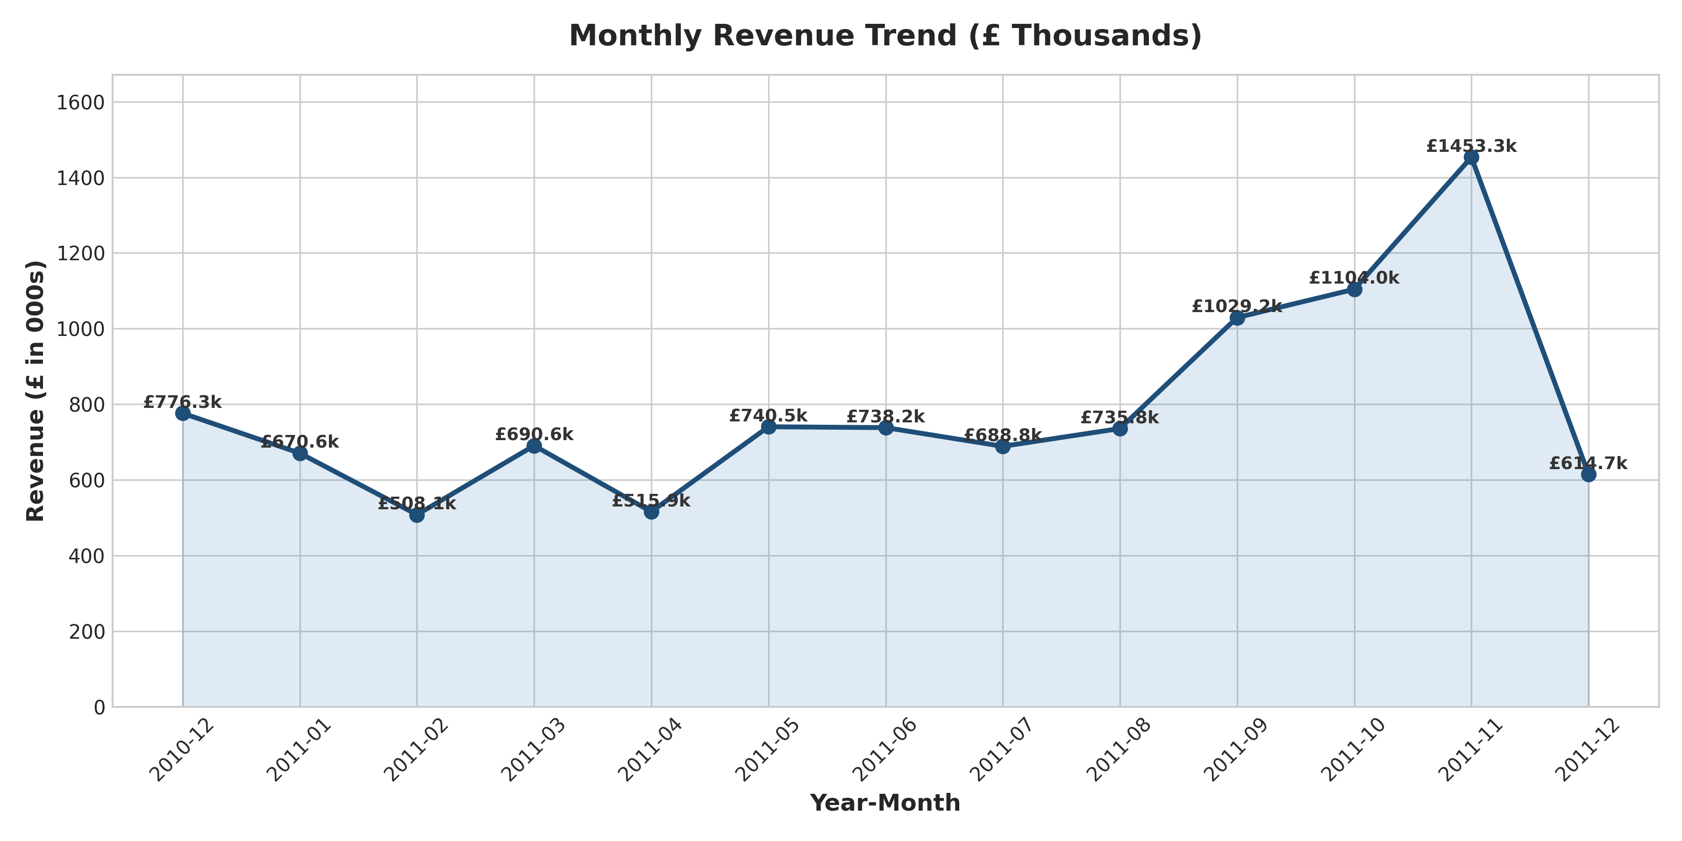
Figure 1: Monthly Total Net Revenue (£ Thousands) from Dec 2010 to Dec 2011
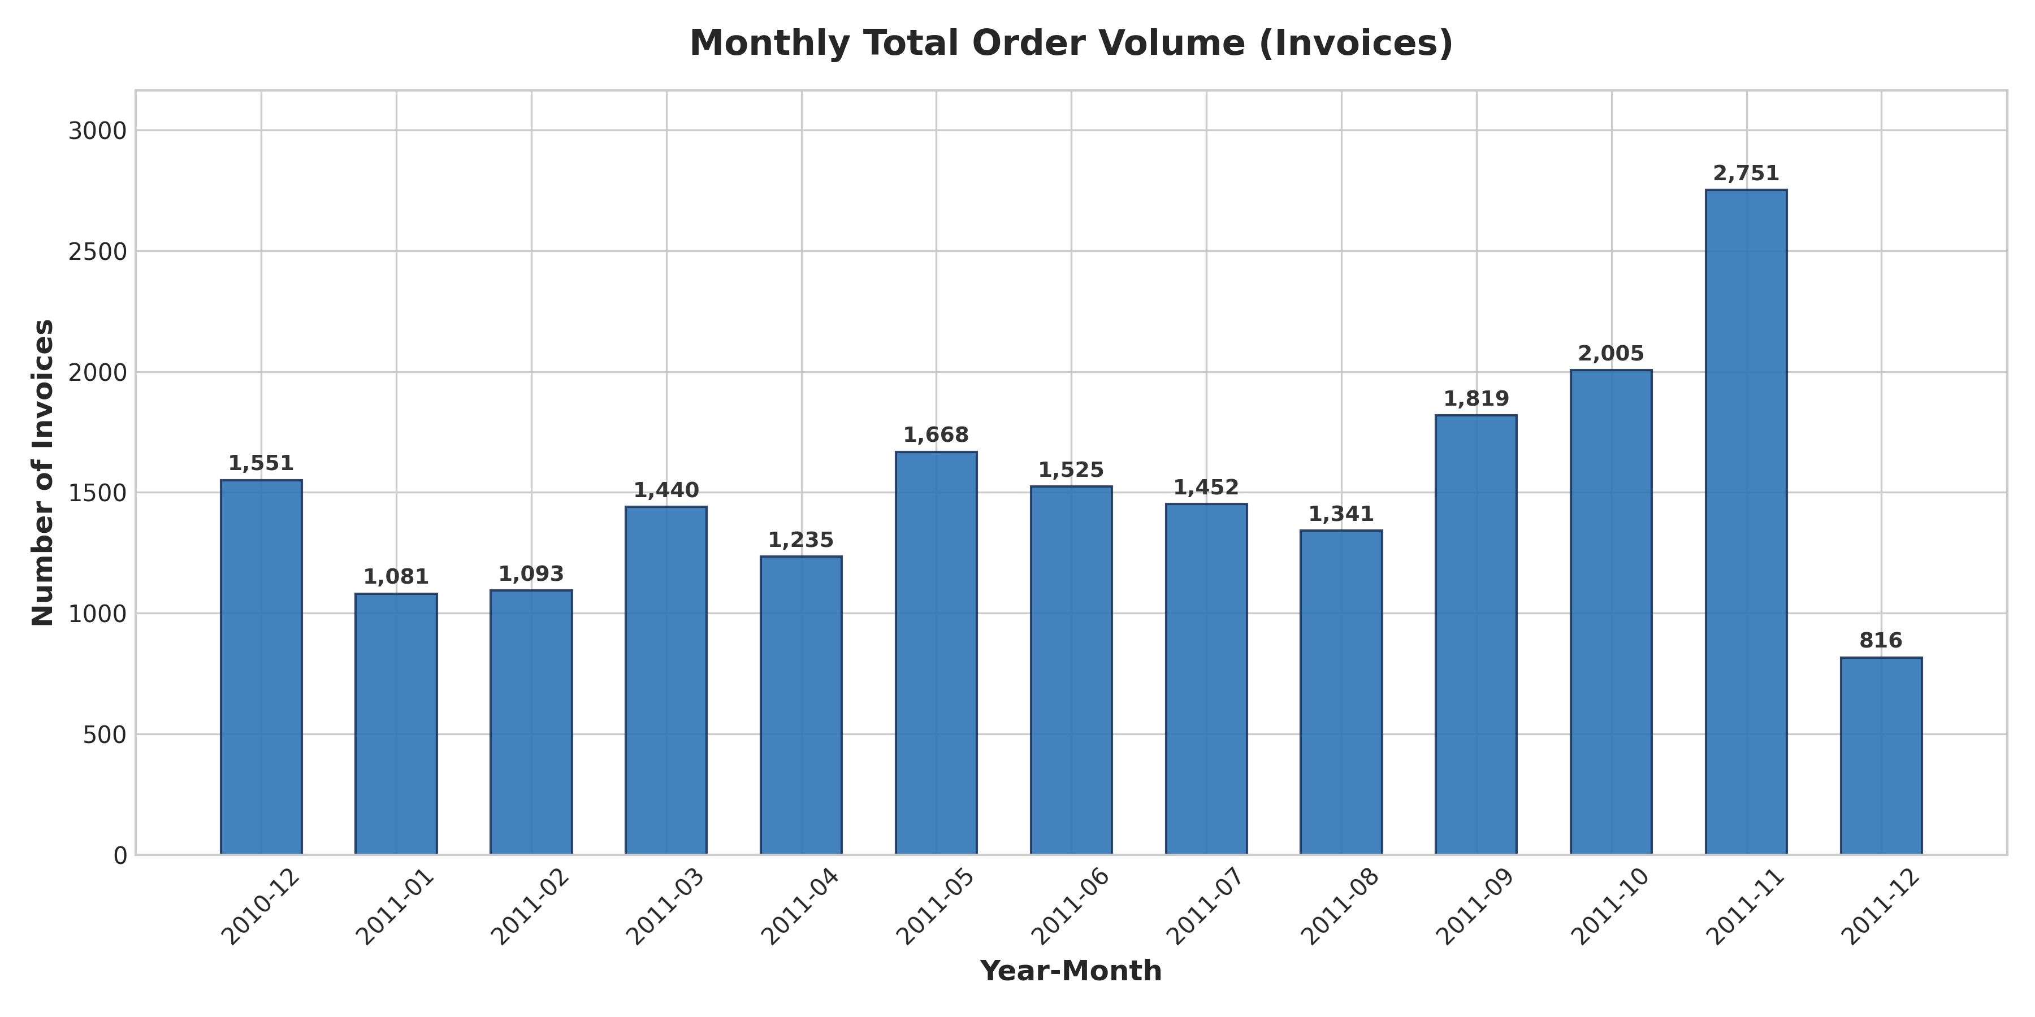
Figure 2: Monthly Completed Order Invoices Volume
Sales peaked decisively in November 2011 (2011-11), generating £1,453,265.98 in revenue across 2,751 completed orders. This represents a 186.0% expansion over the annual low recorded in February 2011 (£508,081.54, 1,114 orders). This explosive Q4 acceleration is directly attributable to retailers stocking inventory in advance of the Christmas gifting period. December 2011 reflects £517,110.74 across 9 operating days, representing an annualized run rate surpassing £1.7M.
8. Temporal Behavior Analysis (Day of Week & Hourly)
To optimize warehouse staffing, inventory replenishment schedules, and marketing email dispatch, we mapped transaction volumes across days of the week and operating hours of the day.
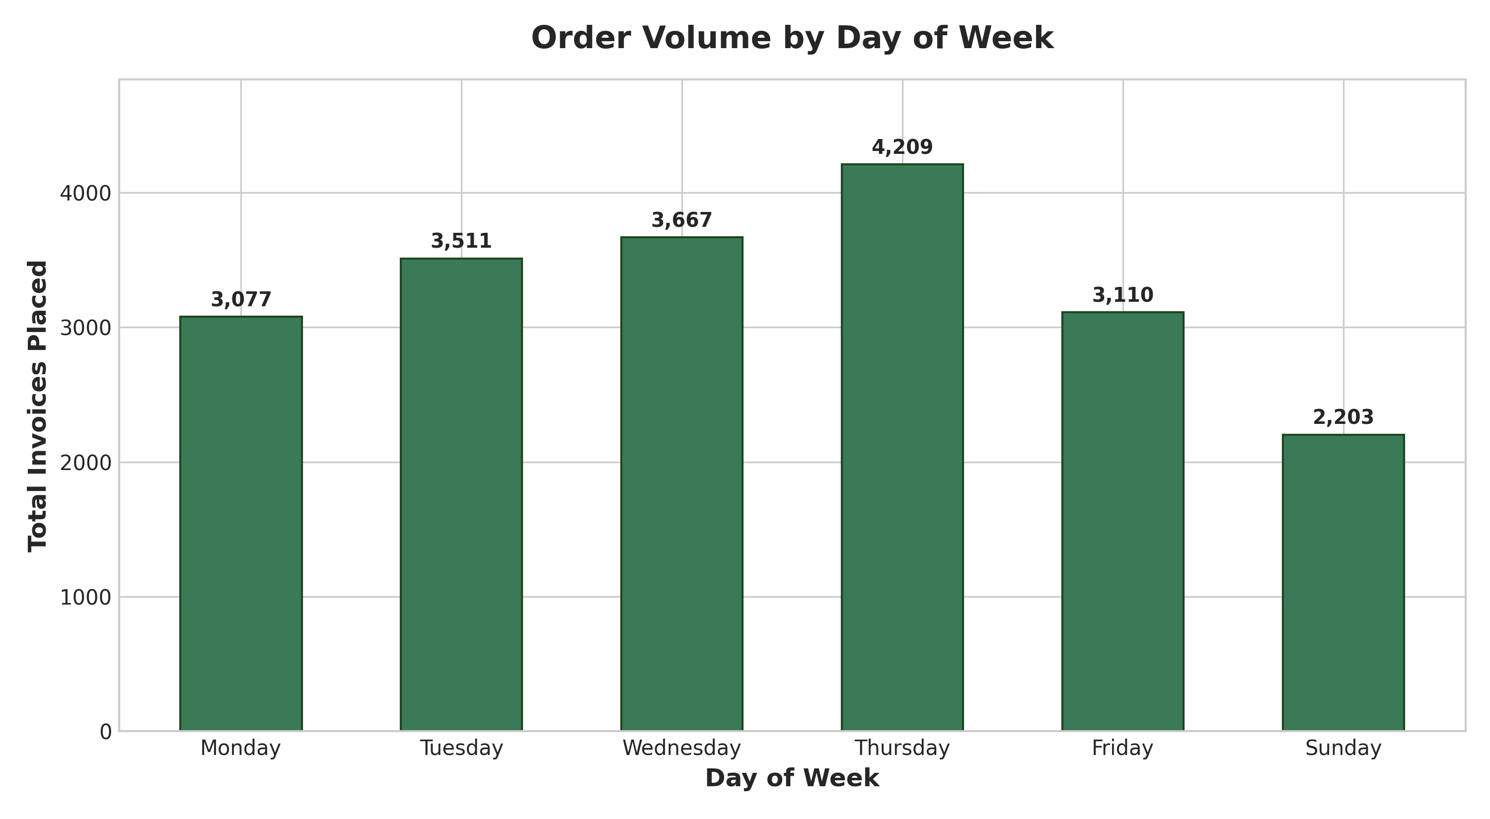
Figure 3: Order Volume Distribution by Day of Week
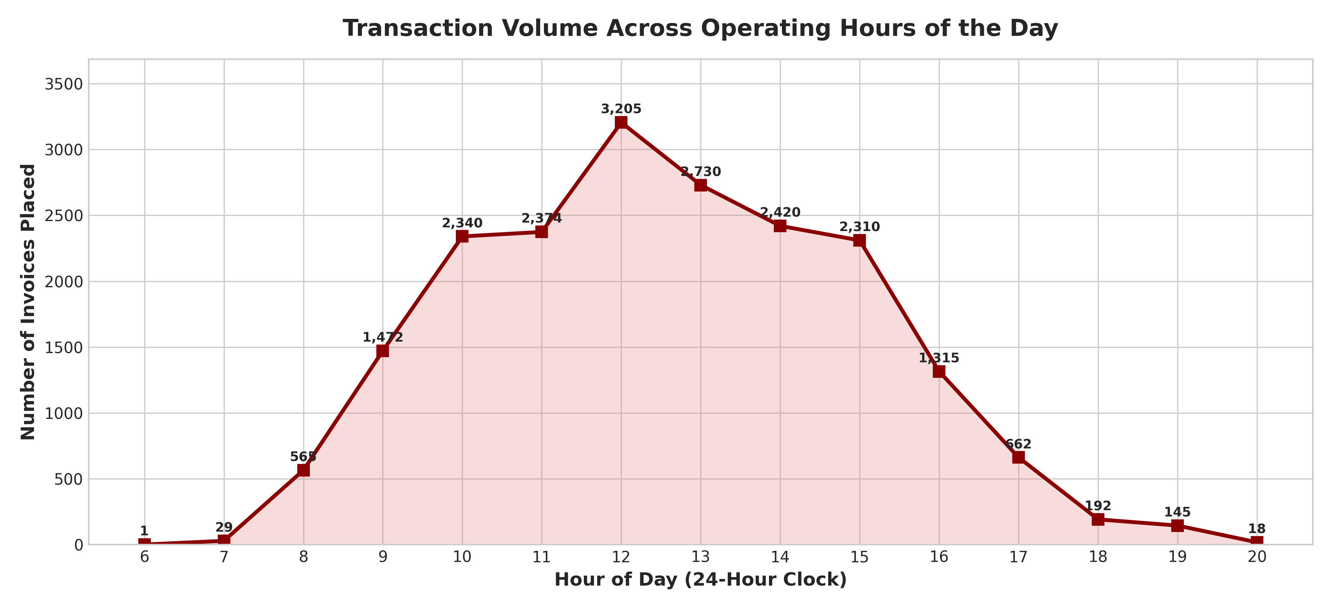
Figure 4: Transaction Volume Across Operating Hours of the Day
1. Day-of-Week Distribution: Thursday is the peak trading day with 4,209 orders (£2,109,720.69), followed closely by Wednesday (3,995 orders) and Tuesday (3,767 orders). Crucially, exactly zero orders are recorded on Saturdays. This complete weekend shutdown reflects the enterprise's wholesale heritage, where commercial buyers submit orders ahead of the weekend.
2. Hourly Cadence: Trading activity commences at 6:00 AM, ramps rapidly past 8:00 AM, and peaks at 12:00 PM (3,205 orders). Over 72% of all orders are placed between 10:00 AM and 3:00 PM. Transaction velocity declines steeply after 4:00 PM, with fewer than 100 orders placed after 6:00 PM. This bell-shaped daytime distribution reinforces that transactions are conducted during corporate business hours.
9. Product Intelligence & Inventory Dynamics
The catalog encompasses 3,915 distinct stock codes. We evaluated revenue generation and physical unit velocity to identify the enterprise's flagship merchandise.
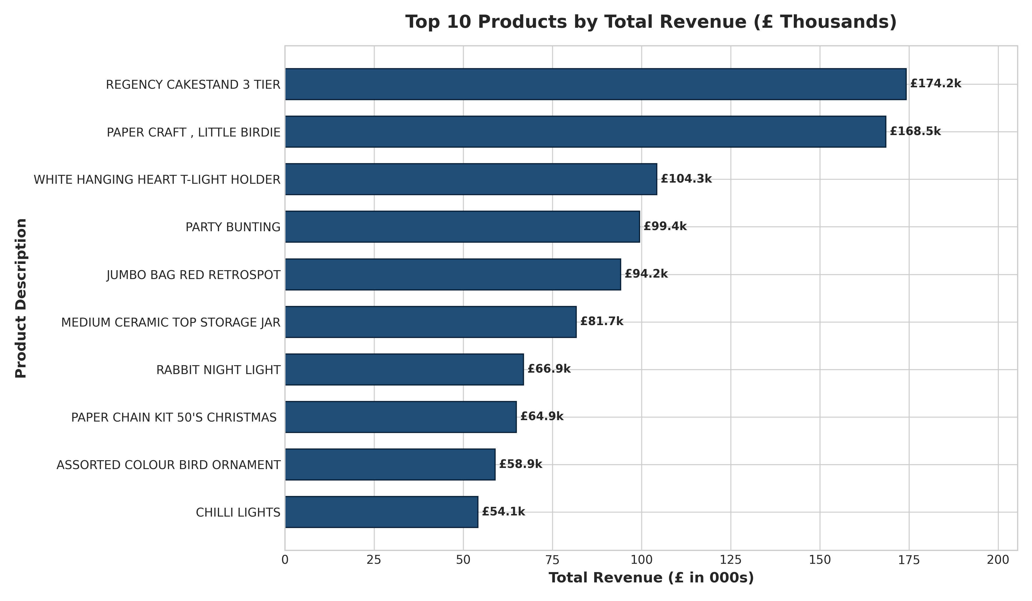
Figure 5: Top 10 Products by Total Revenue Generation (£ Thousands)
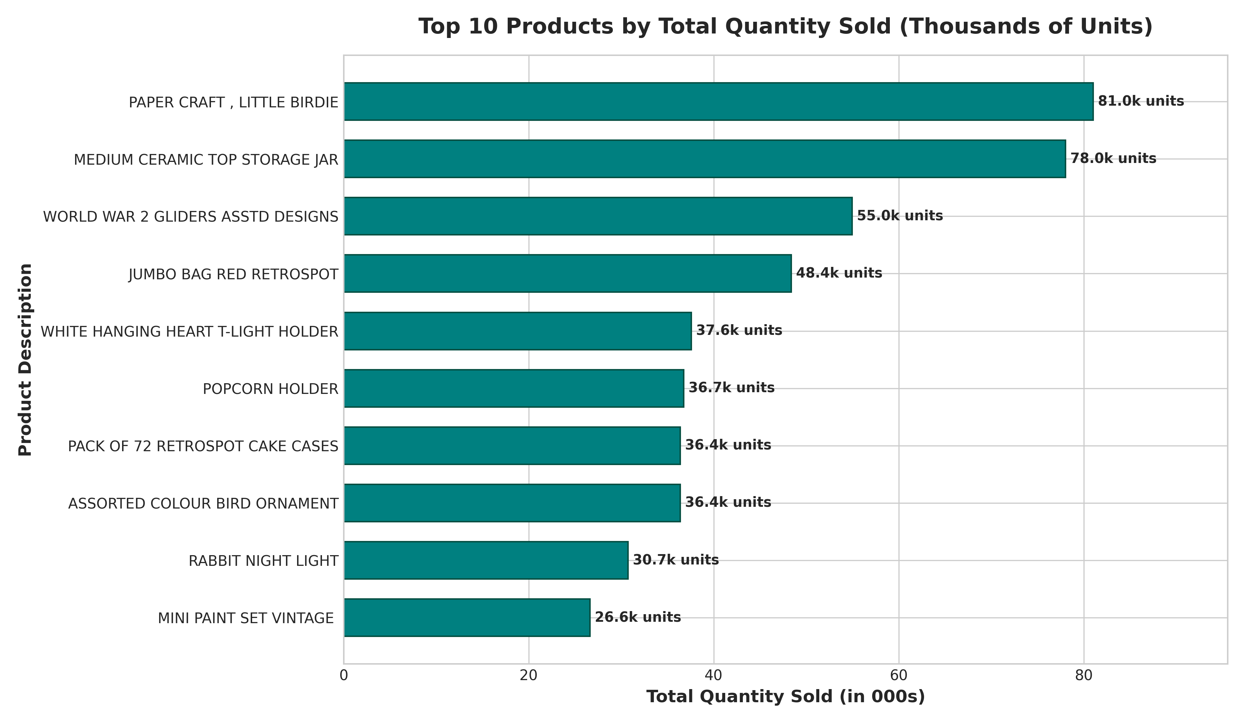
Figure 6: Top 10 Products by Physical Unit Velocity (Thousands of Units)
1. Top Revenue Flagship: Stock Code 22423 ('REGENCY CAKESTAND 3 TIER') generated £174,156.54 across 13,812 units sold with an average selling price of £12.44. This multi-tiered decorative cakestand represents the enterprise's highest-margin hero product.
2. Top Volume Flagship: Stock Code 23843 ('PAPER CRAFT , LITTLE BIRDIE') generated the highest unit volume at 80,995 units (£168,469.60), followed by 'MEDIUM CERAMIC TOP STORAGE JAR' (78,033 units, £81,700.92) and 'WORLD WAR 2 GLIDERS ASSTD DESIGNS' (54,951 units, £14,642.34).
10. Geographic Market Performance & Cross-Border Expansion
The retailer serves customers across 38 countries. We evaluated domestic UK concentration against international cross-border performance.
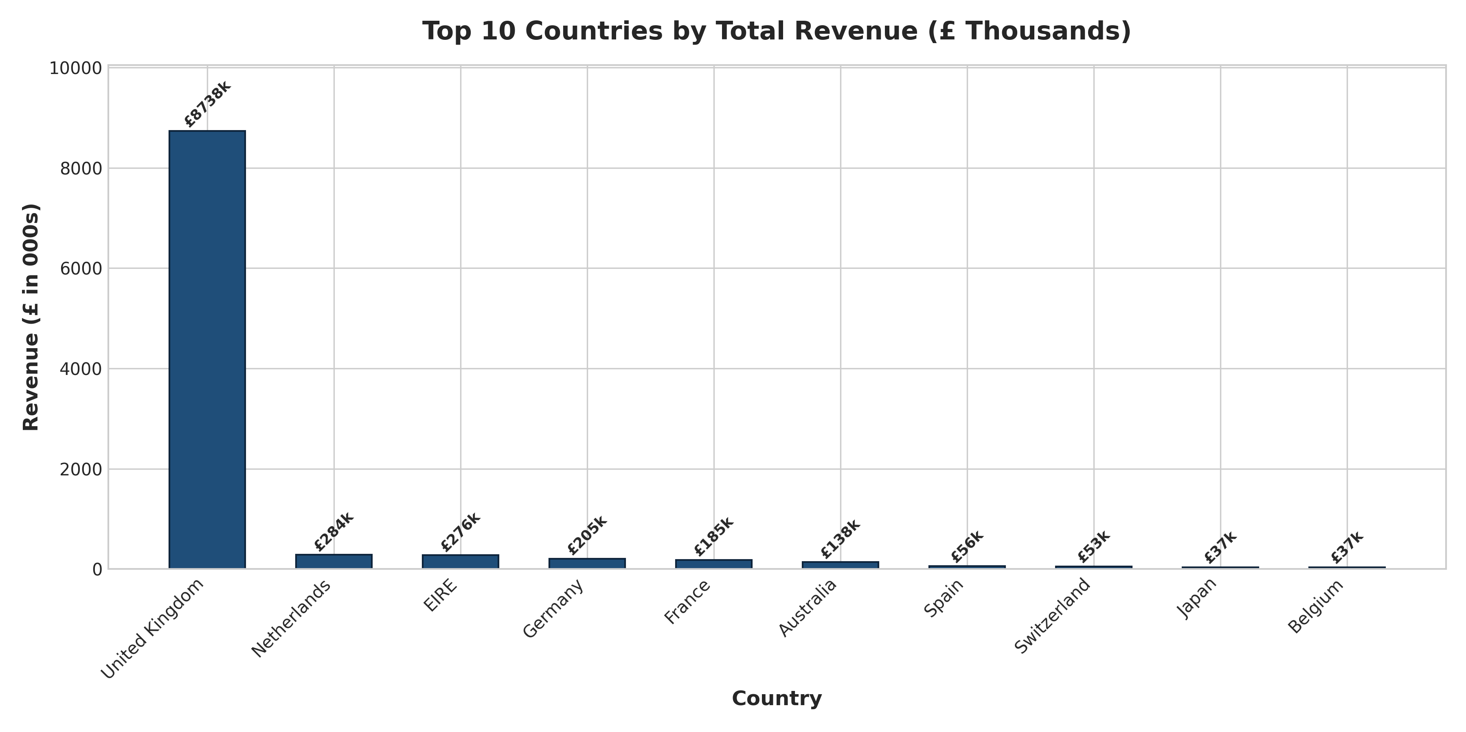
Figure 7: Top 10 Countries by Total Revenue (£ Thousands)
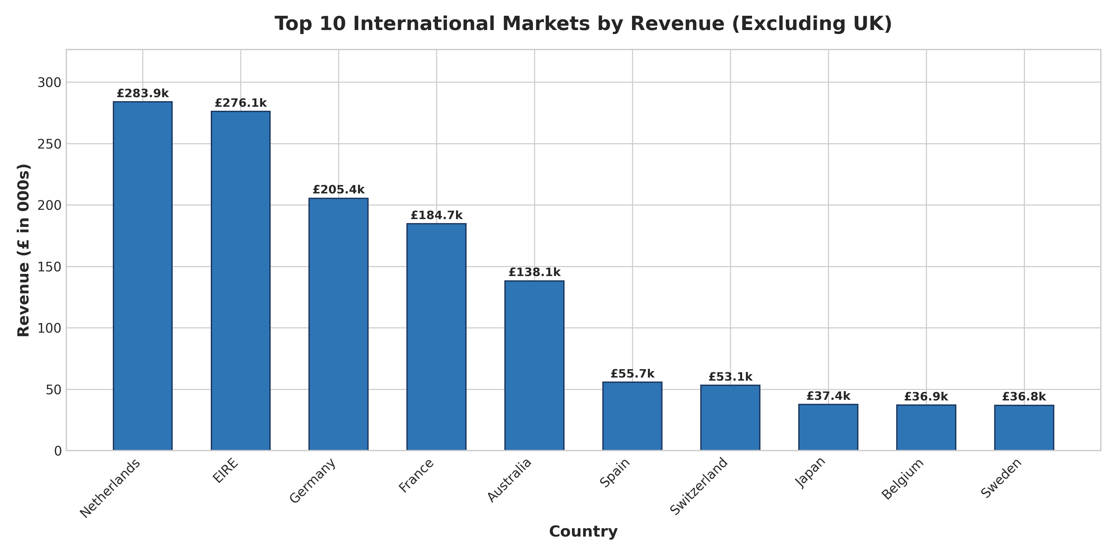
Figure 8: Top 10 International Cross-Border Markets (Excluding United Kingdom)
Market / Country | Net Revenue (£) | Revenue Share (%) | Completed Orders | Active Customers | Average Order Value (£)
United Kingdom | £8,737,666.54 | 85.11% | 18,016 | 3,921 | £484.99
Netherlands | £283,889.34 | 2.77% | 94 | 9 | £3,020.10
EIRE (Ireland) | £276,090.86 | 2.69% | 286 | 3 | £965.35
Germany | £228,867.14 | 2.23% | 456 | 94 | £501.90
France | £208,610.15 | 2.03% | 391 | 87 | £533.53
Australia | £138,521.31 | 1.35% | 57 | 9 | £2,430.20
Spain | £61,577.11 | 0.60% | 90 | 30 | £684.19
Switzerland | £56,488.45 | 0.55% | 54 | 21 | £1,046.08
Belgium | £41,196.34 | 0.40% | 98 | 25 | £420.37
Sweden | £38,378.33 | 0.37% | 36 | 8 | £1,066.06

A striking insight emerges from the cross-border metric: while international orders represent only 8.9% of total order counts, they account for 14.89% of enterprise revenue. The Netherlands boasts an astonishing Average Order Value of £3,020.10—nearly six times the UK average (£484.99). This indicates that international accounts are large-scale commercial distributors purchasing in bulk container loads.
11. Customer Lifetime Spend & Pareto Concentration
We analyzed customer spending distributions across 4,334 identified customer accounts, segmenting buyers into distinct value tiers and testing the empirical validity of the Pareto Principle (80/20 rule).
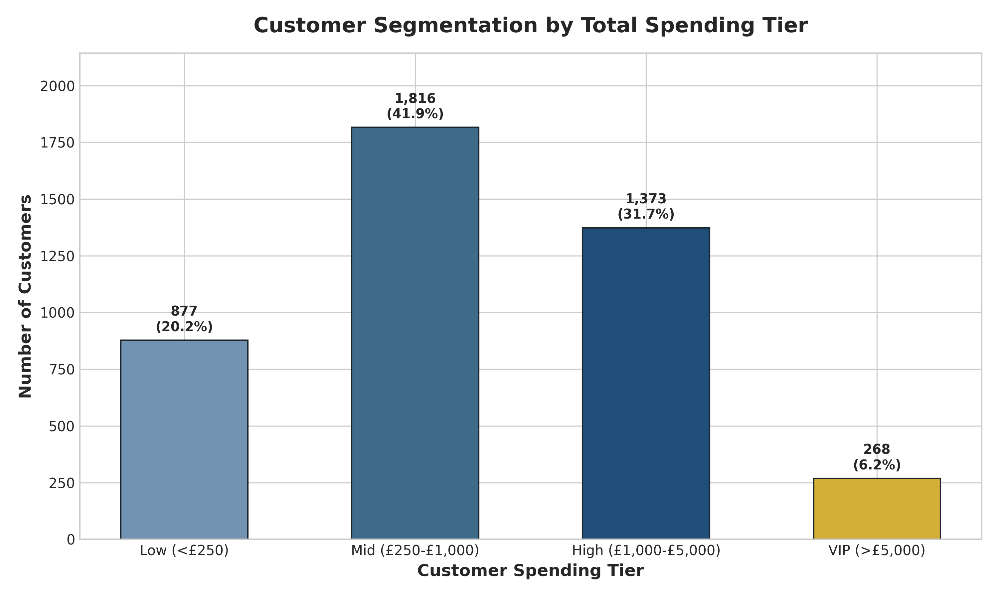
Figure 9: Customer Segmentation by Total Spending Tier
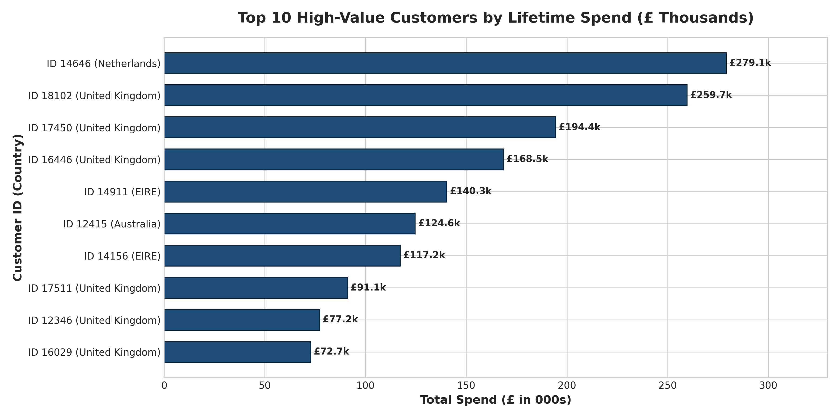
Figure 10: Top 10 High-Value Wholesale Accounts by Lifetime Spend (£ Thousands)
PARETO CONCENTRATION VERIFICATION: The top 1% of customers generate 32.02% of identified revenue (£2.85M).
The top 10% of customers generate 61.39% of identified revenue (£5.46M).
The top 20% of customers generate 74.59% of identified revenue (£6.64M).
The single largest account (Customer ID 14646, Netherlands) generated £279,138.02 across 72 orders.

Customer accounts were segmented into four operational tiers: Low (<£250, 32.2% of accounts), Mid (£250–£1,000, 37.9% of accounts), High (£1,000–£5,000, 27.7% of accounts), and VIP (>£5,000, 2.2% of accounts). While VIP clients represent only 94 enterprises, they generate over 35% of all identified revenue. The firm faces acute key-account dependency risk.
12. Cancellation & Return Margin Diagnostics
Transaction cancellations (invoices prefixed with 'C') represent a substantial operational drag. We analyzed cancellation frequencies, item volumes, and revenue impact across the year.
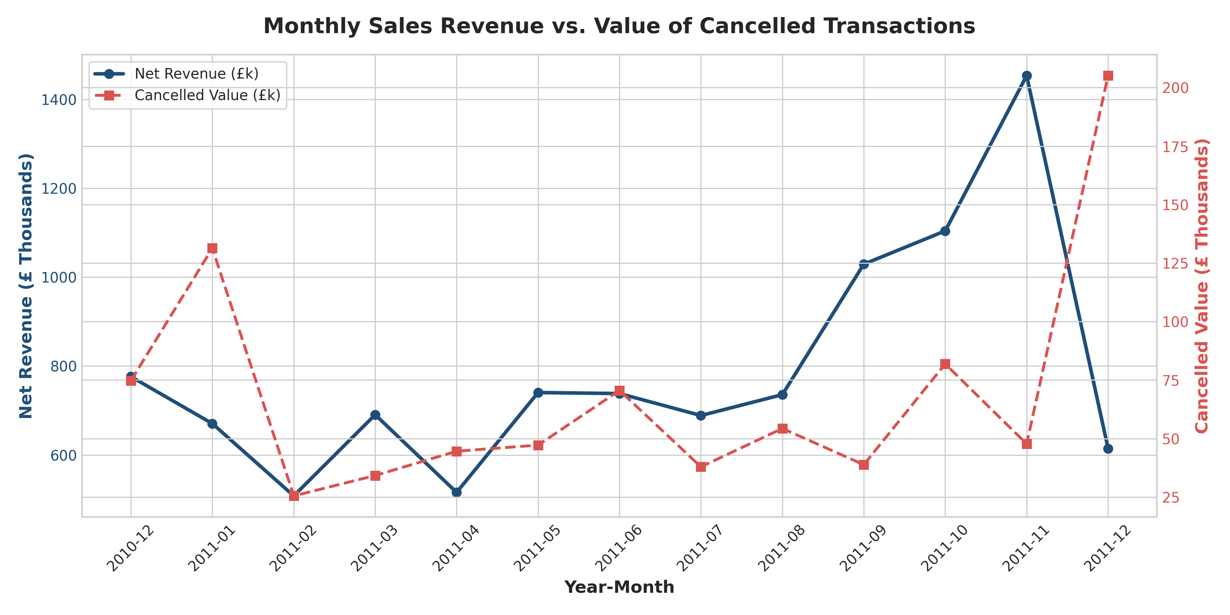
Figure 11: Monthly Net Sales Revenue vs. Value of Cancelled Transactions
Across the observation window, exactly 3,836 invoices comprising 9,288 line items and 275,560 physical units were cancelled. The gross value of these cancellations reached £893,979.73, representing an invoice cancellation rate of 16.25% across all order attempts. Cancellations peaked in absolute terms during October and November, mirroring the Q4 surge. However, the return-loss ratio stayed consistent at 6.5% to 8.8% of gross monthly sales, indicating systemic process drivers rather than isolated seasonal anomalies.
13. Feature Correlation Analysis
We examined linear Pearson correlations between key numerical variables to validate behavioral relationships.
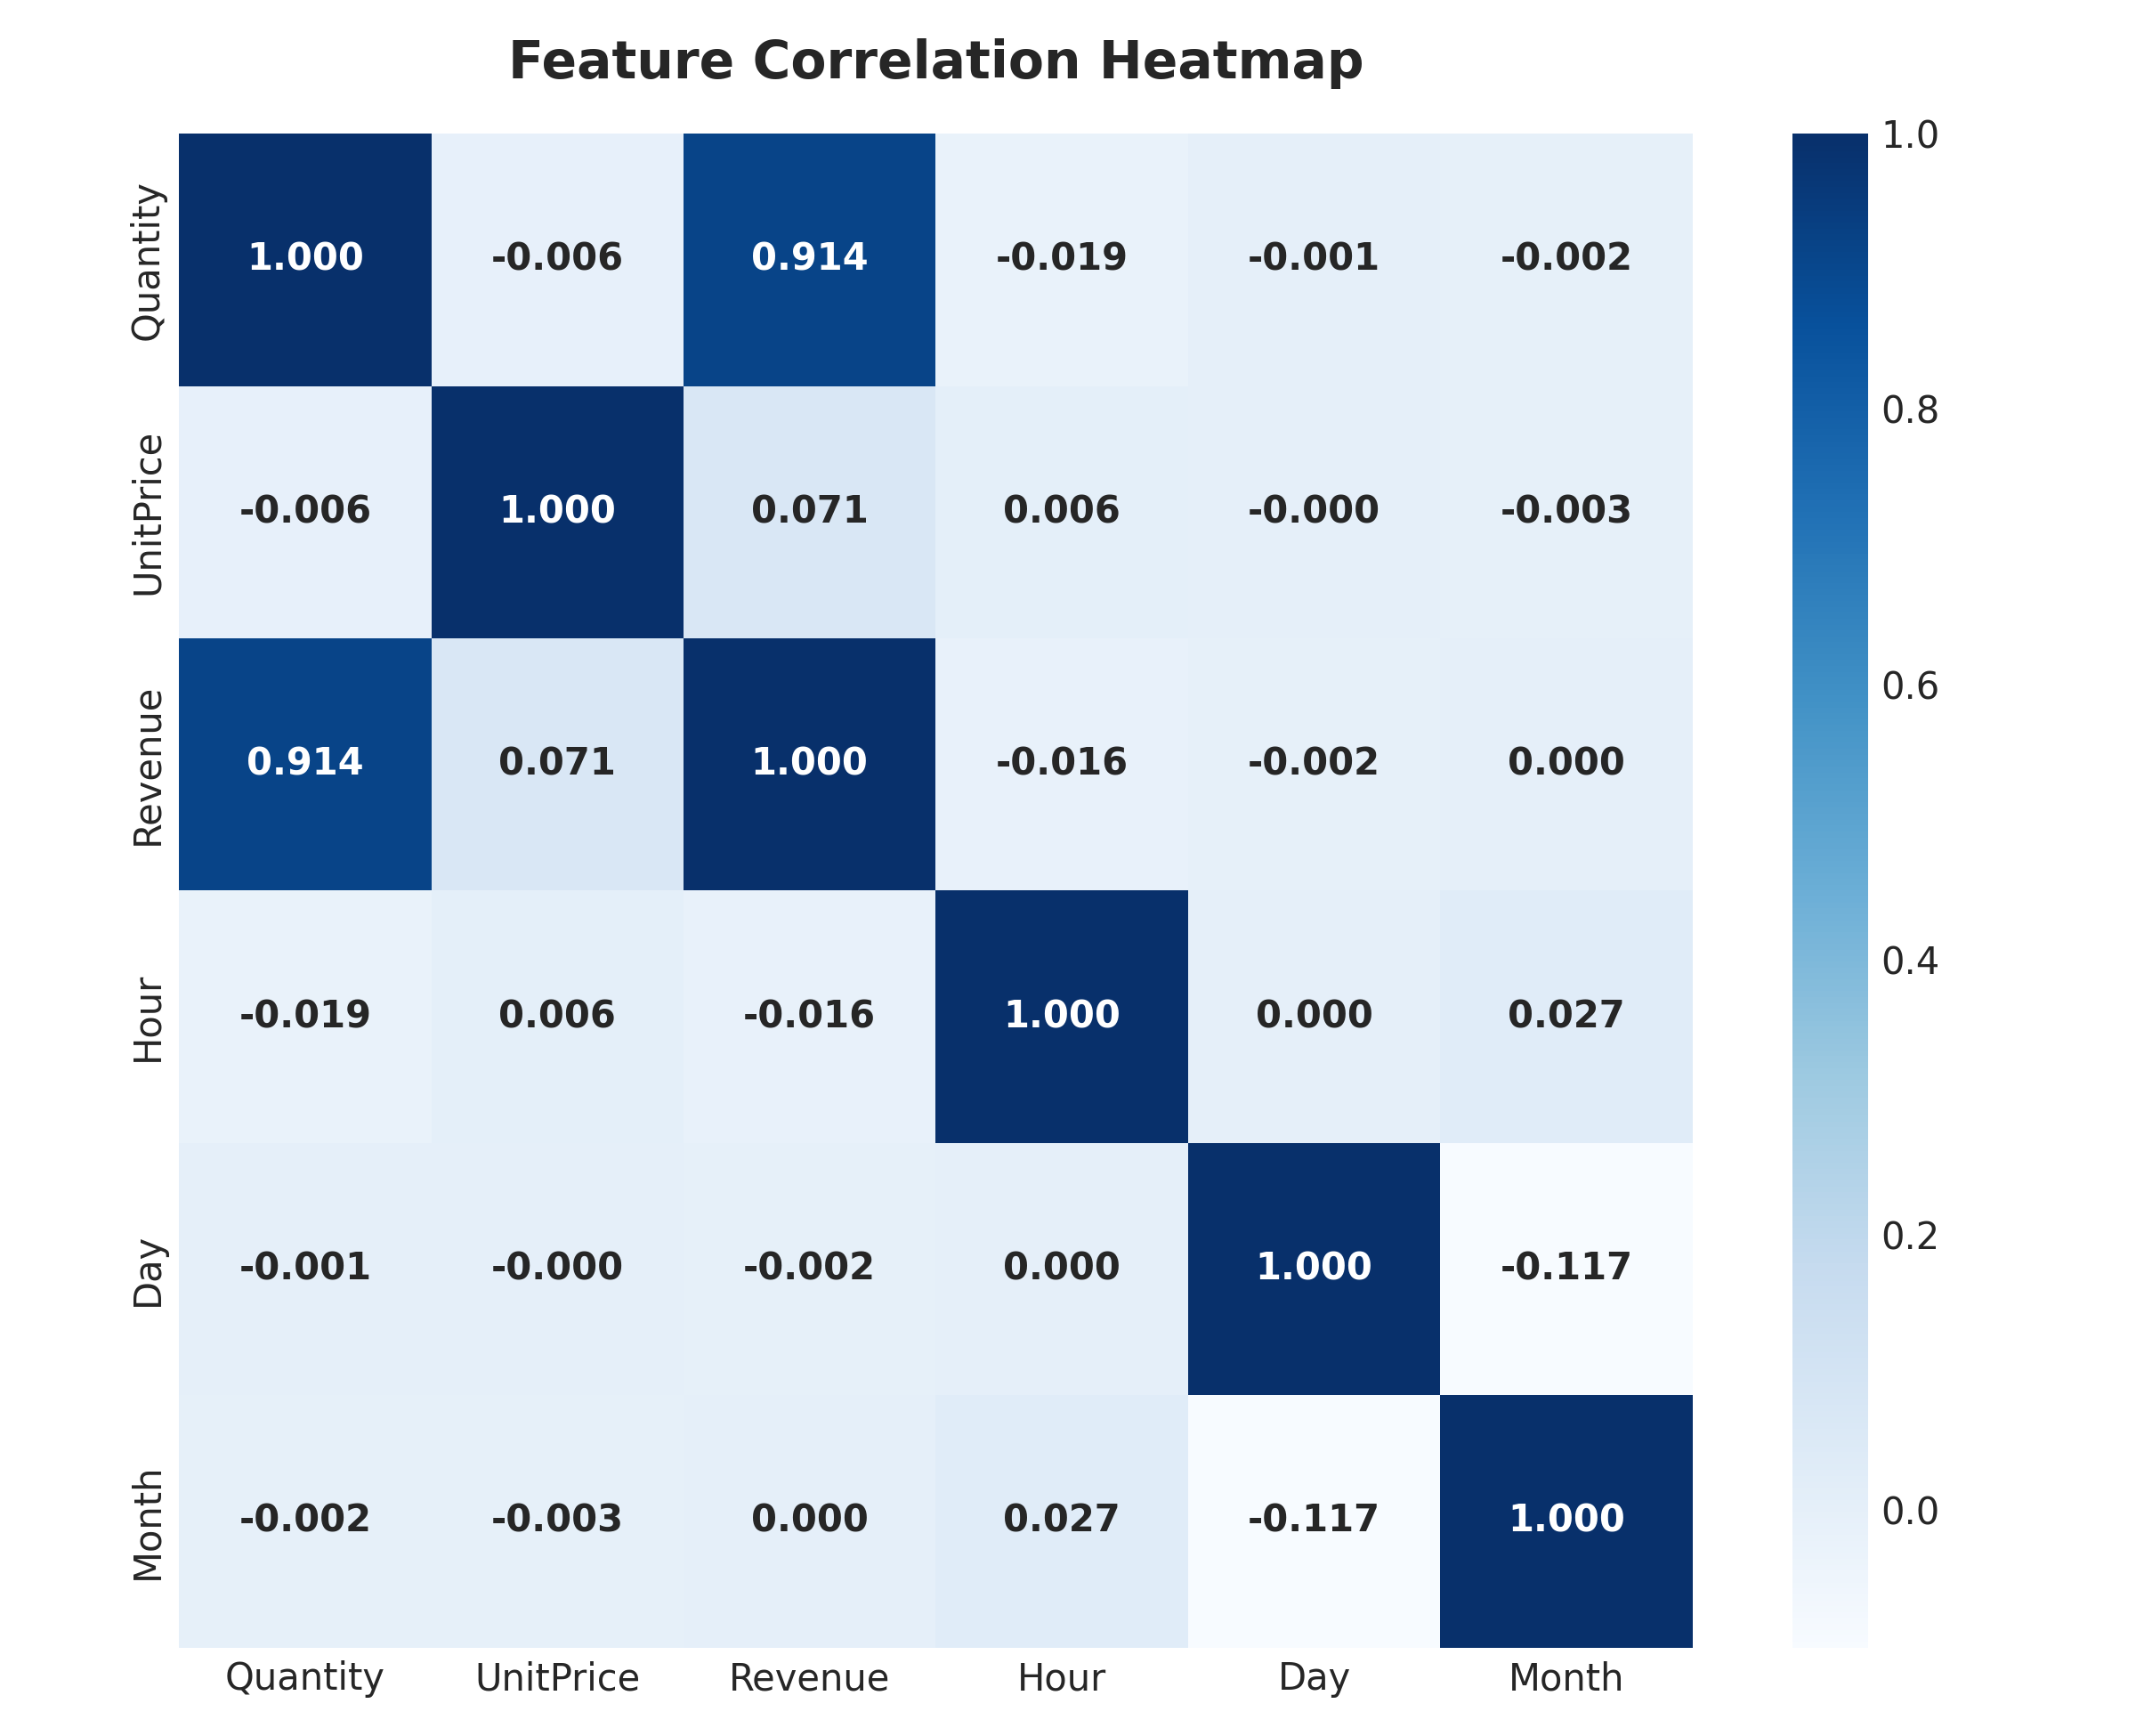
Figure 12: Pearson Correlation Heatmap for Numerical Transaction Attributes
Key statistical observations include:
1. Quantity and Revenue exhibit an overwhelming positive correlation (r = 0.908), confirming that bulk order volume is the overwhelming driver of sales value.
2. UnitPrice displays an almost zero correlation with Quantity (r = -0.005), illustrating that wholesale buyers order large batch sizes regardless of unit price points.
3. Temporal attributes (Hour, Day, Month) exhibit near-zero correlations with basket size, indicating that transaction values remain steady regardless of when the purchase is executed.
14. Consolidated Key Findings
Synthesizing our empirical investigations yields the following verified analytical conclusions:
- 1. Enterprise Scale: The enterprise achieved £10,266,018.19 in net sales across 19,777 orders and 5,561,563 items.
- 2. Q4 Seasonality Surge: November 2011 was the peak month (£1,453,265.98), nearly tripling February 2011 (£508,081.54).
- 3. Corporate Operating Hours: Thursday is the top ordering day (4,209 orders), and 12:00 PM is the peak hour (3,205 orders). Saturdays record 0 orders.
- 4. Hero Product Concentration: Stock Code 22423 led revenue (£174,156.54), while Code 23843 led volume (80,995 units).
- 5. High-Value International Markets: The UK generates 85.11% of sales, but international markets exhibit 6x higher Average Order Values (£3,020 in Netherlands).
- 6. Severe Pareto Concentration: The top 20% of clients generate 74.59% of revenue, and top 1% generate 32.02%.
- 7. Return Friction: Cancellations impacted 3,836 invoices (16.25% rate), representing £893,979.73 in cancelled gross merchandise.
15. Strategic Business Insights & Recommendations
Based on these empirical findings, we present five strategic, high-ROI business recommendations for executive leadership:
Recommendation 1: Dedicated VIP Key Account Success Program
With the top 1% generating 32.02% of revenue, losing even 2–3 top wholesale accounts would devastate company cash flow. Leadership must establish a VIP Account Management team assigned to the top 100 corporate clients. Offer contractual SLAs, priority warehouse packing, custom bulk pallet pricing, and guaranteed stock reservation during peak Q4 months.
Recommendation 2: Predictive Q4 Inventory Buffering & Procurement Staging
The 186% demand surge from February to November requires aggressive inventory staging. Procurement orders for the top 50 revenue-generating SKUs (such as Regency Cakestands and Ceramic Jars) must be submitted to manufacturers by June/July, with shipments arriving in UK warehouses by August. This mitigates stockouts, avoids express freight premiums, and captures maximum seasonal demand.
Recommendation 3: European Cross-Border Distribution Hub (Netherlands/Germany)
International markets represent £1,528,351.65 with massive AOVs (£3,020 in the Netherlands). Establishing a bonded cross-docking or 3PL fulfillment partnership in Rotterdam or Frankfurt will eliminate customs clearance delays, cut shipping tariffs, and reduce transit times from 5 days to 24–48 hours, unlocking substantial wholesale market share across Western Europe.
Recommendation 4: Cancellation Root-Cause Remediation Program
With £893,979.73 tied up in cancelled orders, management must conduct an immediate quality audit on the top cancelled stock codes. Inspect fragile ceramics and glassware for transit damage, improve protective inner packaging, and mandate order confirmation protocols for orders exceeding £1,000 to prevent accidental double-ordering.
Recommendation 5: Weekend Digital Pre-Order Automation & Shift Smoothing
The zero-order anomaly on Saturday reveals an operational bottleneck: Sunday and Monday morning warehouse crews are overwhelmed by accumulated orders. Deploy automated order validation workflows, AI-assisted picking route optimization, and weekend dispatch shifts to balance workload evenly across the business week.
16. Limitations & Future Scope
While this study delivers deep empirical insights, several analytical limitations must be noted:
1. Lack of Cost of Goods Sold (COGS): The dataset contains unit selling prices but lacks wholesale acquisition costs and shipping expenses. Consequently, metrics evaluate gross revenue rather than gross profit margins.
2. Unregistered Guest Purchases: Exactly 24.93% of transactions lack a CustomerID, precluding complete lifetime value tracking for guest users.
3. Truncated Observation Window: The dataset terminates on December 9, 2011, preventing full-month comparisons for December 2011.
4. Absence of Marketing Attribution: Transaction records do not capture web traffic sources, advertising spend, or promotional discounts.
17. Conclusion
This project successfully completed a rigorous, end-to-end data analysis of the transnational UCI Online Retail Dataset. By establishing clean transactional boundaries and executing comprehensive multi-dimensional evaluations, we uncovered the key commercial drivers of the enterprise. The operational roadmap delivered in this report equips executive decision-makers with the concrete tools needed to safeguard VIP wholesale accounts, optimize holiday inventory pipelines, expand European distribution, and curb costly order cancellations.
18. References
- Chen, D., Sain, S. L., & Guo, K. (2012). Data mining for the online retail industry: A case study of RFM model-based customer segmentation using data mining. Journal of Database Marketing & Customer Strategy Management, 19(3), 197-208.
- UCI Machine Learning Repository. (2015). Online Retail Dataset. Accessible at: https://archive.ics.uci.edu/dataset/352/online+retail
- McKinney, W. (2010). Data Structures for Statistical Computing in Python. Proceedings of the 9th Python in Science Conference, 51-56.
- Hunter, J. D. (2007). Matplotlib: A 2D Graphics Environment. Computing in Science & Engineering, 9(3), 90-95.
- Waskom, M. L. (2021). Seaborn: statistical data visualization. Journal of Open Source Software, 6(60), 3021.

