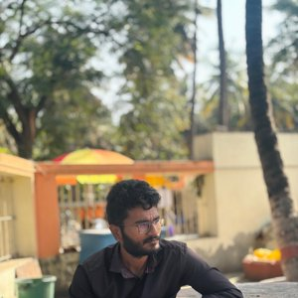 | PRAVEEN S  Associate Consultant · Infosys, Bangalore  Hindu · Vaniya Chettiar · Tamil  Website: https://spraveeen.github.io/Profile/

PERSONAL DETAILS

Date of Birth | : | 08 April 1999
Place of Birth | : | Krishnagiri
Time of Birth | : | 04:25 PM
Rashi (Zodiac) | : | Sagittarius (Dhanusu)
Nakshatra | : | Pooradam (Purvashada)
Religion | : | Hindu
Caste | : | Vaniya Chettiar
Mother Tongue | : | Tamil
Complexion | : | Medium
Height | : | 168 cm
Weight | : | 58 kg

EDUCATION & CAREER

Education | : | Bachelor of Engineering (B.E)
Occupation | : | Associate Consultant
Company | : | Infosys, Bangalore
Annual Salary | : | Rs. 11 Lakhs P.A.

FAMILY DETAILS

Father's Name | : | Suresh Kumar G
Father's Occupation | : | Ex-Bank Employee
Mother's Name | : | Pushpalatha
Mother's Occupation | : | Home Maker
Siblings | : | One Elder Brother
Address | : | No. 2B, FCI Nagar, Vilankurichi, Coimbatore - 641035

CONTACT DETAILS

Contact Person | : | Mother / Myself
Mother's Number | : | 8883105430
Praveen's Number | : | 8524902324
Email ID | : | praveens8498@gmail.com

View Complete Matrimony Profile Online: https://spraveeen.github.io/Profile/

✦ Matrimony Profile of Praveen S ✦

