

**Course code :** CAP777

**Course title :** WEB DEVELOPMENT USING PHP

**Project Title :** INVENTORY MANAGEMENT

SYSTEM

**Section : DE351**

**Group :** 2

**Project Type :** Group of 2

|  |
| --- |
| **S.No. Name Registration No.** |
| 1. DONTHIKURTHI PRADEEP KUMAR 12309248 |
| **2** Sama Premanand Reddy 12304116 |

***Index for Inventory System Documentation :-***

1. ***Project Overview ............................................ 3***
2. ***Project Features (Deliverables) ........................ 4****2.1. Dashboard (1.0) ............................................. 4  
   2.2. User Management (2.0) ................................. 5  
   2.2.1. Manage Groups (2.1) ............................ 5  
   2.2.2. Manage Users (2.2) .............................. 5  
   2.3. Categories (3.0) ............................................. 6  
   2.4. Products (4.0) ............................................... 6  
   2.4.1. Manage Products (4.1) ......................... 6  
   2.4.2. Add Products (4.2) ................................ 7  
   2.5. Media Files (5.0) ............................................ 7  
   2.6. Sales (6.0) .................................................... 8  
   2.6.1. Manage Sales (6.1) ............................... 8  
   2.6.2. Add Sales (6.2) ..................................... 8  
   2.7. Sales Reports (7.0) ........................................ 9  
   2.7.1. Sales by Date (7.1) ............................... 9  
   2.7.2. Monthly Sales (7.2) .............................. 9  
   2.7.3. Daily Sales (7.3) .................................. 9*
3. ***The Process***
4. ***Screenshots and Explanation .......................... 10***
5. ***Project Completion Status .............................. 11***
6. ***Project Pendency Status ................................ 11***
7. ***Team Performance .......................................... 12***
8. ***Bibliography ..................................................... 12***

***Inventory System Documentation:-***

***Project Overview:-***

*The Inventory System is designed to automate the tracking, management, and reporting of stocks, sales, product categories, and user roles within an organization. This system is ideal for small to medium-sized businesses looking to optimize their stock management processes. It provides real-time visibility into inventory and sales trends, improves operational efficiency, and ensures better decision-making. By offering features such as user management, product categorization, sales tracking, and detailed reporting, the system helps businesses avoid stockouts, reduce surplus, and manage sales with ease.*

***Project Features (Deliverables):-***

***Login System Overview for Inventory Management***

***The login system controls access to the Inventory Management System by ensuring only authorized users can enter, providing essential security. It includes user authentication, role-based access given by administrator. There are basically three types of credentials***

***Admin,Special,User***

***Key Features:***

1. ***User Authentication:***
   * ***Login with username/email and password.***
   * ***Passwords are encrypted, and users can reset forgotten passwords via email.***
2. ***Role-based Access Control (RBAC):***
   * ***Access is granted based on roles like Admin, Sales Staff, or Warehouse Staff, ensuring users only interact with relevant system areas.***
3. ***Session Management:***
   * ***Session Timeout automatically logs users out after inactivity for security.***
   * ***Remember Me option allows extended login sessions.***
4. ***Optional Two-factor Authentication (2FA):***
   * ***Adds extra security by requiring a verification code after entering the password.***

***Login Flow:***

1. ***User enters credentials (username/email and password).***
2. ***The system verifies and grants access based on the user role..***
3. ***Successful login takes users to their role-specific dashboard.***

***Security Features:***

* ***Strong Password Enforcement.***
* ***Audit Logs for tracking login activity.***

***The login system ensures security, accountability, and efficient user role management within the Inventory Management System.***

* 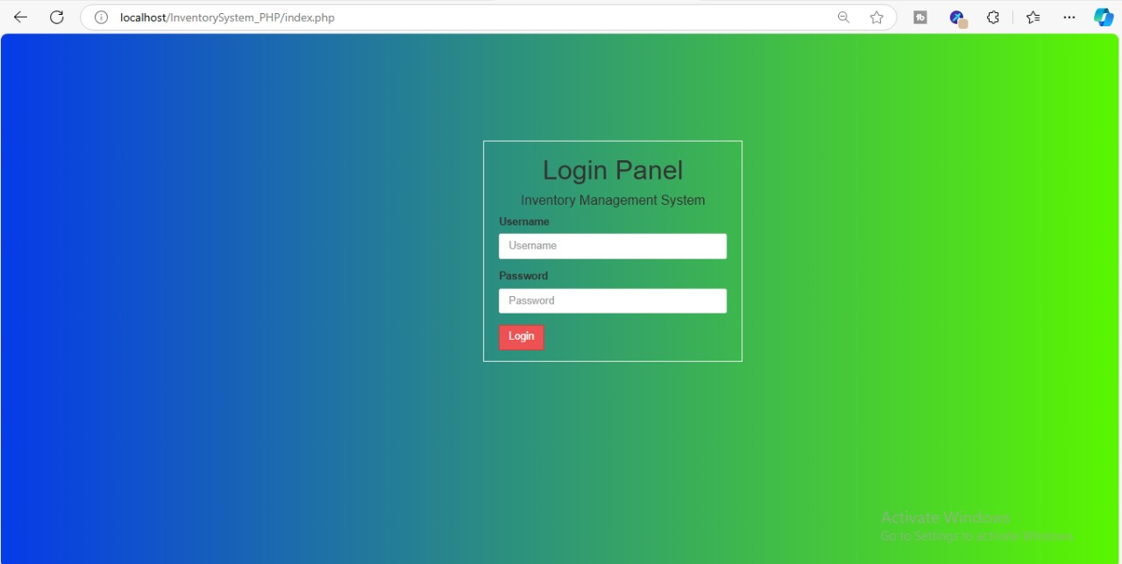

***Here we have three types of logins :-***

* ***Admin***
* ***Special user***
* ***Users***

***Here key difference between Admin Special user and Users they are:***

* ***Admin can Add users, form the groups and Add products and delete them edit and etc. And he can add he can add special users and users and etc.***
* ***Here we comes to special users he can add products, manage the products and he can categories them but compare to Admin he has some restrictions what Admin can do he can not have access that features.***
* ***Now here we come to users they can see sales, manage the sales report according to them but compare to Special users, Admin he has restrictions to access what Admin and Special users can do he can not have access that features.***

***The Inventory System is comprised of the following key features of Admin:***

***1. Dashboard (1.0)***

* *Description: The dashboard serves as the main control panel for the entire system. It provides users with a high-level view of the most critical inventory metrics in real-time. From here, admin can view sales trends, stock alerts, and other important notifications.*
* ***Key Components:-***
  + *Real-time stock levels.*
  + *Sales performance at a glance.*
  + *View for low-stock or out-of-stock products.*
  + *Quick access to different sections of the system.*
* ***Benefits:***
  + *Helps users make quick decisions by providing an overview of the most important metrics.*
  + *Reduces time spent navigating the system by centralizing information.*

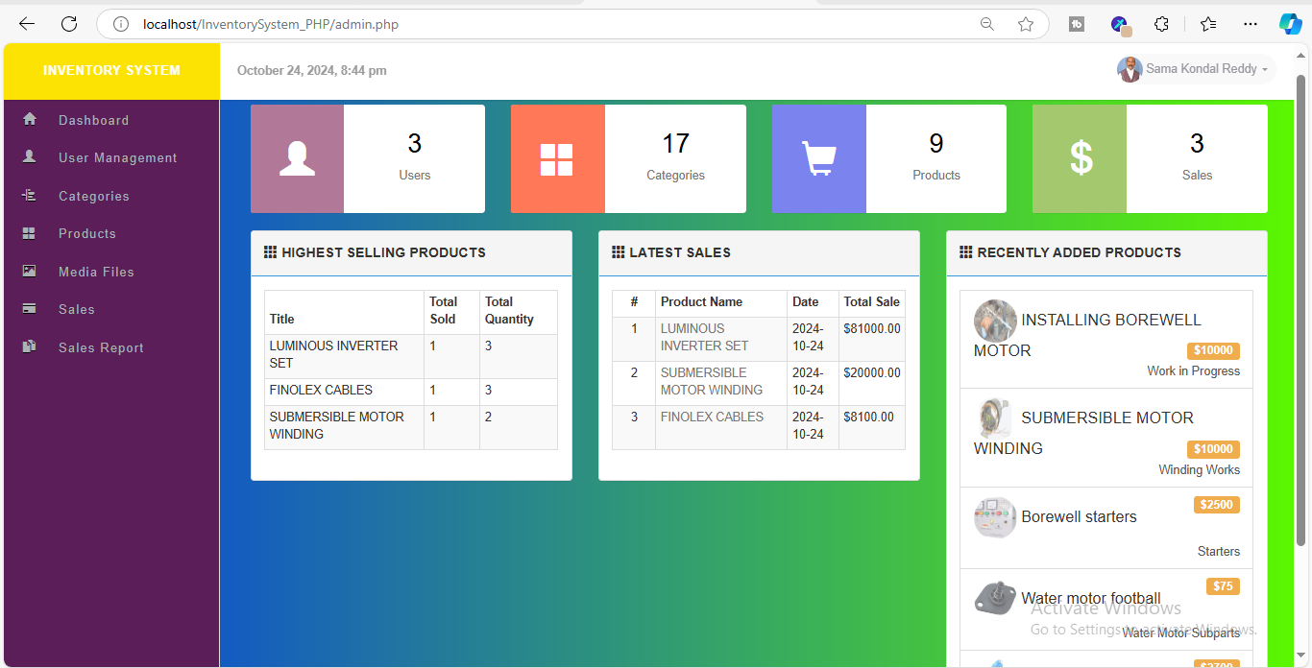

***2. User Management (2.0)***

* *Description: User management allows the system administrator to control access to the system by adding, editing, or removing users and assigning roles or groups. This ensures only authorized personnel have access to specific features.*

***2.1 Manage Groups***

* *Description: The system allows for the creation and management of user groups. These groups help define what permissions each user within the group will have.*
* ***Key Features:***
  + *Create groups (e.g., Admin, Sales, Warehouse).*
  + *Assign permissions (e.g., view, edit, delete).*
  + *Modify or delete existing groups.*
* ***Benefits:***
  + *Enhances security by ensuring only authorized personnel access specific data and functionality.*
  + *Simplifies user management by grouping users according to their roles.*

***2.2 Manage Users***

* *Description: This module allows administrators to add, edit, or remove individual users from the system and assign them to specific groups.*
* ***Key Features:***
  + *Add new users with required credentials and assign them to groups.*
  + *Edit user information and update their permissions.*
  + *Deactivate or remove users.*
* ***Benefits:***
  + *Allows fine-grained control over who has access to the system.*
  + *Facilitates smooth user onboarding and role management.*

***3. Categories (3.0)***

* *Description: This feature helps to categorize products into different groups based on their type, use, or other characteristics, making inventory management more organized and searchable.*
* ***Key Features:***
  + *Create new product categories (e.g., Electronics, Clothing, Food).*
  + *Edit existing categories.*
  + *Assign products to relevant categories.*
* ***Benefits:***
  + *Improves product searchability and classification.*
  + *Helps in generating category-based reports for better insights into stock and sales.*

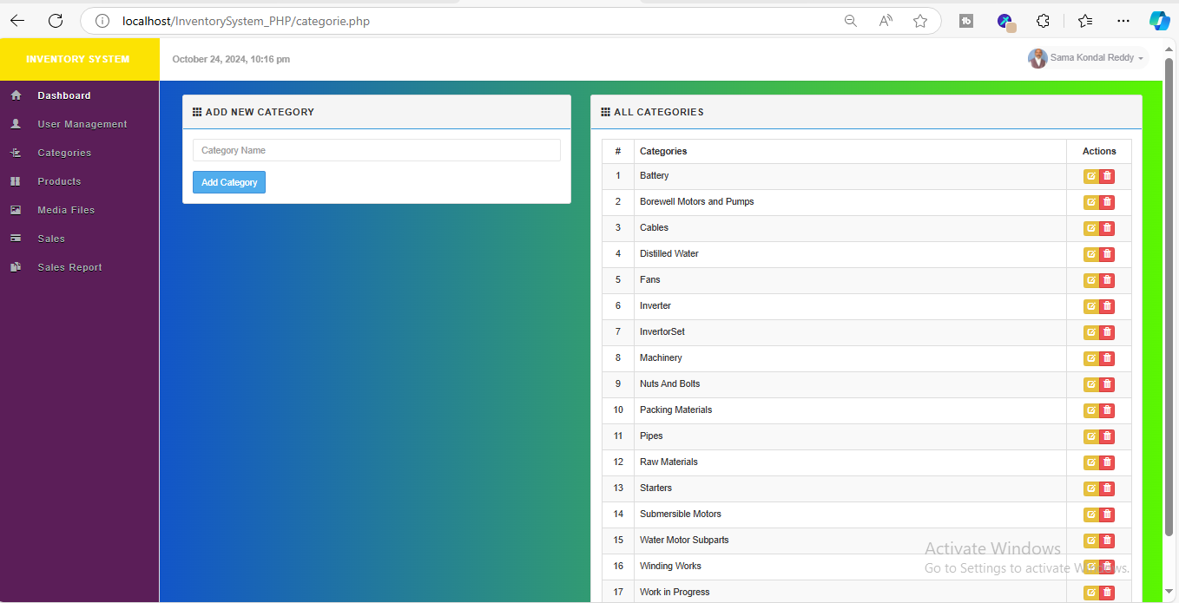

***4. Products (4.0)***

* *Description: The products module is essential for managing all the items within the inventory, allowing the addition and modification of product details, stock levels, and prices.*

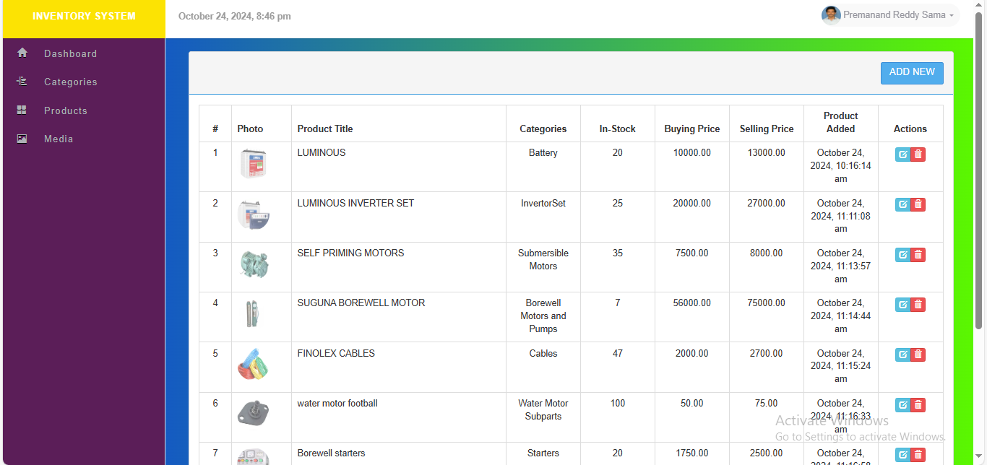

***4.1 Manage Products***

* *Description: This feature allows users to view, edit, or delete products already present in the system.*
* ***Key Features:***
  + *View all products in a tabular format with details like product name, category, stock level, and price.*
  + *Edit product information such as price, stock quantity, or descriptions.*
  + *Delete obsolete or discontinued products.*
* ***Benefits:***
  + *Provides full control over product inventory.*
  + *Ensures the system is always up-to-date with the latest product details.*

***4.2 Add Products***

* *Description: This module facilitates the addition of new products to the system, along with all necessary details like name, price, stock, and category.*
* ***Key Features:***
  + *Add product details such as name, SKU, price, category, and initial stock.*
  + *Upload product images and other media.*
* ***Benefits:***
  + *Simplifies the process of entering new products into the system.*
  + *Ensures accuracy in product tracking from the moment they are added.*

***5. Media Files (5.0)***

* *Description: The media files module allows users to upload and manage media related to products, such as images and promotional content.*
* ***Key Features:***
  + *Upload and manage images for each product.*
  + *Organize and tag files for easy search and access.*
* ***Benefits:***
  + *Enhances the visual representation of products in the system.*
  + *Simplifies media management by centralizing it in one location.*

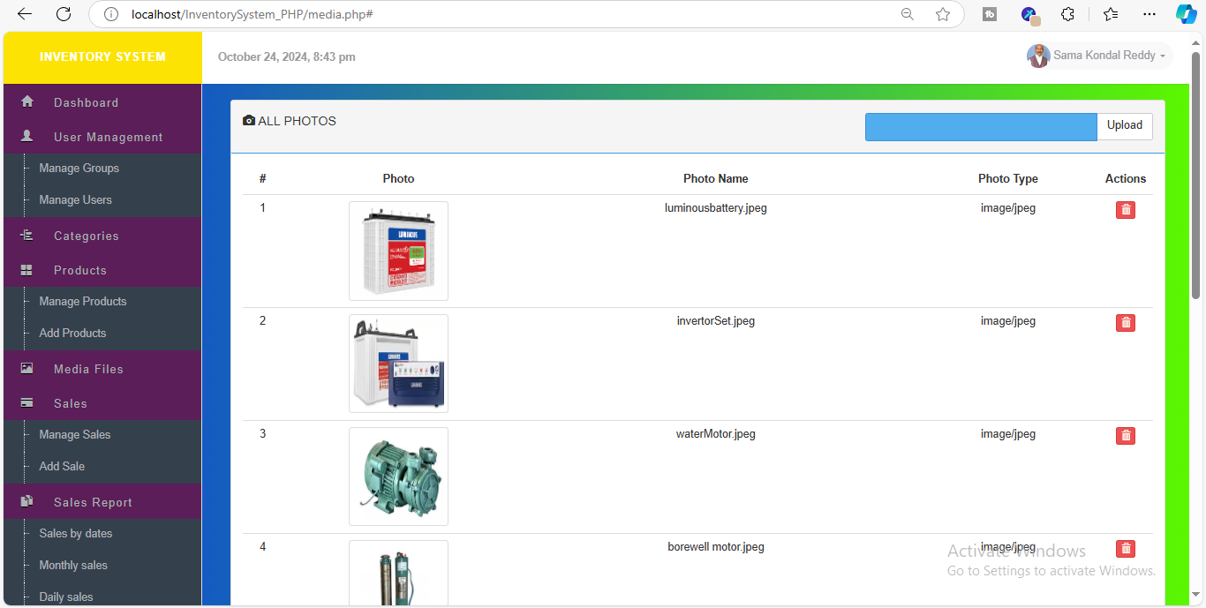

***6. Sales (6.0)***

* *Description: The sales module is critical for tracking and managing all sales transactions within the system. It ensures that every sale is recorded with details, providing transparency and accuracy.*

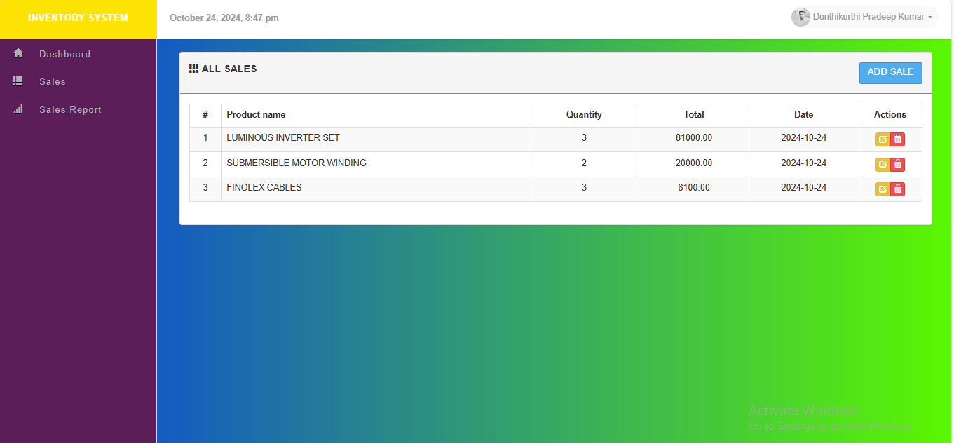

***6.1 Manage Sales***

* *Description: This module lists all sales made in the system, allowing users to view, edit, or delete transactions.*
* ***Key Features:***
  + *View sales in a tabular format, including details such as product sold, quantity, and total amount.*
  + *Search for specific transactions based on date or product.*
  + *Edit or delete incorrect sales records.*
* ***Benefits:***
  + *Provides easy access to all sales records, ensuring accuracy in reporting and management.*

***6.2 Add Sales***

* *Description: This feature allows users to record new sales into the system manually.*
* ***Key Features****:*
  + *Enter sales details such as product, quantity, price, and customer information.*
  + *Automatically update stock levels based on sales.*
* ***Benefits:***
  + *Ensures every transaction is accurately recorded.*
  + *Automates the inventory adjustment process.*

***7. Sales Reports (7.0)***

* *Description: The sales reports module offers detailed reporting features, helping users analyze sales performance over different periods.*

***7.1 Sales by Date***

* *Description: This report generates sales data filtered by specific date ranges.*
* ***Key Features:***
  + *Generate reports for any custom date range.*
  + *View total sales, number of products sold, and revenue.*
* ***Benefits:***
  + *Helps analyze sales trends over specific time periods for better forecasting.*

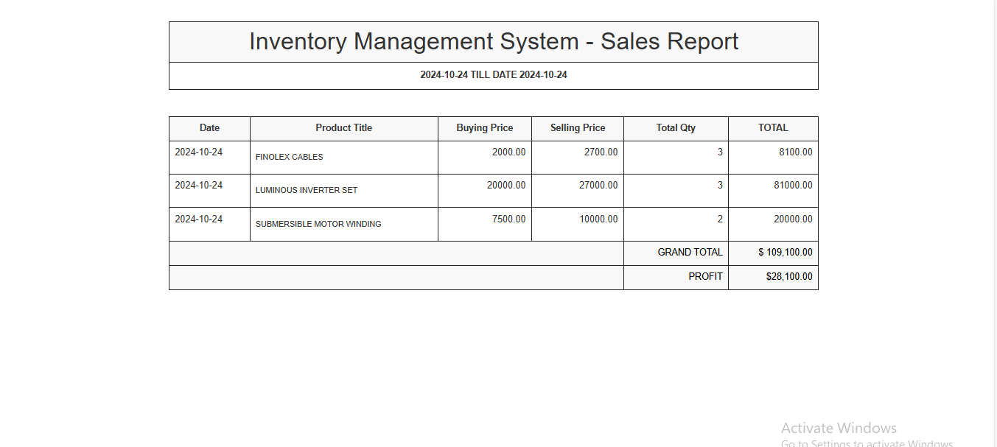

***7.2 Monthly Sales***

* *Description: Provides a summary of sales on a month-by-month basis, allowing businesses to track monthly performance.*
* ***Key Features:***
  + *Automatically generate monthly sales reports.*
  + *Compare performance across different months.*
* ***Benefits:***
  + *Helps identify seasonal trends and plan for future sales strategies.*

***7.3 Daily Sales***

* *Description: Offers insights into daily sales activities, highlighting peak periods and product performance.*
* ***Key Features:***
  + *View daily sales performance.*
  + *Filter sales based on specific products or categories.*
* ***Benefits:***
  + *Useful for identifying top-performing products and peak sales times.*

***Screenshots and Explanation***

***Example Screenshots:***

1. ***Dashboard:***
   * *Displays key statistics like total sales, products in stock, and recent transactions in a clean, visual format. Charts showing daily and monthly sales trends will also be included.*
2. ***User Management:***
   * *Showcases the page where the admin can add or manage users, illustrating the fields available for entering user details and assigning roles.*
3. ***Product Management:***
   * *Displays the table showing all products, including name, category, stock level, and price. An example of the "Add Product" page where users input product details.*
4. ***Sales Reports:***
   * *Example of the monthly sales report page, showcasing data filters and the display of total revenue for each month.*

***. Media Files (5.0)***

* *Description: The media files module allows users to upload and manage media related to products, such as images and promotional content.*
* ***Key Features:***
  + *Upload and manage images for each product.*
  + *Organize and tag files for easy search and access.*
* ***Benefits:***
  + *Enhances the visual representation of products in the system.*
  + *Simplifies media management by centralizing it in one location.*

**

***The Inventory System is comprised of the following key features of Special users:***

***1. Dashboard (1.0)***

* *Description: The dashboard serves as the main control panel for the entire system. It provides users with a high-level view of the most critical inventory metrics in real-time. From here, admin can view sales trends, stock alerts, and other important notifications.*
* ***Key Components:-***
  + *Real-time stock levels.*
  + *Sales performance at a glance.*
  + *View for low-stock or out-of-stock products.*
  + *Quick access to different sections of the system.*
* ***Benefits:***
  + *Helps users make quick decisions by providing an overview of the most important metrics.*
  + *Reduces time spent navigating the system by centralizing information.*

**

***. Categories (3.0)***

* *Description: This feature helps to categorize products into different groups based on their type, use, or other characteristics, making inventory management more organized and searchable.*
* ***Key Features:***
  + *Create new product categories (e.g., Electronics, Clothing, Food).*
  + *Edit existing categories.*
  + *Assign products to relevant categories.*
* ***Benefits:***
  + *Improves product searchability and classification.*
  + *Helps in generating category-based reports for better insights into stock and sales.*

**

***4. Products (4.0)***

* *Description: The products module is essential for managing all the items within the inventory, allowing the addition and modification of product details, stock levels, and prices.*



***4.1 Manage Products***

* *Description: This feature allows users to view, edit, or delete products already present in the system.*
* ***Key Features:***
  + *View all products in a tabular format with details like product name, category, stock level, and price.*
  + *Edit product information such as price, stock quantity, or descriptions.*
  + *Delete obsolete or discontinued products.*
* ***Benefits:***
  + *Provides full control over product inventory.*
  + *Ensures the system is always up-to-date with the latest product details.*

***4.2 Add Products***

* *Description: This module facilitates the addition of new products to the system, along with all necessary details like name, price, stock, and category.*
* ***Key Features:***
  + *Add product details such as name, SKU, price, category, and initial stock.*
  + *Upload product images and other media.*
* ***Benefits:***
  + *Simplifies the process of entering new products into the system.*
  + *Ensures accuracy in product tracking from the moment they are added.*

***The Inventory System is comprised of the following key features of users:***

***1. Dashboard (1.0)***

* *Description: The dashboard serves as the main control panel for the entire system. It provides users with a high-level view of the most critical inventory metrics in real-time. From here, admin can view sales trends, stock alerts, and other important notifications.*
* ***Key Components:-***
  + *Real-time stock levels.*
  + *Sales performance at a glance.*
  + *View for low-stock or out-of-stock products.*
  + *Quick access to different sections of the system.*
* ***Benefits:***
  + *Helps users make quick decisions by providing an overview of the most important metrics.*
  + *Reduces time spent navigating the system by centralizing information.*

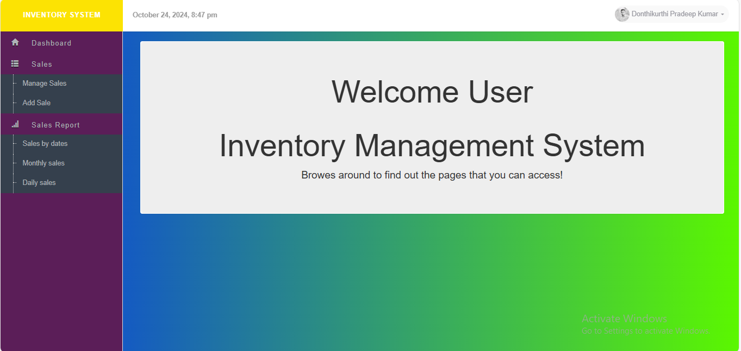

***6. Sales (6.0)***

* *Description: The sales module is critical for tracking and managing all sales transactions within the system. It ensures that every sale is recorded with details, providing transparency and accuracy.*

**

***6.1 Manage Sales***

* *Description: This module lists all sales made in the system, allowing users to view, edit, or delete transactions.*
* ***Key Features:***
  + *View sales in a tabular format, including details such as product sold, quantity, and total amount.*
  + *Search for specific transactions based on date or product.*
  + *Edit or delete incorrect sales records.*
* ***Benefits:***
  + *Provides easy access to all sales records, ensuring accuracy in reporting and management.*

***6.2 Add Sales***

* *Description: This feature allows users to record new sales into the system manually.*
* ***Key Features****:*
  + *Enter sales details such as product, quantity, price, and customer information.*
  + *Automatically update stock levels based on sales.*
* ***Benefits:***
  + *Ensures every transaction is accurately recorded.*
  + *Automates the inventory adjustment process.*

***7. Sales Reports (7.0)***

* *Description: The sales reports module offers detailed reporting features, helping users analyze sales performance over different periods.*

***7.1 Sales by Date***

* *Description: This report generates sales data filtered by specific date ranges.*
* ***Key Features:***
  + *Generate reports for any custom date range.*
  + *View total sales, number of products sold, and revenue.*
* ***Benefits:***
  + *Helps analyze sales trends over specific time periods for better forecasting.*

**

***7.2 Monthly Sales***

* *Description: Provides a summary of sales on a month-by-month basis, allowing businesses to track monthly performance.*
* ***Key Features:***
  + *Automatically generate monthly sales reports.*
  + *Compare performance across different months.*
* ***Benefits:***
  + *Helps identify seasonal trends and plan for future sales strategies.*

***7.3 Daily Sales***

* *Description: Offers insights into daily sales activities, highlighting peak periods and product performance.*
* ***Key Features:***
  + *View daily sales performance.*
  + *Filter sales based on specific products or categories.*
* ***Benefits:***
  + *Useful for identifying top-performing products and peak sales times.*

*THE PROCESS:*

*My project consist of Frontend by using html,css, javascript and for backend we used php for interacting with the database such as crud operations for creating,read,update,deleting operaions.*

*We created component by components. for database connection credentials, config file, for connection- database.php, for repeated operations created functions and stored in functions.php, for loading the located directory file, I used load.php, for session – session.php,*

*For common sql queries with php – sql.php, for media related queries- upload.php.*

*There are three types of layouts,*

1. *Admin Layout*
2. *Special Layout*
3. *User Layout*

*Based on the login credentials, by session, we allowed user to navigate to belonged layout.*

*DIFFICULTIES FACED:*

1. *Repeated error when editing and deleting due to functions and sql queries.*
2. *Connection to database, and xamp server.*
3. *While creating the session and navigating to its regarding page as new to sessions.*
4. *Took a lot a time and adjusting the frontend modules*
5. *As we built module by module. Sometimes I felt difficult to debug.*

***Project Completion Status***

* ***Completed Features:***
  + *Dashboard (1.0) – Fully implemented.*
  + *User Management (2.0) – Fully functional.*
  + *Categories (3.0) – Completed.*
  + *Products (4.0) – Fully implemented.*
  + *Media Files (5.0) – Completed.*
  + *Sales (6.0) – Implemented.*
  + *Sales Reports (7.0) – Fully functional.*
* *All core features are completed and functional. The system is ready for deployment with the ability to manage users, products, sales, and generate reports.*

***Project Pendency Status***

* ***Pending Features:***
  + *Further integration with external e-commerce platforms.*
  + *Automation of notifications for stock thresholds and reorders.*
  + *Custom reporting templates.*
  + *Payment gateway integration for automatic sales processing.*

***Team Performance***

* *Development Team: Effectively built the system within the set timelines, showing strong skills in managing the project scope.*
* *Design Team: Created an intuitive, easy-to-navigate UI that provides a great user experience.*
* *QA Team: Conducted thorough testing, identifying and resolving all critical bugs, ensuring system reliability.*
* *Project Management: Efficiently managed task assignments, timelines, and coordinated across teams to meet the project deadlines.*

*References:*

* *Chat gpt :- https://chatgpt.com/*
* *Code With Harry https://www.youtube.com/watch?v=PaDgry5QAt4&list=PLu0W_9lII9aikXkRE0WxDt1vozo3hnmtR*