OptoFidelity PIT

User Manual
Version 1.0

Contents
1 Introduction 3
2 Setting up PIT 4
3 Managing Power and Interrupt Connectors 5
4 Connecting DUT to PIT 7
5 Change history 8

Introduction
This document describes how to use OptoFidelity PIT (Fig. 1) for communicating with a DUT (device under test) over I2C or SPI interface. A basic setup for PIT can be seen in a flow chart in Fig. 2.
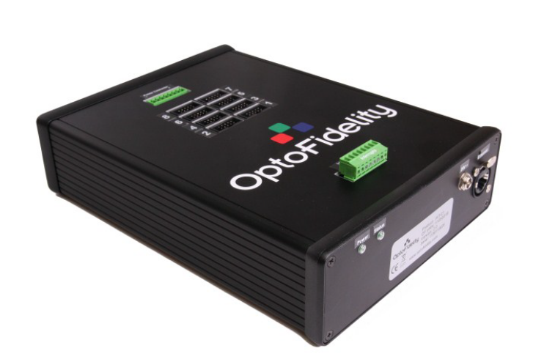
Figure 1: OptoFidelity PIT.
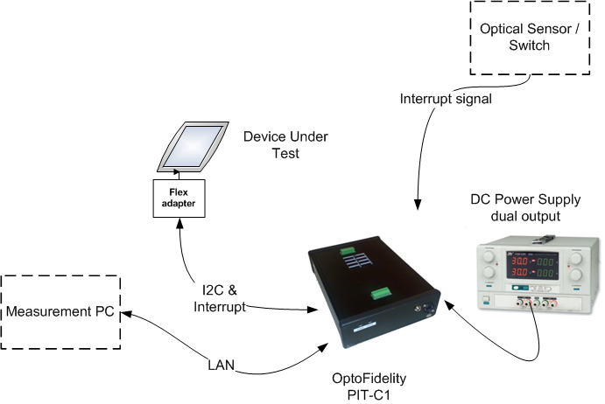
Figure 1: A basic setup for PIT.

Setting up PIT
PIT needs to be powered up and necessary connections are required before operation. Setting up PIT can be done as follows.
- Connect 24 VDC power adapter/cable to the front panel of PIT and turn ON/OFF switch on. As the switch is on, the power led turns on (green light). When the status led starts blinking, the PIT is ready for operation (Fig. 2).
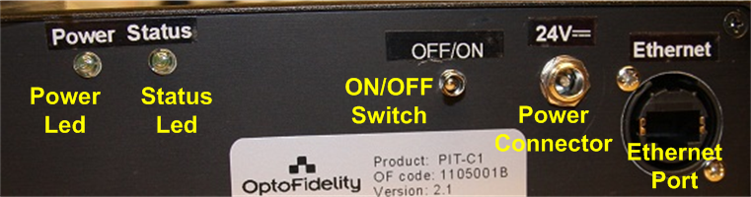
Figure 2: Front panel of PIT-C1.

- Connect PIT to a PC by Ethernet cable. Connect other end of the cable to Ethernet port of PIT and other end to Ethernet card port in the PC.
- Make sure that IP settings are according to PIT specifications. This can be done as follows.
  - Select Start → Control Panel → Network and Internet → Network and Sharing Center.
  - Select Local Area Connection to which the PIT is connected. Select Properties.
  - Select Internet Protocol Version 4 (TCP/IPv4) from the list and click Properties.
  - Make sure that the settings are as follows (Fig. 3):
    - Select Use the following IP address
    - IP address: 10.10.10.1
    - Subnet mask: 255.255.255.0
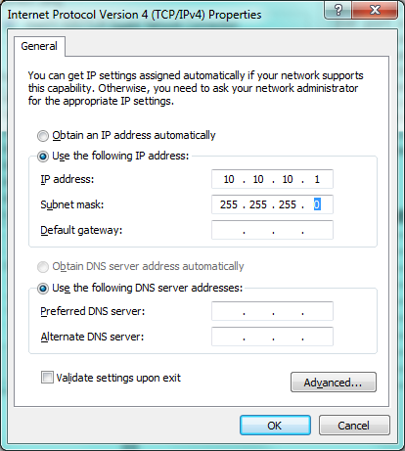
Figure 3: Correct IP settings for PIT.

Managing Power and Interrupt Connectors
PIT includes power and interrupt connectors. Power connector can be used for powering the DUT from an external power source. This is usually a dual output power supply. Interrupt connector can be used for obtaining time stamps from external interrupt sources. Typical interrupt sources include optical sensors (1-finger tool) and switches (2-finger activation device). The setup for power connector and dual output power supply can be done as follows.
- Connect Panel V cable to power connector as follows (Fig. 4).
  - Panel V + → Pin 1 in power connector.
  - Panel V - → Pin 2, 4, 6 or 8 in power connector.
Connect IO Voltage cable to power connector as follows.
- IO Voltage + → Pin 5 in power connector.
- IO Voltage - → Pin 2, 4, 6 or 8 in power connector.
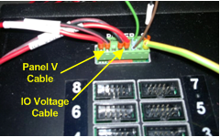
Figure 4: Power Connector with Panel V and IO Voltage cables connected.

- Connect other end of Panel V cable to the power supply (Panel V port is commonly branded, Fig. 5)
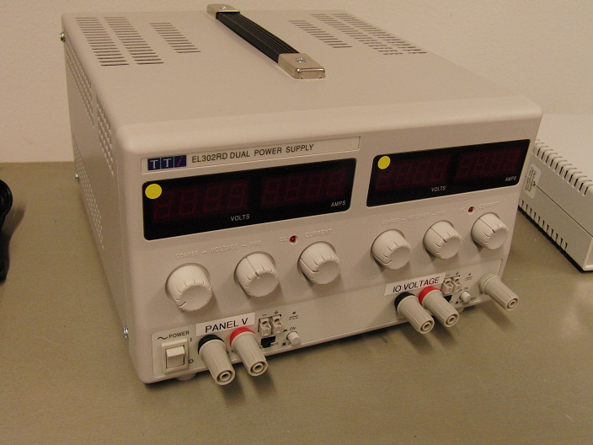
Figure 5: A dual output power supply with Panel V and IO Voltage ports branded.

The setup for interrupt connector can be done as follows.
- Connect interrupt wires to the first pins in the interrupt connector.
  - If using 2-finger activation device, the interrupt wires are connected as follows (Fig. 6):
F1 wire → Pin 1 in interrupt connector.
F2 wire → Pin 2 in interrupt connector.
GND wires → Pin 2, 4, 6 or 8 in power connector.
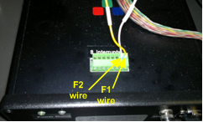
Figure 6: Interrupt wires of 2-finger activation device connected to Interrupt Connector.

  - If using 1-finger tool, the interrupt wires from optical sensor are connected as follows (Fig. 7):
Interrupt 1 wire → Pin 1 in interrupt connector.
GND wire → Pin 2, 4, 6 or 8 in power connector.
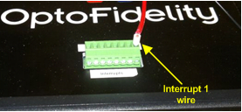
Figure 7: Interrupt wire of optical sensor connected to Interrupt Connector.

- Make sure that 2-finger activation device/1-finger tool have been setup correctly.

Connecting DUT to PIT
When connecting a DUT to PIT in order to communicate through I2C or SPI interface, correct pins are needed to be connected from a DUT to PIT communication ports. Commonly, the pins needed to be connected from DUT to PIT are the following.
- I2C: SDA, SCL, INT, VREF, GND, (RESET)
- SPI: MOSI, MISO, SCK, INT, VREF, IO Low Voltage, SS, GND

There are commonly two options to connect DUT and PIT:
- By a flex adapter and standard flex adapter interface cable. By the flex adapter, the pinout from DUT is made equivalent with PIT ports. This way, the connection can be made with a standard cable. PIT with 8 flex adapter interface cables can be seen in Fig. 8.
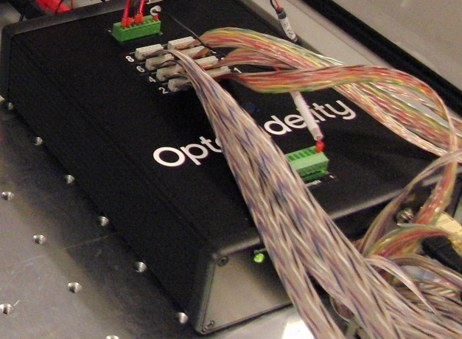
Figure 8: PIT with 8 flex adapter interface cables connected.

- By a custom cable. In this case, the other end of the cable is connected to PIT port and other end is modified based on the DUT pinout.

For more information about pinouts and connections, see OptoFidelity PIT-C1 Quick Reference guide.

Change history
Ver. | Status | Date | Author | Remarks
1.0 | Draft | 30.10.2012 | VHE | First draft version

