Power*Architect User's Guide
SQL Power Group
Copyright © 2006, SQL Power Group, Toronto Canada. All rights reserved.
Revised April 12, 2006 12:02:42

Introduction

SQL Power Group's Power*Architect is a versatile tool for the busy data mining practitioner. Power*Architect lets you select from multiple databases on different machines and different database formats. It offers facilities to examine databases, display relationships, modify data structure, and more. It combines some of the best features of competing products.

Basic Concepts
Project – a Power*Architect project consists of a view of multiple databases; you can load and save a Project to work on it at leisure.
Driver – Most programs need a distinct driver program to communicated with each different type of database. Power*Architect uses Java-based drivers, which normally come from the database vendor in the form of "JAR" files . You need to inform Power*Architect about each driver before you can use it; do this from the User Preferences panel, under JDBC Drivers (just click Add and browse to the Jar file for your driver). If you do not have the JDBC driver for a given database on your network, they are usually available from the database vendor, or you can find a directory of drivers for many database on Sun's website at http://developers.sun.com/product/jdbc/drivers

Playpen – This is the main area of the window, in which you manipulate tables and relationships. You can play here to your heart's content, knowing it will not be saved until you ask the program to save.

Who this book is for
TODO: reword this section
This book is a step-by-step guide on how to use the Power*Architect to its full functionality. It covers topics from how to install the Power*Architect to using the functions of Power*Architect.
This book assumes you are familiar with basic database terms. If you meet any terms that you are unfamiliar with, please refer to the Glossary at the end of this book.
This book also assumes you are familiar with basic computer operations.
We also assume you have SQL Power's Power*Architect software installed on your desktop; if not, please refer to the Installation Guide.

Installation Guide
TODO: Add in Installation Guide

How to Use the Power*Architect
Power*Architect User Interface

Database Tree – This is where you can add, maintain and explore imported connections. It uses a tree-node dropdown method. Therefore to explore inner components, you could expand components within this container if needed.
Playpen – This is the main area of the window, in which you manipulate tables and relationships. You can play here to your heart's content, knowing it will not be saved until you ask the program to save.
Playpen Components – These are the components that can go into the playpen. The playpen components are Tables and Relationships.
TODO: Add more terms?
Setting up the User Preferences
When getting started, you need to set up some files and drivers to use the full functionality of the Power*Architect. If you have not already done so already, please go to “User Preferences” under the File menu to configure the Power*Architect. This will pop up a dialog (see below) where you can specify your file locations.

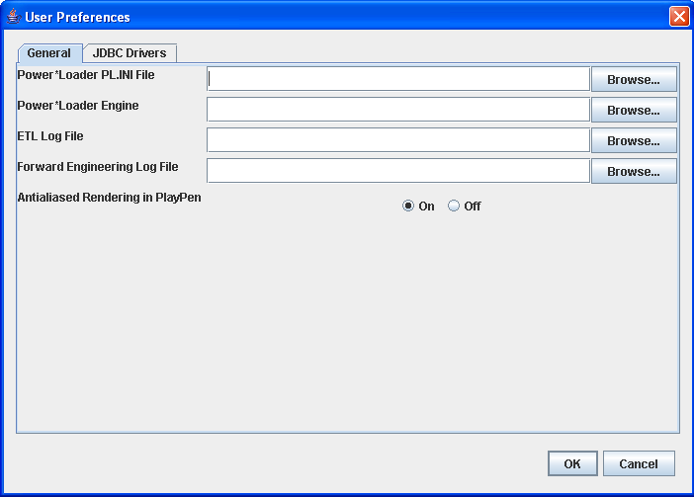
The PL.INI file is your general preferences file; it stores the database connections that you will set up in XXX. If you leave this location blank, the Architect program will prompt you to use a default location when you start it up. If you have a PL.INI file from other SQL Power applications you should generally use the same file, as doing so will save you from having to re-enter all your database connection information.
The Power*Loader Engine setting is optional; if you are not using the Power*Loader enging you can leave this blank; if you are, you should set it to the location where the Power*Loader engine binary is installed on your system.
The next two settings are log file locations for logs that will be written when you use the ETL and Forward Engineering functions of the application.
The final setting controls the operations of graphics in the PlayPen. Turning “antialiased rendering” on may give better display of the graphical database layouts shown in the PlayPen, but may use more CPU time in the process.

JDBC Drivers
Besides setting up these file locations, it is also necessary to set up the JDBC drivers. JDBC Drivers are needed to access most databases. Click on the “JDBC Drivers” tab and specify the location of the JDBC drivers on your system's local disk (or network disk). If you need more information on JDBC drivers, refer to the Basic Concepts of this manual on page 2.
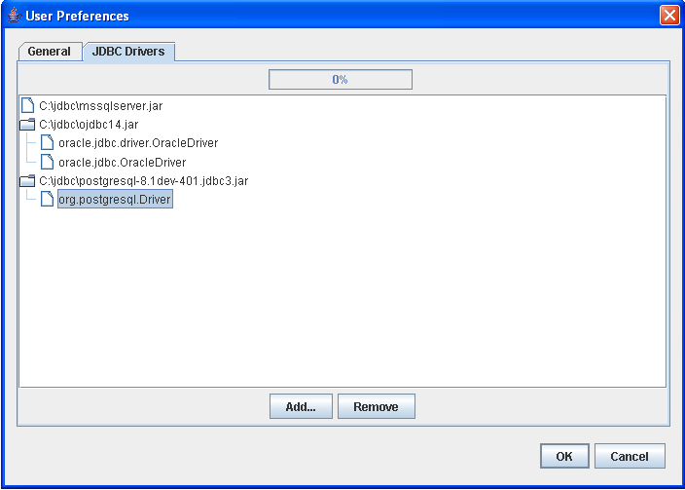
(TODO: get a better screen shot...the current one contradicts the idea of usually being able to find the jdbc driver in the database folders)
Using Diagram Components

Creating New Tables
There are a few ways to create new tables in Power*Architect. The first way is to click on the New Table Icon on the sidebar menu. The cursor turns into a “+” cursor indicating the mode change. Simply click on the playpen on the spot you desire to place the new table at. The second method to create a table is to right click on the playpen and select the “New Table” option. A newly created table will then be placed at the point of the right click. A third way is to hit T on the playpen.

Editing Tables
To edit a table, right click on the table title and select “Table Properties”. This pops up the Table Properties dialog.

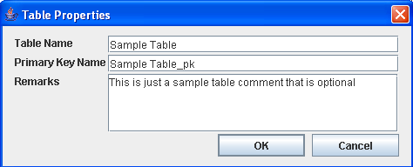
In this dialog, you can:
- Change the name of the table
- Rename the primary key section of the table
- Add comments/notes about the table

Creating a New Column
First select the table the new column will be placed in. Click on the "Insert Column" button and a column is created in the selected table. Another way to add a new column is to right click on a table and select the "New Column..." option. The new column will be added to the table below the selected column. It will be palced at the bottom of the table if no columns are selected. If a table has existing columns in the primary key and you wish to create new columns within the primary key, select a column that is already in the desired primary key and then create a new column. The newly created column will be placed within the primary key as well.

Editing a Column
Select the desired column, right click and select "Column Properties". The Edit Column Properties dialog pops up. Or you can, once the column is selected, click the "Edit Column" button on the Playpen toolbar.
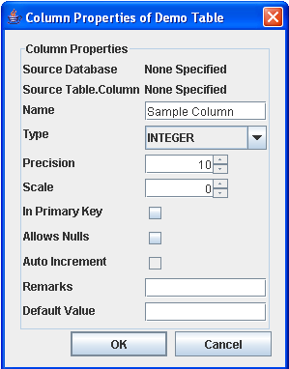

In this dialog you can:
- Rename the column
- Change the type of data the column holds
- Set the precision of the data
- Set the scale
- Indicate if the column is in the primary key or not
- Indicate if the column should handle null information or not
- Indicate if auto increment is allowed or not
- Add additional comments about the column
- Set a default value for the column

A special feature that the Power*Architect has is that if a column orginated from a database, the Power*Architect is able to realize the database and table it orginated from.

Dragging Columns
The Power*Architect allows you to drag columns within a table's key and from table to table freely. Simply select the desired columns and drag them into the desired destination. For now, only one column can be moved at a time.

Creating Non-Identifying and Identifying Relationships
To create a relationship, select the desired type of relationship on the Playpen ToolBar. The non-identifying relationship icon is (shortcut key is shirt+R). The identifying relationship icon is identified by (shortcut key is R ).The cursor changes to the "+" cursor to indicate the mode change. (TODO: might want to use a different cursor so the user can differentiate betwen creating tables and creating relationship) First click on the parent table and then click on the child table. (TODO: We need some kind of indicator to show that a parent table has been selected) Once this has been done, the relationship will be created, and will appear as a link between the two tables.

Editing a Relationship
Select the desired relationship and right click on the relationship. Choose the "Relationship Properties" options. This can also be done by selecting the relationship and clicking on the relationship properties button .In both cases, the Relationship Properties dialog will appear.
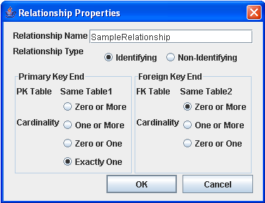
Here you can:
- Rename the relationship
- Choose the relationship type
- Change the primary key end cardinality
- Change the foreign key end cardinality

Selecting Multiple Items in the Playpen
There are two ways to select multiple items in the playpen. One way is to hold down the shift key or the ctrl key as more items are being selected. The alternative method is to use the selection box.

Relocating Objects in the Playpen
The Power*Architect allows diagram objects to move around freely in the playpen. To do so, first select the items you want to move in the Playpen. Click and hold on one of the selected item and drag the items to a desired spot on the playpen.

Deleting Diagram Components
Select the desired diagram components on the playpen and click on the delete items button on the Playpen Toolbar. It is also possible to delete the selected items by right clicking on one of the components and selecting "Delete Selected".
(TODO: Currently if a column and a table/relationship is selected, deleting the items will delete the entire table the column belongs to, this seems to be an undesired behaviour)
Database Usage in Power*Architect

Adding a New Connection to the Power*Architect
To add a new connection, go to "Add Connections" under "Connections" and select "New Connection.." at the top. The other method is to right click a white space on the Database Tree and select "New Connection" under "Add Connections". Both ways open up this dialog:
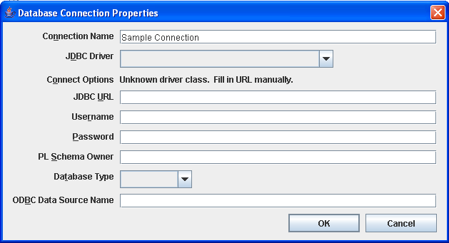
Fill in the requirements based on the JDBC driver you selected. When you are finished, press the OK button. Any new connection will automatically be added in the user-preference.
(TODO: If the user has too many connections [more than the height of the Architect window] , the architect does not have the ability to show all of them)
(TODO: We might want to let users delete connections out of the list of playpen they could choose from)

Adding an Existing Connection
Right click on empty space in the Database Tree and go to "Add Connection", there it shows all databases that were previously stored on the Architect

Editing Database Connection Properties
Select the database connection you wish to change and go to "Connections" and select the option "Connection Properties..", this leads you to the Connection Setting dialog. An alternate solution is to right click on the database and select "Connection Properties..." option.

Removing a Database Connection
Select the database connection you wish to change and go to "Connections" and select the option "Remove Connection..". Right clicking on the database connection and selecting "Remove Connection.." will perform the same action.

Setting the Current Project Database
The project database can be set to an existing database connection or the user can create a new connection for it as well. Setting the project database can be achieved in a few ways. The first method is to right click on any empty space on the playpen and go to "Set Target Database". Another option is to right click on the Target Database (the target database can always be identified by this icon: )and choose "Set Target Database" from there.

Navigating through the Database Tree
The Database Tree works like a tree-dropdown model. Clicking on the (TODO: add the icon here) will cause the component to expand display the items under that specific component. Each item will have an unique icon beside its name to identify the type of object it is. The diagram below shows what each icon mean:
Icon | Representation
 | Database
 | Catalog
 | Schema
 | Owner
 | Table
 | Relationship

Moving Items from the Database Tree
To copy items from the Database Tree to the playpen, simply select the desired items in the tree and drag them ontothe playpen. Depending on the size of the items dragged onto the playpen, it will take some time to load.

Find / Replace Function
What It Does:
This functions searches the whole playpen for any relevant matches with the search constraints and dispalys the resulting matches. The user can request for those items to be focused on the screen.

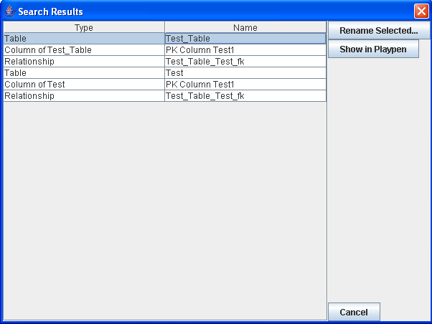
How to Use Find / Replace Function:
Go to "Edit" under the menu bar and click on Find/Replace option. This shows the Find/Replace function. In this window, enter the search constraints and press "OK" when you are finished. This will popup a new window with your search result in a chart format

You can rename the component by selecting the column in the list and clicking on "Rename Component". You can also have Power*Architect focus on a certain component by selecting the component in the list and press the "Show in Playpen".

Forward Engineering and Compare Data Model
These two functions are similar; they both involve using the PlayPen (usually) and generating SQL. The Forward Engineer function always creates a SQL script to generate a database identical with the complete current project (current PlayPen contents). The Compare DM function can output either an English-language description or a SQL script describing the differences between two databases, or stored projects, or one of these and the PlayPen.

Forward Engineering
What It Does:
Forward Engineering creates a SQL Script that can be run to update or put the components on the existing Playpen into a database

How to Use Forward Engineering
First set the target connection to the database you want the changes to be made in. After that has been done, go to "Tools" and click "Forward Engineering". Another way is to press the "Forward Engineering" button at the top. This pops up a dialog that looks similar to the one below:
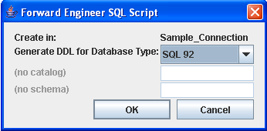
Fill in the fields as necessary and hit "OK" when you are done. Depending on the situation, a dialog warning you of possible side-effects of creating the script may pop up. Finally a script that would create the playpen will be displayed. It is the same dialog used in CompareDataModel-Part 2- In SQL Script.

Compare Data Model Function
What It Does:
The Compare DataModel Function takes two databases or Power*Architect projects (or one of each) or the current PlayPen, and compares and contrasts the structure of the two database/projects.

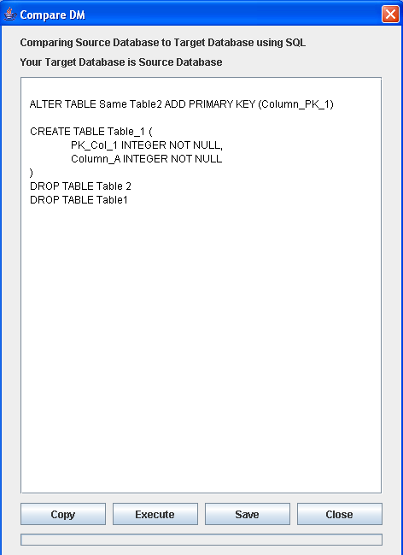
How to use Compare Data Model Function:
Copies the text onto the system clipboard
Runs the SQL Script
Saves the Script in either .sql or .ddl format
Part 1:
To bring up the Compare Data Model Function, either go to "Tools" and click "Compare Data Model" or just click the "Compare Data Model" icon on the project toolbar. This will bring up the main Compare Data Model window. Here select the source and target models you want to compare and contrast. You can choose either the current playpen, an existing database or select a saved project file function. If one of or both the source and the target has invalid models, the start button will not enable. The similarities and differences can be displayed either in SQL Script language or in English.

Part 2:
In English
If this option is selected, a side by side document will be displayed stating the similarlities and differences of the source and target in plain english. The left text gives English descriptions to make the source database look like the target database. In addition to the text, they are also colour coded.

You can copy the text to the clipboard by pressing the copy button, or save the results to a text file. The diagram below explains what each colour means.

Colour | Explaination of the Colour Code
Black | This component exist in both databases
Green | This component only exist on this database but not the other
Red | This componet does not exist on this database but exist on the other
Blue | This component is a column and is on different keys in the two databases
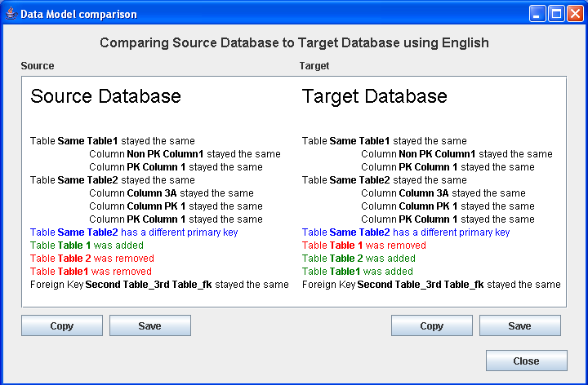
Copies the text onto the system clipboard
Saves the text about the Source Database in a text file
In SQL Script
If this option is chosen, this will produce a SQL Script in the SQL dialect chosen in Step 1 to make the source database look like the target database. You can either copy the results to the clipboard, or save the results in a text file. If the source has a valid connection database, the Execute button will enable and you can directly execute the changes. If the source does not have a valid connection, the execute button is disabled.

AutoLayout
What It Does:
It displays the selected tables (or all tables) in an organized manner.
How to Use AutoLayout:
Select the tables on the playpen that you want to organize and hit the autolayout button at the top. If no table is selected, by default, the program will autolayout every table in the playpen. Note that if only one table is selected, AutoLayout will not do anything; either select two or more tables, or "click away" (not on any table) so that nothing in the Playpen is selected, and click AutoLayout again. Also note that the layout algorithm may produce a few surprises when run with a small number of tables; it works best for a large or medium-sized collection of tables.

Quick Start Wizard
What It Does:
The QuickStart Wizard is a simple five-step process to set up a database using the Power*Loader.

How to Use Quick Start Wizard
To run the QuickStart Wizard, go to ETL and click QuickStart Wizard button under Power*Loader.
TODO: Write the steps in for QuickStart Wizard and maybe add in screenshoots
Step 1
Select the source playpen components you want and click next.

Step 2
Select or create the target database.
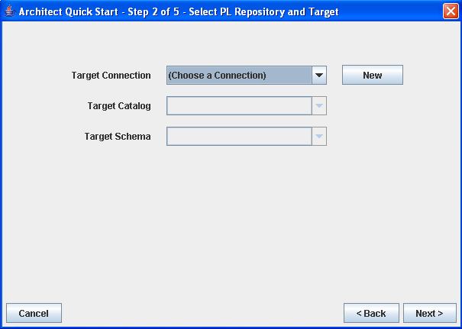

Step 3
Select or create the repository database and fill in any additional information. The JobID must be filled in order to continue.

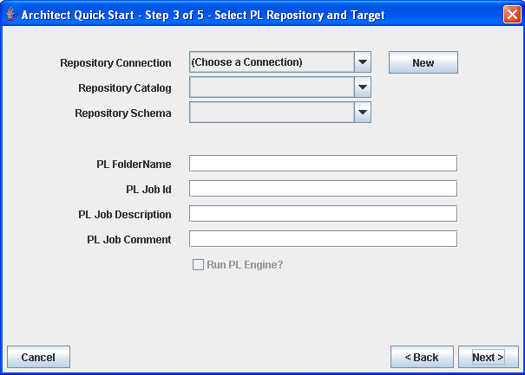

Step 4
A SQL Script will be created; you can review the script and if you wish to execute it, press "Execute"

Step 5
A summary report of the process will be shown

Summary
This is the end of the SQL*Power User's Guide. TODO where to go for more information...

Glossary
This section lists some database-related terms and their meanings.
Column | The set of all instances of a given field from all records in a table.
Database | One or more large structured sets of persistent data, usually associated with software to update and query the data. A simple database might be a single file containing many records, each of which contains the same set of fields where each field is a certain fixed width.
ETL | Extraction, Transforming and Loading – the process of maintaining and transforming data into and out of a relational database.
Foreign key | A column in a database table containing values that are also found in some primary key column (of a different table). By extension, any reference to entities of a different type.  Some RDBMSs allow a column to be explicitly labelled as a foreign key and only allow values to be inserted if they already exist in the relevant primary key column.
JDBC | Java DataBase Connectivity, an unofficial acronym for the "java.sql" package of functionality used to access relational databases from programs written in the Java programming language.
Key | A value used to identify a record in a database, derived by applying some fixed function to the record. The key is often simply one of the fields (a column if the database is considered as a table with records being rows, see "key field"). Alternatively the key may be obtained by applying some function, e.g. a hash function, to one or more of the fields. The set of keys for all records forms an index. Multiple indexes may be built for one database depending on how it is to be searched.
Primary key | The candidate key selected as being most important for identifying a body of information (an entity, object or record).
Record (row) | One or more large structured sets of persistent data, usually associated with software to update and query the data. A simple database might be a single file containing many records, each of which contains the same set of fields where each field is a certain fixed width.
SQL | Originally SEQUEL and still pronounced that way, SQL is the Standard Query Language; a unified language for creating queries that is accepted (with some variations) by almost all relational databases.
Table | A collection of records in a relational database.
Some of hese terms are from FolDoc, "The Free On-line Dictionary of Computing", http://www.foldoc.org/, Editor Denis Howe.

Java Archive files; these are an extension to the file format used by PKZip/WinZip archives
This link is current as of April, 2006

