Fix: Ping Test fails for the external IP of TS-SFTP1 (Linux) machine with message ‘Destination host unreachable’.
Step1: Open PUTTY.EXE

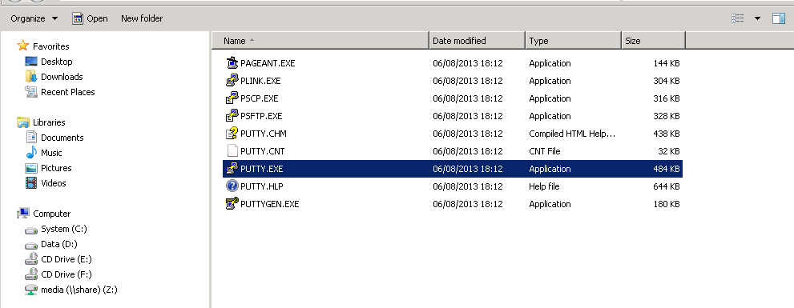

Step2: Enter the Machine IP Open → Click Yes for the Putty Security Alert
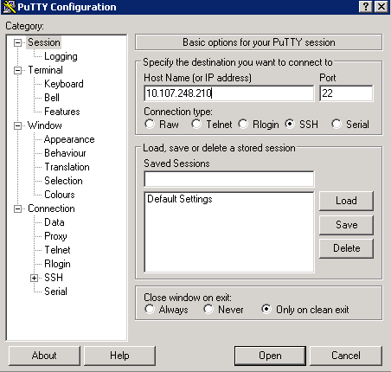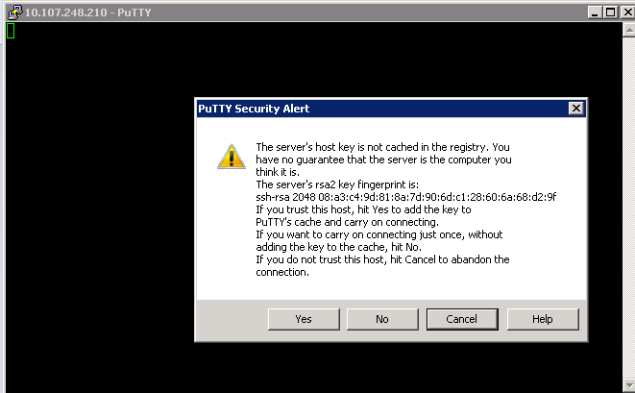

Step3: Login to get the following window
UserName: SFTPClient1, Password: Test1234
More information about the users can be found in the following folder: (D:\src\Deployment\Main\Code\Utilities\SftpServer\setup-sftp)
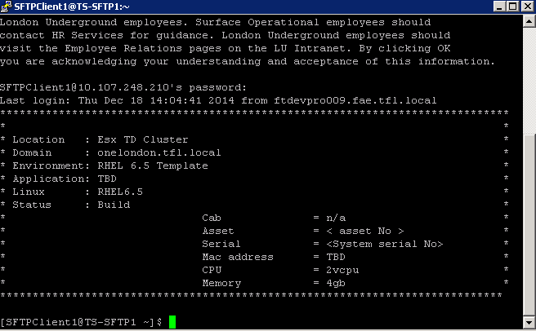
Step4: Change the user to su (super user) ; Password: London2012 to get the following window
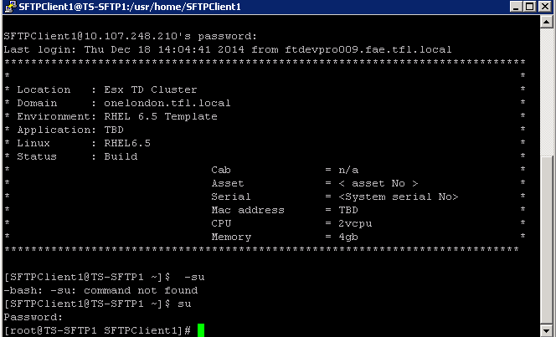
Step 5: cd /etc/sysconfig/
Step 6: type: nano iptables
- nano iptables
Step6: Open the samba-filewall-rules from (D:\src\Deployment\Main\Code\Utilities\SftpServer\setup-sftp)
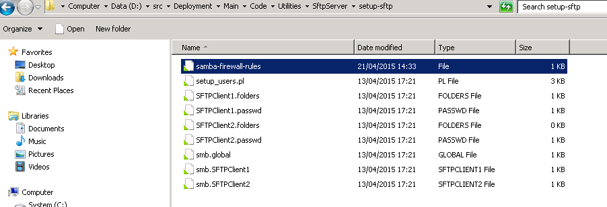
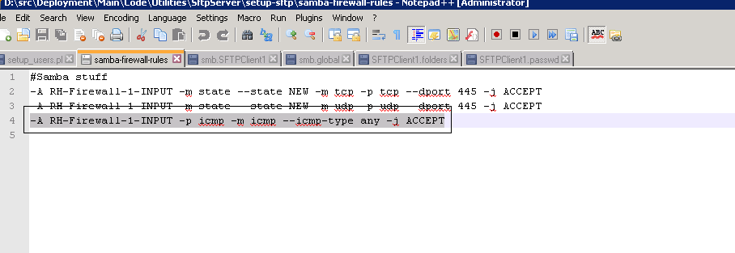
Step7: Add the following line after #Samba stuff or #Allow Ping comments and save file iptables
-A RH-Firewall-1-INPUT -p icmp -m icmp --icmp-type any -j ACCEPT
CTRL+x and Yes to save
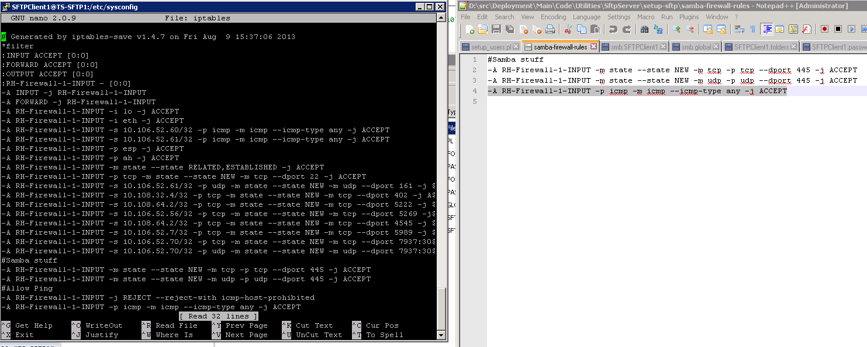
Step8: Enter the following command to restart iptables (you should get all green OK) as below
/sbin/service iptables restart
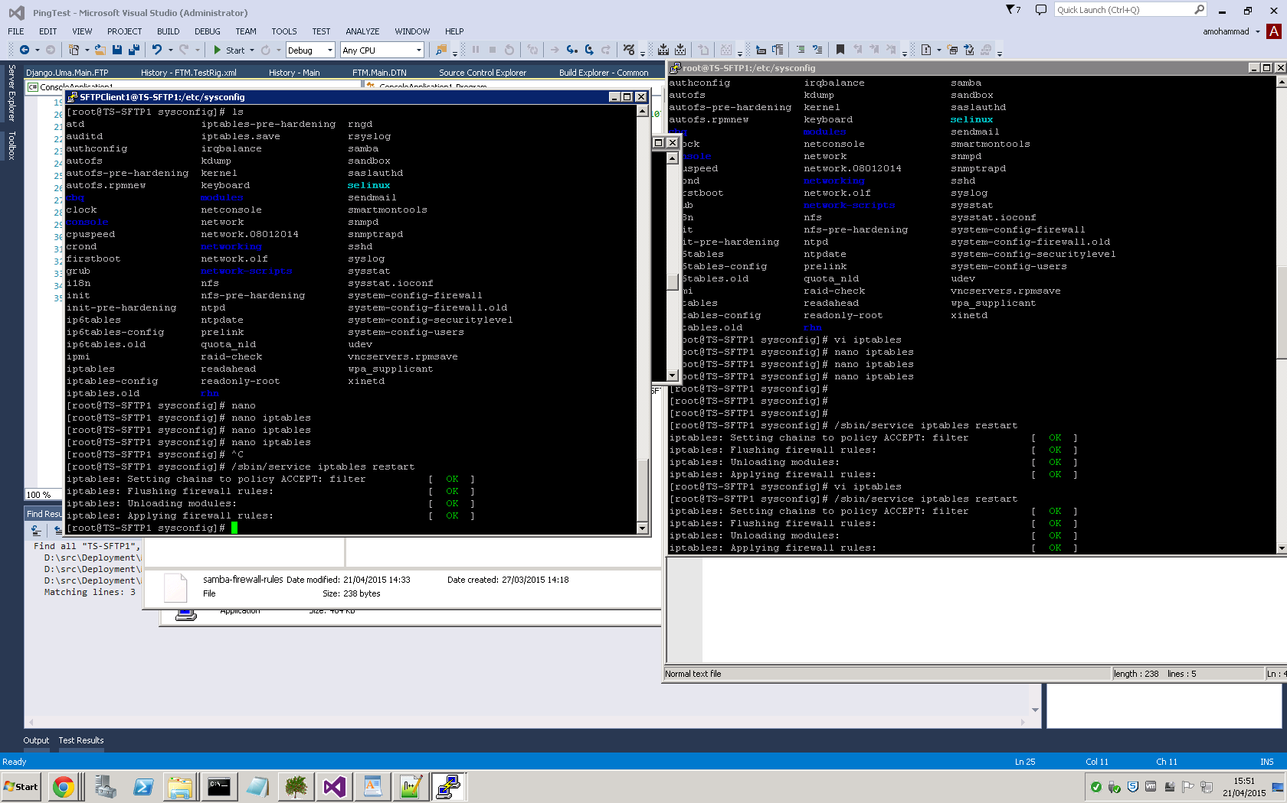
Step9: Test by Pinging the machine with IP address, try the above step8 again if ping fails in the first intstance.
Step10: Recapture the rig to the baseline

