# 통합 형상관리

Writers: 2012-09-05최보라

Updated by:

Published: 2012-09

Table of Contents

통합 형상관리 1

History 3

Overview 3

목적 3

수집 방법 3

수집 내역 3

형상관리 내역 3

JOB정보 4

보안 내역 4

Database운영 정책 4

성능 모니터링 수집 4

Conter수집 항목 5

ERD 8

서버 정보 8

로그인 정보 10

이관 관련 12

보안관련 13

## History

|  |  |  |
| --- | --- | --- |
| 일자 | 작성자 | 변경내역 |
| 2012-09-04 | 최보라 | 프로젝트 설명 초안 작성 |

# Overview

2010년 AUCTION, GMARKET가 통합되어 EBAY KOREA가 되면서 DBA팀에서는 양사 db의 형상관리를 위해 프로젝트를 시작했음.

형상관리는 양사의 db 정보, 서버정보를 수집하여 문제가 되는 상황을 미리 대비하기 위함이다.

# 목적

* DB의 HELTH CHECK의 기반 마련
* DATABASE SERVER 정보 관리
* DATABASE 성능CONTER 수집 자동화
* DBA의 운영 업무시 의사결정 할 수 있는 기초 데이터 생성
* 로그인,JOB 을 수집하여 운영에

# 수집 방법

* 최종 DB
* 형상관리 :DBADB1.ADMIN
* 성능 COUNTER : DBADB1.PERFLOGS
* 모니터링 해야 하는 주요 DB SERVER의 데이터를 SSIS를 이용하여 수집하여 대상 DB에 적재 한다.
* 모니터링 대상 서버는 ADMIN에 있는 SERVER_INFO 테이블을 참고한다.

각각의 수집 하는 서버가 틀리므로 연결 정보를 확인 해서 수집하는 서버를 확인 하면 된다.

새로운 서버가 추가될 때에는 지마켓의 dba, 옥션은 dbadmin에 필요한 스크립트를 생성해야 한다.

스크립트는 같은 tip 사이트에 등록되어 있다.

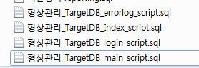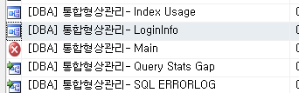

* 통합 현상 관리 Main

exec up_dba_select_connectionstr @site = 'G', @type ='INFO'

통합 형상관리-Index Usage

exec up_dba_select_connectionstr @site = 'G', @type ='INDEX'

* 통합 형상관리-SQL ERRORLOG

exec up_dba_select_connectionstr @site = 'G', @type ='INFO'

* 통합 형상관리-LoginInfo

exec up_dba_select_connectionstr @site = 'G', @type ='LOGININFO'

* 통합형상관리-Query Stats Gap

select convert(int,s.server_id) as server_id, s.server_name, convert(int,i.instance_id)

as instance_id, i.instance_name, s.server_public_ip, i.instance_port

from dbo.SERVERINFO s with(nolock) join dbo.INSTANCE i with(nolock)

on s.server_id = i.server_id

where i.monitor_yn = 'Y' and s.site_gn ='G' and dbms_ver in ('SQL 2005', 'SQL 2008')

order by server_id

# 수집 내역

## 형상관리 내역

|  |  |  |
| --- | --- | --- |
| 내역 | SP 명 | Table |
| 디스크 Size | up_dba_select_disksize  up_dba_update_disksizehist | DISK_SIZE_HIST  DISK_SIZE |
| Database 정보 | up_dba_select_database_info  up_conf_database_list_today | DATABASE_LIST  DATABASE_LIST_TODAY  DATABASE_LIST_DELETE |
| Database File 정보 | up_dba_select_databasefilelist | DATABASE_FILE_LIST |
| AUTOGROWTH 정보 | up_dba_select_autogrowth_info | AUTO_GROWTH_INFO |
| TABLE Size | up_dba_select_table_size | TABLE_SIZE  TABLE_SIZE_CONFIG |
| JOB 정보 | up_conf_JobInfoCollect | JOBINFO |
| DB Server Config정보 | master.dbo.sysconfigures | SERVERCONFIG |
| DB Server 정보 |  | SERVEROBJECTS |
| Login 정보 |  | SERVERUSERS |
| 접속하는 로그인 계정 | up_conf_LoginInfoCollect | LOGININFO |
| SYSPROTECTS 정보 | SYSPROTECTS | SERVERPROTECTS |
| SERVER Audit 정보 |  | SERVERINFO에 UPDATE |
| 백업 정보 | up_conf_BackupHistoryCollect | BACKUPHISTORY |
| SERVER ERRORLOG | up_mon_collect_read_errorlog | SQL_ERROR_LOG |
| LogVLF | up_dba_select_vlf_info | VLF_HIST |
| IDENTITY 컬럼 현황 | up_dba_collect_db_identity_table  up_dba_collect_db_identity_table_indb | DB_IDENTITY_TABLE |
| QUERY STATS | up_mon_collect_query_stats_gap | QUERY_STATS_GAP |
| INDEX 사용현황 | up_dba_select_index_usage | INDEX_USAGE |

## JOB정보

## 보안 내역

* TEST,스테이징 DB 개인 정보 컬럼 처리 수집
* Linked 사용 SP 수집 가능 setting
* Database SQL 계정 관리

## Database운영 정책

* 옥션 이관 정책
* SP 검수툴
* Swat용 Error Reprot

## 성능 모니터링 수집

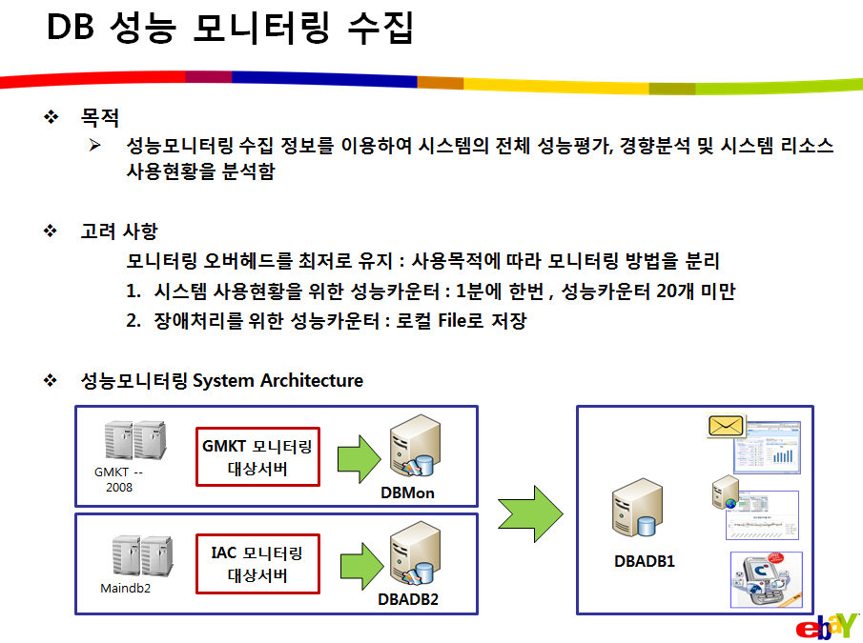문서: [성능 모니터링 수집방안_20100301.pptx 참고](http://tip.ebaykorea.com/sites/Tech/DBA/Project/DB_%ED%98%95%EC%83%81%EA%B4%80%EB%A6%AC/%EC%84%B1%EB%8A%A5%20%EB%AA%A8%EB%8B%88%ED%84%B0%EB%A7%81%20%EC%88%98%EC%A7%91%EB%B0%A9%EC%95%88_20100301.pptx)

### Conter수집 항목

|  |
| --- |
| **통합** |
| \LogicalDisk(*)\* |
| \Memory\Available MBytes |
| \Memory\Cache Bytes |
| \Memory\Cache Bytes Peak |
| \Memory\Cache Faults/sec |
| \Memory\Commit Limit |
| \Memory\Committed Bytes |
| \Memory\Demand Zero Faults/sec |
| \Memory\Free System Page Table Entries |
| \Memory\Page Faults/sec |
| \Memory\Page Reads/sec |
| \Memory\Page Writes/sec |
| \Memory\Pages Input/sec |
| \Memory\Pages Output/sec |
| \Memory\Pages/sec |
| \Memory\Pool Nonpaged Allocs |
| \Memory\Pool Nonpaged Bytes |
| \Memory\Pool Paged Allocs |
| \Memory\Pool Paged Bytes |
| \Memory\Pool Paged Resident Bytes |
| \Memory\System Cache Resident Bytes |
| \Memory\System Code Resident Bytes |
| \Memory\System Code Total Bytes |
| \Memory\System Driver Resident Bytes |
| \Memory\System Driver Total Bytes |
| \Memory\Transition Faults/sec |
| \Memory\Transition Pages RePurposed/sec |
| \Memory\Write Copies/sec |
| \Network Interface(*)\* |
| \PhysicalDisk(_Total)\Avg. Disk Queue Length |
| \PhysicalDisk(_Total)\Avg. Disk sec/Read |
| \PhysicalDisk(_Total)\Avg. Disk sec/Transfer |
| \PhysicalDisk(_Total)\Disk Read Bytes/sec |
| \PhysicalDisk(_Total)\Disk Reads/sec |
| \PhysicalDisk(_Total)\Disk Write Bytes/sec |
| \PhysicalDisk(_Total)\Disk Writes/sec |
| \Processor(_Total)\% Privileged Time |
| \Processor(_Total)\% Processor Time |
| \Process(SQLAGENT90)\% Processor Time |
| \Process(sqlservr)\% Processor Time |
| \SQLAgent:Jobs(_Total)\Active jobs |
| \SQLAgent:Jobs(_Total)\Failed jobs |
| \SQLAgent:Jobs(_Total)\Job success rate |
| \SQLAgent:Jobs(_Total)\Jobs activated/minute |
| \SQLAgent:Jobs(_Total)\Queued jobs |
| \SQLAgent:Jobs(_Total)\Successful jobs |
| \SQLAgent:Statistics\SQL Server restarted |
| \SQLServer:Access Methods\Full Scans/sec |
| \SQLServer:Access Methods\Index Searches/sec |
| \SQLServer:Access Methods\Mixed page allocations/sec |
| \SQLServer:Access Methods\Page Splits/sec |
| \SQLServer:Access Methods\Table Lock Escalations/sec |
| \SQLServer:Access Methods\Workfiles Created/sec |
| \SQLServer:Access Methods\Worktables Created/sec |
| \SQLServer:Access Methods\Worktables From Cache Ratio |
| \SQLServer:Buffer Manager\Buffer cache hit ratio |
| \SQLServer:Buffer Manager\Checkpoint pages/sec |
| \SQLServer:Buffer Manager\Lazy writes/sec |
| \SQLServer:Buffer Manager\Page life expectancy |
| \SQLServer:Catalog Metadata(_Total)\Cache Hit Ratio |
| \SQLServer:Databases(*)\Data File(s) Size (KB) |
| \SQLServer:Databases(*)\Log File(s) Size (KB) |
| \SQLServer:Databases(*)\Log File(s) Used Size (KB) |
| **\SQLServer:Databases(*)\Transactions/sec** |
| **\SQLServer:Databases\tempdb\Log Bytes Flushed/sec** |
| **\SQLServer:Databases\tempdb\ Log Flush Waits/sec** |
| \SQLServer:Exec Statistics(*)\Distributed Query |
| \SQLServer:Exec Statistics(*)\OLEDB calls |
| \SQLServer:General Statistics\Active Temp Tables |
| \SQLServer:General Statistics\Logins/sec |
| \SQLServer:General Statistics\Logouts/sec |
| \SQLServer:General Statistics\Processes blocked |
| \SQLServer:General Statistics\Temp Tables Creation Rate |
| \SQLServer:General Statistics\Temp Tables For Destruction |
| \SQLServer:General Statistics\Transactions |
| \SQLServer:General Statistics\User Connections |
| \SQLServer:Latches\Average Latch Wait Time (ms) |
| \SQLServer:Latches\Latch Waits/sec |
| \SQLServer:Latches\Total Latch Wait Time (ms) |
| \SQLServer:Locks(_Total)\Average Wait Time (ms) |
| \SQLServer:Locks(_Total)\Lock Requests/sec |
| \SQLServer:Locks(_Total)\Lock Timeouts (timeout &gt; 0)/sec |
| \SQLServer:Locks(_Total)\Lock Timeouts/sec |
| \SQLServer:Locks(_Total)\Lock Wait Time (ms) |
| \SQLServer:Locks(_Total)\Lock Waits/sec |
| \SQLServer:Locks(_Total)\Number of Deadlocks/sec |
| \SQLServer:Memory Manager\* |
| \SQLServer:Plan Cache(*)\* |
| \SQLServer:SQL Errors(*)\Errors/sec |
| \SQLServer:SQL Statistics\Batch Requests/sec |
| \SQLServer:SQL Statistics\SQL Compilations/sec |
| \SQLServer:SQL Statistics\SQL Re-Compilations/sec |
| \SQLServer:Transactions\Free Space in tempdb (KB) |
| \SQLServer:Transactions\Longest Transaction Running Time |
| \SQLServer:Wait Statistics(*)\* |
| \System\Context Switches/sec |
| \System\Processor Queue Length |

# ERD

## 서버 정보

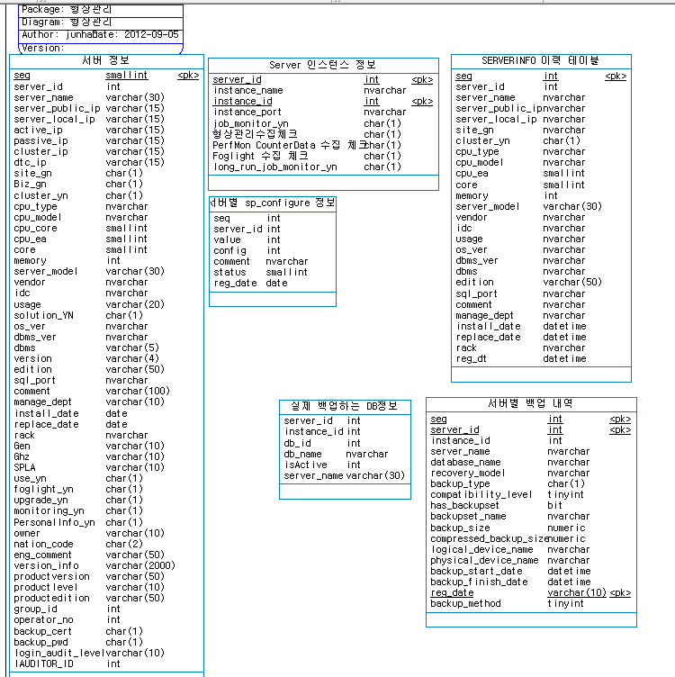

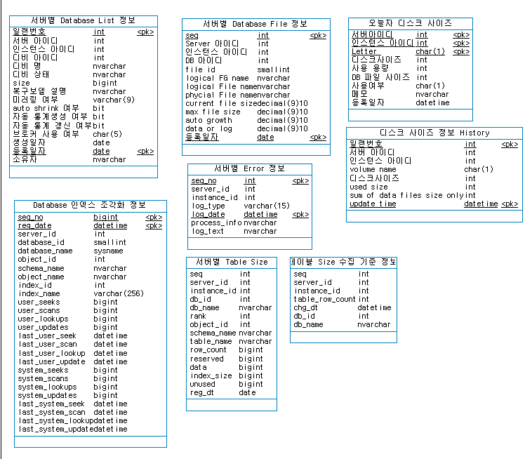

## 로그인 정보

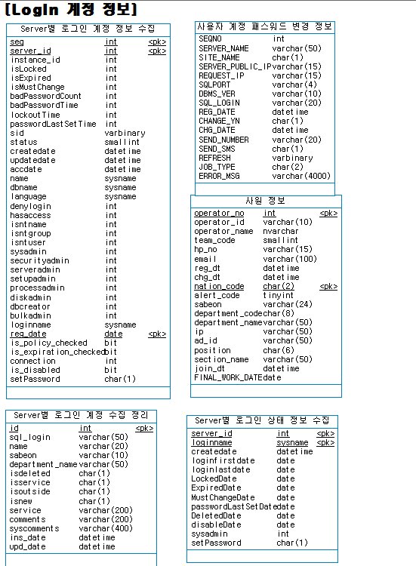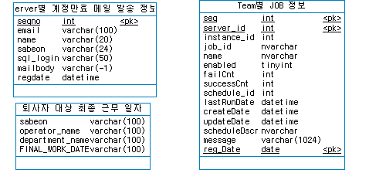



## 이관 관련

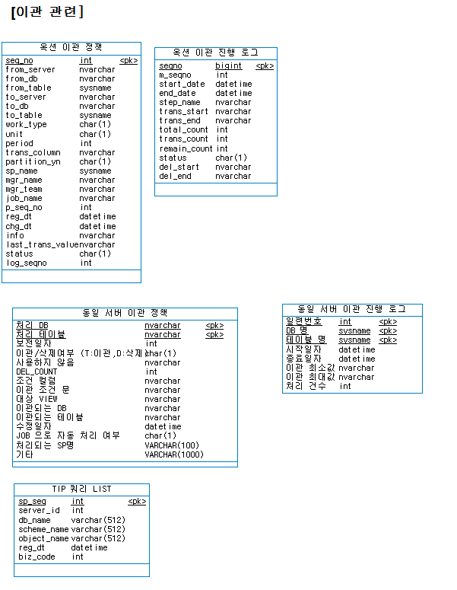



## 보안관련

