Status: Program running well, doing what it is supposed to do. It can crash, because I did not test it thoroughly.

Below are some screenshot of the requested actions.

1. View Courses taken by student previously.

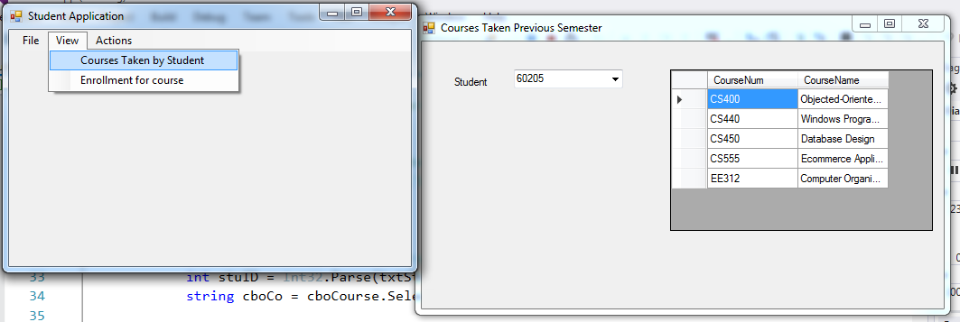

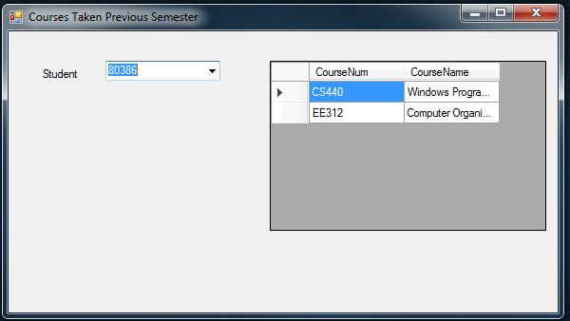

1. View enrollment

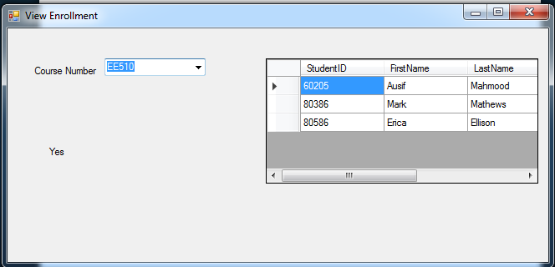

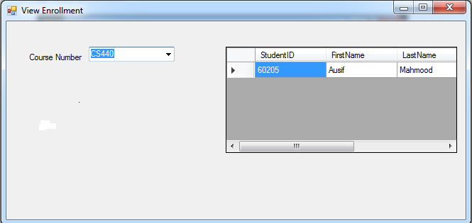

1. Register Student checking the rules

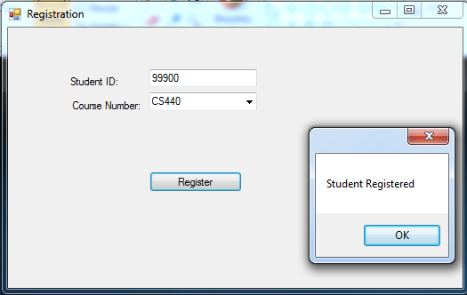

Ruled enforced

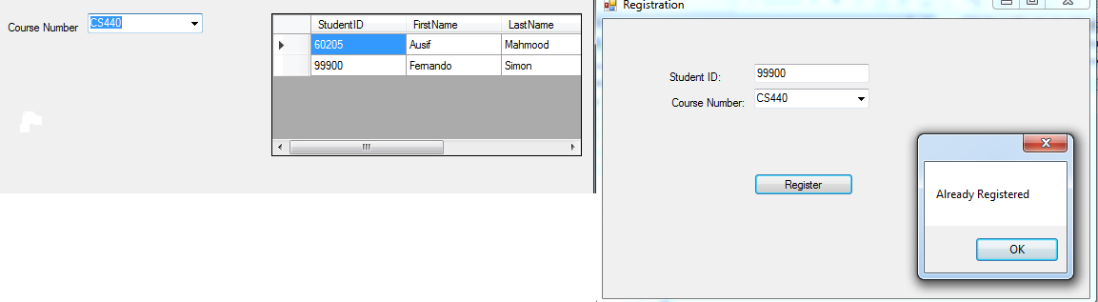

1. Delete from Enrollment

