
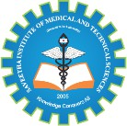
SIMATS ENGINEERING

Saveetha Institute of Medical and Technical Sciences Chennai- 602105

Student Name: A M RAKESH Reg. No.:192424393
Course Code: CSA0621 Slot: D
Course Name: Design and Analysis of Algorithms
Course Faculty: Dr .G. Nagarajan

Project Title: Optimized Medical Resource Allocation During Disasters Using Greedy and Priority Scheduling Algorithms
Module Photographs: (2 photographs –Module Photo and presentation image)
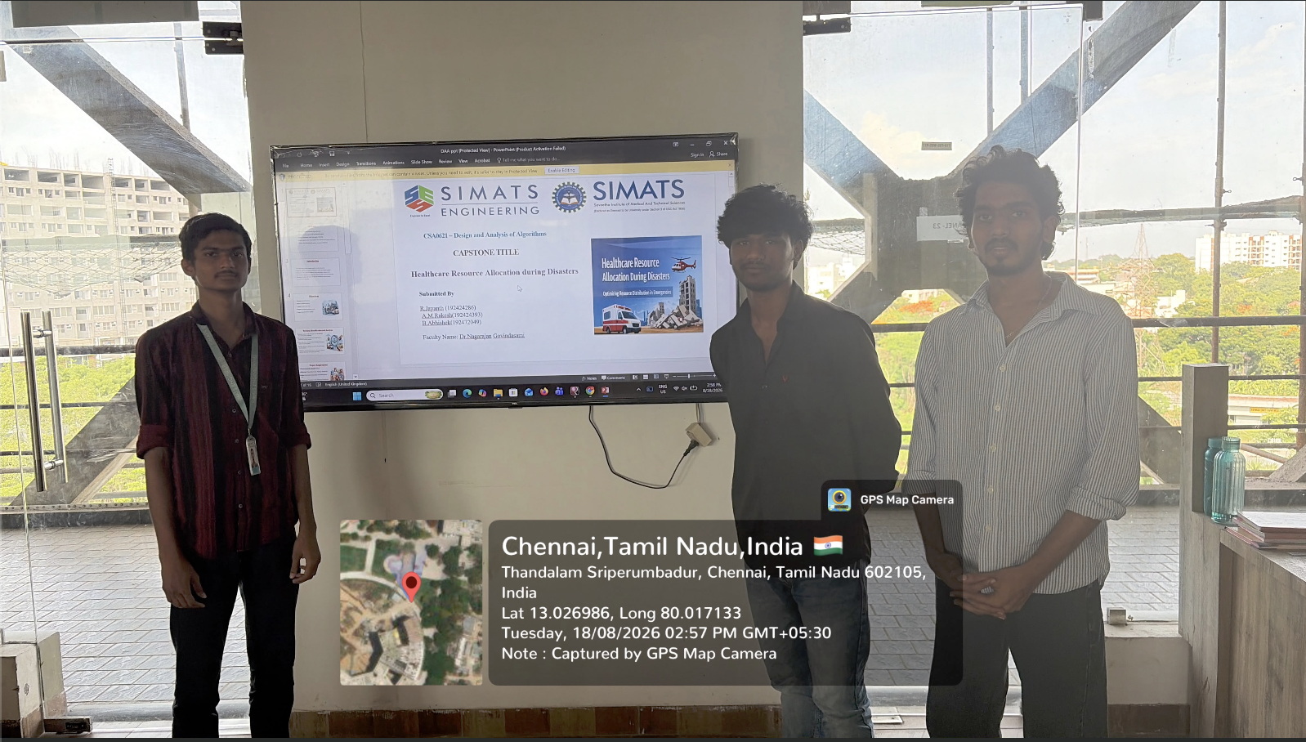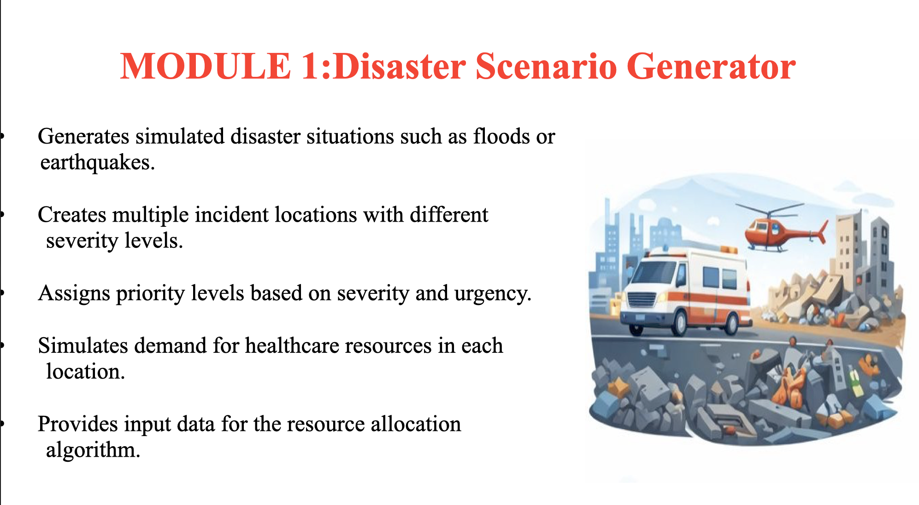
Project Description: MODULE 1:Disaster Scenario Generator
The Disaster Scenario Generator creates different emergency situations for testing the medical resource allocation system. It generates scenarios such as floods, earthquakes, accidents, and other disasters. Each scenario includes information about the disaster location and number of affected people. It also estimates the required ambulances, medical staff, medicines, and other resources. Different severity levels can be assigned to each disaster. The generated data helps identify which emergencies need immediate attention. The scenarios are provided as input to the Greedy and Priority Scheduling Algorithms. This allows the system to test how efficiently resources are allocated. It also helps compare the response time and resource utilization for different situations. Overall, the module provides realistic disaster data for testing and evaluating the complete system.

Student Signature Guide Signature

