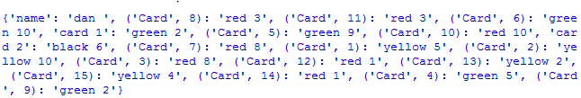

The first major issue I have had is that when writing to the score dictionary intended for tracking hi-scores, instead of writing in order it writes randomly. Additionally, I have not implemented code that prevents for two cards to appear hence Red 1 and Red 3 appearing twice. 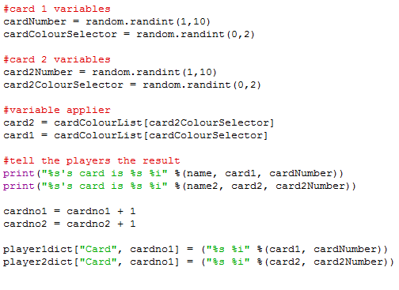

The code that adds cards to the players’ dictionaries. Currently, this code also does not support more than two players at any one time.

Due to the fact that dictionaries are unordered, I believe it is impossible to sort it.