**Mobile Computing – iOS Spring’23**

**Section04 Exam02**

**70 Points**

**Please follow the following instructions to complete this assignment.**

1. Open Xcode from the launchpad of your Mac.
2. Click on create a new Xcode project. Select the iOS template and click on the App application.
3. Click on next which will prompt you to choose options for the project.
4. Provide product name as **LastnameTaskManagerApp**, “**edu.nwmissouri**” for organization identifier, “**Storyboard**” as interface and “**Swift**” as the language.
5. Click on next and select an appropriate location to save your app and click on create. A project directory will be loaded.
6. From the project navigator click on “Main.storyboard” file, a blank mobile screen will be loaded, where the required fields for an app need to be added.

**The View**

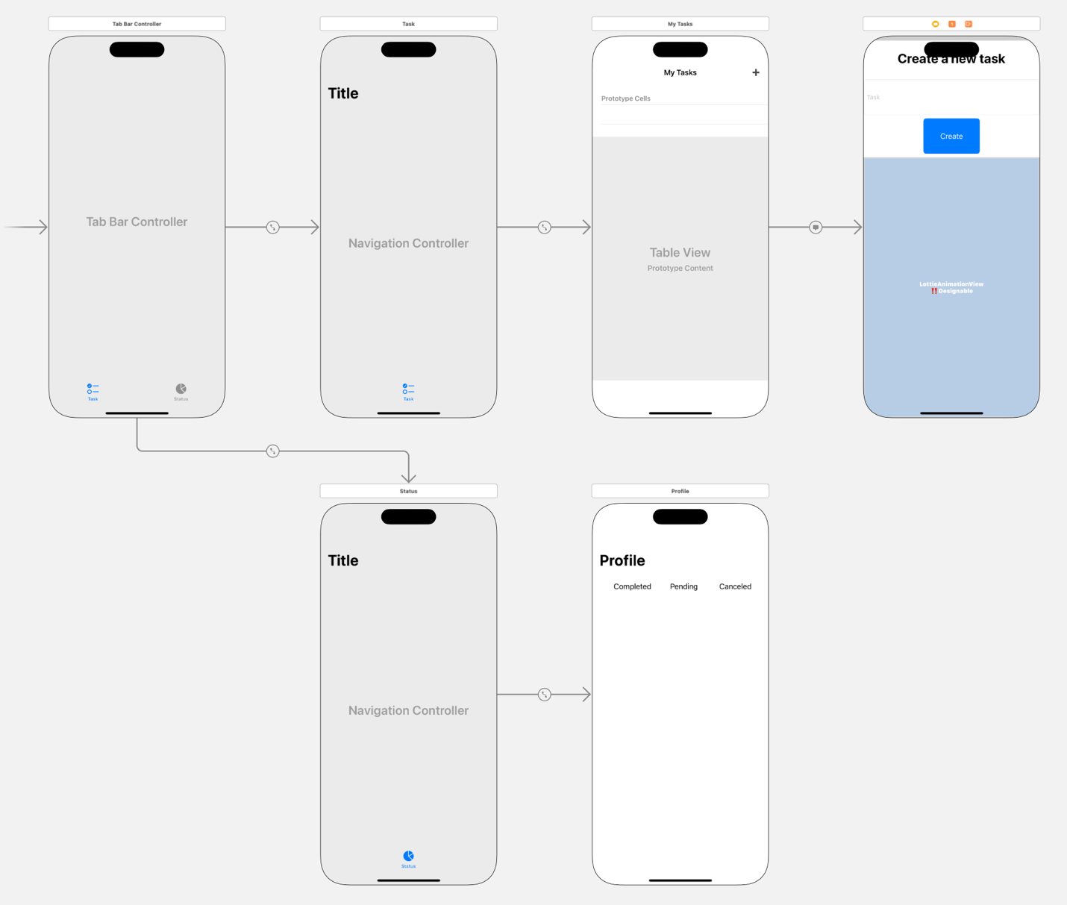

2

1

3

Figure The View

1. Design an app with 2 tabs, namely, Task and Status as per *Figure 1.* Apply auto layout wherever needed.
2. The Task tab, first view controller is a navigation controller.
   1. The navigation controller consists of a table view with 3 sections, namely, Pending, Completed, and Canceled, respectively.
   2. The navigation controller has a bar button item that presents a view controller modally for creating a new task.
      1. Creating a new task will add that task into the Pending section.
      2. When a new task created, play the Lottie animation using the 586-added.json file.
   3. Trailing swipe action on the Pending section tasks should give the user the ability to move an action into Completed or Canceled section.
3. The Status tab will show the overall count of Pending, Completed and Canceled tasks.

Table 1 The View Controllers

|  |  |
| --- | --- |
| **Screen** | **View Controller** |
| 1 | TaskVC |
| 2 | CreateTaskVC |
| 3 | StatusVC |

Table 2 UI elements configuration for TaskVC

|  |  |  |
| --- | --- | --- |
| **UI element** | **Purpose** | **Outlet/action name** |
| 1 UIBarButton item | To set the button title “➕” | n/a |
| 1 UITableView | To show all the tasks | tasksTableView |

Table 3 UI elements configuration for CreateTaskVC

|  |  |  |
| --- | --- | --- |
| **UI element** | **Purpose** | **Outlet/action name** |
| 1 UILabel | To set the title “Create a new task” | n/a |
| 1 UIView | To play Lottie Animation | animationView |
| 1 UITextField | To enter the task details | taskTF |
| readTask: |
| 1 UIButton | To save the task into the Pending section | createTaskBTN |
| createTask: |

Table 4 UI elements configuration for StatusVC

|  |  |  |
| --- | --- | --- |
| **UI element** | **Purpose** | **Outlet/action name** |
| 6 UILabels | To display text “Completed” | n/a |
| To display total number of tasks completed | completedTasksLBL |
| To display text “Pending” | n/a |
| To display total number of tasks pending | pendingTasksLBL |
| To display text “Canceled” | n/a |
| To display total number of tasks canceled | canceledTasksLBL |

*Note: Names that are ending with a colon (****:****) are actions.*

**The Model**

1. Create a Swift file called Model that has the following structs. Use these structures to manage app’s data.



**The Controller**

Create the view controllers and their respective outlets and actions as per *Tables 1, 2, 3, and 4.*

1. ***TaskVC***
   1. The table view should have three sections with headers as “Pending”, “Completed” and “Canceled”.
   2. The first section will be Pending with the list of pending tasks. This section cells should have a trailing swipe action gesture with actions “Completed” and “Canceled”.
   3. When action completed is selected the task should be removed from the “Pending” section and should be added to “Completed” section, which is the second section of the table view.
   4. When action canceled is selected the task should be removed from the “Pending section and should be added to “Canceled” section, which is the third section of the table view.
   5. When the bar button item “➕” is clicked, it should segue to the CreateTaskVC. The CreateTaskVC should be presented modally.
2. ***CreateTaskVC***
   1. Task name should be entered in the taskTF and when the create button is tapped the task should be added to the Pending section in the table view and the play the Lottie animation and then dismiss the CreateTaskVC.
   2. When the text field is empty the create button should be disabled. Use readTask: action for this.
3. ***StatusVC***
   1. When appeared it should show the overall count of Pending, Completed, and Canceled tasks.