**Data Import into Salesforce**

Any program that saves data in csv file format can be imported into Salesforce, for example programs like ACT, Outlook, Excel and Gold-Mine etc.

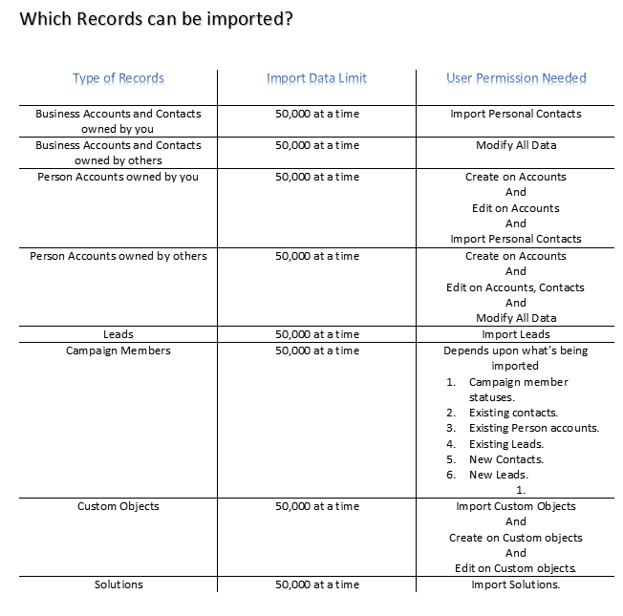

**Notes**

* **Relationship group members can’t be imported**.
* **If ‘comma’ aren’t appropriate for your locale, use ‘tab’ or other delimiter and specify it in data loader settings.**

Which can’t be imported via Data Import Wizard?

* **Assets.**
* **Cases.**
* **Campaigns.**
* **Contracts.**
* **Documents.**
* **Opportunities.**
* **Products.**

What is imported for Business Accounts and Contacts?

The Data Import Wizard allows you to match records in multiple ways to prevent duplicates.

You can match contacts by

* Salesforce ID.
* Name.
* Email.
* External ID.

You can match business accounts by

* Salesforce ID.
* External ID.
* Name and site.

Matching by Salesforce ID is inclusive of both contacts and business accounts. If you match one by Salesforce ID, the other is also matched by Salesforce ID.

**Matching by Name and Site**

* If you are matching contacts by name and business accounts by name and site (which are the recommended options), the Data Import Wizard creates a business account for each unique business account name and site in the import file.
* It also creates a separate contact for each contact name listed in the file.
* The contacts are then associated with the appropriate business accounts.

**Matching by Salesforce ID**

You can also choose to match contacts and business accounts by Salesforce ID. With this option, the Salesforce ID is the criteria for de-duplication. That is, if you are matching by ID and a record in your source file has the same ID as a record in Salesforce, that record is updated in Salesforce. Record IDs are case-sensitive and must match exactly.

**Matching by External ID**

An external ID is a custom field that has the External ID attribute, meaning that it contains unique record identifiers from a system outside of Salesforce. When you select this option, the Data Import Wizard detects existing records in Salesforce with external IDs that match those values in the import file.

What Is Imported for Person Accounts?

The Data Import Wizard prevents creating duplicate person accounts by matching records according to one of the following fields:

* Account Name.
* Salesforce ID.
* Email.
* External ID field.

In your import file, include a column for the field that you’re using for record matching.

**Matching by Name**

When you select this option, the Data Import Wizard detects existing records in Salesforce that have the same name. This type of matching is not case-sensitive. For example, names that begin with a capital letter are matched with the same name that begins with a lowercase letter. If necessary, scan and standardize your record names before performing the import to prevent unintended matches.

**Matching by Salesforce ID**

A Salesforce ID is a system-generated, case-sensitive string of 15 or 18 letters and numbers that uniquely identifies each Salesforce record. When you select this option, the Data Import Wizard detects existing records in Salesforce that have the same Salesforce ID. You can obtain Salesforce IDs by running reports that include the ID field of the record.

**Matching by Email**

With this option, records in your import file are matched with existing records in Salesforce according to the exact value in the Email field.

**Matching by External ID**

An external ID is a custom field that has the External ID attribute, meaning that it contains unique record identifiers from a system outside of Salesforce. When you select this option, the Data Import Wizard detects existing records in Salesforce with external IDs that match those values in the import file.

What Is Imported for Leads?

You can import data into standard lead fields and custom lead fields, even if a field is hidden or read only in your page layout or field-level security settings for leads.

**Importing Leads with Matching Types**

You can choose whether to match leads in your import file with existing leads in Salesforce. Leads can be matched according to the following types:

* Salesforce ID.
* Name.
* Email.
* External ID.

Choosing a matching type sets the criteria for avoiding duplicate leads. For example, if you’re matching by email and a lead in your source file has the same email as a lead in Salesforce, that lead is updated in Salesforce. If you aren’t matching by email and a lead in your source file has the same email as a lead in Salesforce, a lead is created.

**Importing Leads With-out Matching Types**

If you choose a matching type of “None” in the Data Import Wizard, for each lead in your import file, the Data Import Wizard creates a lead in Salesforce. You can merge leads after they are imported.

**Matching by Name**

When you select this option, the Data Import Wizard detects existing records in Salesforce that have the same name. This type of matching is not case-sensitive. For example, names that begin with a capital letter are matched with the same name that begins with a lowercase letter. If necessary, scan and standardize your record names before performing the import to prevent unintended matches.

**Matching by Email**

With this option, records in your import file are matched with existing records in Salesforce according to the exact value in the Email field.

**Matching by Salesforce ID**

A Salesforce ID is a system-generated, case-sensitive string of 15 or 18 letters and numbers that uniquely identifies each Salesforce record. When you select this option, the Data Import Wizard detects existing records in Salesforce that have the same Salesforce ID. You can obtain Salesforce IDs by running reports that include the ID field of the record.

**Matching by External ID**

An external ID is a custom field that has the External ID attribute, meaning that it contains unique record identifiers from a system outside of Salesforce. When you select this option, the Data Import Wizard detects existing records in Salesforce with external IDs that match those values in the import file

What’s imported for Campaign Members?

You can use the Data Import Wizard to update the statuses of campaign members.

You can also import campaign members. For each contact, lead, or person account in your import file, the Data Import Wizard:

* Imports the record.
* Associates the record with the specified campaign, making the contact, lead, or person account a campaign member.
* Inserts a Member Status value for the campaign member.

If your import file has duplicate records, the Data Import Wizard doesn’t merge them. If an imported record matches an existing record, the Data Import Wizard doesn’t merge the duplicate data into one record.

**Matching by External ID**

An external ID is a custom field that has the External ID attribute, meaning that it contains unique record identifiers from a system outside of Salesforce. When you select this option, the Data Import Wizard detects existing records in Salesforce with external IDs that match those values in the import file.

What Is Imported for Custom Objects?

The Data Import Wizard prevents creating duplicate records by matching records according to one of the following fields:

* Custom object name.
* Salesforce ID.
* External ID.

In your import file, include a column for the field that you are using for record matching.

**Matching by Name**

When you select this option, the Data Import Wizard detects existing records in Salesforce that have the same name. This type of matching is not case-sensitive. For example, names that begin with a capital letter are matched with the same name that begins with a lowercase letter. If necessary, scan and standardize your record names before performing the import to prevent unintended matches.

**Matching by Salesforce ID**

A Salesforce ID is a system-generated, case-sensitive string of 15 or 18 letters and numbers that uniquely identifies each Salesforce record. When you select this option, the Data Import Wizard detects existing records in Salesforce that have the same Salesforce ID. You can obtain Salesforce IDs by running reports that include the ID field of the record.

**Matching by External ID**

An external ID is a custom field that has the External ID attribute, meaning that it contains unique record identifiers from a system outside of Salesforce. When you select this option, the Data Import Wizard detects existing records in Salesforce with external IDs that match those values in the import file.

What Is Imported for Solutions?

The Data Import Wizard prevents creating duplicate records by matching records according to one of the following fields:

* Solution title.
* Salesforce ID.
* External ID.

In your import file, include a column for the field that you are using for record matching.

**Matching by Solution Title**

When you select this option, the import wizard detects existing solutions in Salesforce that have the same title. This type of matching isn’t case-sensitive. For example, titles that begin with a capital letter are matched with the same title that begins with a lowercase letter. If necessary, scan and standardize your solution titles before performing the import to prevent unintended matches.

**Matching by Salesforce ID**

A Salesforce ID is a system-generated, case-sensitive string of 15 or 18 letters and numbers that uniquely identifies each Salesforce record. When you select this option, the Data Import Wizard detects existing records in Salesforce that have the same Salesforce ID. You can obtain Salesforce IDs by running reports that include the ID field of the record.

**Matching by External ID**

An external ID is a custom field that has the External ID attribute, meaning that it contains unique record identifiers from a system outside of Salesforce. When you select this option, the Data Import Wizard detects existing records in Salesforce with external IDs that match those values in the import file.

Notes on Importing Data

* Field Accessibility

You can import values into a field only if you have read and edit access. User permissions, page layout assignments, and field-level security settings determine field access.

Field-level security is available in Professional, Enterprise, Unlimited, Performance, and Developer Editions.

* New Values for Picklists and Multi-Select Picklists

If you import a picklist value that doesn’t match an existing picklist value:

* + For an unrestricted picklist, the Data Import Wizard uses the value that’s in the import file.
  + For a restricted picklist, the Data Import Wizard uses the picklist’s default value.
* Multi-Select Picklists

To import multiple values into a multi-select picklist, separate the values by a semicolon in your import file.

You can import up to 100 values at a time in a multi-select picklist field. If you have more than 100 values in your import file for any one record, the import wizard leaves the field blank in that record.

* Checkboxes

To import data into a checkbox field, use 1 for checked values and 0 for unchecked values.

* Default Values

For picklist, multi-select picklist, and checkbox fields, if you do not map the field in the import wizard, the default value for the field, if any, is automatically inserted into the new or updated record.

* Date/Time Fields

Ensure that the format of any date/time fields you are importing matches how they display in Salesforce per your locale setting.

* Formula Fields

Formula fields cannot accept imported data because they are read only.

* Field Validation Rules

Salesforce runs validation rules on records before they are imported. Records that fail validation aren’t imported. Consider deactivating the appropriate validation rules before running an import if they affect the records you are importing.

* Geolocation Custom Fields

To import a geolocation custom field using the Data Import Wizard, supply two values: a latitude and a longitude. Import both values in one field, separated by a semicolon. If you enter only one value, it is imported as the latitude, and the longitude is interpreted as 0. If you supply more than two values, the import fails for the entire row.

* Currency Fields

If you have currency data in your CSV file, format your values for your locale. For example, if you’re in the U.S. locale, use periods for decimals and commas for thousand markers. Using the incorrect currency format could change your imported values.

Importing Multiple Currencies

If your organization has set up the ability to use multiple currencies, you can import amounts in different currencies.

**Organization Import**

When importing accounts, contacts, custom objects, leads, or solutions for your organization, you can specify the currency type for amount fields using the Currency ISO Code column in your import file. The following rules apply.

* Entering currency codes

Enter a currency code in the Currency ISO Code column in your import file. Currency codes are three letter codes that follow an international standard. For example, USD is the currency code for U.S. dollars. From Setup, enter Manage Currencies in the Quick Find box, then select **Manage Currencies** to see a list of valid codes for your organization.

* Updating the currency code

When updating the currency code but not the currency amount for accounts and contacts, the amount isn’t converted to the corresponding number in the new currency.

* **Entering inactive currencies**

If you enter an inactive currency in your import file, your personal currency is used instead. However, amounts aren’t modified. For example, if your file has AUD 100 for 100 Australian dollars but AUD is an inactive currency for your organization, it’s imported as USD 100, assuming your personal currency is U.S. dollars.

* Omitting the Currency ISO Code column

When creating records via importing, if you don’t use the Currency ISO Code column or fail to map it, your personal currency is used. For example, if your file has 100 and your personal currency is U.S. dollars (currency code = USD), it’s imported as USD 100.

When updating existing records via importing, if you don’t use the Currency ISO Code column or fail to map it, any amounts are interpreted as having the currency of the record. For example, if your file has 100 for a record that has a currency of EUR (the currency code for euros), this amount is interpreted as EUR 100.