Lab #2

Sriram R Section : H SRN : PES1UG20CS435

Designing and Simulation of Network Topology using Cisco Packet Tracer

# Objectives:

* To understand the purpose of Cisco Packet Tracer.
* To navigate, choose network and end devices and customize them.
* To interconnect devices and configure them using simple interface.
* To become familiar with building topologies in Packet Tracer.
* To simulate data interactions traveling through a network.

# Prerequisites:

This lab assumes some understanding of the building blocks of communication networks and internet. At this point, we haven’t discussed other protocols but you may use Packet Tracer in later labs to discuss those as well. Several types of devices and network connections can be used. For this experiment we will keep it simple by using end devices, switches, routers, and connections.

# Task 1 (Demo) Network Topology:

To replicate given scenario, create a topology in packet tracer, as shown in following image.

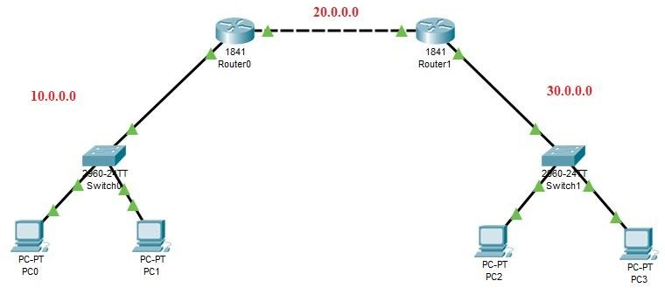

# PC & Router Configuration Details:

**PC0:**

# PC1:

IP Address ---> 10.0.0.1

Gateway ---> 10.0.0.3

IP Address ---> 10.0.0.2

Gateway ---> 10.0.0.3

# Router 0:

FastEthernet0/0 ---> 10.0.0.3

FastEthernet0/1 ---> 20.0.0.1

# Router 1:

FastEthernet0/0 ---> 20.0.0.2

FastEthernet0/1 ---> 30.0.0.1

# PC2:

**PC3:**

IP Address ---> 30.0.0.2

Gateway ---> 30.0.0.1

IP Address ---> 30.0.0.3

Gateway ---> 30.0.0.1

# Routing Table Entries:

|  |  |  |
| --- | --- | --- |
| **Router** | **Network** | **Next Hop** |
| Router 0 | 30.0.0.0 | 20.0.0.2 |
| Router 1 | 10.0.0.0 | 20.0.0.1 |

**Execution Procedure:**

**Task 1:** Design a network topology with desktops, switches and routers similar to the network depicted in the above diagram.

**Task 2:** Configure the PCs and routers with the details provided above.

**Task 3:** Send a simple PDU from any PC on network 10.0.1.0 to any other PC on other network

10.0.3.0 and vice-versa.

**Task 4:** Simulate the network and observe the packet flow from one network to other.

Screenshots :

Network topology :

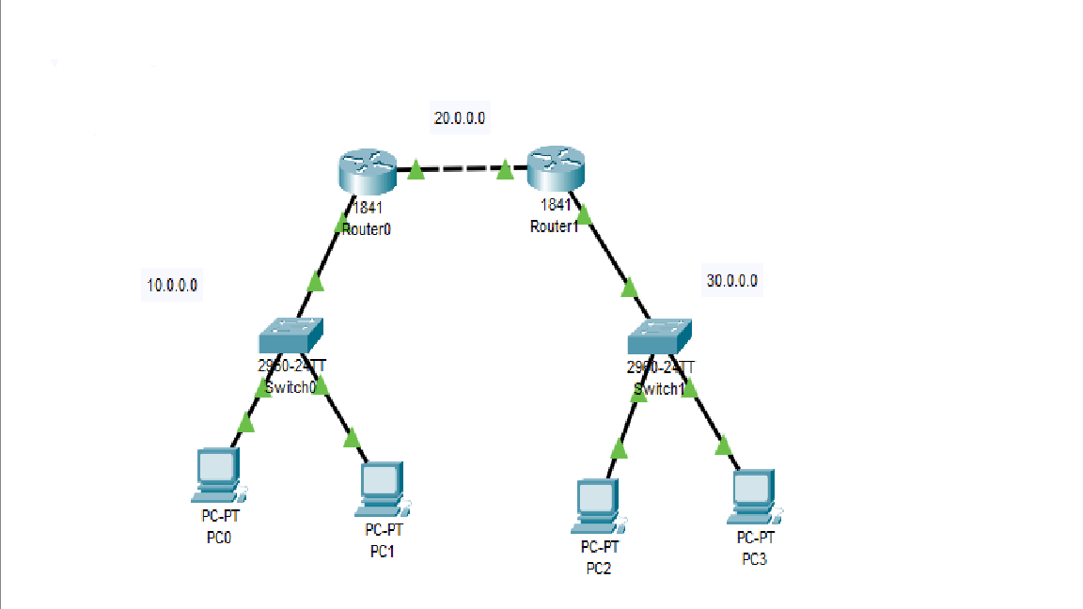

PDU :



Simulation :

# 

# Task 2 (Mandatory for Week-2)

PC & Router Configuration Details:

PC0:

IP Address:1.0.0.2

Gateway:1.0.0.1

PC1:

IP Address:1.0.0.3

Gateway:1.0.0.1

Router0:

FastEthernet0/0 : 1.0.0.1

FastEthernet0/1: 3.0.0.1

Router1:

FastEthernet0/0 : 3.0.0.2

FastEthernet0/1: 5.0.0.2

FastEthernet0/1/0: 2.0.0.1

Router2:

FastEthernet0/0 : 5.0.0.1

FastEthernet0/1: 6.0.0.1

PC2:

IP Address: 6.0.0.2

Gateway: 6.0.0.1

PC3:

IP Address: 2.0.0.2

Gateway: 2.0.0.1

PC4:

IP Address: 2.0.0.3

Gateway: 2.0.0.1

Routing table entries :

|  |  |  |
| --- | --- | --- |
| Router | Network | Next Hop |
| Router0 | 2.0.0.0 | 3.0.0.3 |
| Router0 | 5.0.0.0 | 3.0.0.2 |
| Router1 | 1.0.0.0 | 3.0.0.1 |
| Router1 | 6.0.0.0 | 5.0.0.1 |
| Router2 | 1.0.0.0 | 5.0.0.2 |
| Router2 | 2.0.0.0 | 5.0.0.2 |

Screenshots :

Network topology :

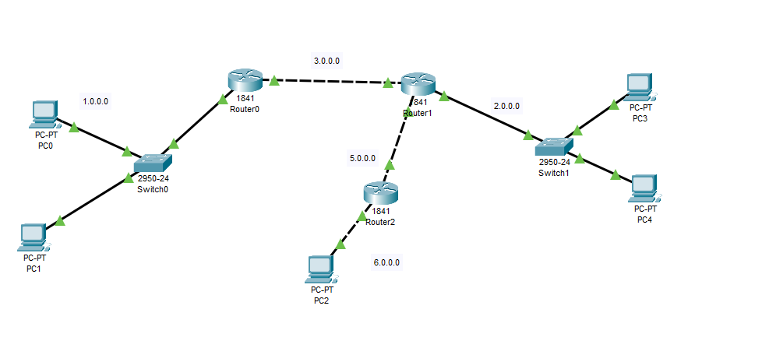

Simulation :

# 