**Week #4**

**Sriram R SRN : PES1UG20CS435 Section : H**

**Screenshots :**

**Observation 1 :**

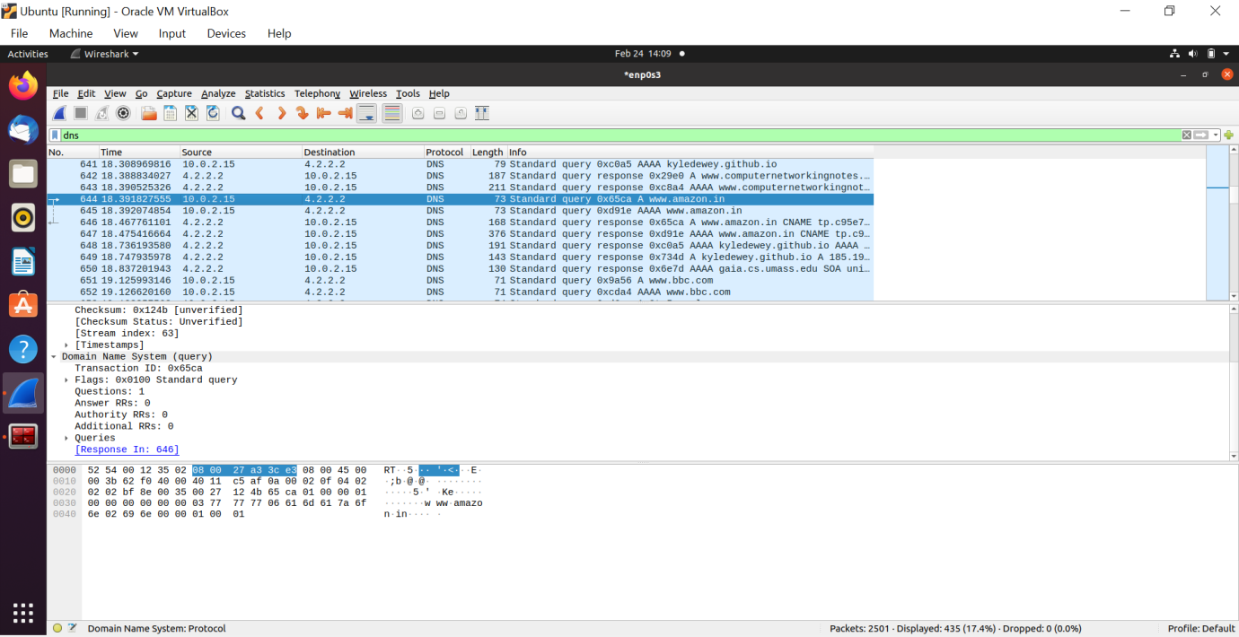

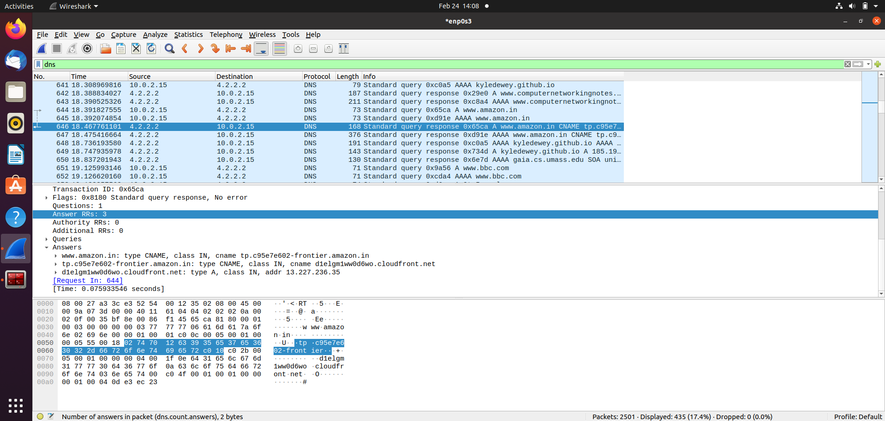

**Observation 2 :**

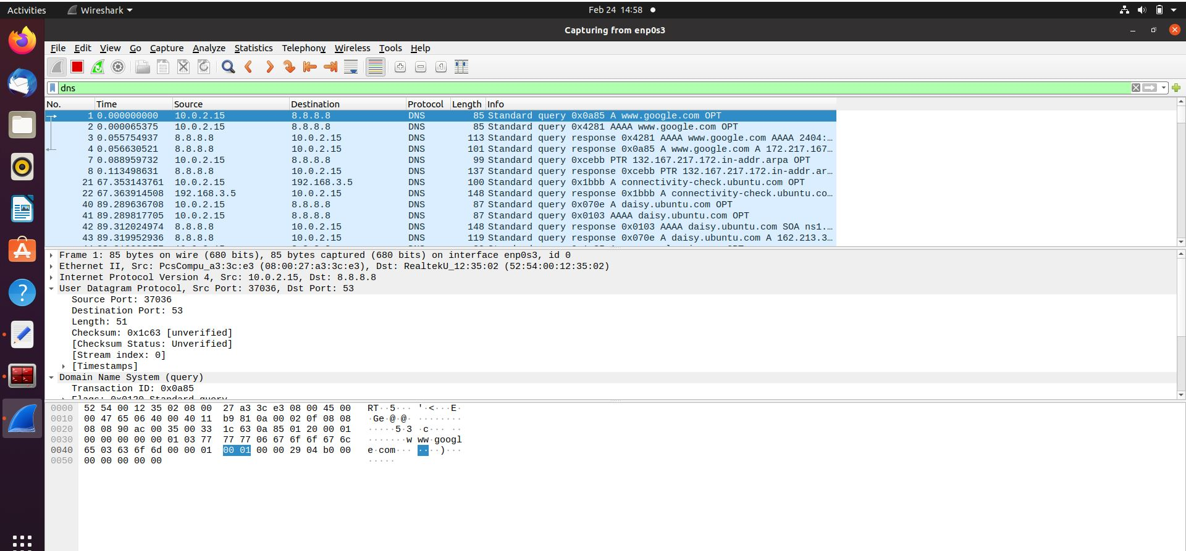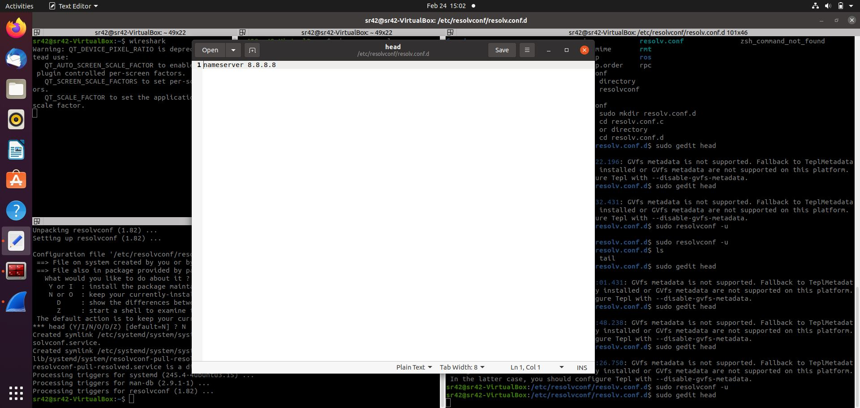

**Observation 3 :**

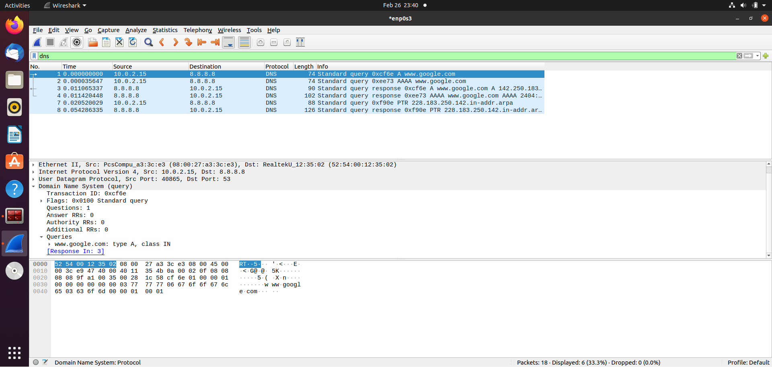

**Observation 4 (DNS cache) :**

;

; Start view _default

;

;

; Cache dump of view '_default' (cache _default)

;

; using a 604800 second stale ttl

$DATE 20220219182533

; secure

. 1122239 IN NS a.root-servers.net.

1122239 IN NS b.root-servers.net.

1122239 IN NS c.root-servers.net.

1122239 IN NS d.root-servers.net.

1122239 IN NS e.root-servers.net.

1122239 IN NS f.root-servers.net.

1122239 IN NS g.root-servers.net.

1122239 IN NS h.root-servers.net.

1122239 IN NS i.root-servers.net.

1122239 IN NS j.root-servers.net.

1122239 IN NS k.root-servers.net.

1122239 IN NS l.root-servers.net.

1122239 IN NS m.root-servers.net.

; secure

1122239 RRSIG NS 8 0 518400 (

20220311170000 20220226160000 9799 .

EZ02Y6Bomku5fk9N5w2JaaVYoBc2t6wuP74+

c4mGEUzYpVr6M05Yltxm+W+txe+grByh/0Ny

FIrQ5aK3r2jaqJebKmhmTyeReKhS2vX1M2RZ

8Uazx5NlPbe66Omj6k13uZvEizTkF9mFlQ/3

T/QS6d+Z821tS9vYSwd5YcUYVAKQ0vnOnwrX

vMMfe0kxro0OvrksvgQMNLdGFli8ItP6iaHh

gBH1vRemFWHGI/ao69eHQOO8QWXIqBXulkYB

+VDFXgt4IugD71PCxSnTakwz0Ml0LxiT6Ped

VDj4IFxHjoc6Gtp1sHRBVPPhSNNq4VuFYsuU

LUdPb5RZO+yzzUp0/A== )

; secure

776639 DNSKEY 256 3 8 (

AwEAAZym4HCWiTAAl2Mv1izgTyn9sKwgi5eB

xpG29bVlefq/r+TGCtmUElvFyBWHRjvf9mBg

lIlTBRse22dvzNOI+cYrkjD6LOHuxMoc/d4W

tXWKdviNmrtWF2GpjmDOI98gLd4BZ0U/lY84

7mJP9LypFABZcEn3zM3vce4Ee1A3upSlFQ2T

FyJSD9HvMnP4XneFexBxV96RpLcy2O+u2W6C

hIiDCjlrowPCcU3zXfXxyWy/VKM6TOa8gNf+

aKaVkcv/eIh5er8rrsqAi9KT8O5hmhzYLkUO

QEXVSRORV0RMt9l3JSwWxT1MebEDvtfBag3u

o+mZwWSFlpc9kuzyWBd72Ec=

) ; ZSK; alg = RSASHA256 ; key id = 9799

776639 DNSKEY 257 3 8 (

AwEAAaz/tAm8yTn4Mfeh5eyI96WSVexTBAvk

MgJzkKTOiW1vkIbzxeF3+/4RgWOq7HrxRixH

lFlExOLAJr5emLvN7SWXgnLh4+B5xQlNVz8O

g8kvArMtNROxVQuCaSnIDdD5LKyWbRd2n9WG

e2R8PzgCmr3EgVLrjyBxWezF0jLHwVN8efS3

rCj/EWgvIWgb9tarpVUDK/b58Da+sqqls3eN

buv7pr+eoZG+SrDK6nWeL3c6H5Apxz7LjVc1

uTIdsIXxuOLYA4/ilBmSVIzuDWfdRUfhHdY6

+cn8HFRm+2hM8AnXGXws9555KrUB5qihylGa

8subX2Nn6UwNR1AkUTV74bU=

) ; KSK; alg = RSASHA256 ; key id = 20326

; secure

776639 RRSIG DNSKEY 8 0 172800 (

20220313000000 20220220000000 20326 .

VhdGJ/WGqEEtOoRHalnxxy19ASlnzOIM9D4i

Ri5bvBo3MdUFRE1pVCqVGF627MIVsFH10/Xz

ntV0jIEU0Ft5kdSTxqBdj0YlQpnisEBFAp+o

elReMxVoHQYuwyNG6rmtZnj6RctVfajdC3DP

e4t48O7vggAK4vfpB/HW125hAP2xaeqOInDc

ZVIQogYM7kBxeTB3ZxUmRJcN57am4MP+k6bR

A50xyiRpuLdMKIsaf/Gpjmvj16yxG19ojTvC

oUQu853mI6ul79T8sh5J9bwC+FmXQXgPBg8O

ZOIFudng6GN1QC4dEhZtFMIV4Bw9Tl2KKjfB

OBGai6f0OWurlfNfMg== )

; glue

a.root-servers.net. 1122239 A 198.41.0.4

; glue

1122239 AAAA 2001:503:ba3e::2:30

; glue

b.root-servers.net. 1122239 A 199.9.14.201

; glue

1122239 AAAA 2001:500:200::b

; glue

c.root-servers.net. 1122239 A 192.33.4.12

; glue

1122239 AAAA 2001:500:2::c

; glue

d.root-servers.net. 1122239 A 199.7.91.13

; glue

1122239 AAAA 2001:500:2d::d

; glue

e.root-servers.net. 1122239 A 192.203.230.10

; glue

1122239 AAAA 2001:500:a8::e

; glue

f.root-servers.net. 1122239 A 192.5.5.241

; glue

1122239 AAAA 2001:500:2f::f

; glue

g.root-servers.net. 1122239 A 192.112.36.4

; glue

1122239 AAAA 2001:500:12::d0d

; glue

h.root-servers.net. 1122239 A 198.97.190.53

; glue

1122239 AAAA 2001:500:1::53

; glue

i.root-servers.net. 1122239 A 192.36.148.17

; glue

1122239 AAAA 2001:7fe::53

; glue

j.root-servers.net. 1122239 A 192.58.128.30

; glue

1122239 AAAA 2001:503:c27::2:30

; glue

k.root-servers.net. 1122239 A 193.0.14.129

; glue

1122239 AAAA 2001:7fd::1

; glue

l.root-servers.net. 1122239 A 199.7.83.42

; glue

1122239 AAAA 2001:500:9f::42

; glue

m.root-servers.net. 1122239 A 202.12.27.33

; glue

1122239 AAAA 2001:dc3::35

;

; Address database dump

;

; [edns success/4096 timeout/1432 timeout/1232 timeout/512 timeout]

; [plain success/timeout]

;

;

; Unassociated entries

;

; 192.58.128.30 [srtt 3] [flags 00000000] [edns 0/0/0/0/0] [plain 0/0] [ttl 839]

; 2001:500:a8::e [srtt 48140] [flags 00000000] [edns 0/2/2/2/2] [plain 0/0] [ttl 839]

; 192.36.148.17 [srtt 24] [flags 00000000] [edns 0/0/0/0/0] [plain 0/0] [ttl 839]

; 192.5.5.241 [srtt 20362] [flags 00004000] [edns 2/0/0/0/0] [plain 0/0] [udpsize 512] [ttl 839]

; 2001:500:2d::d [srtt 142840] [flags 00000000] [edns 0/2/2/2/2] [plain 0/0] [ttl 839]

; 199.7.83.42 [srtt 3] [flags 00000000] [edns 0/0/0/0/0] [plain 0/0] [ttl 839]

; 2001:500:200::b [srtt 41700] [flags 00000000] [edns 0/2/2/2/2] [plain 0/0] [ttl 839]

; 193.0.14.129 [srtt 11] [flags 00000000] [edns 0/0/0/0/0] [plain 0/0] [ttl 839]

; 192.112.36.4 [srtt 23] [flags 00000000] [edns 0/0/0/0/0] [plain 0/0] [ttl 839]

; 202.12.27.33 [srtt 4] [flags 00000000] [edns 0/0/0/0/0] [plain 0/0] [ttl 839]

; 198.97.190.53 [srtt 28] [flags 00000000] [edns 0/0/0/0/0] [plain 0/0] [ttl 839]

; 192.203.230.10 [srtt 29] [flags 00000000] [edns 0/0/0/0/0] [plain 0/0] [ttl 839]

; 2001:500:2::c [srtt 155760] [flags 00000000] [edns 0/2/2/2/2] [plain 0/0] [ttl 839]

; 2001:500:12::d0d [srtt 45800] [flags 00000000] [edns 0/2/2/2/2] [plain 0/0] [ttl 839]

; 2001:500:1::53 [srtt 30580] [flags 00000000] [edns 0/2/2/2/2] [plain 0/0] [ttl 839]

; 199.9.14.201 [srtt 20] [flags 00000000] [edns 0/0/0/0/0] [plain 0/0] [ttl 839]

; 2001:500:2f::f [srtt 85780] [flags 00000000] [edns 0/2/2/2/2] [plain 0/0] [ttl 839]

; 2001:500:9f::42 [srtt 179730] [flags 00000000] [edns 0/2/2/2/2] [plain 0/0] [ttl 839]

; 2001:503:ba3e::2:30 [srtt 114620] [flags 00000000] [edns 0/2/2/2/2] [plain 0/0] [ttl 839]

; 2001:7fd::1 [srtt 196730] [flags 00000000] [edns 0/2/2/2/2] [plain 0/0] [ttl 839]

; 2001:7fe::53 [srtt 74720] [flags 00000000] [edns 0/2/2/2/2] [plain 0/0] [ttl 839]

; 199.7.91.13 [srtt 24] [flags 00000000] [edns 0/0/0/0/0] [plain 0/0] [ttl 839]

; 2001:dc3::35 [srtt 251240] [flags 00000000] [edns 0/2/2/2/2] [plain 0/0] [ttl 839]

; 198.41.0.4 [srtt 23] [flags 00000000] [edns 0/0/0/0/0] [plain 0/0] [ttl 839]

; 2001:503:c27::2:30 [srtt 167370] [flags 00000000] [edns 0/2/2/2/2] [plain 0/0] [ttl 839]

; 192.33.4.12 [srtt 8] [flags 00000000] [edns 0/0/0/0/0] [plain 0/0] [ttl 839]

;

; Bad cache

;

;

; SERVFAIL cache

;

;

; Start view _bind

;

;

; Cache dump of view '_bind' (cache _bind)

;

; using a 604800 second stale ttl

$DATE 20220219182533

;

; Address database dump

;

; [edns success/4096 timeout/1432 timeout/1232 timeout/512 timeout]

; [plain success/timeout]

;

;

; Unassociated entries

;

;

; Bad cache

;

;

; SERVFAIL cache

;

; Dump complete

**Observation 5 (dig www.example.com) :**

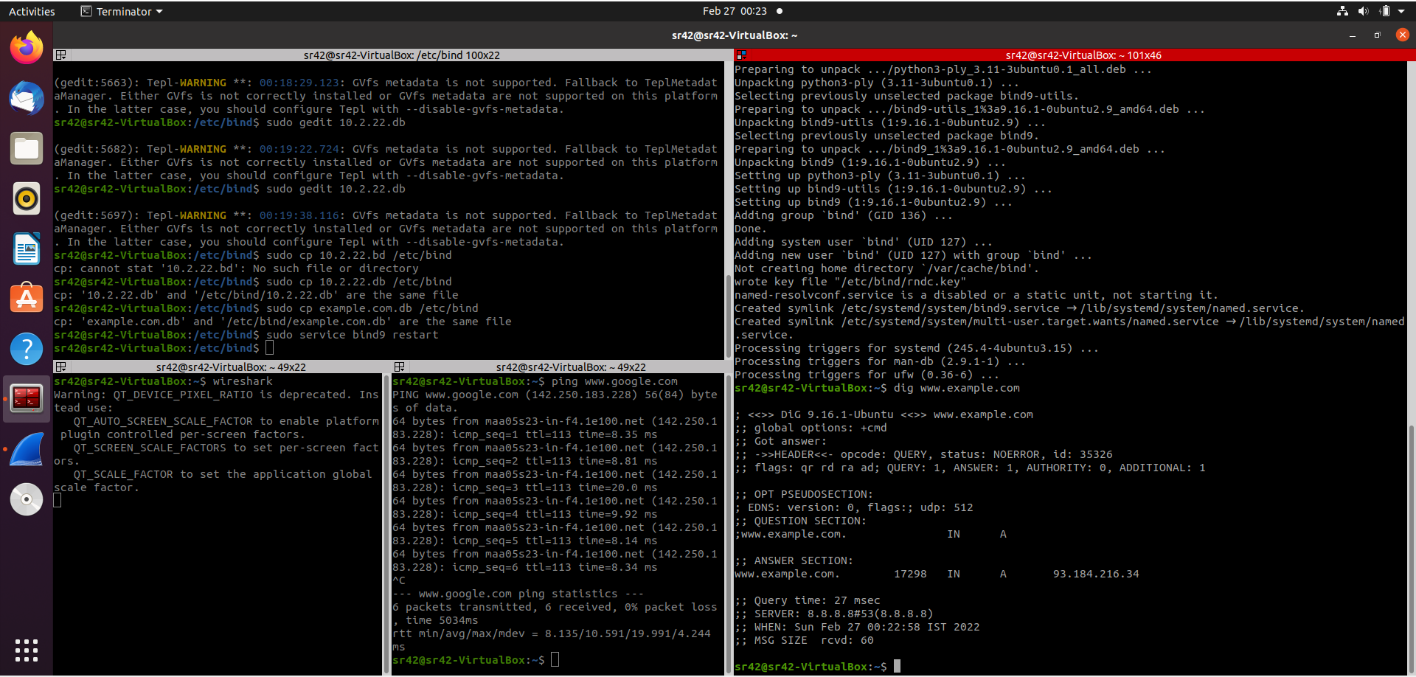

**Observation 6 (**[**www.example.com**](http://www.example.com) **wireshark capture):**

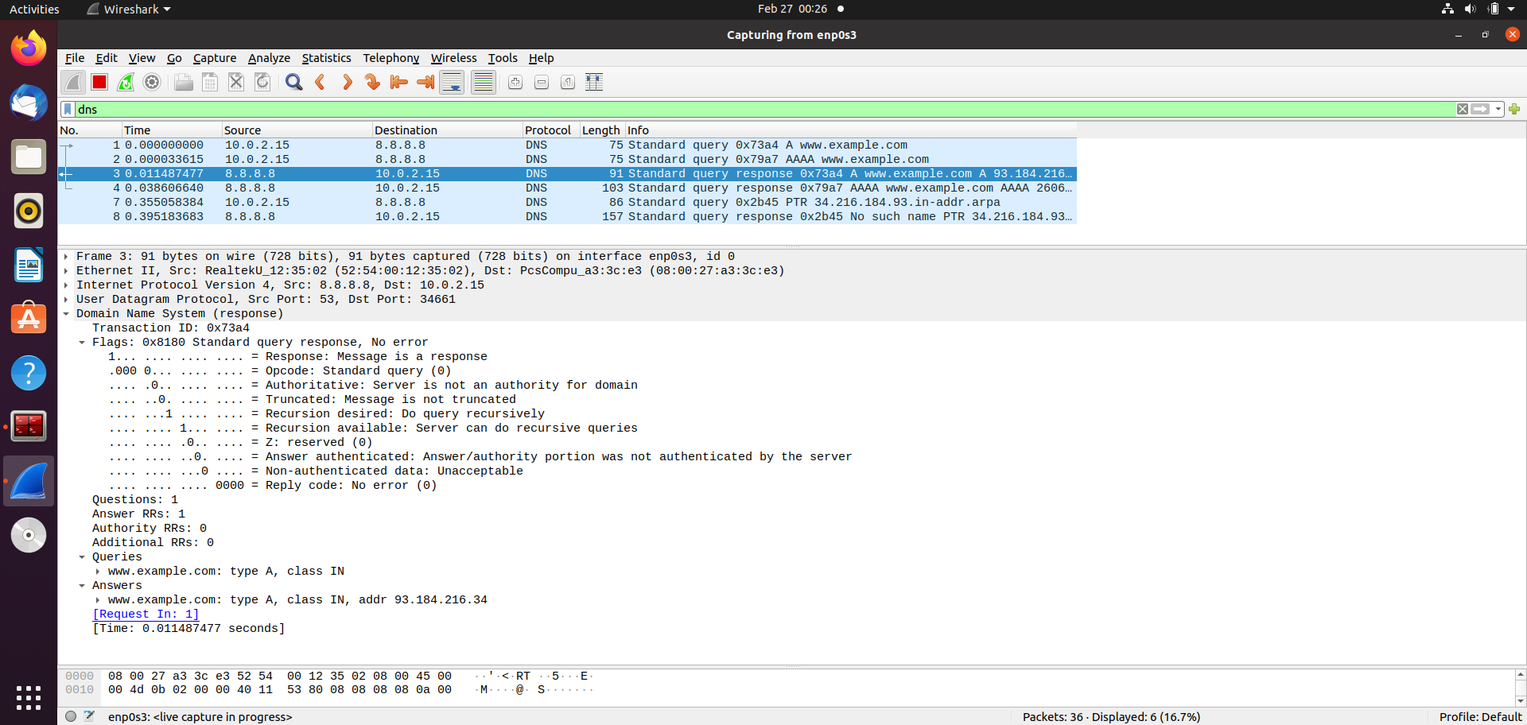

**Questions :**

1) Locate the DNS query and response messages. Are then sent over UDP or TCP? - **UDP.**

2) What is the destination port for the DNS query message? What is the source port of DNS response message? – **53 & 36727 respectively.**

3) To what IP address is the DNS query message sent? Use ipconfig to determine the IP address of your local DNS server. Are these two IP addresses the same? – **8.8.8.8. This is the same as that of the local DNS server.**

4) Examine the DNS query message. What “Type” of DNS query is it? Does the query message contain any “answers”? - **Standard query, no answers.**

5) Examine the DNS response message. How many “answers” are provided? What do each of these answers contain? – **1 answer.**

Data contained -

www.flipkart.com: type CNAME, class IN, cname flipkart.com

Name: www.flipkart.com

Type: CNAME (Canonical NAME for an alias) (5)

Class: IN (0x0001)

Time to live: 33 (33 seconds)

Data length: 2

CNAME: flipkart.com