**Microprocessor and Computer Architecture (MPCA) Laboratory**

**UE20CS252 4th Semester,**

**Academic Year 2021-22**

**Date: 28/01/2022**

**Sriram R Section : H SRN : PES1UG20CS435**

**Week # 1 Program Number: 1**

**Title of the Program**

Write a program in ARM7TDMI-ISA to copy a block of N data items from Location A to Location B using half words.

**Program Code**

.DATA

A: .HWORD 10,20,30,40,50,60,70,80,90,100

B: .HWORD 0,0,0,0,0,0,0,0,0,0

.TEXT

LDR R1, =A

LDR R2, =B

MOV R5, #1; count register initialization to 1

L1: LDRH R3, [R1]

STRH R3, [R2]

ADD R1, R1, #2; address to next data

ADD R2, R2, #2

ADD R5, R5, #1; incrementing

CMP R5, #11; condition to break loop at 10 values

BNE L1

SWI 0x011

**Screenshot of ArmSimulator of the Program Executed**

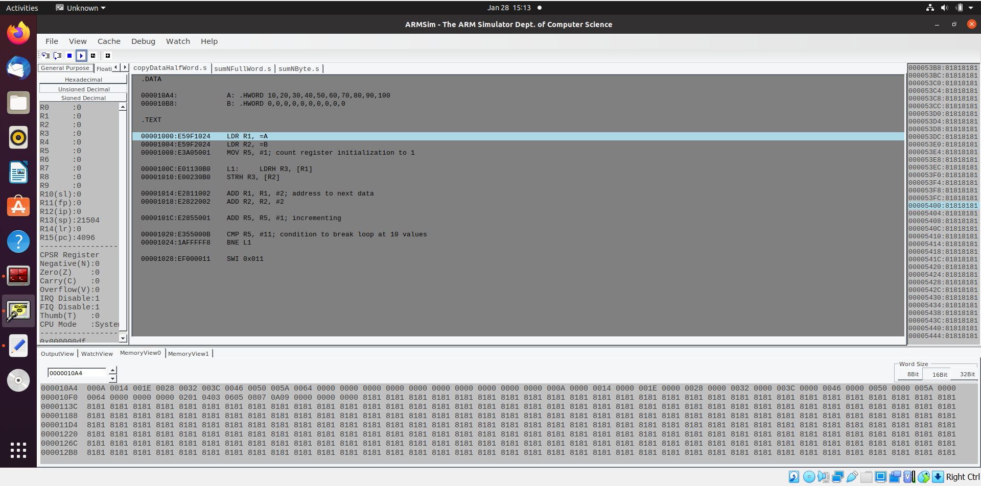

**Week # 1 Program Number: 2**

**Title of the Program**

Write a program in ARM7TDMI-ISA to find the sum of N data items in the memory using full words.

**Program Code**

.DATA

A: .WORD 10,20,30,40,50,60,70,80,90,100

SUM: .WORD 0

.TEXT

LDR R1, =A

LDR R2, =SUM

MOV R4, #0; sum register

MOV R5, #1; count register

L1: LDR R3, [R1]

ADD R4, R4, R3

ADD R1, R1, #4

ADD R5, R5, #1

CMP R5, #11

BNE L1

STR R4,[R2]

SWI 0X011

**Screenshot of ArmSimulator of the Program Executed**

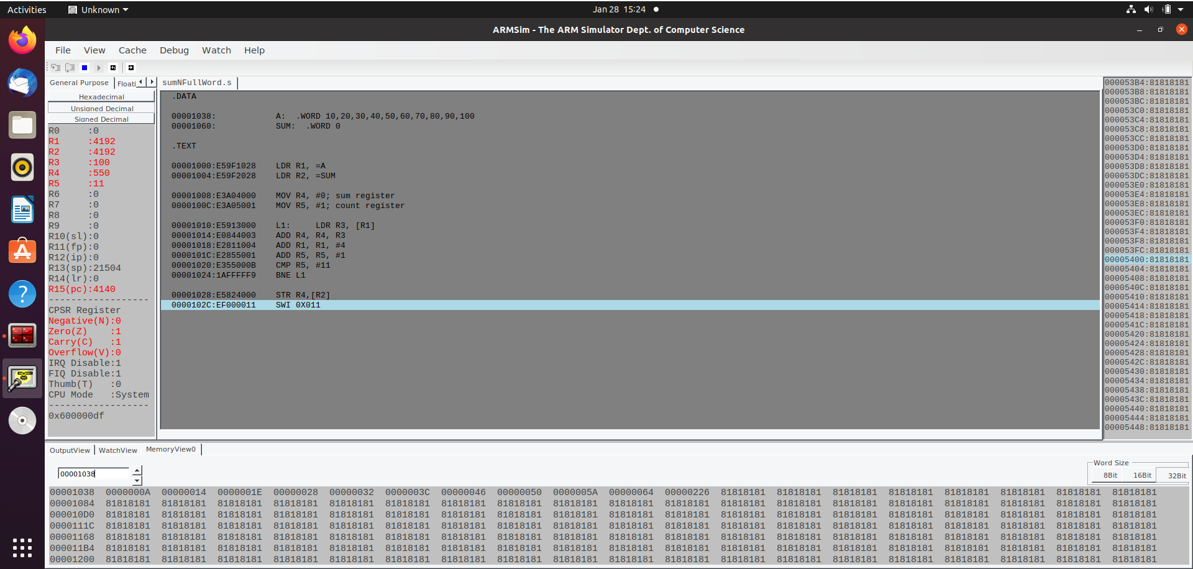

**Week # 1 Program Number: 3**

**Title of the Program**

Write a program in ARM7TDMI-ISA to find the sum of N data items in the memory using bytes.

**Program Code**

.DATA

A: .BYTE 1,2,3,4,5,6,7,8,9,10

SUM: .WORD 0

.TEXT

LDR R1, =A

LDR R2, =SUM

MOV R4, #0

MOV R5, #1

L1: LDRB R3, [R1]

ADD R4, R4, R3

ADD R1, R1, #1

ADD R5, R5, #1

CMP R5, #11

BNE L1

STRB R4,[R2]

SWI 0X011

**Screenshot of ArmSimulator of the Program Executed**

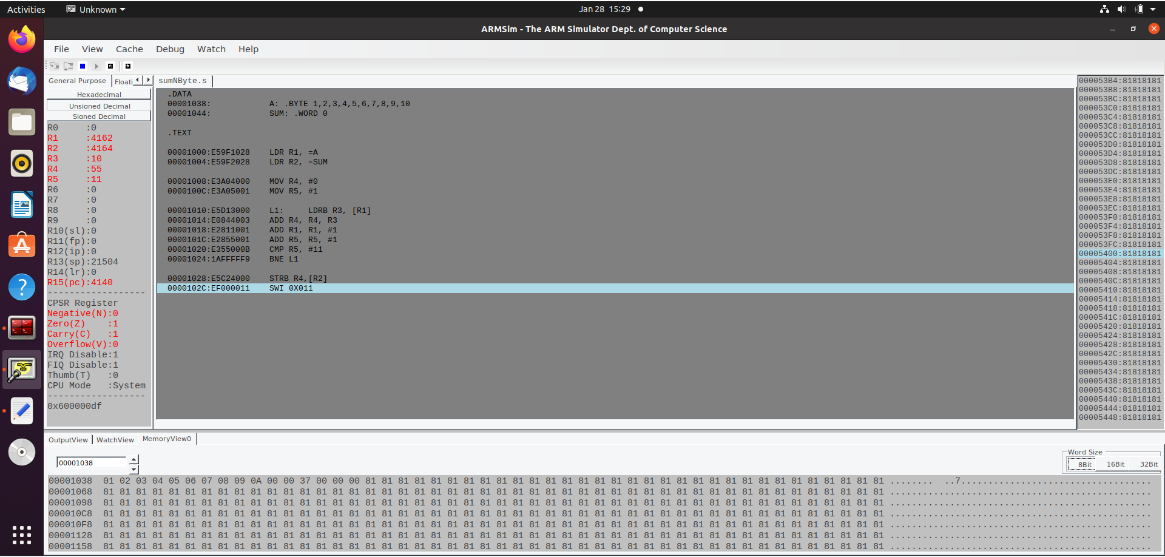

**Week # 1 Program Number: 4**

**Title of the Program**

Write a program in ARM7TDMI-ISA to find the sum of N natural numbers using full words.

**Program Code**

.DATA

SUM: .WORD 0

.TEXT

LDR R2, =SUM

MOV R1, #1 ; count doubles up as natural number generator

L1: ADD R0, R0, R1; performs addition

ADD R1, R1, #1; increments by 1

CMP R1, #11

BNE L1

STR R0, [R2]

SWI 0X011

**Screenshot of ArmSimulator of the Program Executed**

