**Linear Algebra Assignment 1 (I & II included)**

**Sriram Radhakrishna PES1UG20CS435 Section : ‘H’**

**Python code :**

1. Hill cipher encryption using matrix inversion :

# implementation of basic cryptographic techniques to appreciate matrix inversion  
  
keyMatrix = [[0] * 3 for i in range(3)]  
messageVector = [[0] for i in range(3)]  
Cipher = [[0] for i in range(3)]  
cipherMatrix = [[0] for i in range(3)]  
DTextMatrix = [[0] for i in range(3)]  
  
  
def transposeMatrix(m):  
 return list(map(list,zip(*m)))  
  
def getMatrixMinor(m,i,j):  
 return [row[:j] + row[j+1:] for row in (m[:i]+m[i+1:])]  
  
def getMatrixDeternminant(m):  
  
 # base case for 3x3 matrix  
 if len(m) == 2:  
 return m[0][0]*m[1][1]-m[0][1]*m[1][0]  
  
 determinant = 0  
  
 for c in range(len(m)):  
 determinant += ((-1)**c)*m[0][c]*getMatrixDeternminant(getMatrixMinor(m,0,c))  
 return abs(determinant)  
  
def getmodInverse(a, m):  
 for x in range(1, m):  
 if (((a%m) * (x%m)) % m == 1):  
 return x  
 return -1  
  
def getMatrixInverse(m):  
 determinant = getMatrixDeternminant(m)  
  
 if(getmodInverse(determinant,26) != -1):  
 det = getmodInverse(determinant,26)  
  
 # special case for 2x2 matrix:  
 if len(m) == 2:  
 return [[m[1][1]/determinant, -1*m[0][1]/determinant],[-1*m[1][0]/determinant, m[0][0]/determinant]]  
  
 # find matrix of cofactors  
 cofactors = []  
 for r in range(len(m)):  
 cofactorRow = []  
  
 for c in range(len(m)):  
 minor = getMatrixMinor(m,r,c)  
 cofactorRow.append(((-1)**(r+c)) *  
 getMatrixDeternminant(minor))  
 cofactors.append(cofactorRow)  
  
 cofactors = transposeMatrix(cofactors)  
 for r in range(len(cofactors)):  
 for c in range(len(cofactors)):  
 if (cofactors[r][c] < 0):  
 cofactors[r][c] = (cofactors[r][c] + 26) % 26  
 cofactors[r][c] = (cofactors[r][c] * det) % 26  
  
 return cofactors  
  
 else:  
 print('Non-invertible matrix. Decryption not possible')  
 exit  
  
def getKeyMatrix(key):  
 k = 0  
 for i in range(3):  
 for j in range(3):  
 keyMatrix[i][j] = ord(key[k]) % 65  
 k += 1  
 return keyMatrix  
  
def encrypt(messageVector):  
 for i in range(3):  
 for j in range(1):  
 cipherMatrix[i][j] = 0  
 for x in range(3):  
 cipherMatrix[i][j] += (keyMatrix[i][x] * messageVector[x][j])  
 cipherMatrix[i][j] = cipherMatrix[i][j] % 26  
  
def decrypt(inverse,Cipher):  
 for k in range(3):  
 for l in range(1):  
 DTextMatrix[k][l] = 0  
 for y in range(3):  
 DTextMatrix[k][l] += (inverse[k][y] * Cipher[y][l])  
 DTextMatrix[k][l] = DTextMatrix[k][l] % 26  
  
def HillCipher(message, key):  
  
 # encryption  
  
 keyMatrix = getKeyMatrix(key)  
  
 for i in range(3):  
 messageVector[i][0] = ord(message[i]) % 65  
  
 encrypt(messageVector)  
  
 CipherText = []  
 for i in range(3):  
 CipherText.append(chr(cipherMatrix[i][0] + 65))  
  
 print('Cipher text : ', ''.join(CipherText))  
 Ciphertext = ''.join([str(elem) for elem in CipherText])  
  
 # decryption  
 inverse = getMatrixInverse(keyMatrix)  
  
 for i in range(3):  
 Cipher[i][0] = ord(Ciphertext[i]) % 65  
  
 if(inverse):  
 decrypt(inverse,Cipher)  
 Text = []  
 for i in range(3):  
 Text.append(chr(int(DTextMatrix[i][0]) + 65))  
  
 print('Message vector : ', ''.join(Text))  
  
# Driver Code  
def main():  
 message = input('Input a 3 Letter message(All in capital Letters): ')  
 key = input('Input a 9 Letter key(All in Capital Letters): ')  
 HillCipher(message, key)  
  
# main  
if __name__ == '__main__':  
 main()

1. Implementation of Markov Chains for :

* Population migration distribution between two Indian states :

import numpy as np  
import random as rm  
  
state = ["S", "T"]  
transitionName = [["SS", "ST"], ["TS", "TT"]]  
transitionMatrix = [[0, 100], [250, 0]]  
  
if len(transitionMatrix) == 2:  
 print("Move forward.")  
else:  
 print("Transition matrix error")  
  
  
def pop_mig(transition):  
  
 activityToday = "S"  
 print("Start state: " + activityToday)  
 activityList = [activityToday]  
 i = 0  
 prob = 0  
  
 while i != transition:  
  
 if activityToday == "S":  
 change = np.random.choice(transitionName[0], replace=True)  
 if change == "SS":  
 prob = prob + 0  
 activityList.append("S")  
 pass  
 else:  
 prob = prob + 400  
 activityToday = "ST"  
 activityList.append("T")  
  
 elif activityToday == "T":  
 change = np.random.choice(transitionName[1], replace=True)  
 if change == "TS":  
 prob = prob + 500  
 activityList.append("S")  
 pass  
 else:  
 prob = prob + 0  
 activityToday = "TT"  
 activityList.append("T")  
  
 else:  
 return -1;  
  
 i += 1  
  
 print("Possible states : " + str(activityList))  
 print("End state after " + str(transition) + " transition: " + activityToday + ", current population of " + str(transition) + " : " + str(prob))  
  
pop_mig(1)

* Vote changing pattern of three political parties from one election to the next :

import numpy as np  
  
states = ["A", "B", "C"]  
transitionName = [["AA", "AB", "AC"], ["BA", "BB", "BC"], ["CA", "CB", "CC"]]  
  
if len(transitionName) == 3:  
 print("move forward")  
else:  
 print("N/A")  
  
  
def vote_change(elections):  
  
 activityToday = "A"  
 print("Start state: " + activityToday)  
  
 activityList = [activityToday]  
 i = 0  
  
 while i != elections:  
  
 if activityToday == "A":  
  
 change = np.random.choice(transitionName[0], replace=True)  
  
 if change == "AA":  
 activityList.append("A")  
 pass  
 elif change == "AB":  
 activityToday = "B"  
 activityList.append("B")  
 else:  
 activityToday = "C"  
 activityList.append("C")  
  
 elif activityToday == "B":  
  
 change = np.random.choice(transitionName[1], replace=True)  
 if change == "BB":  
 activityList.append("B")  
 pass  
 elif change == "BC":  
 activityToday = "C"  
 activityList.append("C")  
 else:  
 activityToday = "A"  
 activityList.append("A")  
  
 elif activityToday == "C":  
  
 change = np.random.choice(transitionName[2], replace=True)  
  
 if change == "CC":  
 activityList.append("C")  
 pass  
 elif change == "CA":  
 activityToday = "A"  
 activityList.append("A")  
 else:  
 activityToday = "B"  
 activityList.append("B")  
  
 i += 1  
  
 print("Possible states: " + str(activityList))  
 print("After " + str(elections) + " elections the votes shifted to party " + activityToday)  
  
vote_change(4)

**Output screenshots :**

1. Hill cipher encryption using matrix inversion :

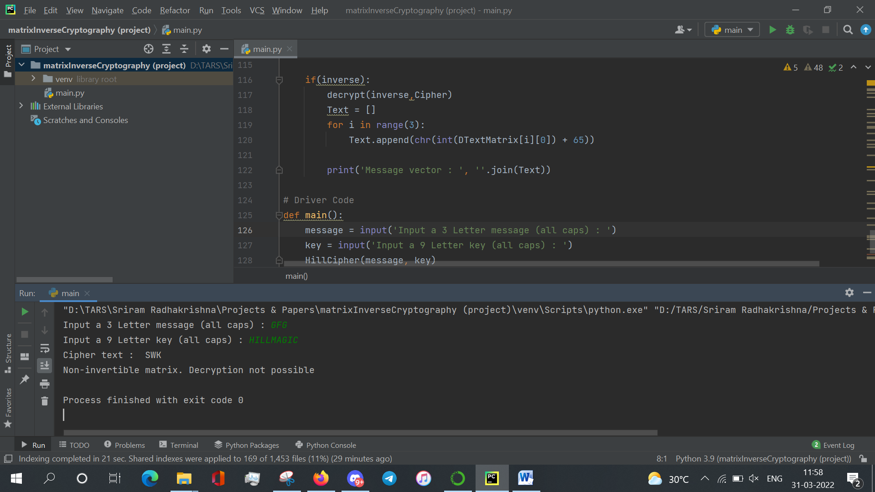

1. Implementation of Markov Chains for :

* Population migration distribution between two Indian states :

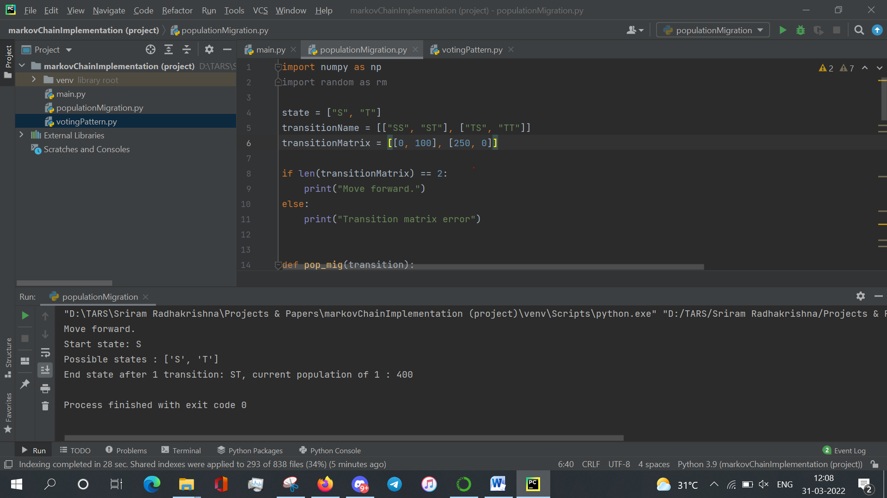

* Vote changing pattern of three political parties from one election to the next :

