**Linear Algebra Assignment 3**

**Sriram Radhakrishna PES1UG20CS435 Section : ‘H’**

**Note : Markov chains and Hill Cipher was submitted in the same document for assignment 1 instead of splitting them and submitting separately. This document was submitted in the form for assignment 2 but is actually assignment 3.**

**Python code (executed on processing IDE) :**

1. Translation :

def setup():

size(200, 200)

background(255)

noStroke()

# draw the original position in gray

fill(192)

rect(20, 20, 40, 40)

# draw a translucent red rectangle by changing the coordinates

fill(255, 0, 0, 128)

rect(20 + 60, 20 + 80, 40, 40)

# draw a translucent blue rectangle by translating the grid

fill(0, 0, 255, 128)

pushMatrix()

translate(60, 80)

rect(20, 20, 40, 40)

popMatrix()

1. Rotation :

def setup():

size(200, 200)

background(255)

smooth()

fill(192)

noStroke()

rect(40, 40, 40, 40)

pushMatrix()

# move the origin to the pivot point

translate(40, 40)

# then pivot the grid

rotate(radians(45))

# and draw the square at the origin

fill(0)

rect(0, 0, 40, 40)

popMatrix()

1. Scaling :

def setup():

size(200, 200)

background(255)

stroke(128)

rect(20, 20, 40, 40)

stroke(0)

pushMatrix()

scale(2.0)

rect(20, 20, 40, 40)

popMatrix()

**Output screenshots :**

1. Translation :

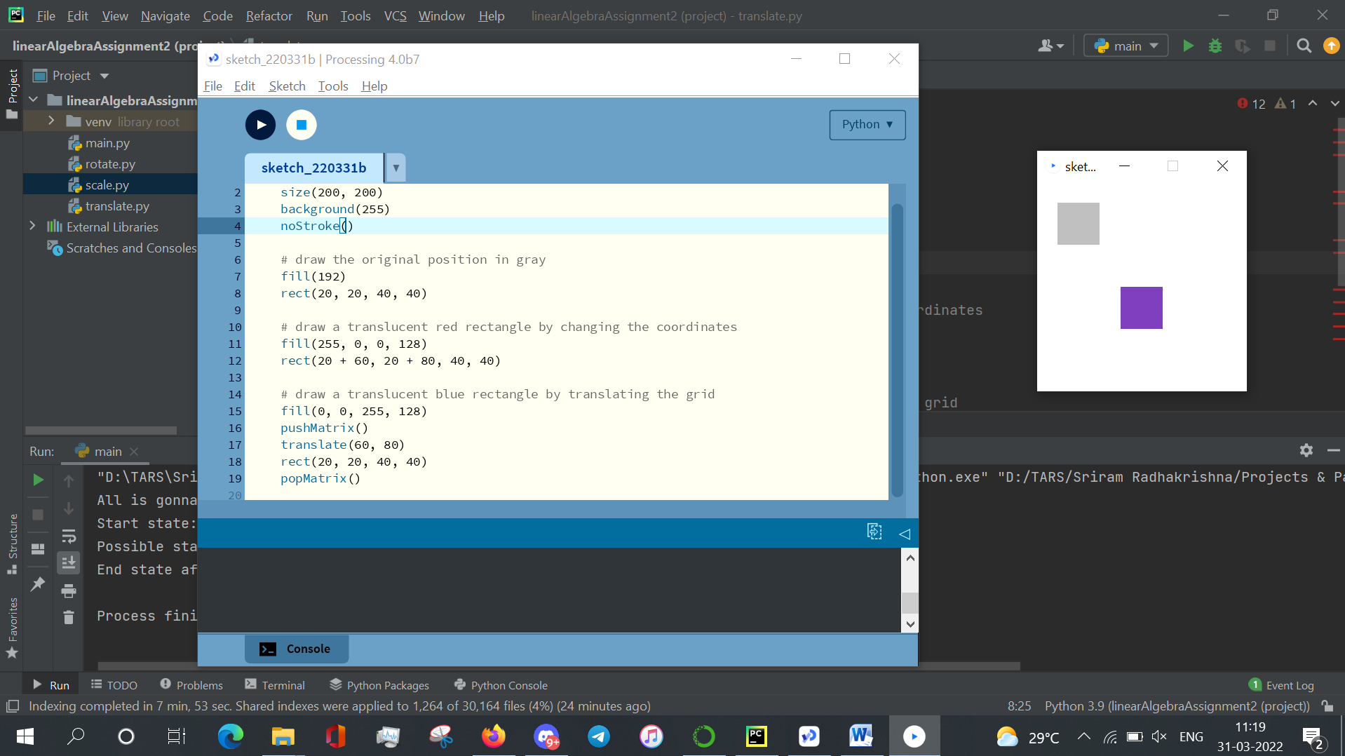

1. Rotation :

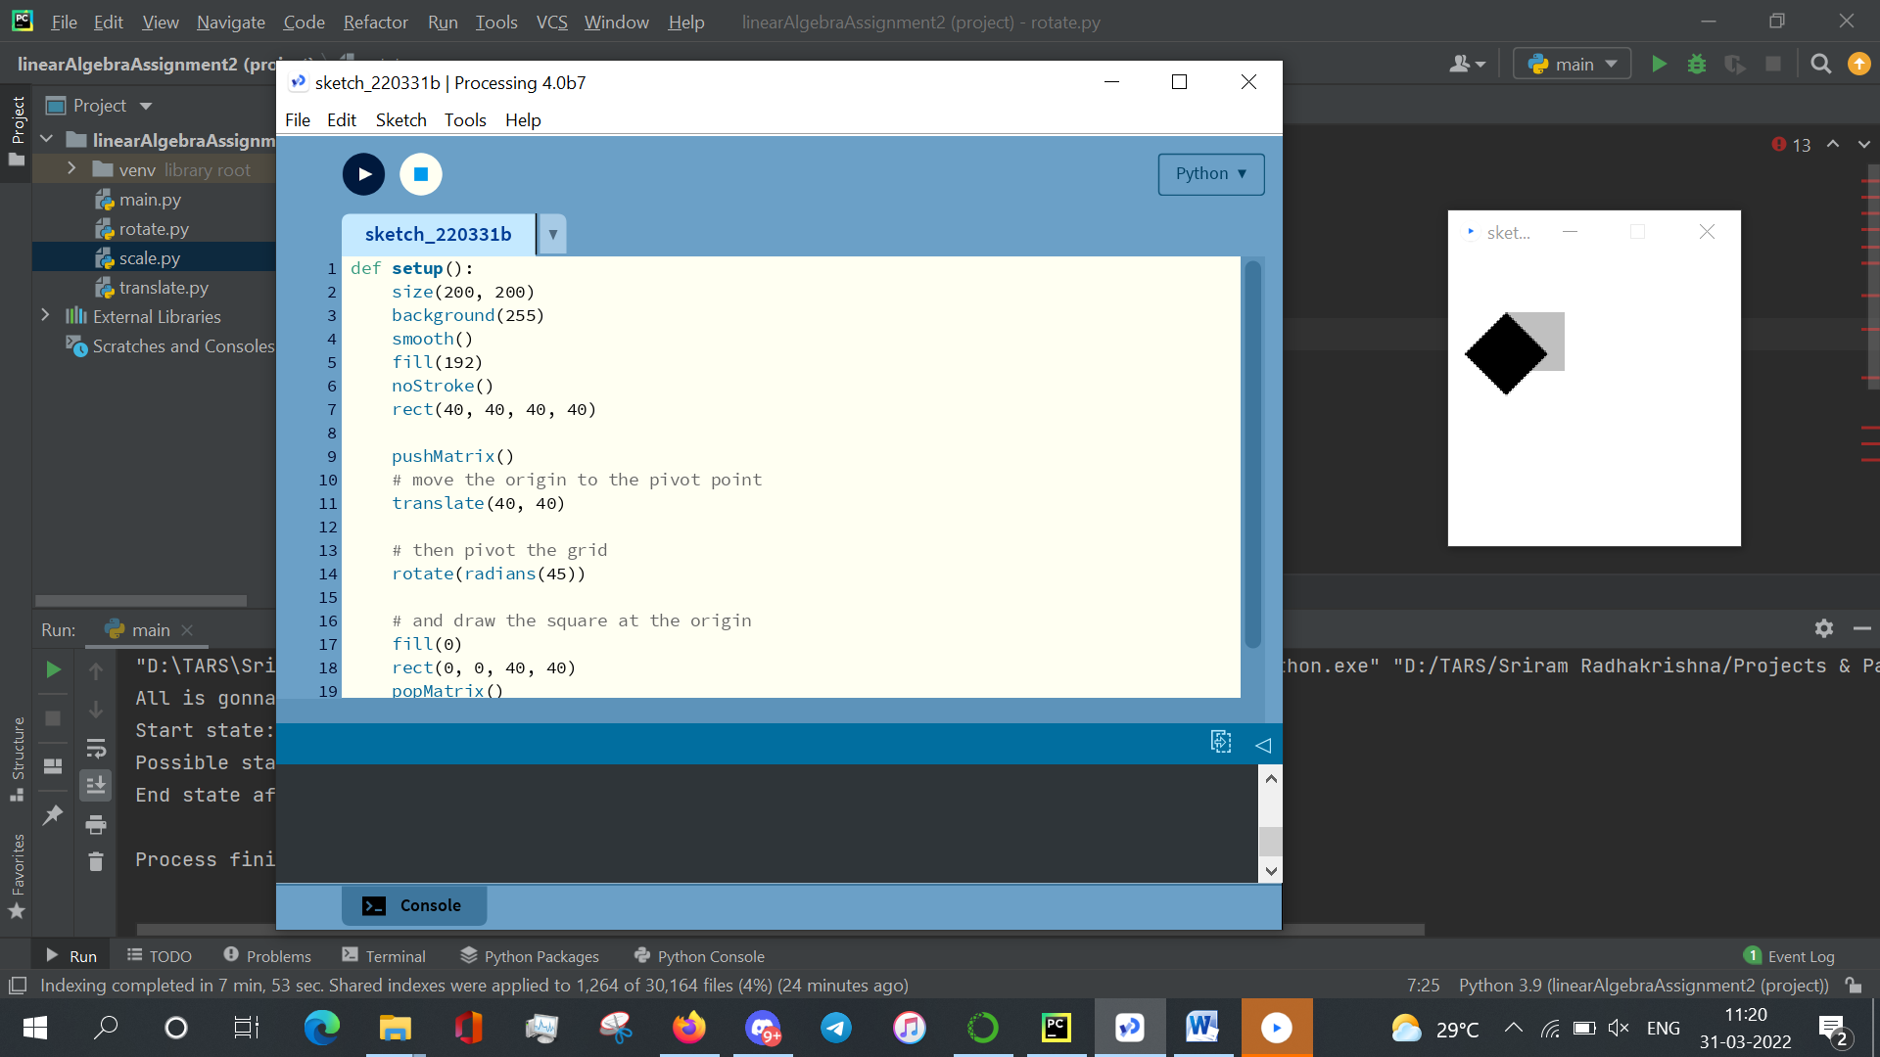

1. Scaling :

