# TASK 1

## CODE

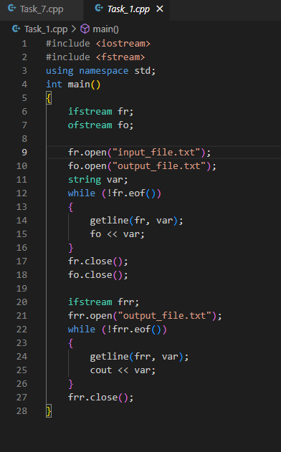

## OUTPUT 1

# TASK 2

## CODE

## OUTPUT 2

# TASK 3

## DEBUG WINDOW

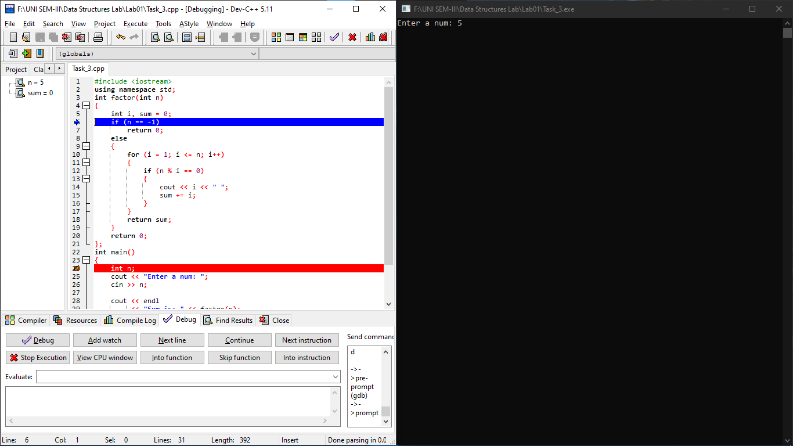

# TASK 4A

## CODE

## OUTPUT 4A

# TASK 4B

## CODE

## OUTPUT 4B

# TASK 5

## CODE

## OUTPUT 5

# TASK 6

## CODE

## OUTPUT 6

# TASK 7

## CODE

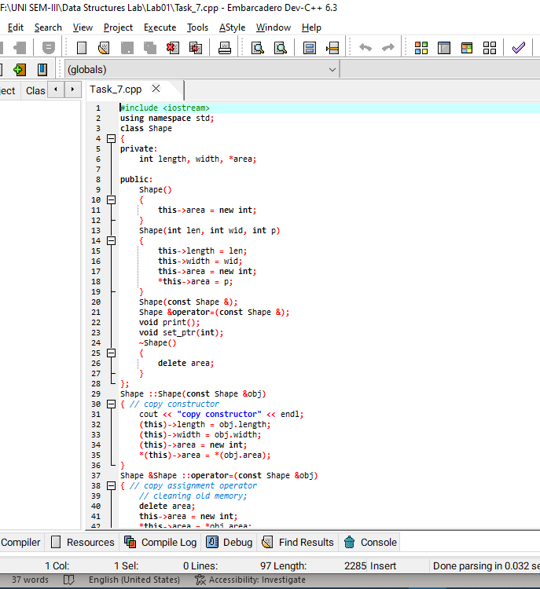

# OUTPUT

### WITHOUT ASSIGNMENT OPERATOR:

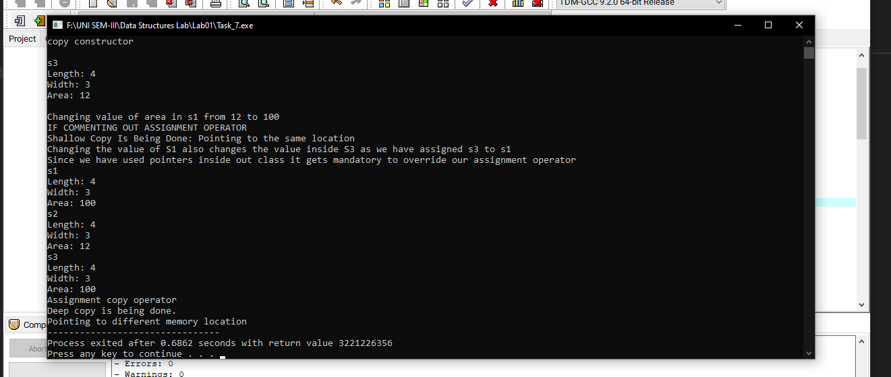

### WITH ASSIGNMENT OPERATOR:

