# TASK 1 CODE

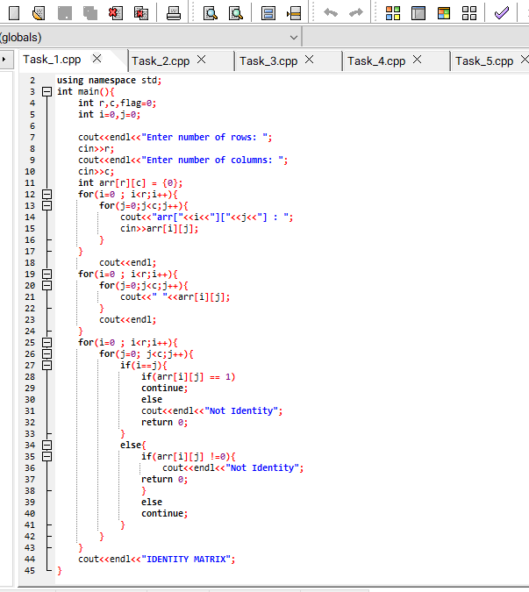

# TASK 1 OUTPUT

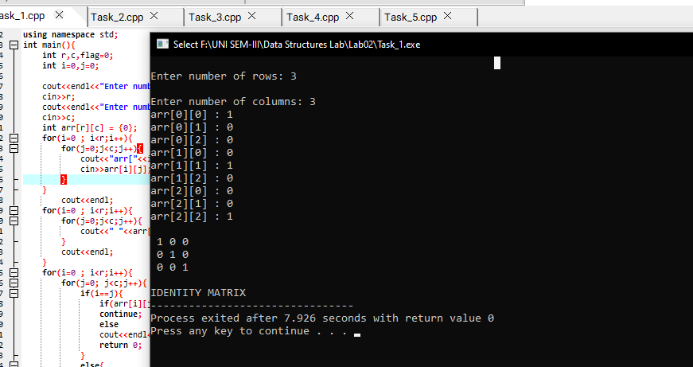

# TASK 2 CODE

# TASK 2 OUTPUT

# TASK 3 CODE

# TASK 3 OUTPUT

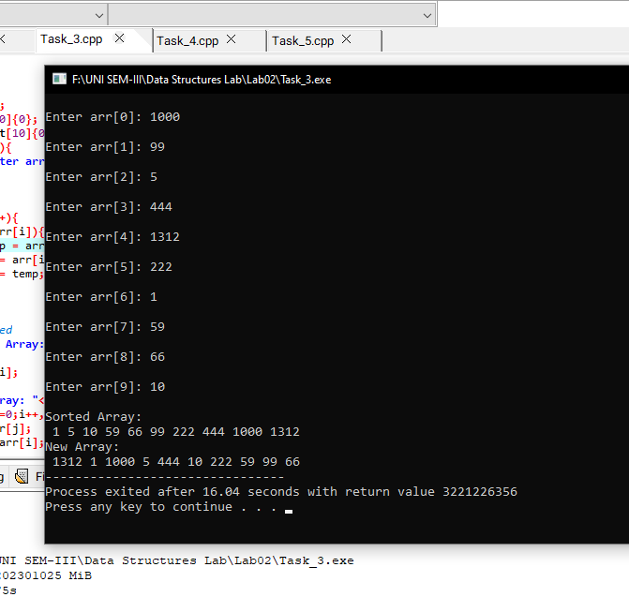

# TASK 4 CODE

# TASK 4 OUTPUT

# TASK 5 CODE

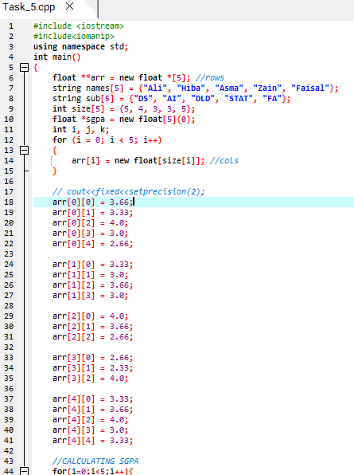

# TASK 5 OUTPUT

