# TASK 1 A CODE AND OUTPUT

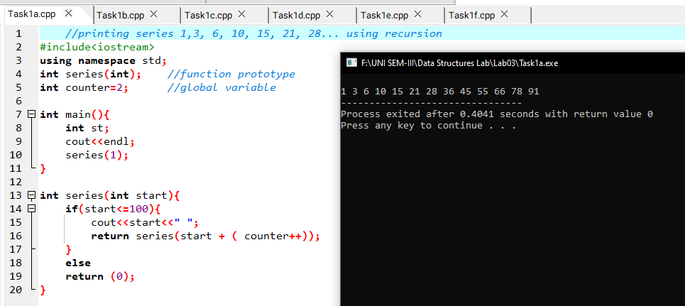

# TASK 1 B CODE AND OUTPUT

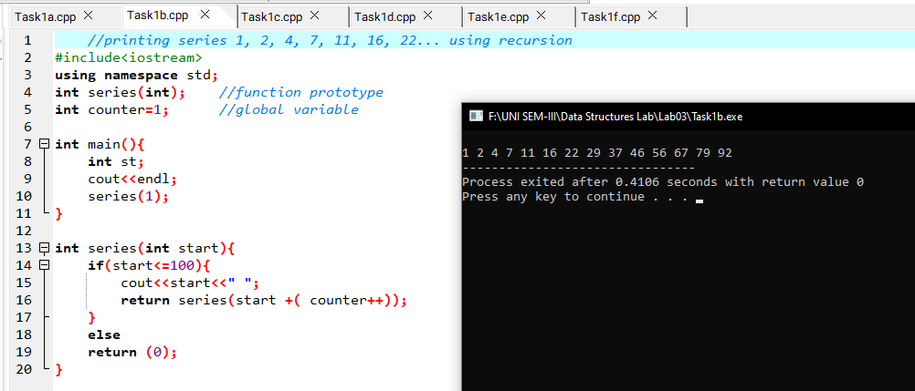

# TASK 1 C CODE AND OUTPUT

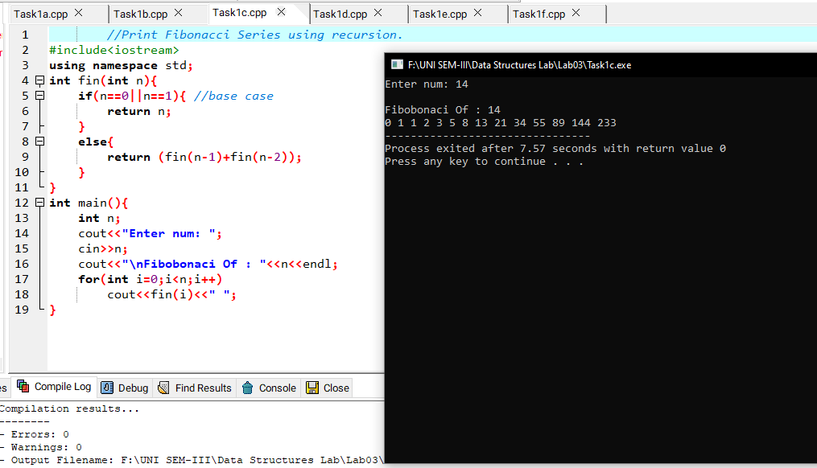

# TASK 1 D CODE AND OUTPUT

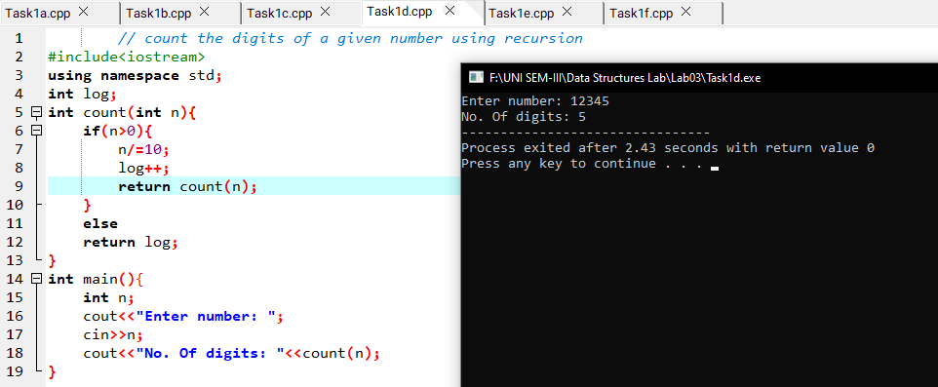

# TASK 1 E CODE AND OUTPUT

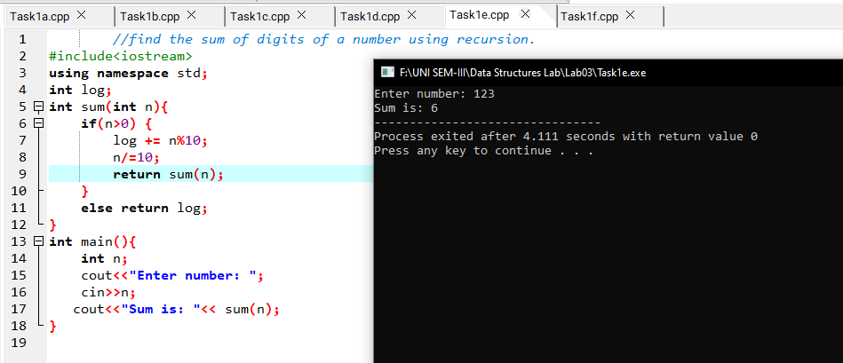

# TASK 1 F CODE AND OUTPUT

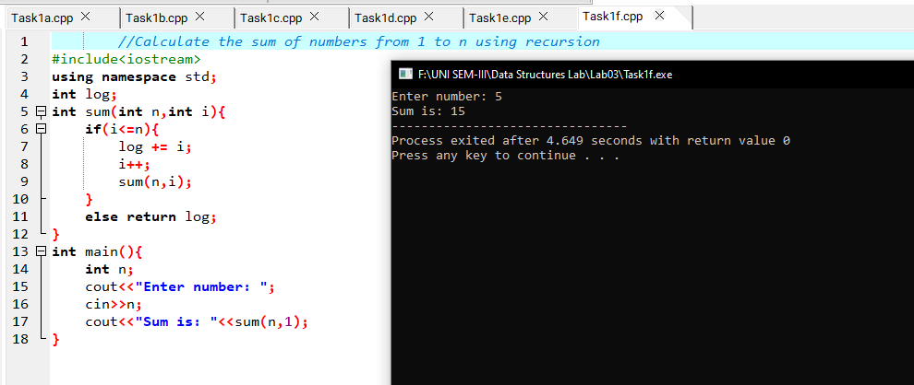

# TASK 2 A CODE AND OUTPUT

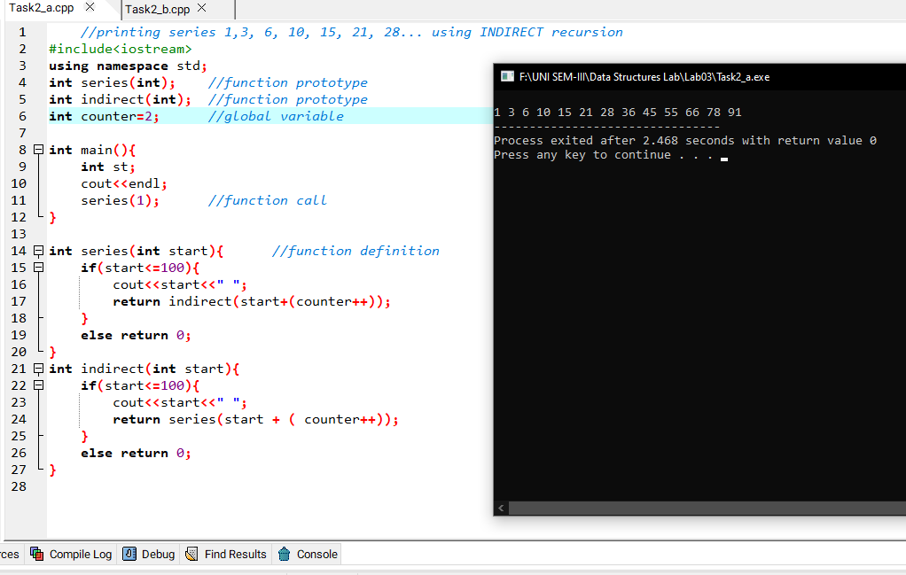

# TASK 2 B CODE AND OUTPUT

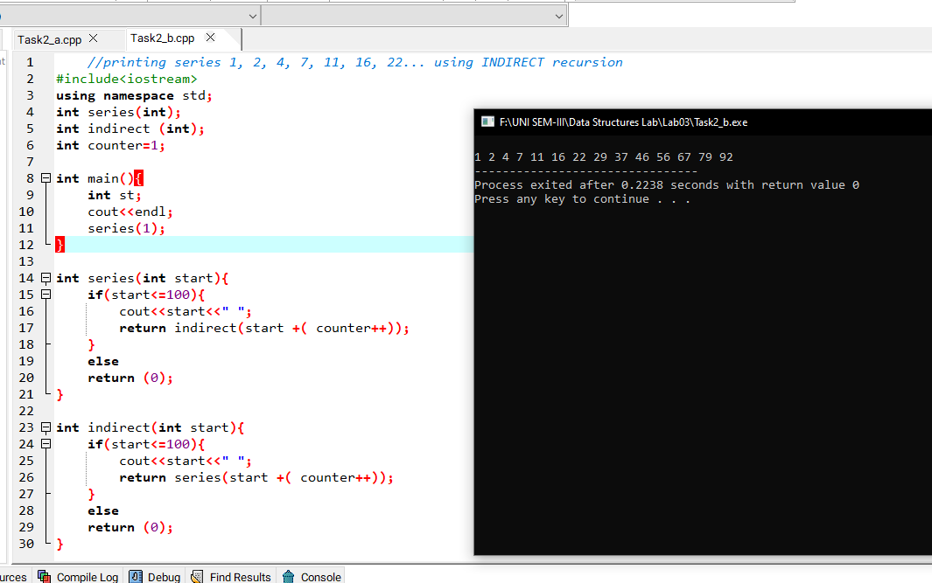

# TASK 3 A CODE AND OUTPUT

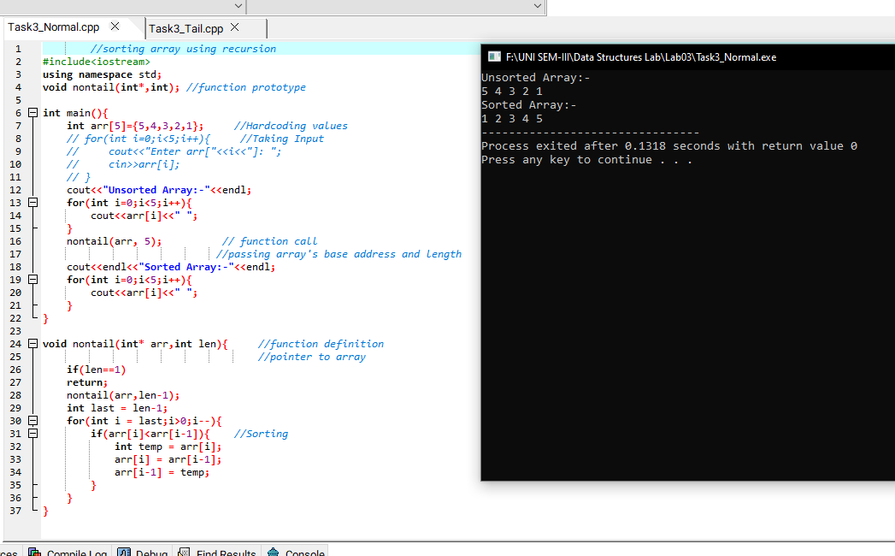

# TASK 3 B CODE AND OUTPUT

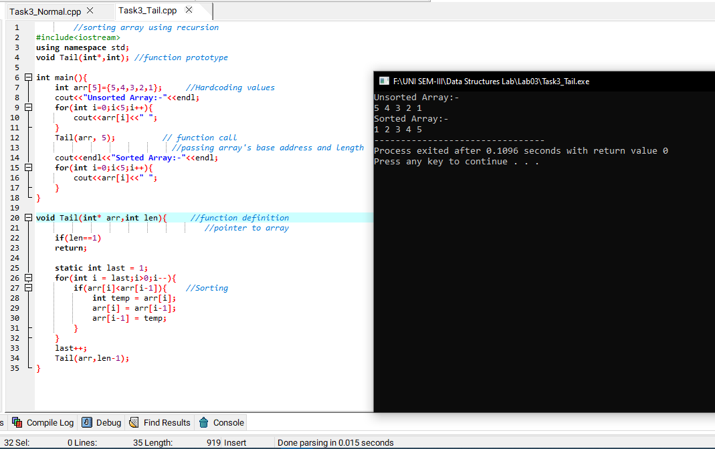

# TASK 4 STACK

|  |  |
| --- | --- |
| Fun(101) | Return 91 |
| Fun(fun(111)) | Return 101 |
| Fun(100) |  |
| Fun(110) | Return 100 |
| Fun(Fun(110)) |  |
| Fun(99) |  |
| Fun(109) | Return 99 |
| Fun(fun (109)) |  |
| Fun(98) |  |
| Fun (108) | Return 98 |
| Fun(fun (108)) |  |
| Fun (97) |  |
| Fun(107) | Return 97 |
| Fun(fun (107)) |  |
| Fun(96) |  |
| Fun(106) | Return 96 |
| Fun(fun(106)) |  |
| Fun(95) |  |
| Main |  |
|  | Prints 91; |

# TASK 5A CODE AND OUTPUT

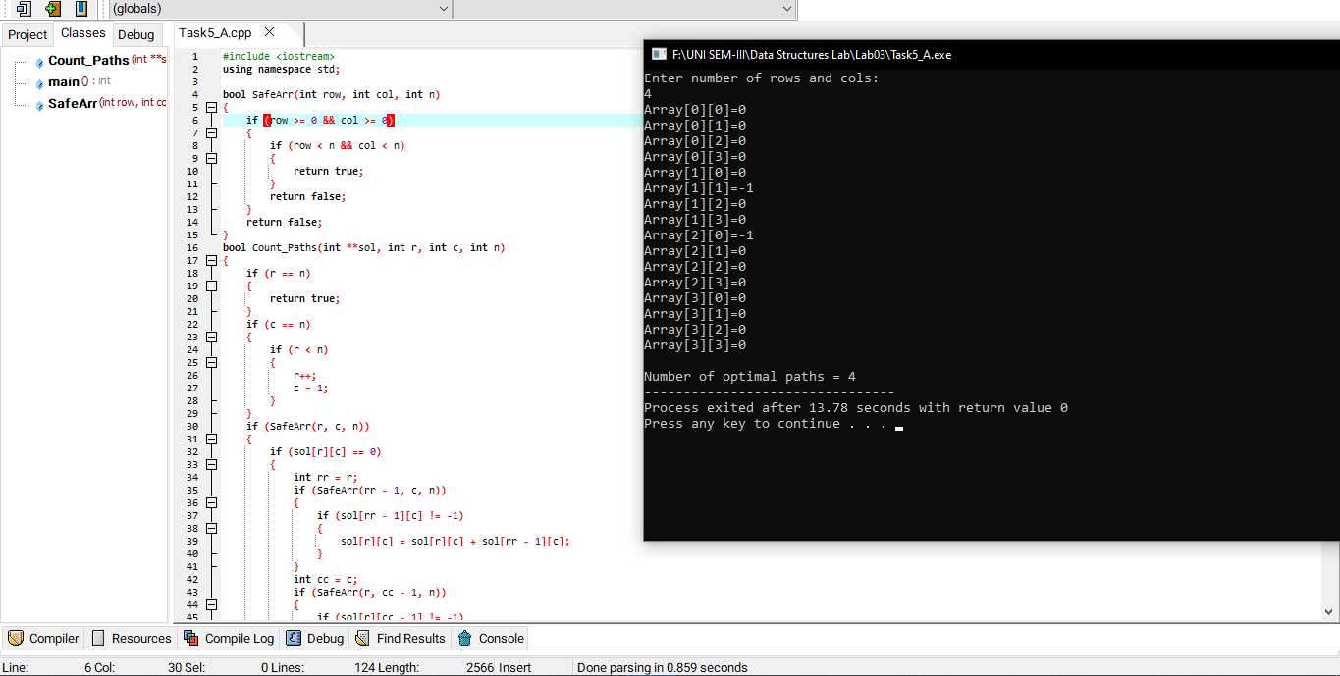

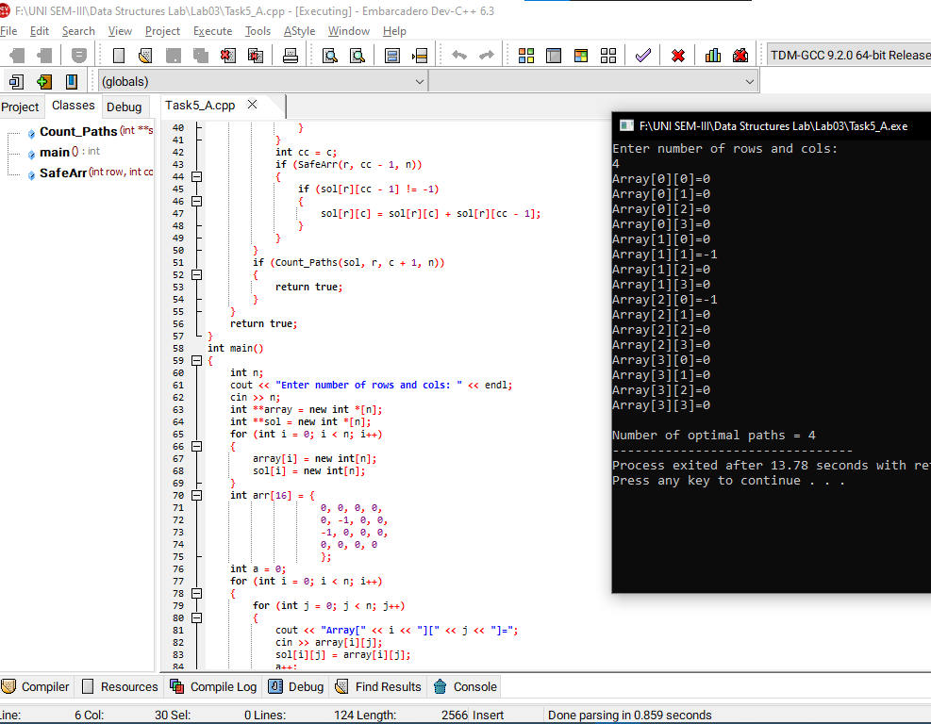

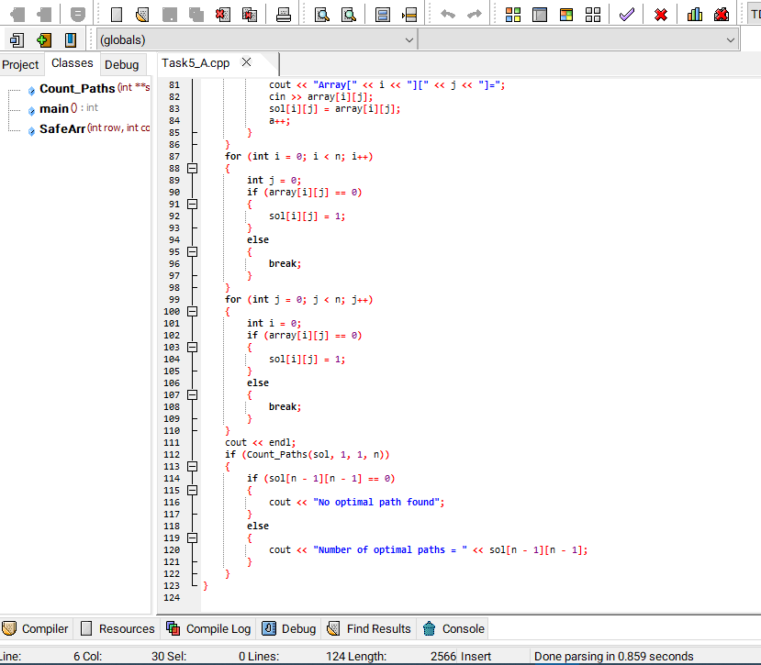

# TASK 5B CODE AND OUTPUT

# TASK 5C CODE AND OUTPUT



