XYZ COLLEGE OF ENGINEERING
Department of Computer Science Engineering
Semester 2 |  | Total Students: 231 |  |  | Appeared: 231 |  |  | Date: 19-Aug-2025 |  | TOPPER LIST
FACULTY NAME | SUBJECT CODE | TOTAL | ATTEMPTED | SUBJECT NAME | FCD | FC | SC | FAIL | PASS | % | USN | MARKS
Name 59 | BCEDK203 | 231 | 228 | COMPUTER-AIDED ENGINEERING DRAWING | 153 | 41 | 22 | 12 | 216 | 94% | 1XX24CS227 | 100
Name 58 | BCHES202 | 231 | 229 | APPLIED CHEMISTRY FOR CSE STREAM | 106 | 73 | 26 | 24 | 205 | 89% | 1XX24CS134 | 98
Name 64 | BESCK204C | 231 | 228 | INTRODUCTION TO ELECTRONICS COMMUNICATION | 42 | 80 | 68 | 38 | 190 | 83% | 1XX24CS018 | 90
Name 61 | BICOK207 | 231 | 229 | INDIAN CONSTITUTION | 97 | 88 | 39 | 5 | 224 | 97% | 1XX24CS203 | 94
Name 62 | BIDTK258 | 231 | 228 | INNOVATION AND DESIGN THINKING | 93 | 117 | 16 | 2 | 226 | 99% | 1XX24CS085 | 92
Name 57 | BMATS201 | 231 | 227 | MATHEMATICS-II FOR CSE STREAM | 76 | 77 | 19 | 55 | 172 | 75% | 1XX24CS132 | 97
Name 63 | BPLCK205B | 231 | 229 | INTRODUCTION TO PYTHON PROGRAMMING | 63 | 84 | 18 | 64 | 165 | 72% | 1XX24CS070 | 98
Name 60 | BPWSK206 | 231 | 228 | PROFESSIONAL WRITING SKILLS IN ENGLISH | 146 | 76 | 1 | 5 | 223 | 97% | 1XX24CS121 | 92
GRADING SCHEMA |  |  |  |  |  | OVERALL RESULTS
Included |  | Grade |  | Excluded |  | Total Passed |  | 135 |  | 58%
75 <= |  | FCD |  | <= 100 |  | FCD |  | 81 |  | 35%
60 <= |  | FC |  | > 75 |  | FC |  | 54 |  | 23%
40 <= |  | SC |  | > 60 |  | SC |  | 0 |  | 0%
0 <= |  | Fail |  | > 40 |  | Fail |  | 96 |  | 42%
TOP PERFORMERS
GOLD MEDALIST |  |  | 1XX24CS017 |  |  |  |  | 713 |  |  | 89.125%
SILVER MEDALIST |  |  | 1XX24CS224 |  |  |  |  | 712 |  |  | 89.0%
BRONZE MEDALIST |  |  | 1XX24CS108 |  |  |  |  | 706 |  |  | 88.25%
SRAC - Results Powered by Tanishq JM.
_______________  HOD |  |  |  |  |  |  |  |  | _______________  PRINCIPAL
Separate file will be provide
Separate file will be provided in output.
USN | BENGK206 |  |  | More Subjects … | BSFHK258 |  |  | Final
 | IA | EA | Total | marks | IA | EA | Total | Total | Percentage | CGPA | Grade | Fail count
1XY24CO001 | 50 | 32 | 82.0 | data | 50 | 30 | 80.0 | 610 | 76.25 | 8 | FCD
1XY24CO002 | 46 | 43 | 89.0 | data | 50 | 31 | 81.0 | 565 | 70.625 | 7.35 | FC
1XY24CO003 | 46 | 28 | 74.0 | data | 50 | 34 | 84.0 | 636 | 79.5 | 8.45 | FCD
1XY24CO004 | 45 | 22 | 67.0 | data | 50 | 32 | 82.0 | 535 | 66.875 | 7 | F | 1
1XY24CO005 | 50 | 40 | 90.0 | data | 49 | 37 | 86.0 | 618 | 77.25 | 7.9 | FCD
1XY24CO007 | 50 | 31 | 81.0 | data | 50 | 34 | 84.0 | 666 | 83.25 | 8.9 | FCD
1XY24CO008 | 40 | 30 | 70 | data | 48 | 30 | 78 | 341 | 42.625 | 3.7 | F | 3
1XY24CO009 | 50 | 30 | 80.0 | data | 50 | 32 | 82.0 | 651 | 81.375 | 8.8 | FCD
1XY24CO010 | 40 | 31 | 71 | data | 48 | 29 | 77 | 297 | 37.125 | 3.1 | F | 4
1XY24CO011 | 45 | 36 | 81.0 | data | 25 | 32 | 57.0 | 536 | 67 | 7.15 | FC
1XY24CO012 | 43 | 21 | 64.0 | data | 49 | 31 | 80.0 | 516 | 64.5 | 6.45 | FC
1XY24CO013 | 50 | 29 | 79.0 | data | 50 | 30 | 80.0 | 600 | 75 | 7.9 | FCD
1XY24CO014 | 42 | 30 | 72.0 | data | 50 | 35 | 85.0 | 600 | 75 | 7.7 | FCD
1XY24CO015 | 42 | 25 | 67 | data | 50 | 22 | 72 | 277 | 34.625 | 2.75 | F | 4
1XY24CO016 | 40 | 25 | 65.0 | data | 25 | 28 | 53.0 | 231 | 28.875 | 2.6 | F | 4
1XY24CO017 | 50 | 36 | 86.0 | data | 50 | 41 | 91.0 | 710 | 88.75 | 9.45 | FCD
1XY24CO018 | 50 | 32 | 82.0 | data | 50 | 31 | 81.0 | 680 | 85 | 9 | FCD
1XY24CO019 | 46 | 29 | 75.0 | data | 50 | 33 | 83.0 | 556 | 69.5 | 7.15 | FC
1XY24CO020 | 42 | 24 | 66.0 | data | 50 | 26 | 76.0 | 538 | 67.25 | 6.95 | FC
1XY24CO021 | 42 | 23 | 65.0 | data | 49 | 29 | 78.0 | 613 | 76.625 | 8.15 | FCD
1XY24CO022 | 45 | 25 | 70.0 | data | 50 | 33 | 83.0 | 518 | 64.75 | 6.55 | F | 1
1XY24CO023 | 50 | 40 | 90.0 | data | 50 | 34 | 84.0 | 668 | 83.5 | 8.65 | FCD
1XY24CO024 | 39 | 21 | 60 | data | 49 | 30 | 79 | 333 | 41.625 | 3.9 | F | 3

Separate file will be provided
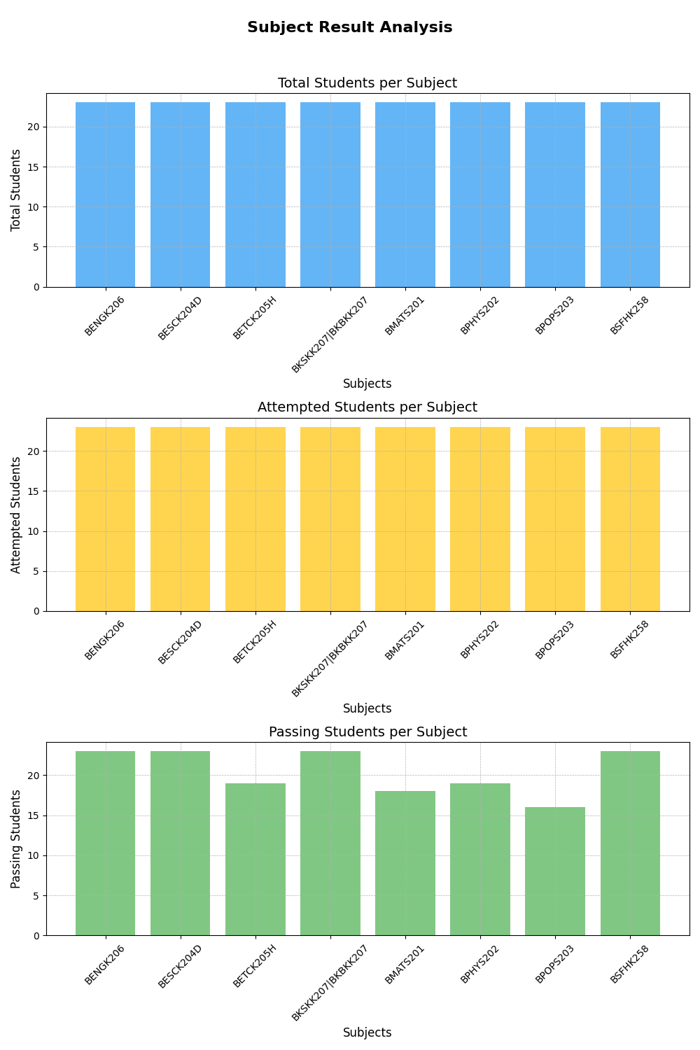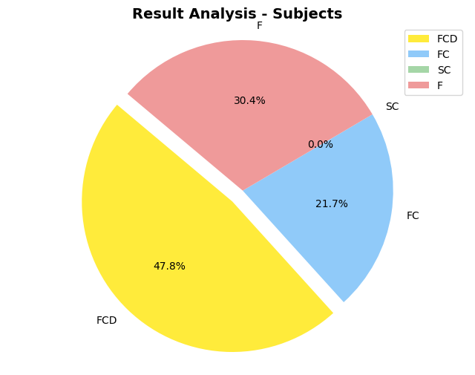
And Many more formats …

