|  |  |  |  |  |  |  |  |  |  |  |  |  |
| --- | --- | --- | --- | --- | --- | --- | --- | --- | --- | --- | --- | --- |
| **XYZ COLLEGE OF ENGINEERING** | | | | | | | | | | | | |
|  | | | | | | | | | | | | |
| **Department of Computer Science Engineering** | | | | | | | | | | | | |
| **Semester 2** | | **Total Students: 231** | | | **Appeared: 231** | | | **Date: 19-Aug-2025** | | **TOPPER LIST** | | |
| **FACULTY NAME** | **SUBJECT CODE** | **TOTAL** | **ATTEMPTED** | **SUBJECT NAME** | **FCD** | **FC** | **SC** | **FAIL** | **PASS** | **%** | **USN** | **MARKS** |
| Name 59 | BCEDK203 | 231 | 228 | COMPUTER-AIDED ENGINEERING DRAWING | 153 | 41 | 22 | 12 | 216 | 94% | 1XX24CS227 | 100 |
| Name 58 | BCHES202 | 231 | 229 | APPLIED CHEMISTRY FOR CSE STREAM | 106 | 73 | 26 | 24 | 205 | 89% | 1XX24CS134 | 98 |
| Name 64 | BESCK204C | 231 | 228 | INTRODUCTION TO ELECTRONICS COMMUNICATION | 42 | 80 | 68 | 38 | 190 | 83% | 1XX24CS018 | 90 |
| Name 61 | BICOK207 | 231 | 229 | INDIAN CONSTITUTION | 97 | 88 | 39 | 5 | 224 | 97% | 1XX24CS203 | 94 |
| Name 62 | BIDTK258 | 231 | 228 | INNOVATION AND DESIGN THINKING | 93 | 117 | 16 | 2 | 226 | 99% | 1XX24CS085 | 92 |
| Name 57 | BMATS201 | 231 | 227 | MATHEMATICS-II FOR CSE STREAM | 76 | 77 | 19 | 55 | 172 | 75% | 1XX24CS132 | 97 |
| Name 63 | BPLCK205B | 231 | 229 | INTRODUCTION TO PYTHON PROGRAMMING | 63 | 84 | 18 | 64 | 165 | 72% | 1XX24CS070 | 98 |
| Name 60 | BPWSK206 | 231 | 228 | PROFESSIONAL WRITING SKILLS IN ENGLISH | 146 | 76 | 1 | 5 | 223 | 97% | 1XX24CS121 | 92 |
|  | | | | | | | | | | | | |
| **GRADING SCHEMA** | | | | | | **OVERALL RESULTS** | | | | | | |
| **Included** | | **Grade** | | **Excluded** | | **Total Passed** | | **135** | | **58%** | | |
| **75 <=** | | **FCD** | | **<= 100** | | **FCD** | | **81** | | **35%** | | |
| **60 <=** | | **FC** | | **> 75** | | **FC** | | **54** | | **23%** | | |
| **40 <=** | | **SC** | | **> 60** | | **SC** | | **0** | | **0%** | | |
| **0 <=** | | **Fail** | | **> 40** | | **Fail** | | **96** | | **42%** | | |
|  | | | | | | | | | | | | |
| **TOP PERFORMERS** | | | | | | | | | | | | |
| **GOLD MEDALIST** | | | **1XX24CS017** | | | | | **713** | | | **89.125%** | |
| **SILVER MEDALIST** | | | **1XX24CS224** | | | | | **712** | | | **89.0%** | |
| **BRONZE MEDALIST** | | | **1XX24CS108** | | | | | **706** | | | **88.25%** | |
| ***SRAC - Results Powered by Tanishq JM.*** | | | | | | | | | | | | |
|  | | | | | | | | | | | | |
| _______________  **HOD** | | | |  | | | | | _______________  **PRINCIPAL** | | | |

Separate file will be provide

Separate file will be provided in output.

|  |  |  |  |  |  |  |  |  |  |  |  |  |
| --- | --- | --- | --- | --- | --- | --- | --- | --- | --- | --- | --- | --- |
| **USN** | **BENGK206** | | | More Subjects … | **BSFHK258** | | | **Final** | | | | |
| **IA** | **EA** | **Total** | **marks** | **IA** | **EA** | **Total** | **Total** | **Percentage** | **CGPA** | **Grade** | **Fail count** |
| 1XY24CO001 | 50 | 32 | 82.0 | data | 50 | 30 | 80.0 | 610 | 76.25 | 8 | FCD |  |
| 1XY24CO002 | 46 | 43 | 89.0 | data | 50 | 31 | 81.0 | 565 | 70.625 | 7.35 | FC |  |
| 1XY24CO003 | 46 | 28 | 74.0 | data | 50 | 34 | 84.0 | 636 | 79.5 | 8.45 | FCD |  |
| 1XY24CO004 | 45 | 22 | 67.0 | data | 50 | 32 | 82.0 | 535 | 66.875 | 7 | F | 1 |
| 1XY24CO005 | 50 | 40 | 90.0 | data | 49 | 37 | 86.0 | 618 | 77.25 | 7.9 | FCD |  |
| 1XY24CO007 | 50 | 31 | 81.0 | data | 50 | 34 | 84.0 | 666 | 83.25 | 8.9 | FCD |  |
| 1XY24CO008 | 40 | 30 | 70 | data | 48 | 30 | 78 | 341 | 42.625 | 3.7 | F | 3 |
| 1XY24CO009 | 50 | 30 | 80.0 | data | 50 | 32 | 82.0 | 651 | 81.375 | 8.8 | FCD |  |
| 1XY24CO010 | 40 | 31 | 71 | data | 48 | 29 | 77 | 297 | 37.125 | 3.1 | F | 4 |
| 1XY24CO011 | 45 | 36 | 81.0 | data | 25 | 32 | 57.0 | 536 | 67 | 7.15 | FC |  |
| 1XY24CO012 | 43 | 21 | 64.0 | data | 49 | 31 | 80.0 | 516 | 64.5 | 6.45 | FC |  |
| 1XY24CO013 | 50 | 29 | 79.0 | data | 50 | 30 | 80.0 | 600 | 75 | 7.9 | FCD |  |
| 1XY24CO014 | 42 | 30 | 72.0 | data | 50 | 35 | 85.0 | 600 | 75 | 7.7 | FCD |  |
| 1XY24CO015 | 42 | 25 | 67 | data | 50 | 22 | 72 | 277 | 34.625 | 2.75 | F | 4 |
| 1XY24CO016 | 40 | 25 | 65.0 | data | 25 | 28 | 53.0 | 231 | 28.875 | 2.6 | F | 4 |
| 1XY24CO017 | 50 | 36 | 86.0 | data | 50 | 41 | 91.0 | 710 | 88.75 | 9.45 | FCD |  |
| 1XY24CO018 | 50 | 32 | 82.0 | data | 50 | 31 | 81.0 | 680 | 85 | 9 | FCD |  |
| 1XY24CO019 | 46 | 29 | 75.0 | data | 50 | 33 | 83.0 | 556 | 69.5 | 7.15 | FC |  |
| 1XY24CO020 | 42 | 24 | 66.0 | data | 50 | 26 | 76.0 | 538 | 67.25 | 6.95 | FC |  |
| 1XY24CO021 | 42 | 23 | 65.0 | data | 49 | 29 | 78.0 | 613 | 76.625 | 8.15 | FCD |  |
| 1XY24CO022 | 45 | 25 | 70.0 | data | 50 | 33 | 83.0 | 518 | 64.75 | 6.55 | F | 1 |
| 1XY24CO023 | 50 | 40 | 90.0 | data | 50 | 34 | 84.0 | 668 | 83.5 | 8.65 | FCD |  |
| 1XY24CO024 | 39 | 21 | 60 | data | 49 | 30 | 79 | 333 | 41.625 | 3.9 | F | 3 |

Separate file will be provided

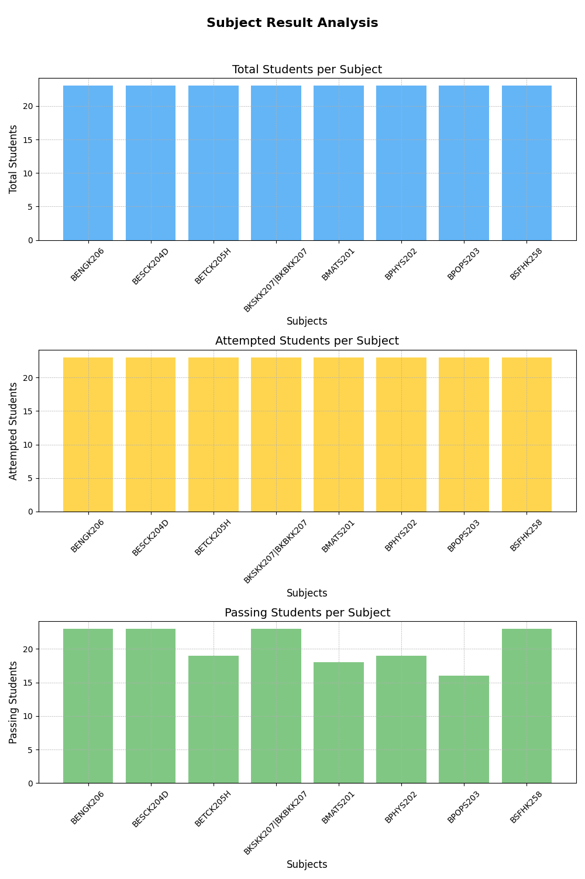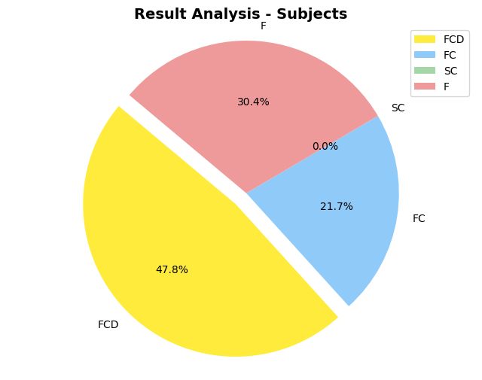

And Many more formats …