* **2×1 MUX gate using gates**
* 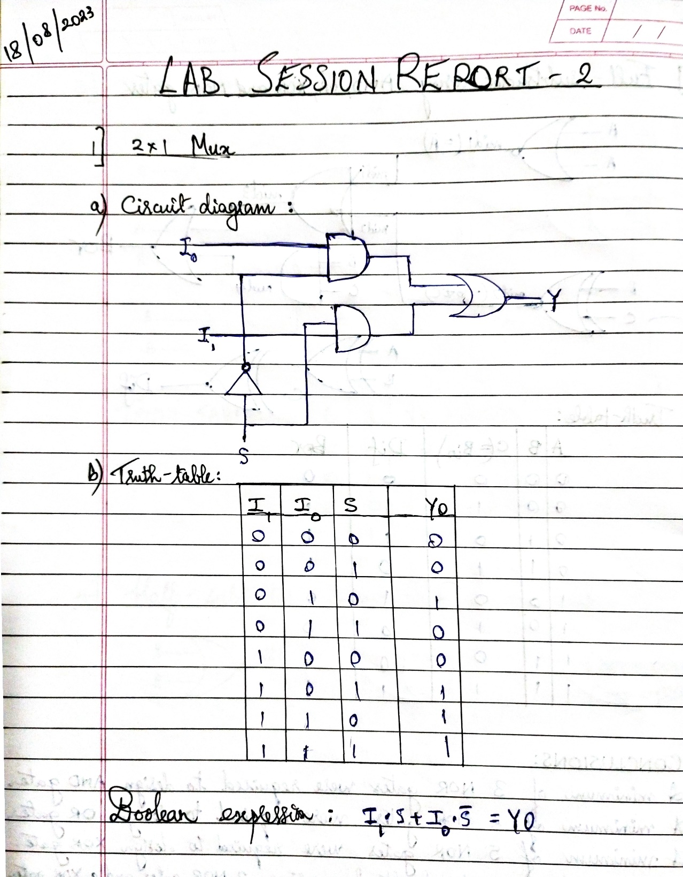Circuit Diagram
* 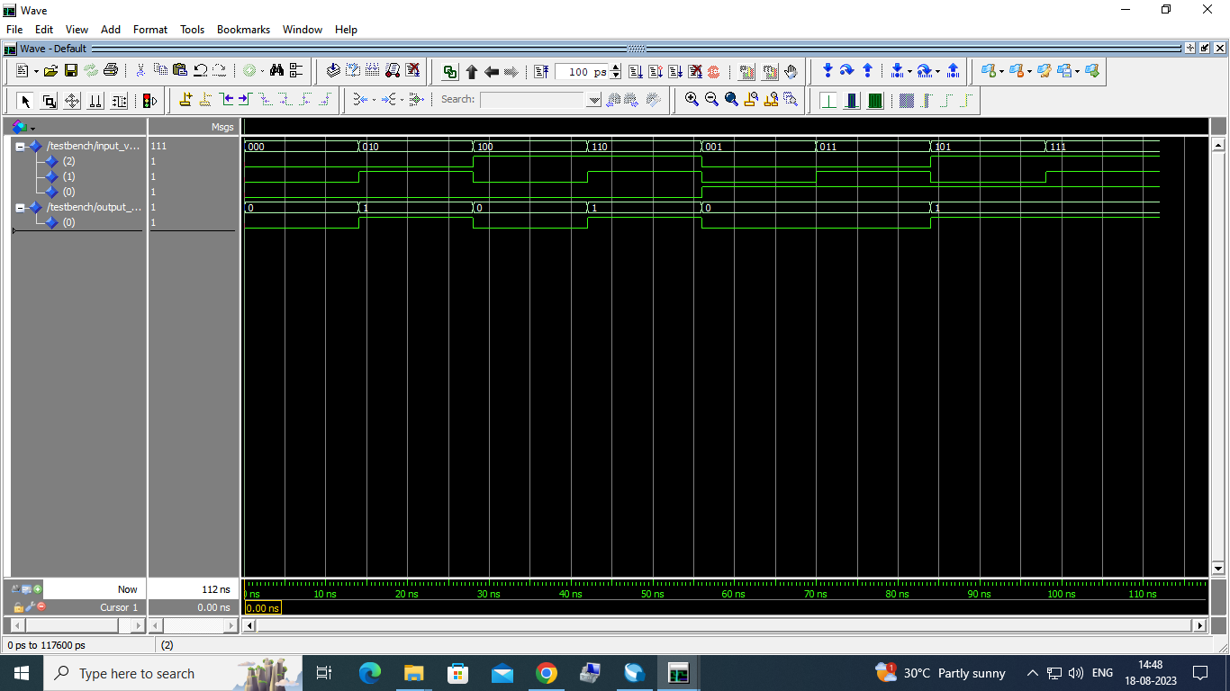ModelSim Waveforms
* 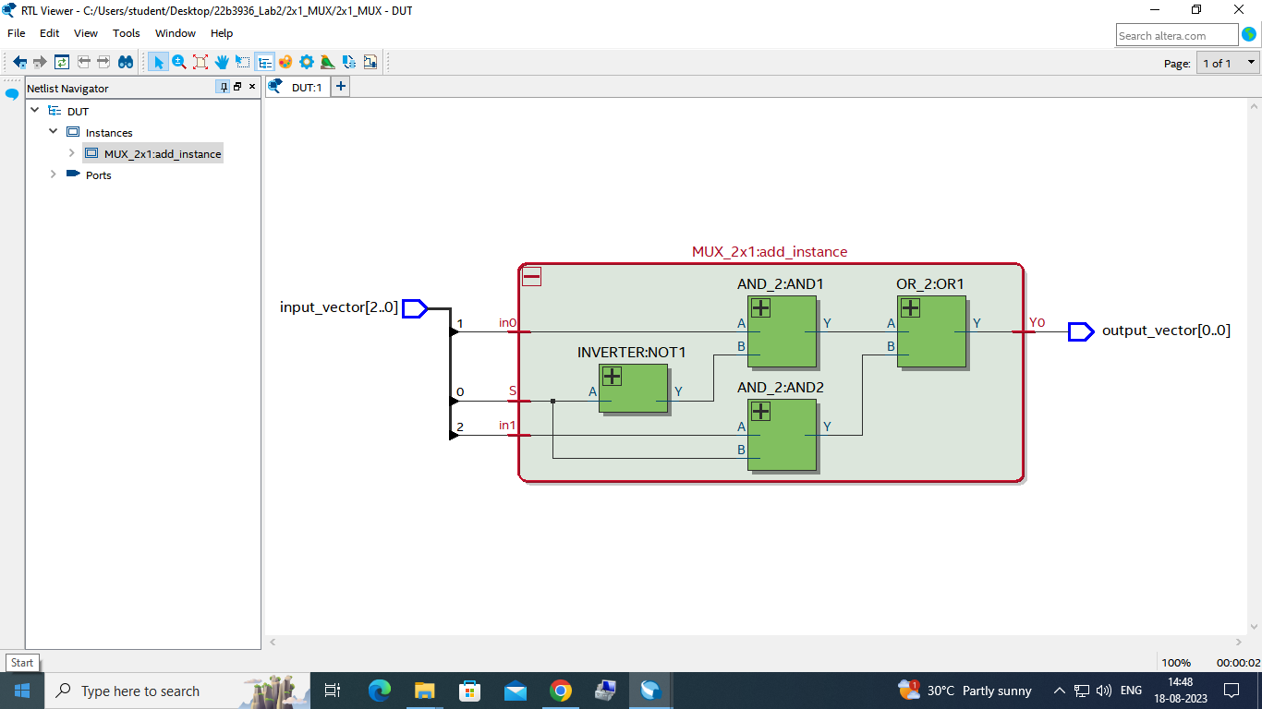RTL Netlist viewer
* **4×1 MUX gate using 2×1 MUX**
* 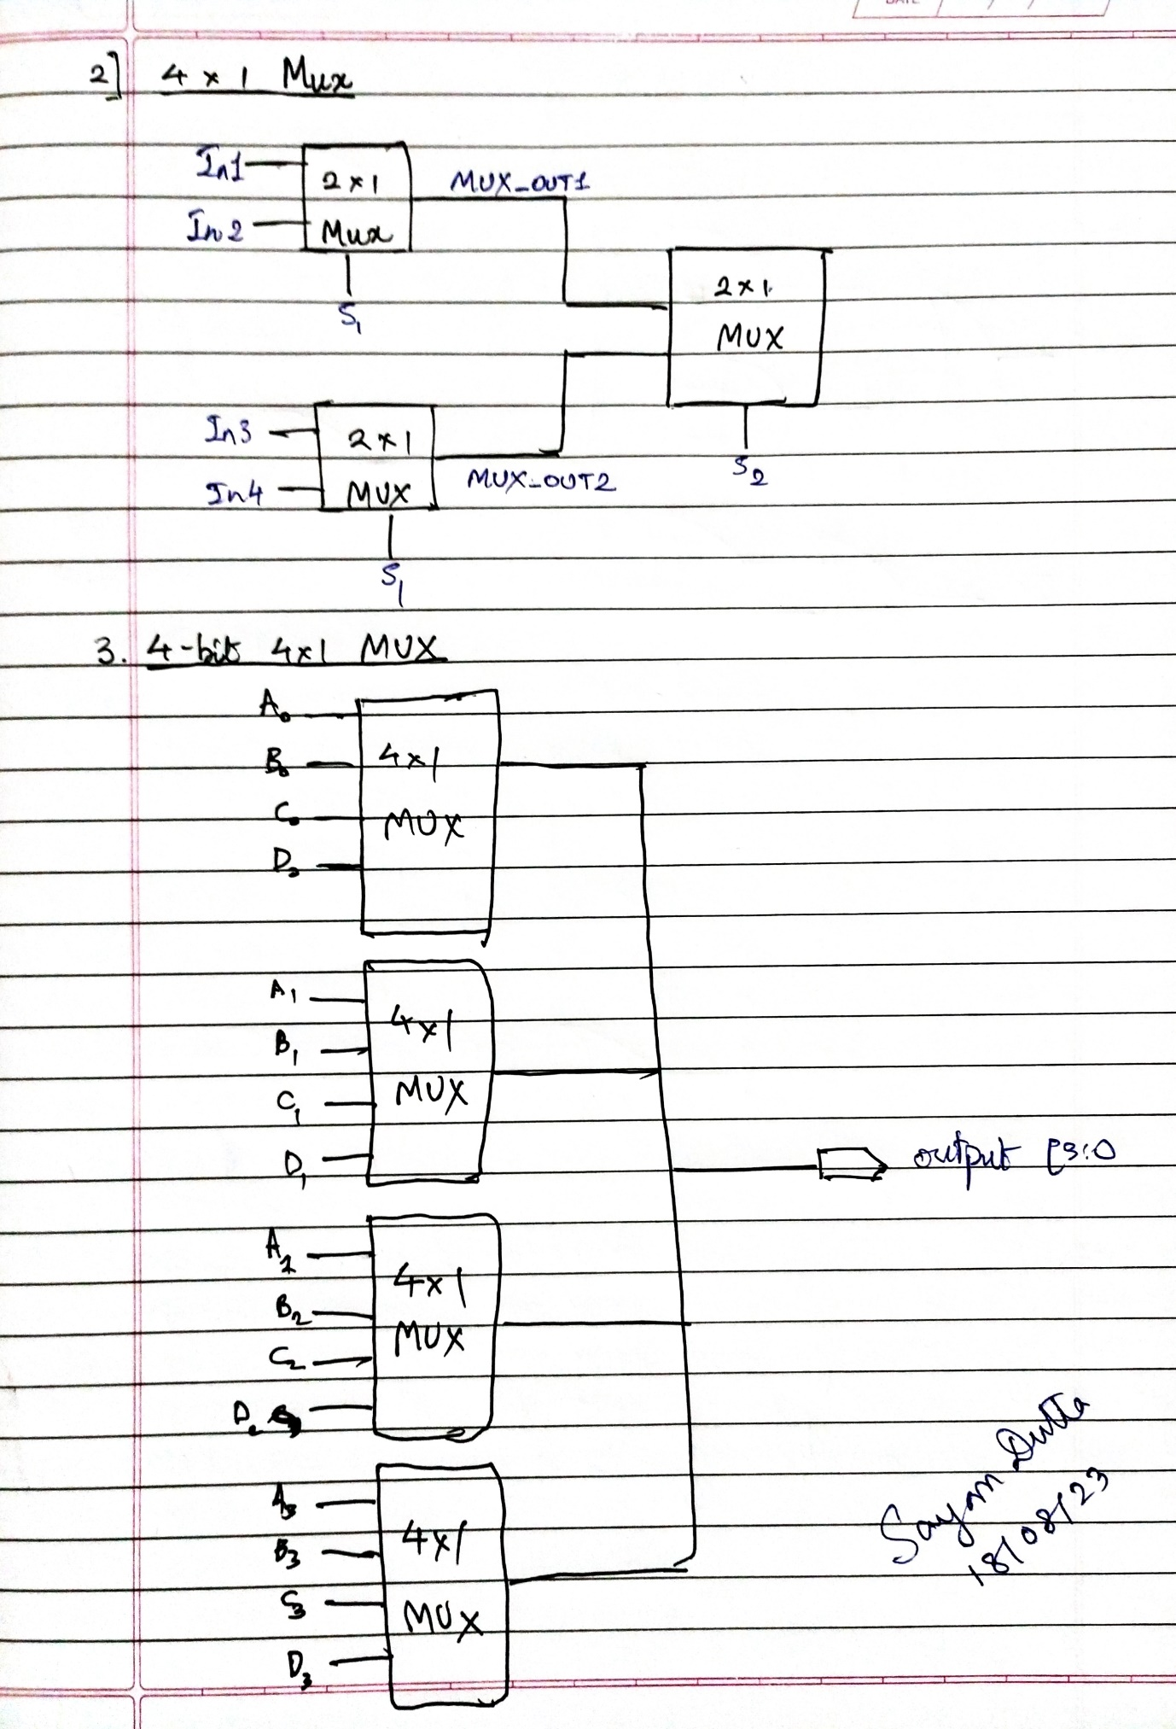Circuit Diagram
* 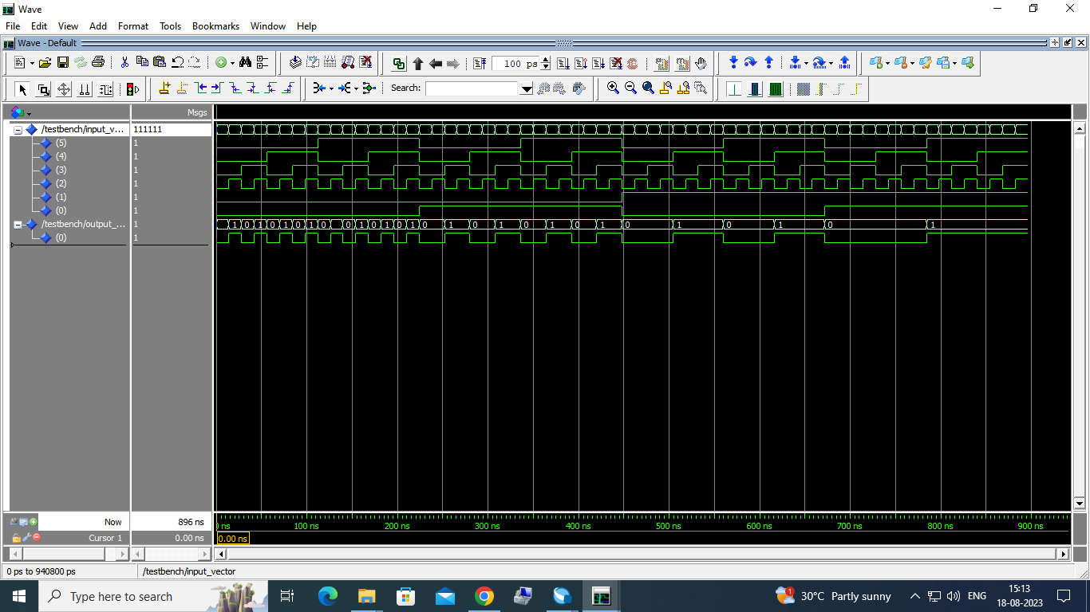ModelSim Waveforms
* 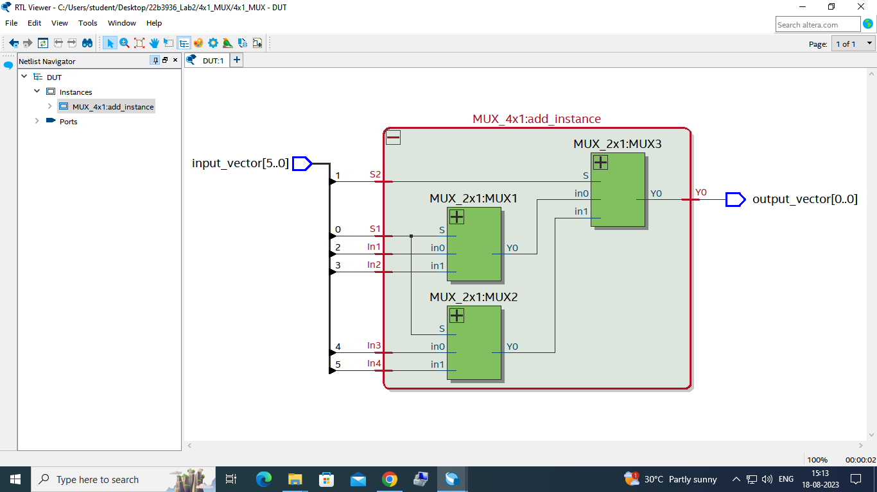RTL Netlist viewer

* **4-bit 4×1 MUX gate using 4×1 MUX**
* 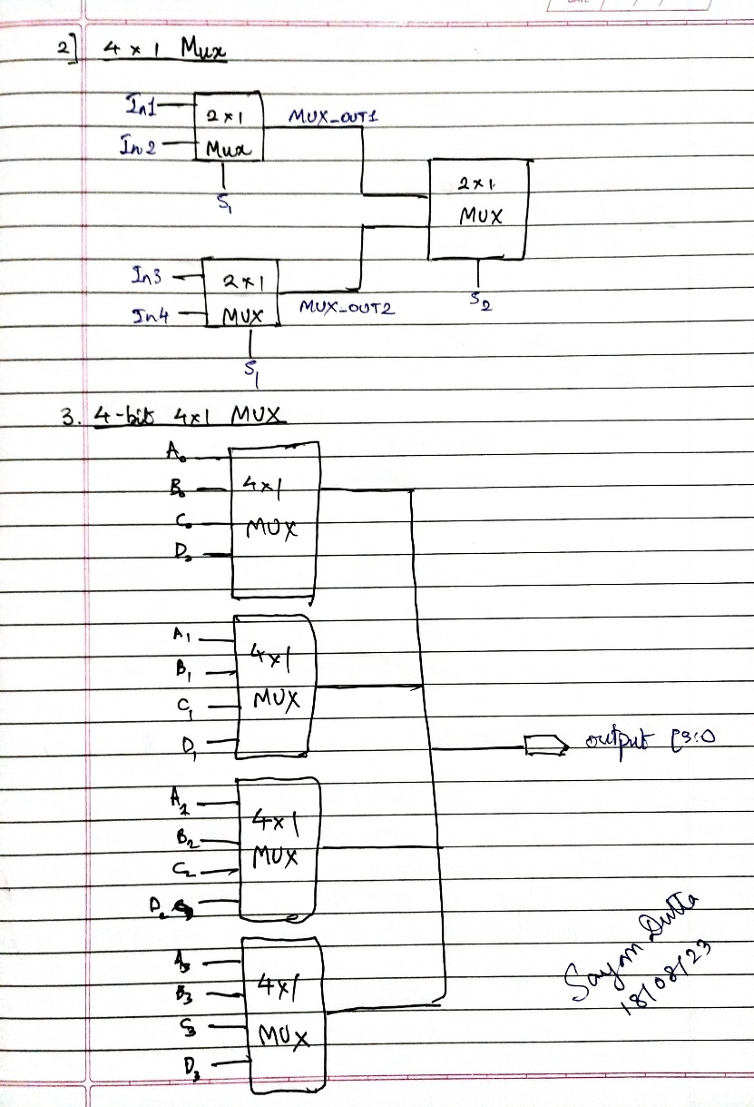Circuit Diagram
* ModelSim Waveforms

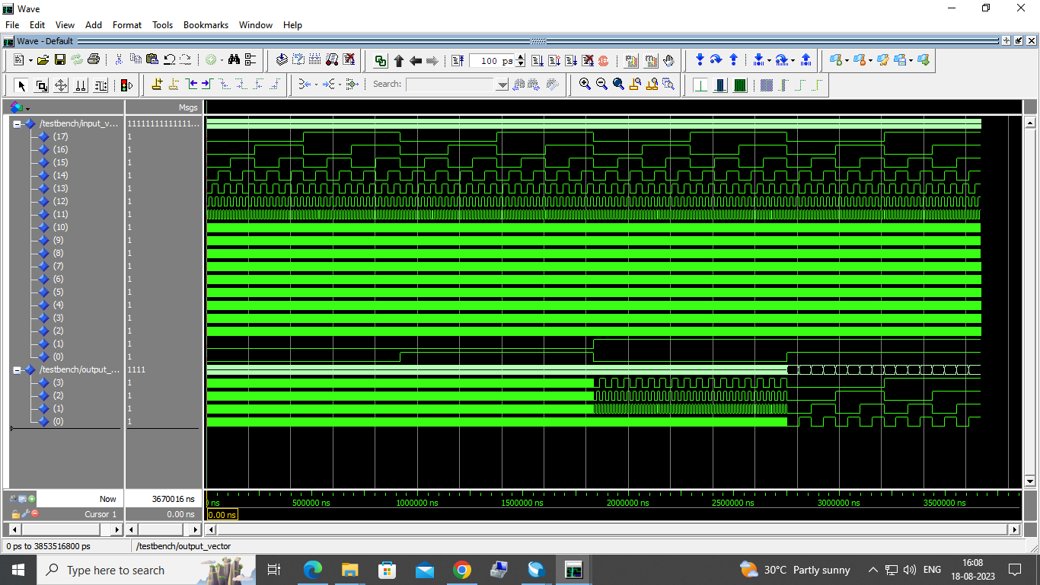

* 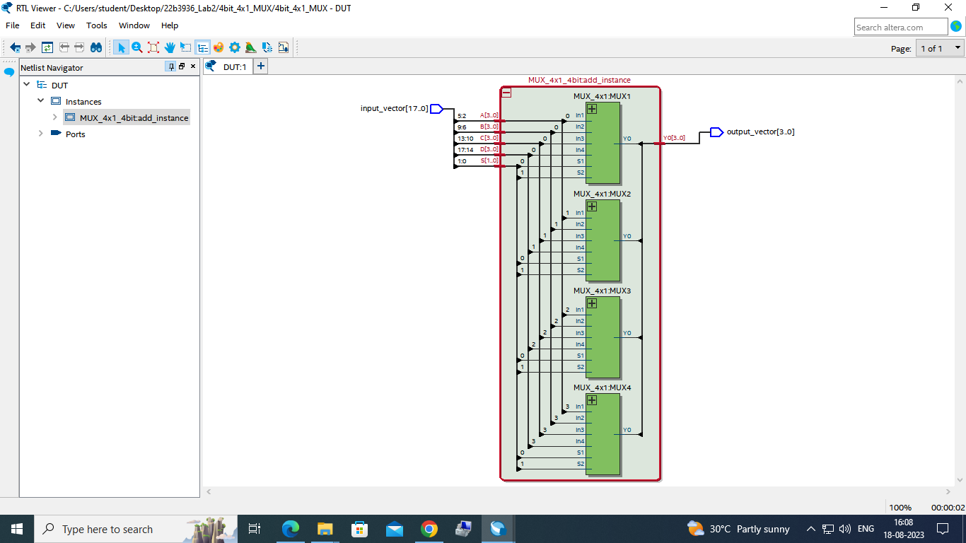RTL Netlist viewer