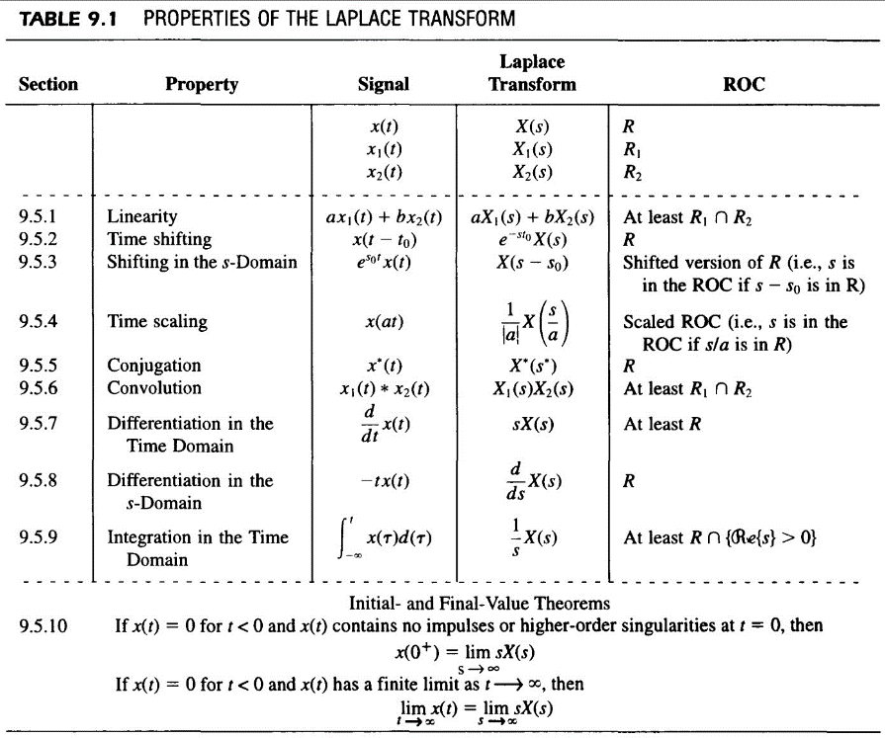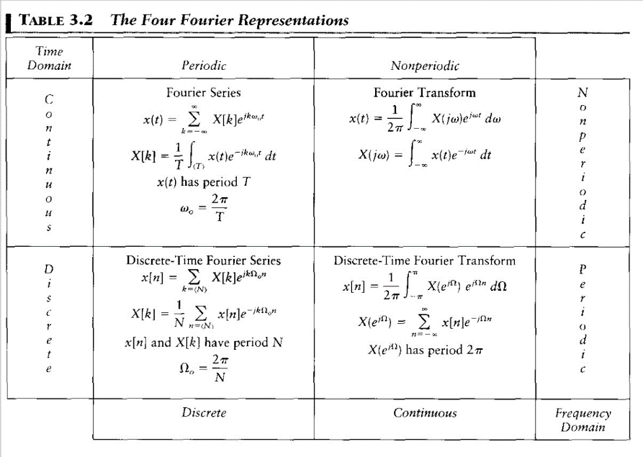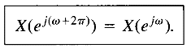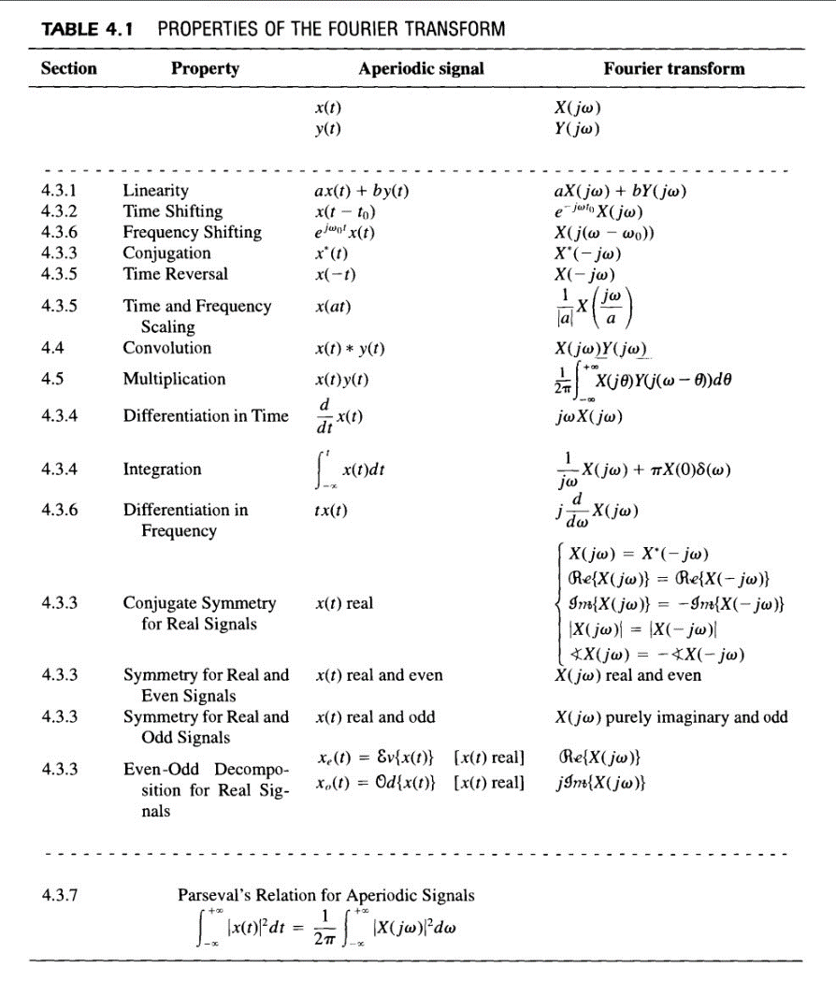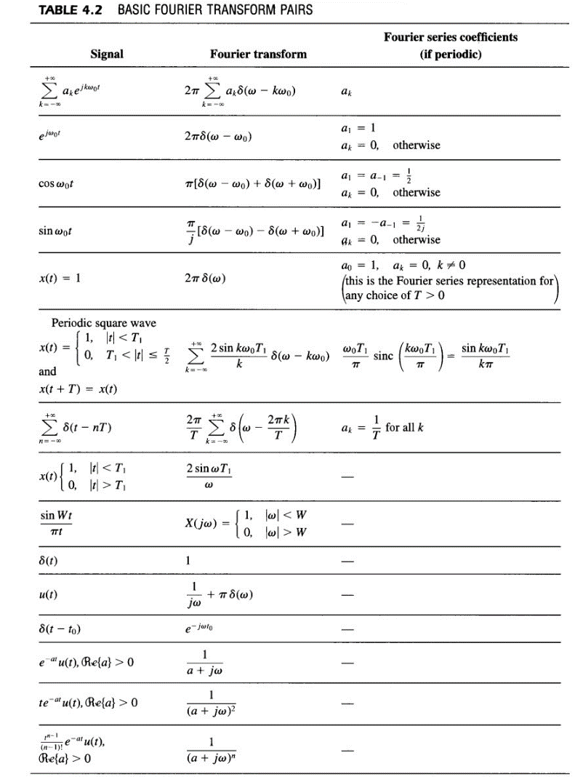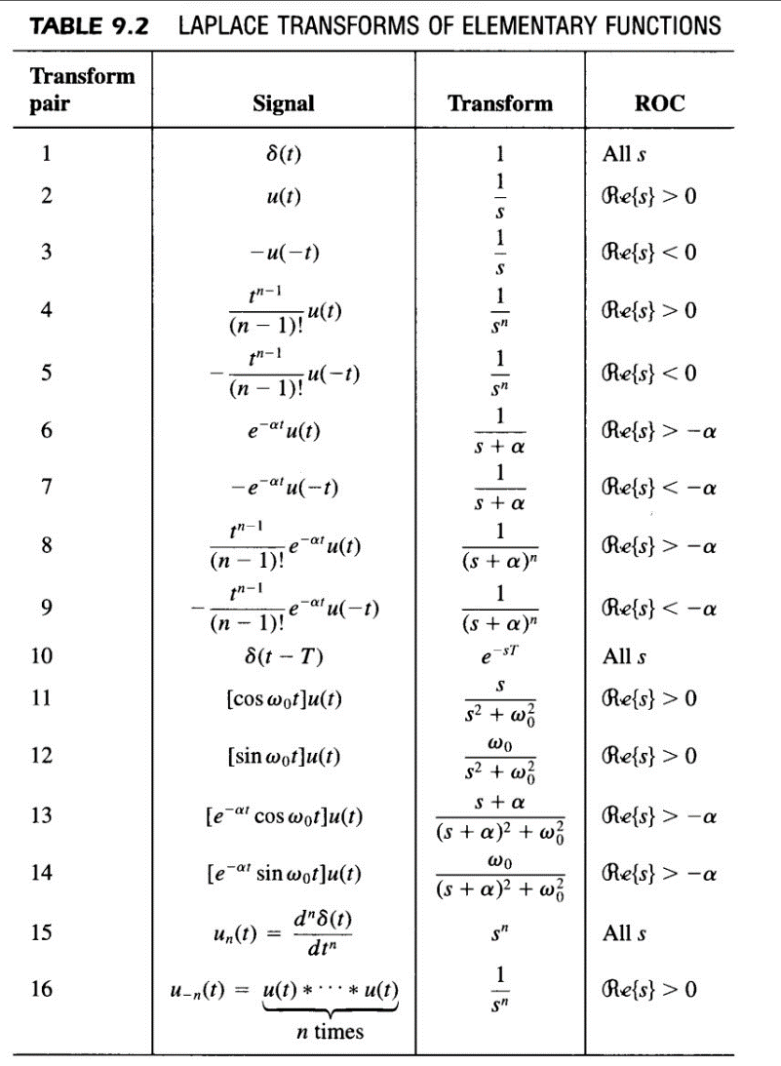

**Name: Sravan K Suresh**

**Roll no: 22B3936**

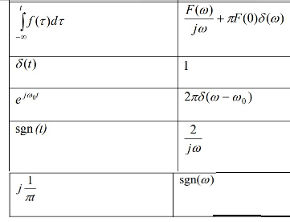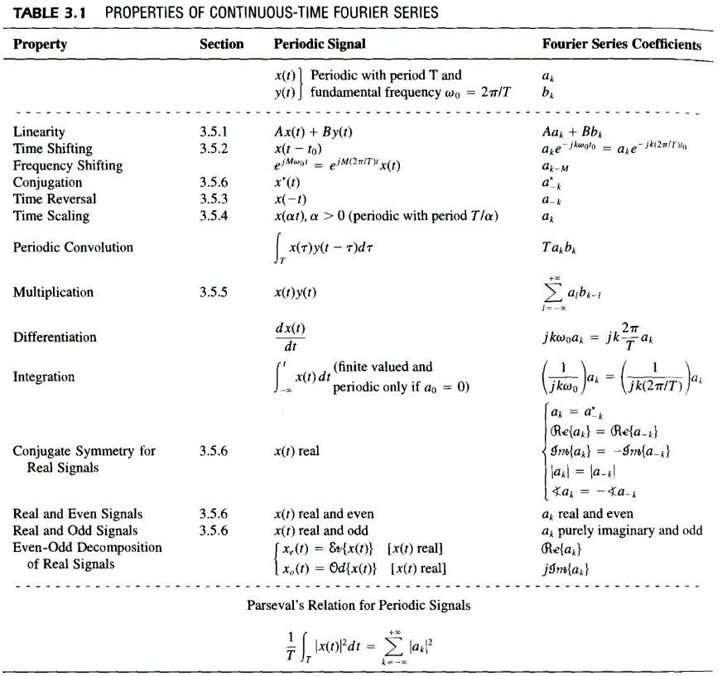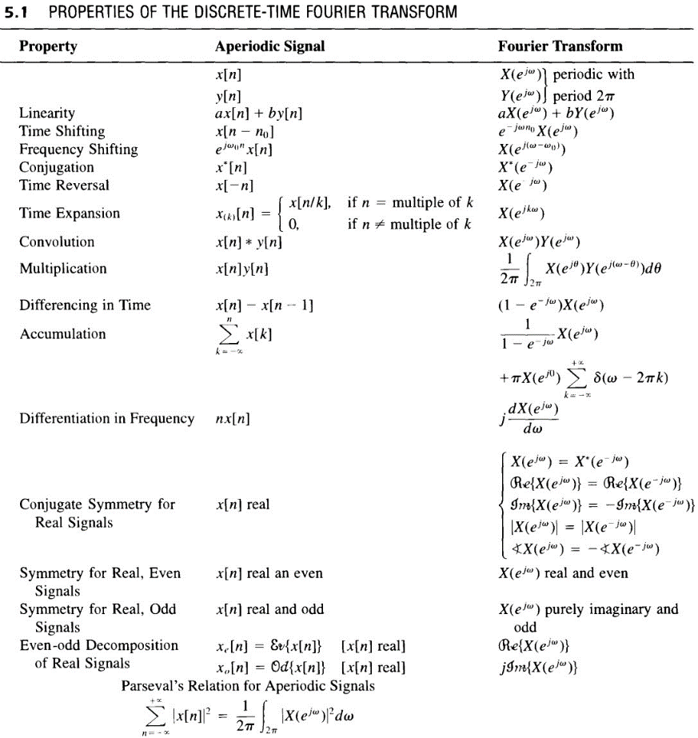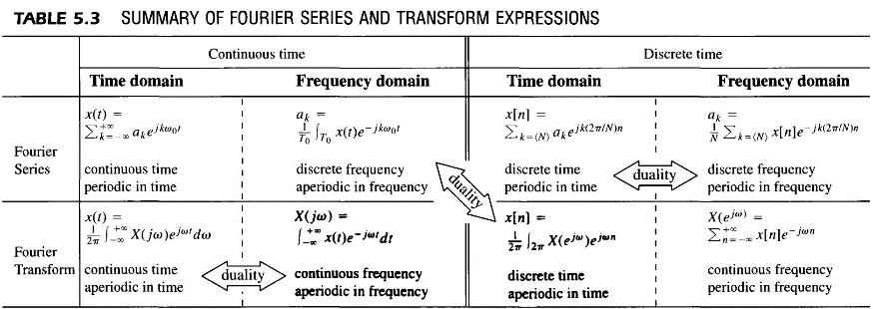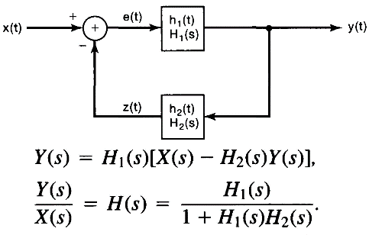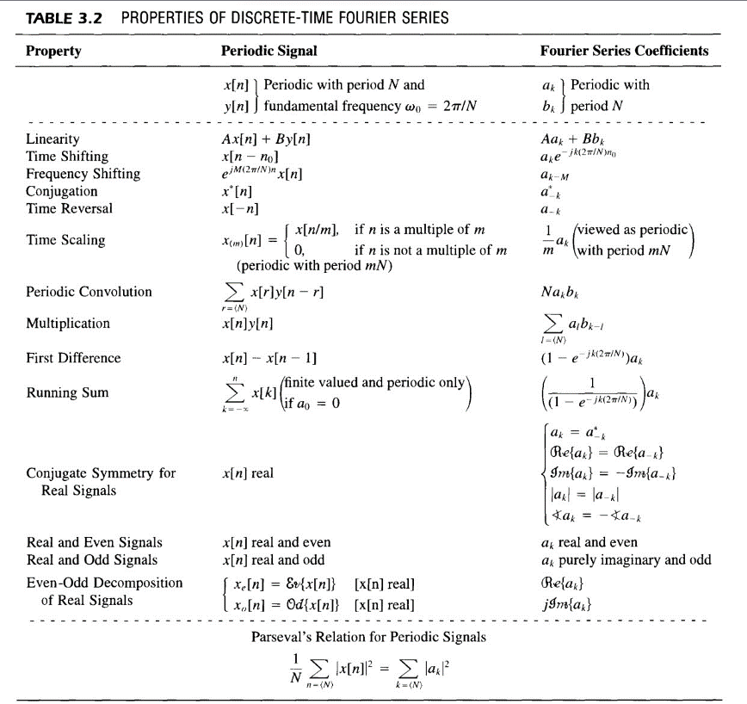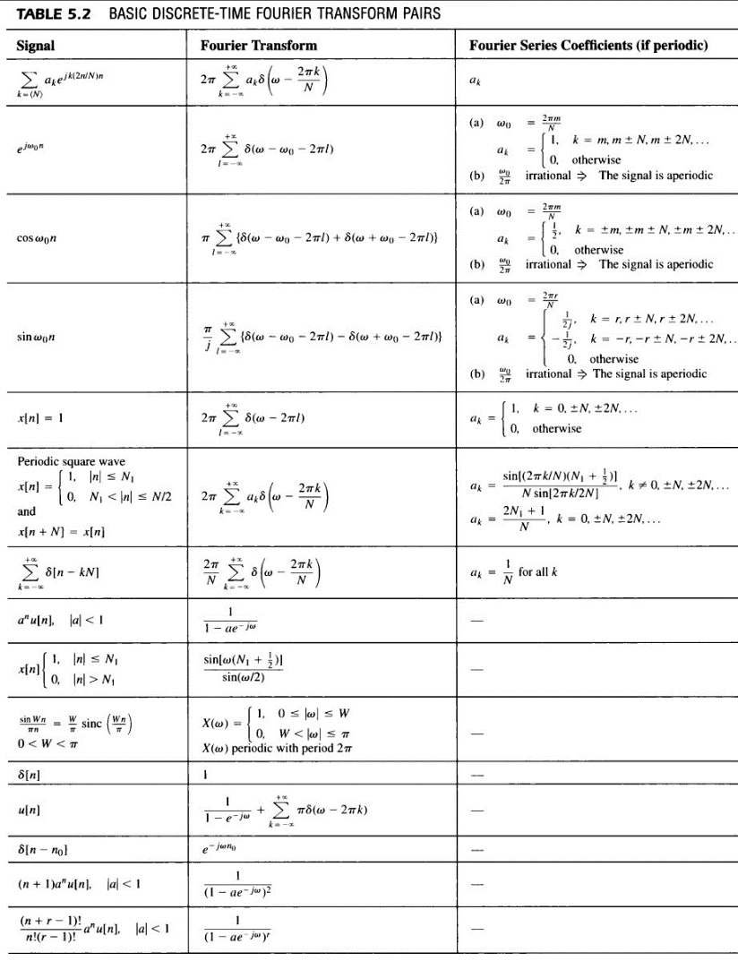

We first must identify a continuous-time signal g(t) [=x(t) of our equation] with period T = 2 and Fourier coefficients ak = x[k]. We then ‘brand’ g(t) as X(ejw) and mould the equation to synthesis equation of DTFT!

**Name: Sravan K Suresh**

**Roll no: 22B3936**

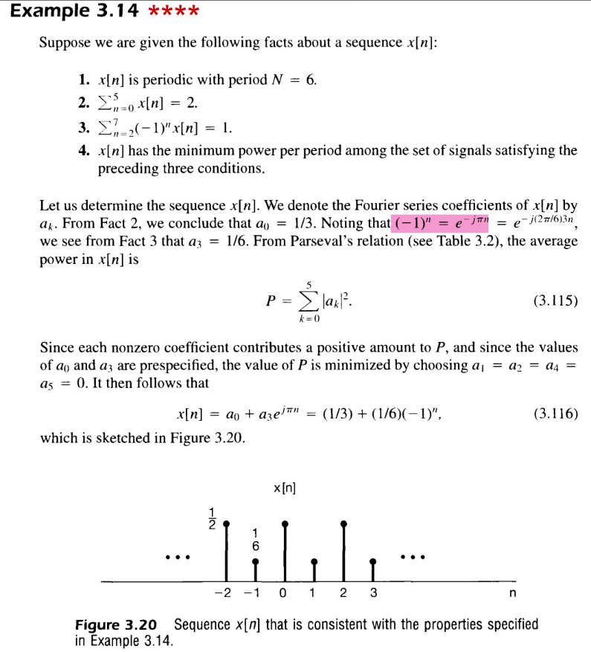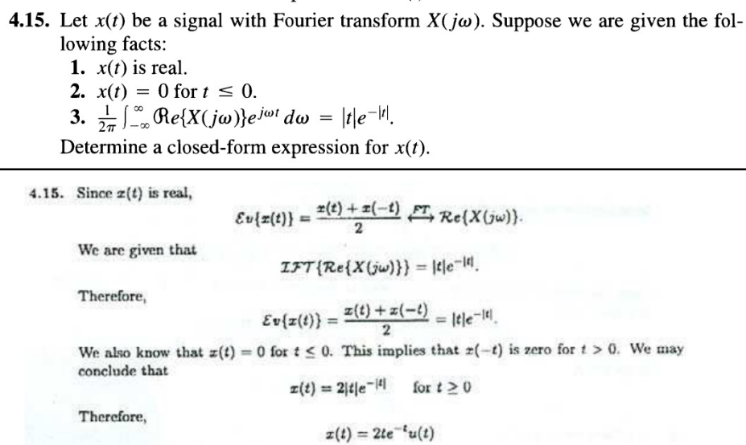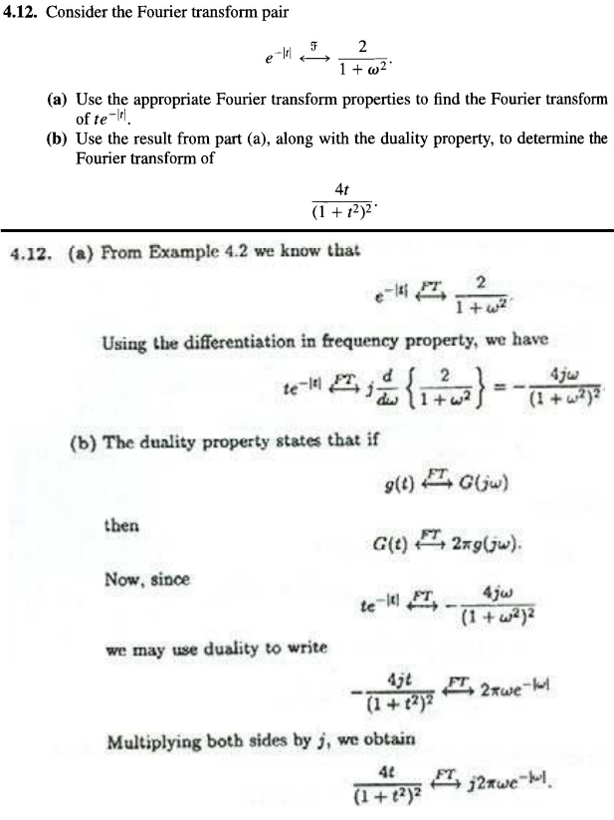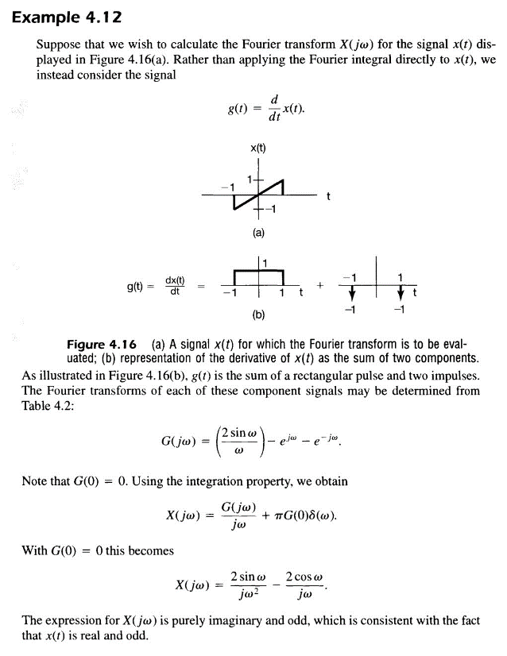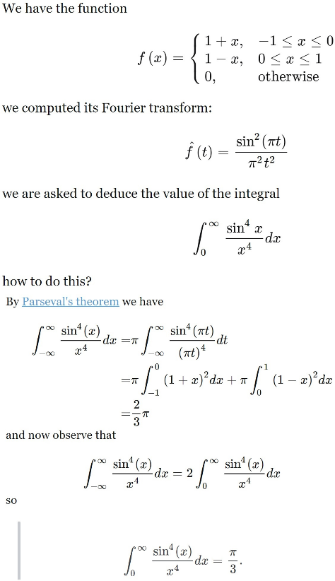

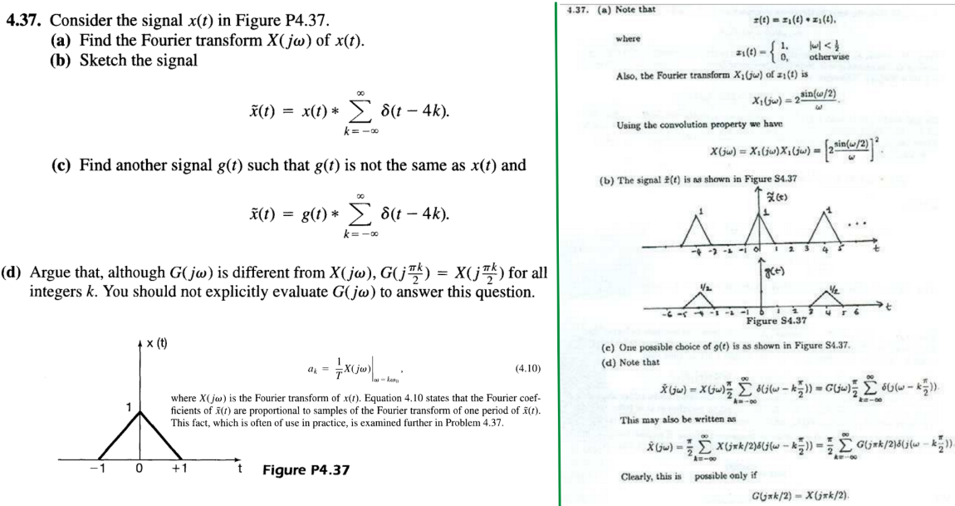

**Name: Sravan K Suresh**

**Roll no: 22B3936**

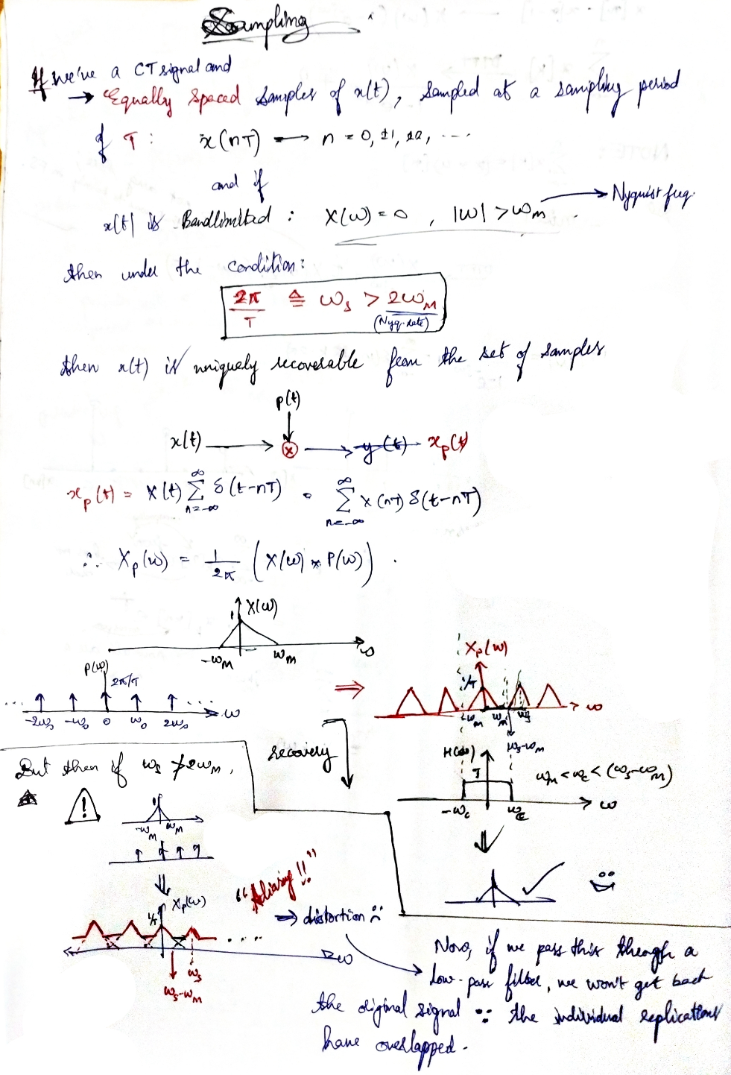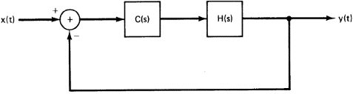

**Properties of Laplace Transform**

**Property 1:** The ROC of X(s) consists of strips parallel to the jw-axis in the s-plane.

**Property 2:** For rational Laplace transforms, the ROC does not contain any poles.

**Property 3:** If x(t) is of finite duration and is absolutely integrable, then the ROC is the entire s-plane.

**Property 4:** If x(t) is right sided, and if the line Re{s} = **σ**0 is in the ROC, then all values of s for which Re{s} > **σ**0 will also be in the ROC.

**Property 5:** If x(t) is left sided, and if the line Re{s} = **σ**0 is in the ROC, then all values of s for which Re{s} < **σ**0 will also be in the ROC.

**Property 6:** If x(t) is two sided, and if the line Re{s} = **σ**0 is in the ROC, then the ROC will consist of a strip in the s-plane that includes the line Re{s} = **σ**0.

**Property 7:** If the Laplace transform X(s) of x(t) is rational, then its ROC is bounded by poles or extends to infinity. In addition, no poles of X(s) are contained in the ROC.

**Property 8:** If the Laplace transform X(s) of x(t) is rational, then if x(t) is right sided, the ROC is the region in the s-plane to the right of the rightmost pole. If x(t) is left sided, the ROC is the region in the s-plane to the left of the leftmost pole.

**Property 9:** The ROC associated with the system function for a causal system is a right-half plane.

**Property 10:** For a system with a rational system function, causality of the system is equivalent to the ROC being the right-half plane to the right of the rightmost pole.

**Property 11:** An LTI system is stable if and only if the ROC of its system function H(s) includes the entire jw-axis [i.e., Re{s} = 0].

**Property 12:** A causal system **with rational system function H(s)** is stable if and only if all of the poles of H(s) lie in the left-half of the s-plane-i.e., all of the poles have negative real parts.

**Name: Sravan K Suresh**

**Roll no: 22B3936**