*1. Data Collection and Understanding:*

*- EEG Data: Electroencephalography is a non-invasive technique used to record electrical activity in the brain. EEG data consists of voltage measurements from multiple electrodes placed on the scalp. Each electrode corresponds to a specific brain region and captures electrical signals generated by neurons.*

*- EEG Channels: EEG data typically contains multiple channels corresponding to different brain regions. In your dataset, features like AF3, F7, F3, FC5, T7, P7, O1, O2, P8, T8, FC6, F4, F8, and AF4 represent EEG measurements from specific electrode positions.*

*- Label: The 'eyeDetection' column indicates whether eyes are detected (1) or not detected (0) during EEG recordings.*

*2. Data Preprocessing:*

*- EEG Data Preprocessing: EEG data is often noisy and requires preprocessing. This involves filtering (e.g., bandpass filtering) to remove noise, referencing (e.g., average referencing) to mitigate common noise sources, and segmenting data into relevant time windows.*

*- Feature Extraction: Extract features from EEG data that capture relevant information. Features may include statistical measures (mean, median, variance), spectral features (power in specific frequency bands), and time-domain features (e.g., autoregressive coefficients).*

*- Handling Imbalance: Check for class imbalance in the dataset. Since EEG data collection often involves long periods without eye detection, you may need to address class imbalance through oversampling, undersampling, or using class weights during training.*

*3. Data Splitting:*

*- Split the dataset into training and testing sets to evaluate model performance. Consider using techniques like stratified sampling to ensure that both classes are represented in both sets.*

*4. Model Selection:*

*- Choose appropriate machine learning algorithms for binary classification. Start with logistic regression, which is interpretable. Experiment with more complex models like random forests, support vector machines, or deep neural networks for capturing intricate patterns in EEG data.*

*5. Model Training and Hyperparameter Tuning:*

*- Train your selected models on the training dataset using the EEG features as input and 'eyeDetection' as the target variable.*

*- Hyperparameter tuning is crucial. Perform hyperparameter optimization (e.g., grid search or Bayesian optimization) to find the best configuration for each model. Consider the choice of regularization strength, learning rates, kernel types (for SVM), or layer architectures (for neural networks).*

*6. Model Evaluation:*

*- Assess the performance of your models using appropriate metrics:*

*- Accuracy : The proportion of correct predictions.*

*- Precision : The ratio of true positives to the total predicted positives.*

*- Recall : The ratio of true positives to the total actual positives.*

*- F1-Score : The harmonic mean of precision and recall.*

*- Receiver Operating Characteristic (ROC) Curve : Plot the true positive rate vs. false positive rate.*

*- Interpret the results using confusion matrices to understand how well the model is performing, especially regarding false positives and false negatives.*

*7. Biological Insights:*

*- Consult with neuroscientists or domain experts to gain insights into EEG signals related to eye detection. Biological factors, such as the role of different brain regions in eye movements or cognitive processes, can inform feature selection and model interpretation.*

*8. Model Interpretation:*

*- Use techniques like feature importance analysis (e.g., permutation importance) or SHAP (SHapley Additive exPlanations) values to interpret the model's predictions and understand which EEG features are most relevant for eye detection.*

*9. Handling Temporal Aspects:*

*- Consider the temporal nature of EEG data. Recurrent Neural Networks (RNNs) or convolutional neural networks (CNNs) can capture temporal dependencies in EEG signals. LSTM (Long Short-Term Memory) networks, in particular, are well-suited for sequential data.*

*10. Model Deployment and Real-World Application (Optional):*

*- If the model proves successful, consider deploying it in real-world applications, such as assisting in monitoring eye-related medical conditions or alerting users to drowsiness.*

*11. Ethical Considerations:*

*- Be mindful of ethical considerations when working with medical data. Ensure data privacy and patient consent. Follow ethical guidelines and obtain necessary approvals.*

*This project combines machine learning techniques with insights from neuroscience to create a model capable of detecting eye-related events from EEG data. Collaboration with domain experts and thorough understanding of EEG signals are essential for the success of this endeavor.*

*DATA SET:*

* *The dataset provided is related to electroencephalography (EEG) signals and eye detection. Here's a biological explanation of the columns in the dataset, along with suggested diagrams that relate to each term:*
* *1. AF3, F7, F3, FC5, T7, P7, O1, O2, P8, T8, FC6, F4, F8, AF4 (Columns 0 to 13) :*
* *- These columns likely represent the electrical voltage measurements recorded from different EEG electrodes placed on the scalp. EEG electrodes are used to detect electrical activity generated by neurons in the brain. Each electrode measures the electrical potential at a specific location on the scalp.*
* *- Suggested Diagram: A diagram showing the placement of EEG electrodes on the human scalp, illustrating their positions and corresponding labels.*

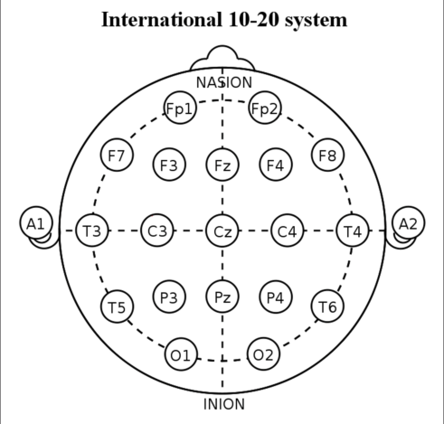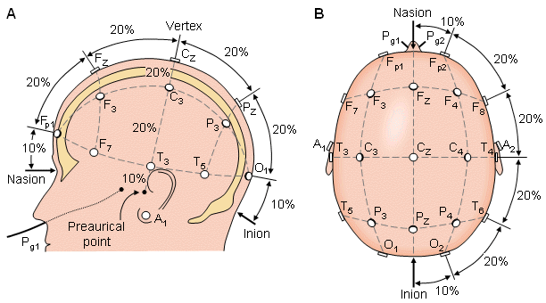

* *2. eyeDetection (Column 14) :*
* *- This binary column indicates whether eyes were detected or not during the EEG recording. It's likely that this column is used as the target variable for classification.*
* *- Suggested Diagram: A simple binary classification diagram showing "Eyes Detected" and "Eyes Not Detected" as two distinct categories.*
* *EEG electrodes are typically placed on the scalp based on standardized positions in the 10-20 system. The electrodes in your dataset may correspond to specific positions on the scalp, and the column names (AF3, F7, F3, etc.) might indicate these positions. The electrical activity measured at each electrode can provide insights into brain activity, such as changes associated with eye movements or other cognitive processes.*

*Detailed Description :*

*1. Data Loading and Preprocessing : The code loads the EEG Eye State dataset, removes outliers using Z-score, and splits it into training and testing sets. It also standardizes the features.*

*2. Model Selection : Three classification models (Logistic Regression, Random Forest, Support Vector Machine) are trained and evaluated. The F1-Score is used to select the best model.*

*3. Random Forest Classifier : The Random Forest classifier is trained on the entire dataset. Feature importance is visualized to understand the contribution of each feature. A decision tree from the Random Forest is also visualized.*

*4. Predict Function : A user-defined function, `predict_eye_detection`, takes dependent variables as input and predicts whether eyes are detected or not using the trained Random Forest model*

*.*

*Benefits :*

*- Outlier Removal : Removing outliers ensures that the models are not influenced by noisy data points, leading to more accurate predictions.*

*- Model Selection : The code evaluates multiple classification models to choose the one with the best F1-Score, which is a balance between precision and recall.*

*- Random Forest: Random Forest is a powerful ensemble learning algorithm that can handle complex relationships in data, is less prone to overfitting, and provides feature importance insights.*

*- Visualization: Visualizations, such as confusion matrices, feature importance, and decision tree visualization, help in understanding model performance and behaviour.*

*- User-Friendly Prediction: The `predict_eye_detection` function allows users to make predictions on new data easily.*

*Pro Points on Random Forest :*

*- Random Forest is highly versatile and can be applied to both classification and regression tasks.*

*- It performs well on large datasets with high dimensionality.*

*- It handles missing values and maintains accuracy even when a substantial portion of data is missing.*

*- It reduces the risk of overfitting compared to individual decision trees.*

*- It provides a feature importance score, allowing you to understand which features contribute the most to predictions.*

*It's capable of handling both categorical and numerical features without requiring extensive preprocessing.*

*Research Papers:*

*"Electrooculography for Human-Computer Interaction"*

*Authors: Kenneth P. Citron, et al.*

*Published in: IEEE Transactions on Systems, Man, and Cybernetics, 1992.*

*This paper discusses the use of electrooculography (EOG) and EEG for eye tracking and human-computer interaction.*

*"EEG-Based Detection and Visualization of Eyelid Movements for Human Computer Interfaces"*

*Authors: Matthias Zöhrer, et al.*

*Published in: Sensors, 2017.*

*The paper explores the use of EEG to detect eyelid movements and its applications in human-computer interfaces.*

*"EEG Signals Analysis for Human Emotion Detection"*

*Authors: Kavitha M, et al.*

*Published in: Procedia Computer Science, 2016.*

*While focused on emotion detection, this paper discusses EEG signal analysis, which is relevant to understanding eye-related EEG features.*

*Journals:*

*"Journal of Neural Engineering"*

*This journal covers various topics in neural engineering, including EEG signal processing and its applications in brain-computer interfaces (BCIs) and eye tracking.*

*"Journal of Neurophysiology"*

*This journal publishes research on the physiology of the nervous system, including studies related to EEG, neural activity, and eye movement.*

*"Clinical Neurophysiology"*

*Clinical Neurophysiology is a journal that often features research related to EEG in clinical and diagnostic settings, which may include studies on eye movement and brain activity.*

*"Journal of Eye Movement Research"*

*While primarily focused on eye movement research, this journal may feature studies that use EEG to investigate eye-related phenomena.*