Comparing and Combining Kalman and Wiener Estimates for the purpose of Video Denoising

*Abstract*— **Video signals are often corrupted by additive noises, due to disturbance in acquisition system or in the process of transmission over networks. So video denoising is an important aspect of video applications. The noise is often Gaussian in nature, independent of the video signal. There are a number of filtering schemes to remove Gaussian noises from video signals and enhance the performance of the recovered video signals, such as Wiener filter, Kalman filter. In this report, we propose a filtering method combining Kalman and Wiener filter to remove noises from the video. First we apply Kalman filter and then Wiener filter for the purpose of denoising the video. Then we take an average of the result derived from both Kalman and Wiener filter, which combines the advantages of both filters and shows better performance than both Kalman and Wiener filtering schemes with respect to PSNR (Peak Signal to Noise Ratio) value.**

*Index Terms*— Wiener, Kalman, Video Denoising. *(Key words)*

**I. Introduction**

Video signals are often corrupted by additive noise and/or motion blur due to transmission over channels. As a result, to remove the noise from the obtained video signals is an important field in Signal Processing. Often, the noise can be modeled effectively after a Gaussian distribution model, irrespective of the signal. In such cases, we can use different filters based on statistical signal processing techniques to denoise the video signal. In this project, we implement Wiener filter to the process video signals corrupted by additive white Gaussian noise. Wiener filters are the best linear filters in minimizing the mean squared error (MSE) between the original and the recovered signal. We also implement a Kalman filter to denoise it. Finally, we compare both of these methods. We also combine these two filtering algorithm to implement a combined filtering algorithm with both Kalman and Wiener estimates. Figure-I is the introduction, a general outline of our work which describes in brief the theory of the noise models and the algorithms. The report is structured as follows. In Section II, we briefly present our proposed methodology and discuss methods of applying the video signals. In Section III, we our findings and results gained. Next, draw the conclusions in Section IV. We list the papers and resources used as references in section V.

**A. Additive White Gaussian Noise**

Gaussian noise is a statistical noise that has the probability density function of that of the normal or Gaussian distribution i.e. it is normally distributed over time domain. White Gaussian Noise is uniformly distributed over the frequency band. We add Additive White Gaussian Noise (AWGN) so as to replicate the effect of noise that is generated while the video signals are transmitted over channel. Here for implementation purpose in our project we use the in-built matlab function for additive white Gaussian noise.

**B.Wiener Filter**

The Wiener filter is widely used in signal processing. Its purpose is to reduce the amount of noise in a signal, which is done by comparing the received signal with an estimation of a desired noiseless signal. Wiener filter is not an adaptive filter as it assumes its input to be wide-sense stationary. It takes a statistical approach to solve its goal of removing the noise from video signal. Before the implementation of the filter, it is assumed that the use knows the spectral properties of the original signal and the noise. Wiener filter works by linear time-invariant (LTI) filtering of an observed noisy process, assuming signal and additive noises as wide sense stationary, with known spectral characteristics. The Wiener filtering scheme works on minimizing the mean square error between the estimated process and the desired process. The purpose of the Wiener filter is to statistically estimate an unknown signal. The Wiener filter uses a related signal as an input and filters that known signal to produce the estimated signal as an output.

There are three main features of the Wiener filtering algorithm. Firstly, it is assumed that signal and noise are stationary in wide sense. They are processes with known spectral characteristics. Secondly, the requirement that the filter should be physically realizable. Thirdly, the performance criterion of minimum mean-square error (MMSE) i.e. the goal is to minimize the mean square error between the estimated and the desired process. The wiener filtering executes an optimal tradeoff between inverse filtering and noise removal. It removes additive noise and inverts the blurring simultaneously.

The wiener filter in Fourier domain can be expressed as follows-

 **..(1)** [7]

Where  , are the power spectra of the original image and additive noise respectively.  is the blurring filter.[2]



The Wiener filter has two different parts, an inverse filtering part to deblur the image and a noise smoothing part to remove the noises. To implement the Wiener filter in practice, we consider a signal, which is corrupted by a white Gaussian process ,which has zero mean and the variance is. The resulting signal is denoted by . If is considered to be an independent and identically distributed Gaussian process of mean  and variance , then the estimation filter is given by –



**……….. (2)**



If the signal is white, it will have a constant power spectral density, and the previous equation simplifies to the following form. Then the best estimate of X(k), given observations Y(k), is given by-

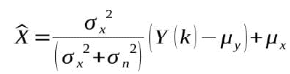

Since N(k) is zero mean, .



The equation holds only if the signal is stationary. This is not true in general for video signals. We solve this problem by dividing the signal in small blocks in which they are reasonably stationary and construct a different filter for each block.

**C. Kalman Filter**

The Kalman filter is a linear estimator filter which is widely used for digital signal processing. It can give estimates of the past, present and future states of a system even when the underlying model is flawed .It is a two step process and recursive in nature. The two steps are time update or prediction, and measurement update or correction. The calculated previous estimates are used as the input for calculating the current estimates. The Kalman filter calculates the estimated signal value and the measured value (of previous state) in each iteration. The signal value we get in each iteration is a linear combination of its previous value and the process noise. The measured value that we get is a linear combination of the signal value and the measurement noise. The purpose of Kalman filter is to find the most optimum averaging factor for each consequent state. The estimates are updated using a weighted average, ie more weight is given to estimates with higher certainty. Thus, over the time, the Kalman filtering algorithm converges the recovered signal value to the original value.

The Kalman Filter can be represented by the following equation-

 **………….(3)**



Where  is the current estimation of the signal value, is the previous estimation of signal value, is the measurement value and  is the Kalman gain.



This equation can further be divided into two different equations-

** ……………..(4)**



** ……………………(5)**

Where is the process noise and is measurement noise. Kalman filtering algorithm obtains the best estimate by the forward recursion method.

**Proposed Methodology**

In this report, we present an approach of combining the Kalman and Wiener filtering algorithm. First, we take a video and add Gaussian noise to it. After that, we pass the video through Kalman filter, and then through Wiener filter. At each step, we split the video into a number of frames. We try to reduce the noise at every stage, i.e. we try to remove noise from a video frame and enhance its performance and make it better than the previous frame. Then we take the median value of the results obtained from both the filters, and show the output of the resulting video frames in our report.  
 **a) Algorithm**

The filter performs the following steps:

Initialization  
User input specifies the filter gain: G  
User input specifies the noise variance estimate: V  
Use the first image as the prediction seed: I-k = Ik  
Use the variance estimate as the error seed: E-k = V  
Correction  
Compute the Kalman Gain:

Kk = E-k / (E-k + V)  
Update the image prediction with the (Mk) measurement:

Ik = G*I-k + (1.0-G)*Mk + Kk(Mk-I-k)  
Update the variance estimate:

Ek=E-k(1-Kk)  
Prediction  
Predict the next image: I-k+1 = Ik  
Predict the variance: E-k+1 = Ek  
Update values  
E-k=E-k+1  
I-k=I-k+1  
Repeat 2,3,4

*Flow Chart:*

Pass through Wiener filter

Convert

Colored to grey-scale

Output Denoise video/

image

Pass through KalmanFilter

Input  
Image/Video

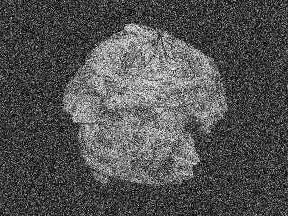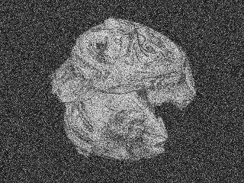

Filtered frame (frame 10, frame 20) using Kalman Filter

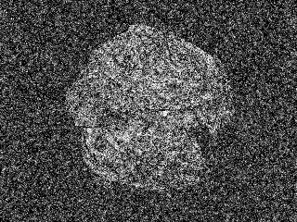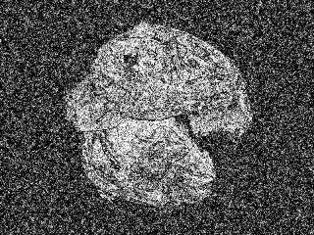

Real Frame (frame 10, frame 20) with added Gaussian Noise

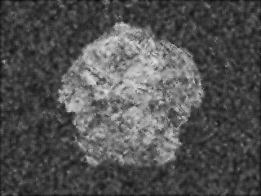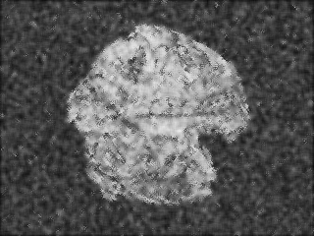

Filtered frame(frame10,frame 20) using Wiener Filter

**b) Kalman Filter**

For the purpose of applying it in video signals, we define the parameters of the equations (4) and (5) as given below-

 is the estimate of value of pixel in the current frame,



 is the estimate of value of pixel in the previous frame,

 is the error in estimation and

 is the additive Gaussian noise that has to be removed.



**c) Wiener Filter**

For the purpose of applying the wiener filter for video denoising, we consider a 5x5 neighborhood around a pixel in a given frame. We work here on a frame by frame basis.

**d) Combined Algorithm**

Video is passed through wiener filter and kalman filter separately then we took mean of frames denoised by wiener and kalman filter. In video denoising dynamic part of image better denoised by kalman filter and static part of image better denoised by wiener filter so mean of both denoised video used in combine algorithm.

The performance of the proposed method, we use the PSNR values to measure the performance of the video denoising algorithms. Mean Square Error (MSE) is a measure of similarity between a filtered image and the original image. For a grey-scale image consisting of an M x N array of pixels at locations (x, y)

 **……(6)** [8]

Where I is the original image, f is the noiseless image or filtered image of size N x M. Another similarity measure, PSNR (peak signal to noise ratio) , is related to MSE as in the following:

 **………(7**)

**Results and Discussions**

We executed all our algorithms on MATLAB platform. We judge performance of the algorithms based on the PSNR (Peak Signal to Noise Ratio) value. We plot graphs showing the performance of different filters, where the x axis represents the number of frames, and y axis represents the PSNR values.

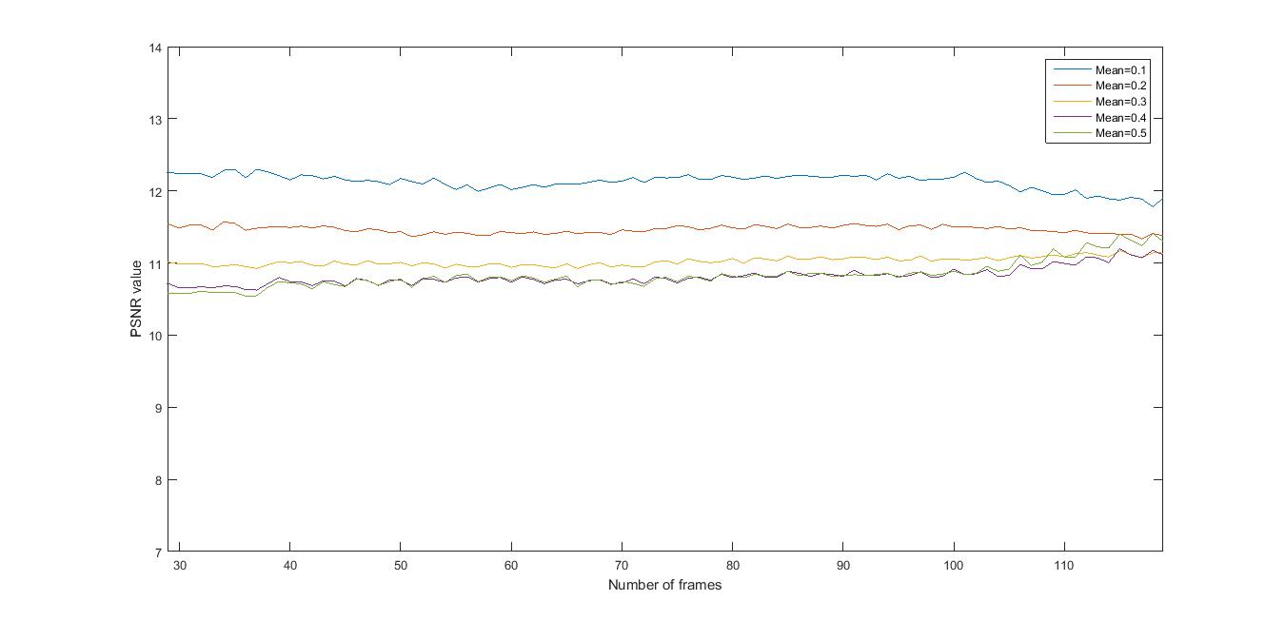

Here the graph shows PSNR values for varying means. As we can see from the graph, when the mean value is lowest (0.1) we get the highest PSNR value. For the highest mean (0.5) we get the lowest PSNR value. From this we can conclude that the performance of the combined filtering algorithm enhances when the mean value is less.

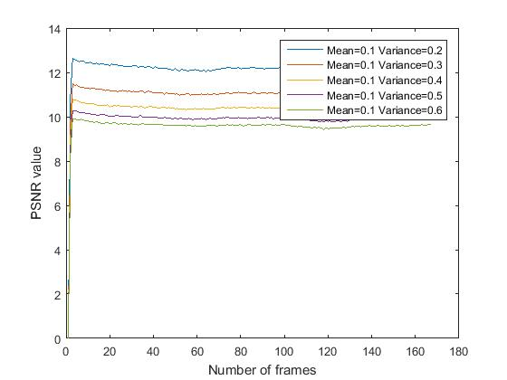

This graph shows the PSNR values where the signals are with constant mean and varying variance. As we can see from the graph, the lesser the variance, the better is the performance of the filtering algorithm.

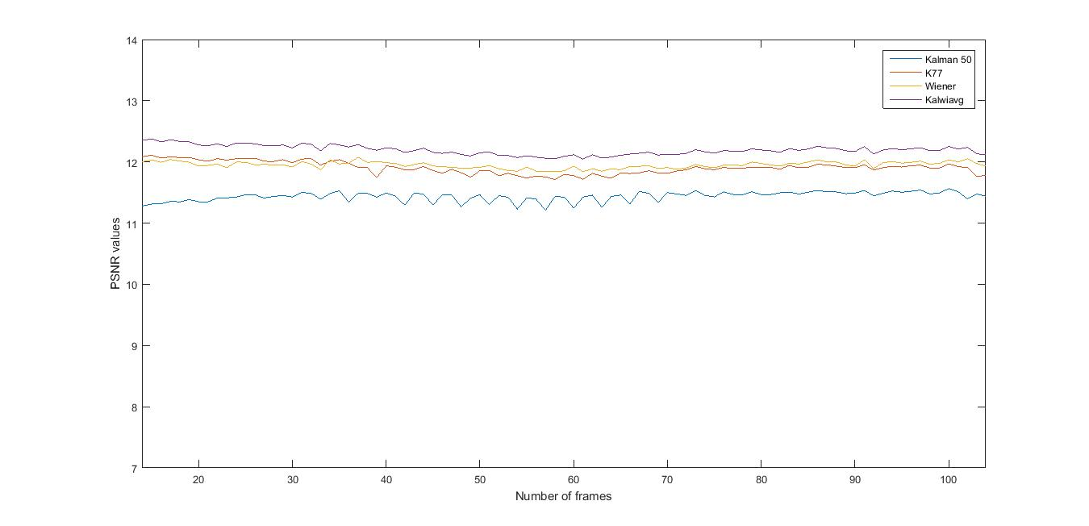

This graph shows the comparative performance of the different filtering algorithms with respect to the PSNR values. As we can see, that the combined filtering algorithm outperforms both Kalman and Wiener filtering algorithms. Kalman algorithm with Kalman Gain .50 does poorly with respect to the Wiener filtering algorithm. Kalman filtering algorithm with .75 Kalman Gain almost overlaps with the Wiener filtering algorithm.

**Conclusion :**

Here in this paper we study and compare different filtering algorithms for the purpose of video denoising. As a general conclusion, we say that the performance of Wiener and Kalman filtering algorithm are comparable. The combined filtering algorithm with Kalman and Wiener Estimates outperforms both the algorithms in terms of performance. This gives us an insight about Video denoising techniques and leaves scope for further research in this matter.

**Reference**

[1]H.W. Sorenson, Least-Squares Estimation: from Gauss to Kalman

[2]J.D. Gibson, B. Koo, S.D. Gray, Filtering of Colored Noise for Speech Enhancement and Coding, IEEE Transaction on Signal Processing, August 1991

[3]R. Dugad, N. Ahuja, Video Denoising by Combining Kalman and Wiener Estimates

[4]M. Morf, G.S. Sidhu, T. Kailath, Some New Algorithms for Recursive Estimation in Constant, Linear, Discrete Time Systems, IEEE Transaction of Automatic Control, August 1974

[5] R.A. Singer, P.A. Frost, On the Relative Performance of Kalman and Wiener Filters

[6]Lakshmanan.S, Mythili C,V Kavitha,Kalman Filtering Technique for Video Denoising Method

[7] E. Ercelebi,S. Koc, Lifting-based wavelet domain adaptive Wiener filter for image enhancement

[8]Rafael C. Gonzalez, Richard E. Woods Digital Image

Processing Third Edition (Pearson)