NovaTech Employee Handbook
This handbook summarizes key workplace policies for full-time employees of NovaTech Solutions.

Leave Policy
All full-time employees are entitled to 24 days of paid annual leave per calendar year.
Leave requests must be submitted at least 7 days before the intended start date.

Working Hours
Standard working hours are 9:00 AM to 6:00 PM, Monday through Friday.

Remote Work
Employees may work remotely up to 2 days per week, subject to manager approval.
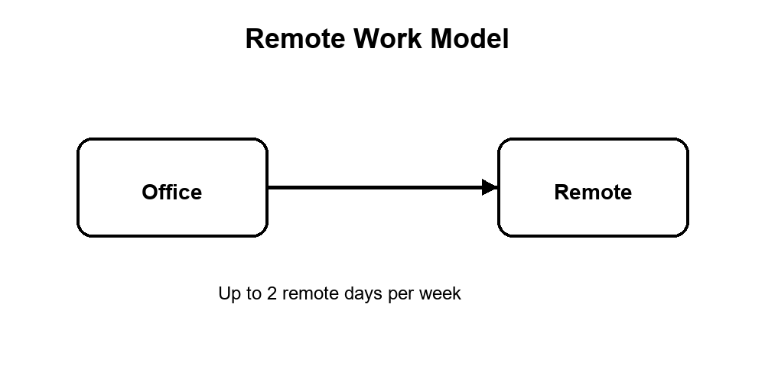
Figure 1: NovaTech remote work model.

Benefits Table
Benefit | Eligibility | Annual Allowance
Paid Annual Leave | Full-time employees | 24 days
Remote Work | Manager approval | Up to 2 days/week
Training Leave | After probation | 5 days

Important Contact
HR Operations: hr@novatech.example

