irevolution: a data-driven exploration of apple's iphone impact in india

INTRODUCTION :

iPhone is a line of smartphones produced by Apple Inc. that use Apple's own iOS mobile operating system. The first-generation iPhone was announced by then-Apple CEO Steve Jobs on January 9, 2007. Since then, Apple has annually released new iPhone models and iOS updates. As of November 1, 2018, more than 2.2 billion iPhones had been sold. As of 2022, the iPhone accounts for 15.6% of global smartphone market share.[3]
Overview:
The iPhone was the first mobile phone to usemulti-touch technology.[4] Since the iPhone's launch, it has gained larger screen sizes, video-recording, waterproofing, and many accessibility features. Up to the iPhone 8 and 8 Plus, iPhones had a single button on the front panel with the Touch ID fingerprint sensor. Since the iPhone X, iPhone models have switched to a nearly bezel-less front screen design with Face ID facial recognition, and app switching activated by gestures. Touch ID is still used for the budget iPhone SE series.
Purpose:
The iPhone is one of the two largest smartphone platforms in the world alongside Android, and is a large part of the luxury market. The iPhone has generated large profits for Apple, making it one of the world's most valuable publicly traded companies. The first-generation iPhone was described as a "revolution" for the mobile phone industry and subsequent models have also garnered praise.[5] The iPhone has been credited with popularizing the smartphone and slate form factor, and with creating a large market for smartphone apps, or "app economy". As of January 2017, Apple's App Store contained more than 2.2million applications for the iPhone.
Problem definition & design thinking:
Apple, which is an American technology company that is headquartered in Cupertino, California is a brand name that most of us know about. It designs, develops, and sells electronic products, online services, and computer software. Their hardware products include the iPhone, iPad, Mac Personal Computer, Apple watch, and more. Apple is a well-known brand, but how did it become successful? The answer to this questions is Design Thinking.
Empathy map
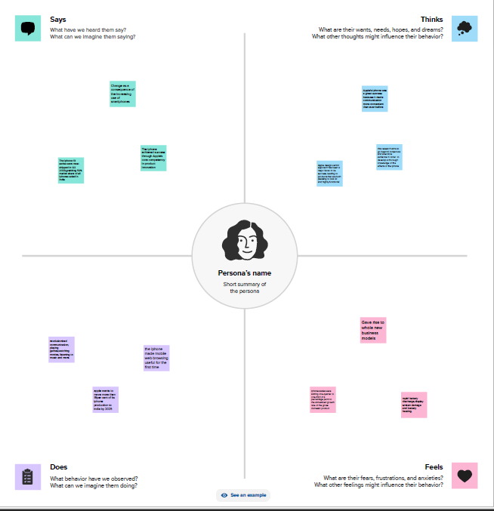

Ideation & Brainstroming map
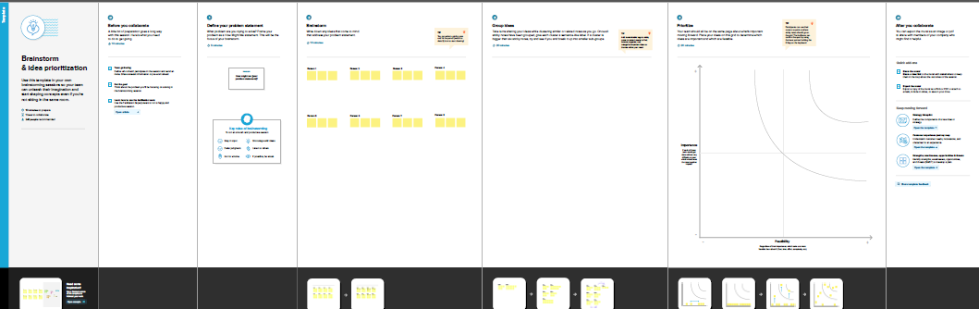
Result:
When you think of Steve Jobs, you instantly think about Apple’s user experience, and how well thought out it is. He focused on crafting the best quality products and services while focusing on simplicity of design and user-friendliness of their products. Design thinking enabled Apple to reach the greatest heights in the market, and take over the world of technology in all aspects; be it usability, design or User Interface.
Advantage & Disadvantages
Advantages:
1. User-Friendly Interface:The iPhone has an intuitive user interface that makes it easy to navigate. The touch screen interface is easy to use, and the iPhone’s smooth operating system is simple to learn and use.
2. High-Quality Display:The iPhone’s Retina display is one of the best in the market. With a density of over 300ppi, pictures and videos appear clear and crisp. This high-quality display is perfect for streaming TV shows, movies, and graphic-intensive games.
3. Advanced Camera: iPhone devices have some of the best cameras in the market. They have been known to produce stunning images and videos of the highest quality. They also come with image stabilization features that help reduce blur and take better pictures in low light.
4. Apps Ecosystem: The App Store is unparalleled in terms of access and ease of use. With millions of apps to choose from, users have access to a plethora of tools, games, and services that cater to their needs.
5. Seamless Integration with other Apple devices: The iPhone has a seamless integration with other Apple devices such as MacBook, iPad, and Apple Watch. It allows users to access and transfer data across multiple devices.
Disadvantages:
1. Cost: The iPhone is one of the most expensive smartphones on the market. High-end models can cost over $1000, which makes it a luxury item for many people.
2. Non-Removable Battery: The iPhone’s batteries are non-removable, which means that users cannot replace them. This can be a disadvantage for people who rely heavily on their phones and have to replace them regularly.
3. Limited Customization: One of the disadvantages of the iPhone is that it has limited customization options. Unlike Android devices, users cannot customize their phone’s interface, which can be a disadvantage for some people.
4. No Expandable Storage: Another disadvantage of the iPhone is that it has no expandable storage options. Users have to purchase iPhones with larger storage capacities, which can be costly.
5. Frailty: The iPhone is known to be fragile and prone to breaking if dropped. Many users have reported cracking or shattering their screens after accidentally dropping their devices.
Applications:
Native applications are not quite the same as web-based applications. In some ways you have a lot more freedom to develop in Xcode; as with the Dashcode module, you still have the option of configuring existing objects. The Xcode module essentially allows new levels of customization; for example, the iPhone has a number of sensors like the accelerometer and GPS and WiFi that we cannot completely take advantage of with the Dashcode module.
Conclusion:
Convolution is a common image-processing technique that changes the value of a pixel according to the values of its surrounding pixels. Many common image filters, such as blurring, detecting edges, sharpening, and embossing, derive from convolution.
Kernels form the basis of convolution operations. Kernels are arrays or matrices of weights that indicate the influence of a pixel’s neighbors on its final value. To calculate the value of each transformed pixel, a convolution operation adds the products of each surroun changes the value of a f a pixel’s neighbors on its final value. To calculate the value of each transformed pixel, a convolution operation adds the products of each surrounding pixel value with the corresponding kernel value. During a convolution operation, the kernel passes over every pixel in the image, repeating this procedure, and then applies the effect to the entire image
Future Scope
The digital marketplace isn't restricted to the internet, and mobile devices have become prominent. They are now eclipsing all other forms of advertising that were popular up until a while ago. Companies have quickly realized that their clients are increasingly mobile, hence their efforts to establish an effective mobile presence. Their marketing strategies for mobile have become more genuine and focused. Since the smartphone market is expanding exponentially, it has gained prominence in the larger global picture of digital. This has resulted in an increasing demand for highly skilled mobile application developers.
Appendix:
Many mobile app developers and even companies have been taking advantage of this platform to develop more effective strategies and improve mobile application development in the last few years. iOS is the operating system of Apple has always enjoyed an honorable place in the digital realm and offers a highly specialized and unique approach to developing mobile apps for the platform. It is distinctive because it is a complex process that requires extensive planning and the right implementation when it comes to developing apps.

