COMPUTER NETWORKS (CN)

LAB 2 ASSIGNMENT

*SREENATH R RA2211026050042*

*CSE AIML A*

*3rd Year*

**Lab 1: Implementation of Network Topologies**

Procedure:

1. Open Packet Tracer:
   * Launch Cisco Packet Tracer on your computer.
2. Implement a Bus Topology:
   * Drag three computers onto the workspace.
   * Connect them using a single backbone cable (Coaxial Cable).

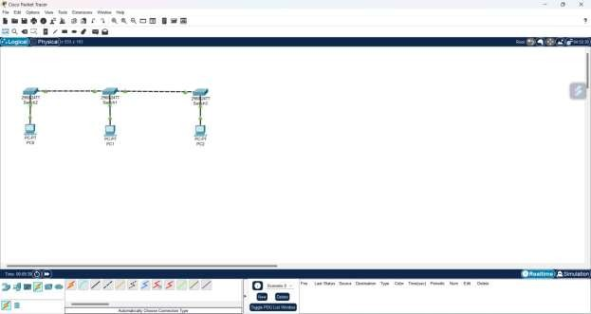

1. Implement a Star Topology:
   * Drag three computers and a switch onto the workspace.
   * Connect each computer to the switch using straight-through Ethernet cables.

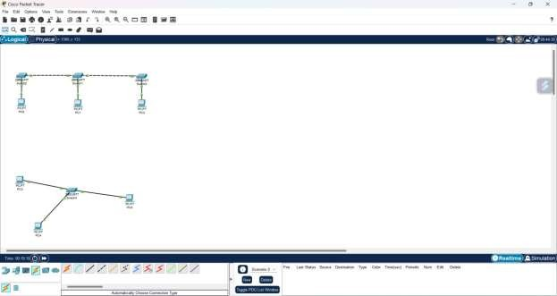

1. Implement a Ring Topology:
   * Drag three computers onto the workspace.
   * Connect them in a circular manner using crossover cables.

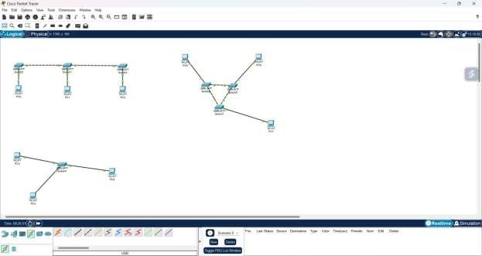

1. Implement a Mesh Topology:
   * Drag three computers onto the workspace.
   * Connect each computer to every other computer using crossover cables.

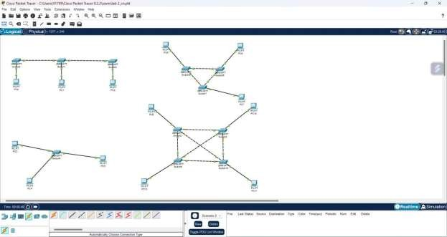

1. Test Connectivity:
   * For each topology, assign IP addresses to the computers.
   * Use the “ping” command to test connectivity between all computers.

