COMPUTER NETWORKS (CN)

LAB 3 ASSIGNMENT

*SREENATH R RA2211026050042*

*CSE AIML A*

*3rd Year*

# PROCEDURE

**STEP 1:**

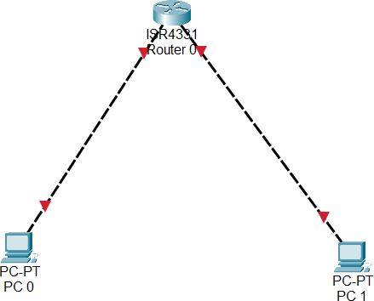

Dragged a ISR4331 Switch and 2 PCs on to the canvas and used Copper Cross-over cable to connect each PC’s port FastEthernet0/0 to the router’s GigabitEthernet0/0/0 and 0/0/1 respectively.

# STEP 2:

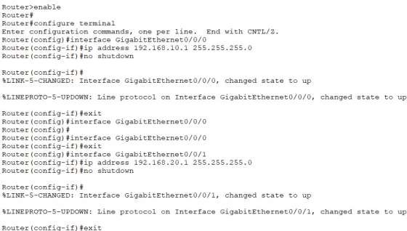

After typing the above commands on the Router, the connection is successful indicated by the green triangles on the cables below.

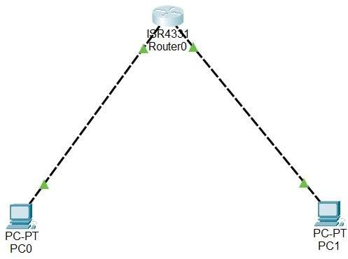

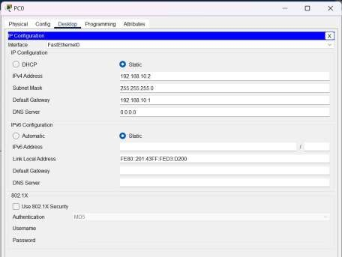

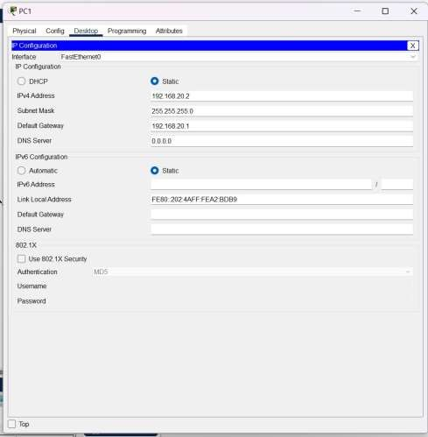

Pinging from PC1 to PC0:

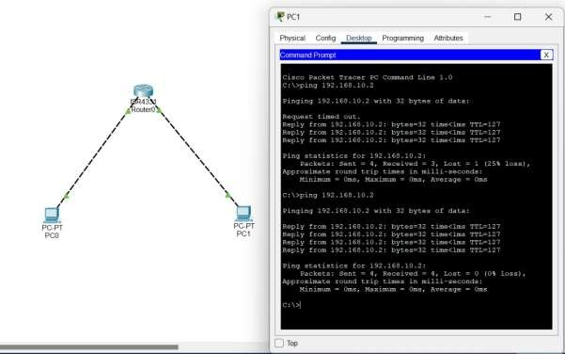

# STEP 3:

BASIC ROUTER SETUP

Setting passwords/authentication to the router

