COMPUTER NETWORKS (CN) LAB 2 ASSIGNMENT

Objective

*SREENATH R RA2211026050042*

*CSE AIML A*

*3rd Year*

* To configure static and default routing on routers to enable communication between different network segments.
* To use Cisco Packet Tracer to create a network with multiple routers and PCs and configure routing to ensure proper data transfer between devices.

Steps taken to set up the network

# STEP 1:

Set up the network by dragging required end devices (PC0 and PC1), and network devices (Router PT, 2 Switch 2960-24TT's) and connect them using straight through copper cables.

# STEP 2:

Using the config table given, just label the devices with a text box with ip address and subnet mask to ease it up

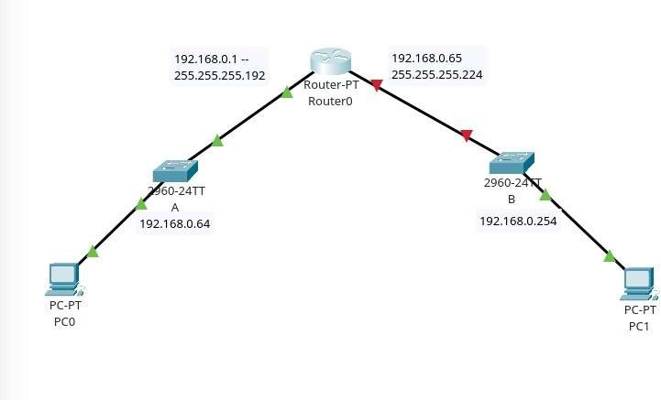

# STEP 3:

Tap on Router-PT and navigate to the physical tab, add PT-ROUTER-NM-1CGE Module to the router after turning the power off, and turn on the power after adding at least two of those modules.

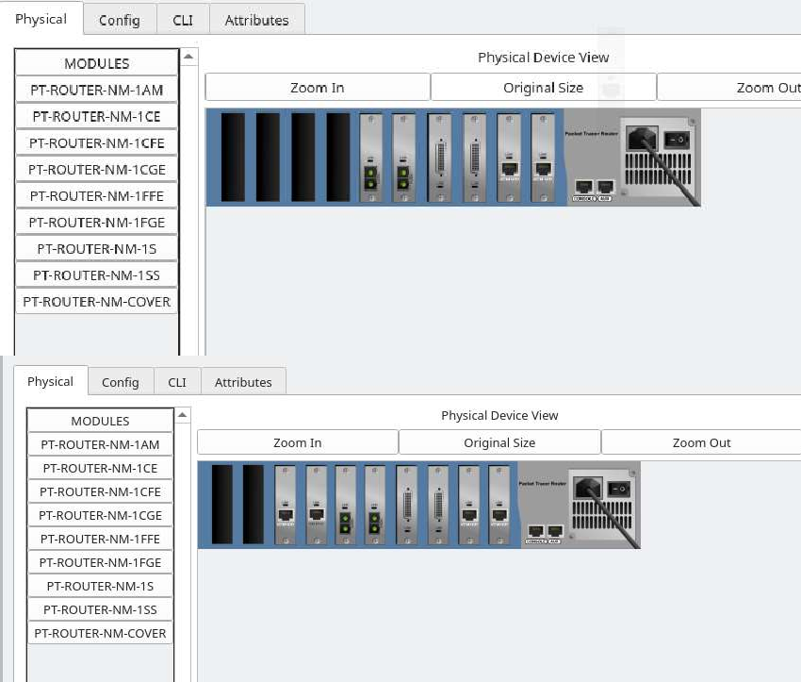

# STEP 4:

Now connect the Switches via Straight through the cable to the router PT on GigabitEthernet 6/0 and 7/0 respectively.

# STEP 5:

Open the Router PT and open the CLI tab;

On CLI tab follow up with these commands below;

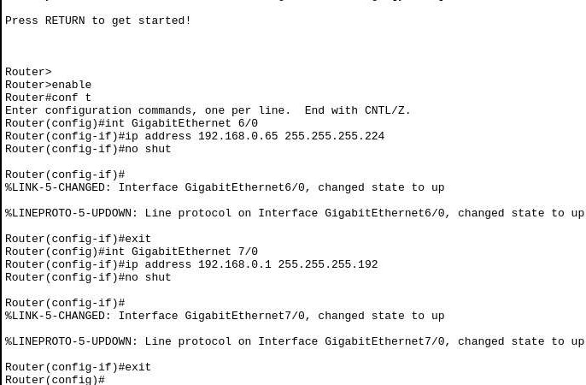

# STEP 6:

Open switches and open the CLI and use the commands as shown

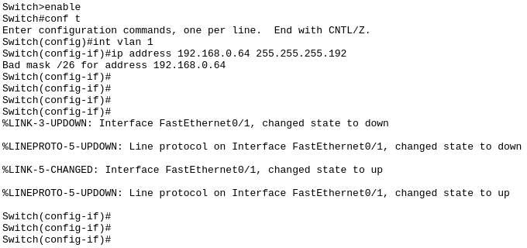

# STEP 7:

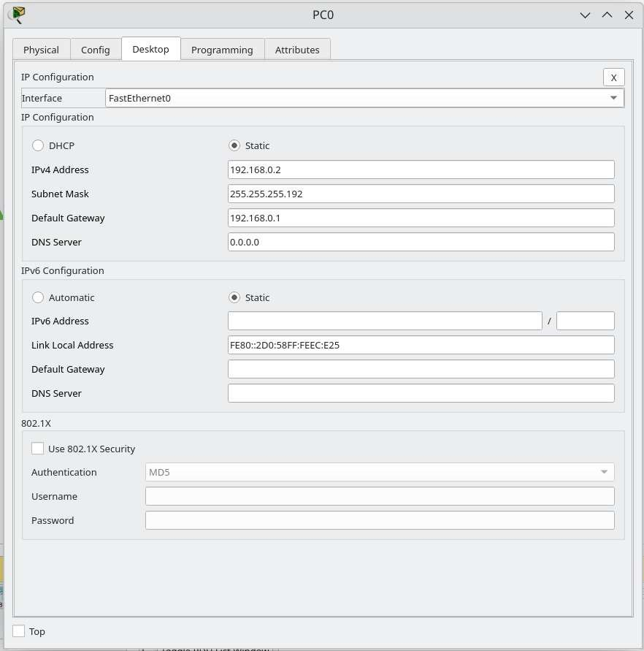Open the PC0 and PC1 and configure IP addresses

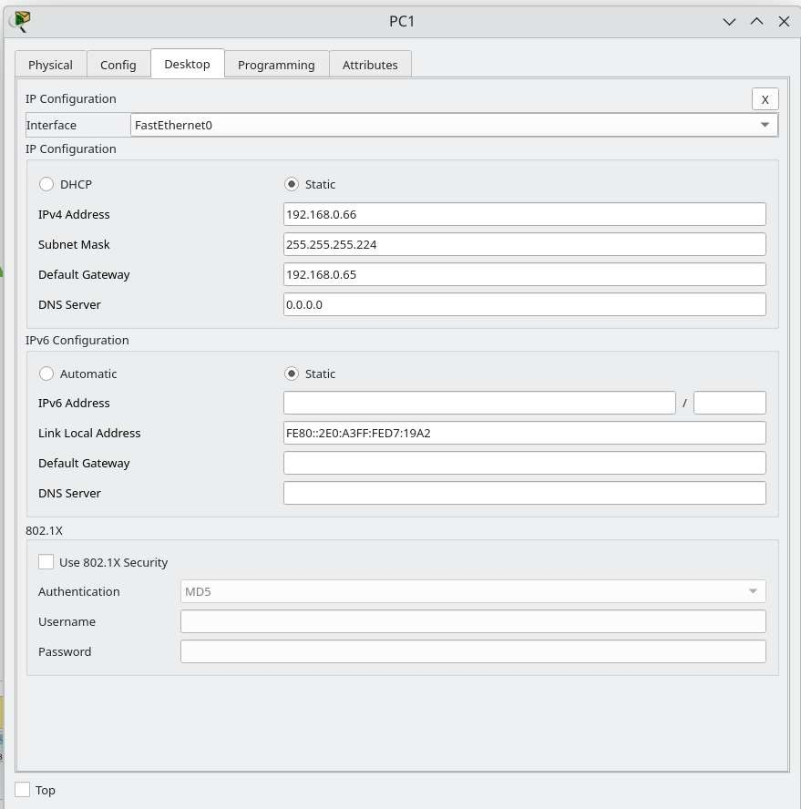

# STEP 8:

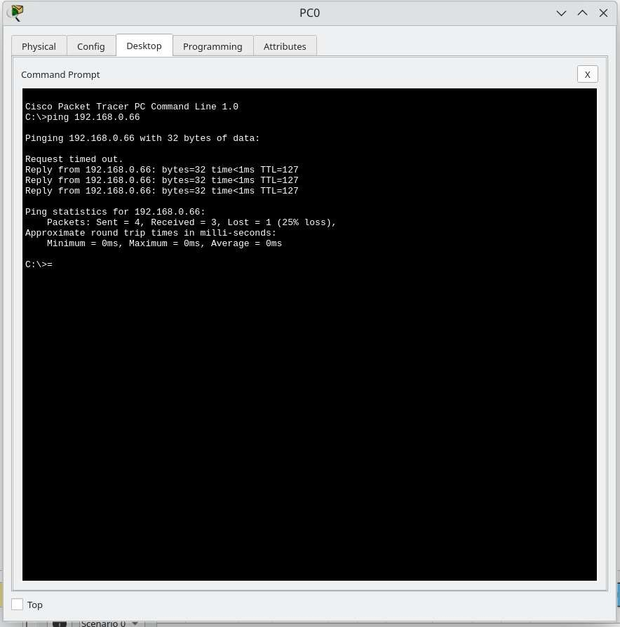Ping PC1 from PC0

Simulation ping PC1 from PC0: ARP REQUEST:

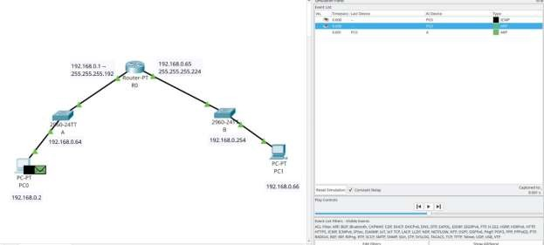

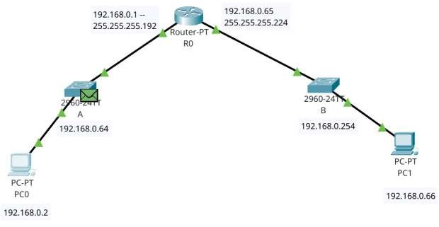

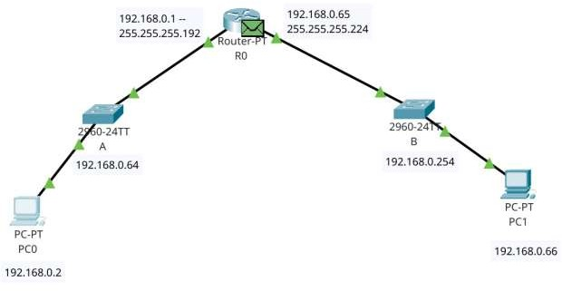

ARP REPLY:

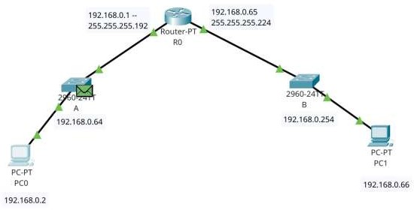

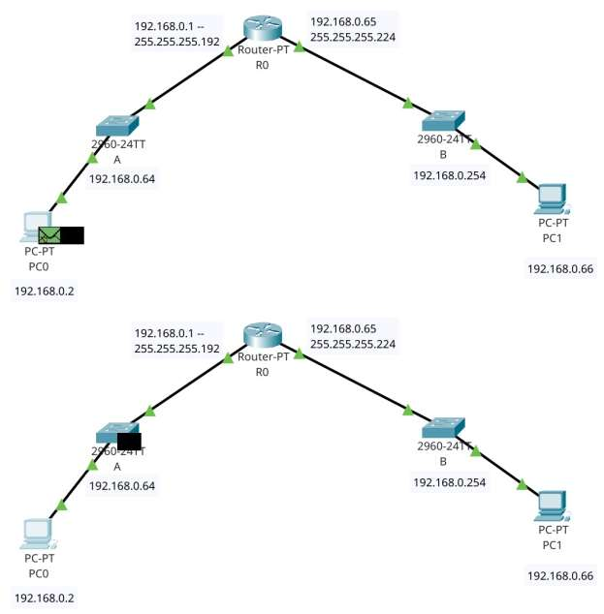

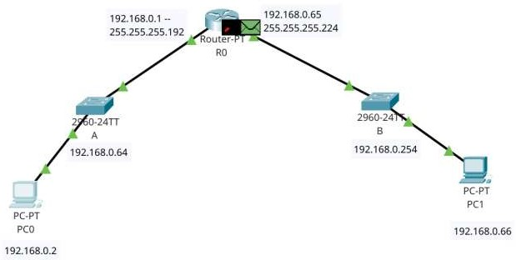

ARP REQUEST:

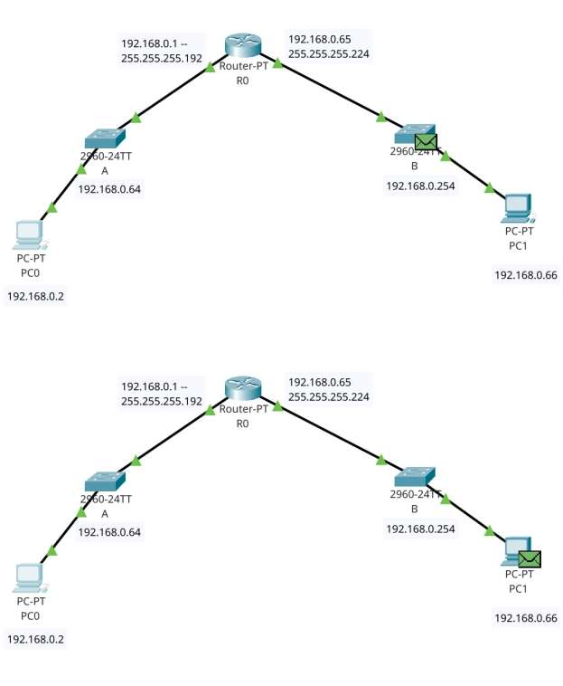

ARP REPLY:

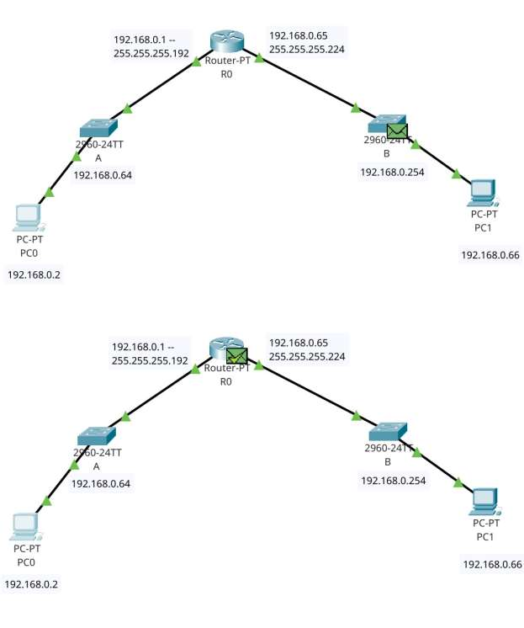

ICMP ECHO REQUEST:

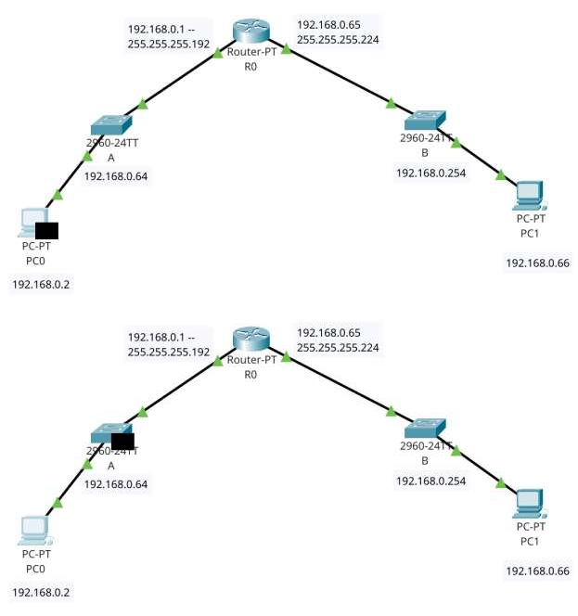

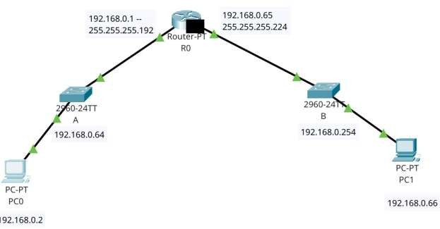

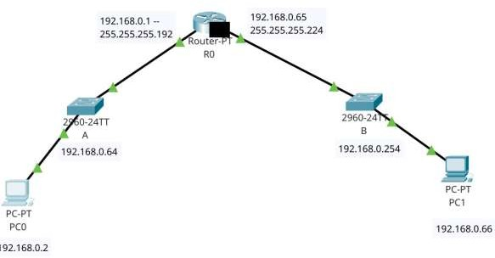

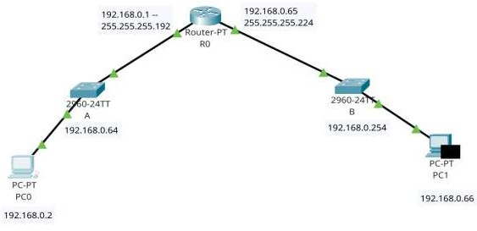

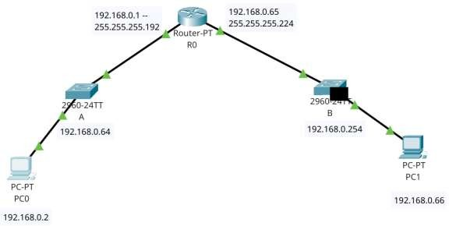ICMP ECHO REPLY:

